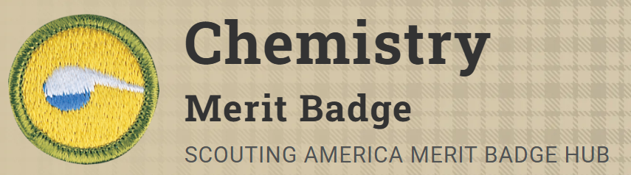
Merit Badge Counselor: Nathan Alcalde, natealcalde724@gmail.com
Link: https://www.scouting.org/merit-badges/chemistry/
Chemistry explores how substances react with each other, how they change, how certain forces connect molecules, and how molecules are made are all parts of chemistry. Stretch your imagination to envision molecules that cannot be seen - but can be proven to exist - and you become a chemist.
Pre-Requisites
5. Describe how chemistry can be used to reduce the environmental impacts of single-use items, such as water bottles, bags, straws, or batteries.
Resources: Upcycling Plastic Bags Into Battery Parts (video)
What Is Sustainable Development (video)
Edible, Biodegradable Food Packaging (video)
6. Identify five fields of chemistry. Briefly describe each, tell how each applies to your life and how they interact.
Resource: Areas of Chemistry - American Chemical Society (website)
8. Do ONE of the following:
- (a) Visit a research laboratory, and discuss the research performed there with a chemist or chemical technician. Learn what education and training they received.
- (b) Visit a company or plant that makes chemical products or uses chemical processes. Learn about their products or processes, and talk with someone who works there. Learn what they do, and what education and training they received.
- (c) Identify three career opportunities that would use skills and knowledge in chemistry. Pick one and research the training, education, certification requirements, experience, and expenses associated with entering the field. Research the prospects for employment, starting salary, advancement opportunities and career goals associated with this career. Discuss what you learned with your counselor and whether you might be interested in this career.
Resources: What do Chemical Engineers Do? (video)
Interactive Site for Chemical Careers (website)
Careers in Science and Engineering (video)

