Exploring the Skies:
An Aviation Adventure

2026 Western Division
Spring Camporee
Crossroads of America Council,
Scouting America

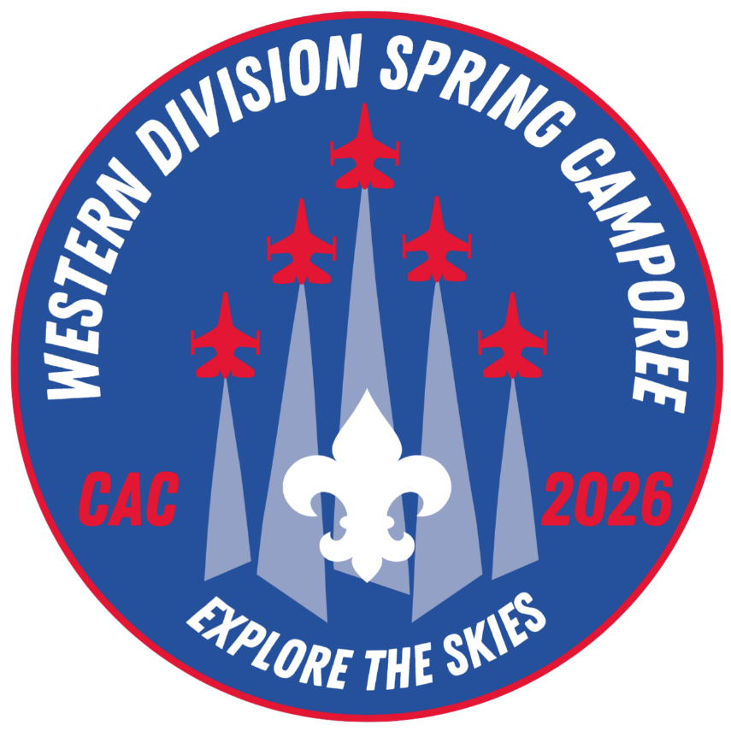
Camp Krietenstein
April 24-26, 2026

Welcome!
Welcome to the 2026 Western Division Spring Camporee! This year, Wabash Valley and Five Creeks Districts of Crossroads of America Council will be learning all about the amazing world of aviation!. Our theme for this year is Exploring the Skies: An Aviation Adventure. Join us as we learn about the wonderful history, innovation, bravery, and opportunities involved in American aviation!

Camporee Details
What: 2026 Western Division Spring Camporee
Where: Camp Krietenstein, 6445 East County Road 575 N., Center Point, Indiana 47840
When: April 24-26, 2026
Registration: Via BlackPug
Cost:
Fees | Scouts | Adults | Staff
Until April 19* | $20 | $10 | $0

Chris Cordray of Wabash Valley District will serve as Camp Director for this event, and may be reached at cncordray@gmail.com, or (812)878-7328.

Registration will close at 11:59pm on April 19, 2026. Late registration will not be accepted (except in extreme circumstances). Five Creeks or Wabash Valley District volunteers wishing to volunteer should make contact with Chris Cordray to make specific arrangements.

Publicity and communication will be conducted via the email addresses provided at the time of registration and via the Western Division Camporee Facebook Page (see link below). Please follow this group if you are able.

(CAC Western Division Camporees; https://www.facebook.com/groups/CACWESTcamporees)

Camporee Merchandise & Apparel
Event patches will be provided to each registered participant, and any additional patches will be available in the camp trading post at a cost of $5.00 each. An event t-shirt is available for purchase via the BlackPug registration page at a cost of $15.00 each, with larger sizes at a slightly increased cost.

Arrival & Check-In
Scouting units may arrive between 5:00 pm and 8:00 pm on Friday, April 24. Event staff will be located near the parking lot. Units must present all required health forms, stored in three-ring binders, at the time of arrival. Units will NOT be allowed to check in without proper, two-deep leadership present at the time of arrival. Any Scouts or Scouting units who plan to arrive after 8:00 pm must contact the Camp Director (Chris Cordray, 812-878-7328) to inform him of these plans and to make arrangements for late arrival. For those Scouts or Scouting units arriving late, please check in with event staff at the Dining Hall.

Unit trailers may be parked in the unit’s assigned campsite (weather and ground conditions permitting). All attendee vehicles must be parked in the camp parking lot and must remain there for the duration of the event, unless parking a unit trailer (vehicle must be removed to the parking lot when the trailer is set.), or unless given explicit permission by event staff.

Senior Patrol Leader & Adult Leader Meeting
An informational meeting to go over any last minute changes to the program or schedule will be held on Friday night at 8:30 pm and will be held in the Dining Hall.

Event Programming
The 2026 Western Division Spring Camporee will be an advancement event, offering Scouts the opportunity for valuable merit badges while they learn about American aviation and associated topics. We will offer the Weather and Radio merit badges in full, and Scouts will have the opportunity to begin the Aviation merit badge, with additional events throughout the summer to complete the missing requirements and learn more about aviation.

In addition to youth programming, we are thrilled to be offering Introduction to Outdoor Leadership Skills (IOLS). Adult leaders from Five Creeks and Wabash Valley Districts in need of this training will be given priority registration for this event. Scouters are reminded, this is required training for direct-contact Scout Leaders and it is strongly recommended for all other leaders. Adult leaders who sign up for this training MAY NOT be counted toward a unit’s two-deep leadership and must be considered separate from their regular unit.

IOLS training will take place in the Dining Hall. These Scouters will need to concentrate on their training and therefore, the Dining Hall will be strictly off-limits to Scouts and Scouters not participating in IOLS. The Dining Hall will be unavailable on Saturday until the Cracker Barrel program following the campfire. We kindly ask anyone in need of a restroom to refrain from using the Dining Hall facilities. The Health Officer will still be located in the Dining Hall, and those Scouts or Scouters in need of the medical care will be allowed to access this site as needed.

Please register for this training via BlackPug. The cost for this training will be $20 per participant.

Meal Preparation & Considerations
As always, meals will not be provided by Camporee staff. Units will be expected to prepare and eat meals on their own, in their campsites. Food and equipment will not be supplied by Camporee staff, and units must provide their own equipment and supplies. Approximately an hour and a half has been scheduled for lunch on Saturday.

Campfire Program
Following dinner on Saturday evening, we will close our camporee program with our beloved campfire program (brought to us by IOLS participants) and Order of the Arrow Callout. Scouts and Scouters are expected to join us at the Campfire Ring beginning at 7:00 pm. The OA Callout is a solemn, meaningful ceremony and often a highlight of a youth’s Scouting journey. We encourage families with Scouts who may be called out to join us for the Campfire Program and Cracker Barrel. All visitors MUST sign in and out, and Unit Leaders are expected to coordinate with your unit families to ensure a smooth experience. If you have any questions, please reach out to Chris Cordray.

Cracker Barrel
Following the Campfire Program, at approximately 8:30 pm, Allogogan and Kickapoo Chapters of the Jaccos Towne Lodge will host our traditional Cracker Barrel in the Dining Hall. Units and families are encouraged to attend and celebrate our new Order of the Arrow Scouts.

Scout’s Own Interfaith Service
A brief Scouts’ Own worship service will be held on Sunday morning in the Dining Hall (brought to us by IOLS participants). We will reflect on what it means to be a member of the world’s greatest youth movement. All units are requested to attend. Field (Class A) uniform is appropriate attire. The service will be followed by final instructions for check-out and departure.

Check-Out & Departure
Scout Units may depart between 9:00 am and 11:00 am on Sunday, after they have completed their assigned camp chore and it has been reviewed by camporee staff. Units will be assigned a camp chore which must be completed before closeout paperwork and health forms are returned. Camp chores will be distributed at the conclusion of the Scout’s Own Service. Upon the completion of camp chores and the successful review by camporee staff, Unit Health Binder and closeout paperwork will be distributed by the Health Officer.

Any Scouting units who plan to depart prior to 9:00 am must arrange an early departure site inspection with event staff. No units may depart until their campsite has been inspected, their camp chores have been completed, and they have been cleared to leave. Camp chores may include the policing of program areas for trash, sweeping and mopping the Dining Hall, and other similar tasks. Health binders and/or health forms will be returned to unit leadership upon departure clearance.

Any attendee who must leave prior to the end of the event must notify event staff. A sign-in/sign-out sheet will be located in the Health Office (in the Dining Hall) and will be sufficient for this notification.

Camporee Staff
The multi-district camporee staff are volunteers from throughout the Council. They have donated a great deal of time and effort to make this a successful event. They are ready to answer any questions and are interested in suggestions for ways to improve the camporee. Additionally, the volunteer staff will make every attempt to be fair and reasonable in all activities. Our goal is to make it as much fun as possible for all participants. Your consideration and cooperation is appreciated when and if it becomes necessary for a staff member to take action or make a command decision.

Campsites & Cleanliness
Units attending the 2026 Western Division Spring Camporee will be assigned a campsite based on needs by event staff. Camporee staff reserve the right to reassign campsites based on the specific needs.

Please DO NOT drop off any trailers at campsites until your unit has checked in. Some campsite assignments may change prior to the event, and ground conditions will be considered before trailers will be authorized in camp. One vehicle per unit will be allowed to drive to the campsite upon arrival and check-in, and then again on Sunday when the unit is preparing to depart. Once the trailer has been dropped off and is set, the vehicle must be removed to the parking lot for the duration of the event.

Water will be available. To promote proper sanitation, no dishwashing, bathing, or hand washing will be allowed at communal water pumps. Water should be taken back to your campsite for proper cleaning. Please do not waste water. Latrines and bathhouse restrooms are all nearby. Showers may be available, depending on the seasonal maintenance schedule of the caretaker. Restrooms will remain available.

Be sure to keep your campsite well organized and clean. Remember that other units will be camping next to or near your site so please be respectful of their space and recognize the designated quiet hours. Unit campsites should be maintained in good taste and in accordance with Scouting America guidelines. Individual units are responsible for all of their camping equipment and supplies. Scouting America units may camp together if the units are linked by the same Charter Organization. YPT guidelines must be followed for boy and girl units. Generators will not be allowed in campsites.

Units are reminded to practice Leave No Trace. Campsites are expected to be maintained in a neat and orderly manner. Trash receptacles are located throughout camp, and dumpsters are located near the Bathhouse and the Dining Hall. Please leave the area cleaner than you found it.

Campfires are encouraged to be used responsibly and in keeping with Scouting principles and policy. Fires are only to be built in established fire pits. Firewood is provided by the camp and will be available to any unit wishing to use it. Do not bring firewood from outside locations.

The Buddy System
As with everything in Scouting, safety is paramount. The use of the buddy system must be utilized while in camp. Any Scout leaving their campsite should have a buddy, regardless of destination.

Buddy System Guidelines per Guide to Safe Scouting: The buddy system should be used at all times. Horseback riding, cycling, canvassing the neighborhood during a fundraiser…you name it, you need a buddy. It’s recommended that buddies know and be comfortable with each other. No youth should be forced into or made to feel uncomfortable by a buddy assignment. It is strongly encouraged to pair Scouts of similar abilities, ages and maturity. Buddy pairs should be no more than two years apart in age and should be single gender. There are no boy-girl buddy pairs in any programs, including Venturing and Sea Scouts. A buddy team may consist of three Scouts when necessary, like an odd number in a group.

Responsibility & Restricted Items
Leaders must ensure that everyone participating in Scouting activities abide by the Scout Oath and Scout Law. Adult leaders and youth members share the responsibility for the safety of all participants in the program, including adherence to Youth Protection and health and safety policies. Adult leaders are responsible for monitoring behavior and intervening when necessary, not just for their own unit but for this event in general.

Physical violence, sexual activity, emotional abuse, spiritual abuse, unauthorized weapons, hazing, discrimination, harassment, initiation rites, bullying, cyberbullying, theft, verbal insults, drugs, alcohol, and pornography have no place in the Scouting program and may result in revocation of membership. All leaders are required to adhere to the Scouter Code of Conduct.

Alcoholic beverages and illegal drugs are not permitted in camp. Possession or use of them on camp property will be cause for removal from camp. Smoking is prohibited in camp (per state law and Scouting America policy). This includes electronic nicotine delivery systems. All buildings are smoke-free environments. Smoking in campsites or outside the entrance or exit of the building is not permitted.

Health & Safety
Campers should not participate if they are experiencing any symptoms of infectious disease, including but not limited to fever, vomiting, diarrhea, or cough. Unit leaders are asked to screen their participants prior to departure for camp. For more information about pre-event medical screening, see the checklist available at:

https://www.scouting.org/health-and-safety/safetymoments/pre-event-medical-screening/.

On arrival, each unit MUST submit a roster with names of youth and adult participants, complete health forms for each participant, and notify health staff of any specific medial alerts or needs. All adults in attendance must have up-to-date Youth Protection Training (YPT), regardless of their registration status with BSA.

The unit must, through direct familiarity with a participant’s medical history, or by reviewing health forms submitted by participants, identify any medical alerts or needs that the Camporee Health Officer should be aware of. These include, but are not limited to, participants with mobility issues requiring assistance, rescue medications such as epi-pens or inhalers, acute environmental or food allergies, seizure disorders, or other conditions which might reasonably require monitoring or result in a medical emergency during the camporee.

Each participant – youth and adult – must have a current (i.e., dated within the past year) BSA health form parts A&B. All areas of the form must be complete. This includes either listing vaccination dates in section B2 or attaching a list of vaccination dates. An insurance card (or note indicating there is no applicable insurance) should be attached. Youth forms must be signed by a parent or guardian. Prior to arrival, the unit leader must assemble a paper copy of health forms for all participants, and place them in a 3-ring binder. The spine of the binder must be labeled with the unit number. Forms will be checked against the unit roster at check-in. Any youth or adult without a current health form will not be permitted to remain at the event. Health forms will be held by the Camporee Health Officer in a secure location throughout the event, and returned to the unit leader at check-out. Any health forms not claimed by the unit at check-out will be shredded promptly after the event.

Unit adults are responsible for collection and distribution of youth medication in their unit. The unit must have and use its own process to track the frequency and dosage of medications to be taken, and log that they have been administered to the youth. The unit should be prepared to share this information with the Camporee Health Officer if requested. If your unit has medications that require special handling, such as refrigeration, please inform the Camporee Medical Officer at check-in. These may be kept at the Health Lodge. Emergency-use medications (Epi-pen, inhalers, etc.) should be kept on the person to whom they are prescribed.

Each unit must have a stocked first aid kit available and accessible to unit participants. It is expected that minor first aid treatment is rendered by unit adults in the unit campsite. Leaders and participants are required to report to the Camporee Health Officer any accidents, incidents, or illnesses occurring during the camporee which require treatment beyond minor first aid. The Camporee Health Officer is required to document each accident, incident, or illness on the BSA first aid form. The form will be submitted to the council following the event.

Personal Gear
Field (Class A) uniform is requested for arrival, for the Saturday evening campfire, and for the Sunday morning Scouts’ Own service. Activity (Class B) uniform, suitable for the weather, is sufficient for all other activities at camp.

Scouts should be prepared for the weather. Please plan ahead and prepare by bringing the appropriate clothes and footwear. No special gear is required for the camporee outside of the normal Scout Essentials found in the Scout Handbook.

All Scouts are reminded to BRING YOUR SCOUTBOOK!

Outdoor Ethics
Units are to adhere to the Leave No Trace principles while in camp. Units are encouraged to review the principles with all campers/participants prior to arrival at the camporee. Fires are only to be built in established fire pits. Be respectful to wildlife and fellow campers by minimizing campsite noise. Do not cut down live vegetation unless directed by Camp Ranger at the service station. Travel on established paths and durable surfaces. Dispose of waste in the proper receptacles.

Lost & Found
During the camporee, Lost & Found will be located on a table in the Health Station. Gear and clothing items not claimed prior to the closing of the event will be disposed of or donated one week after the event.

Changes & Event Cancellation
The Camporee Director & their Staff are the only individuals authorized to change or cancel a scheduled activity. Any necessary changes will be made at the earliest possible time and posted in writing at the Health Station. If you have a question about the program, please feel free to come to the Health Station at any time or ask a staff member.

In the unlikely event Camporee must be canceled ahead of time, an email notification will go out to all persons who made an online reservation as well as to the unit leader general distribution list. A notification will go out no later than noon on Friday, February 21, 2025, if the event is canceled, refunds will be given. Otherwise, individual cancellations will be handled by the Council office on a case by case basis and with a physician’s note or other appropriate documentation.

Schedule

Friday, April 24
5:00 pm to 8:00 pm | Arrival & Check-In (Parking Lot)
8:30 pm | SPL & Leader Meeting (Dining Hall)
10:00 pm | Quiet Hours Begin
Saturday, April 25
8:00 am to 8:25 am | Morning Flags (Parade Ground)
8:30 am to 11:25 am | Morning Merit Badge Sessions
11:30 am to 12:50 pm | Lunch On Your Own (Campsites)
1:00 pm to 4:55 pm | Afternoon Advancement Sessions
5:00 pm to 5:25 pm | Evening Flags (Parade Ground)
5:30 pm to 6:50 pm | Dinner On Your Own (Campsites)
7:00 pm to 8:20 pm | Evening Campfire & Order of the Arrow Callout (Campfire Ring)
8:30 pm to 9:30 pm | Cracker Barrel (Dining Hall)
10:00 pm | Quiet Hours Begin
Sunday, April 26
8:00 am to 8:50 | Scout’s Own Service (Dining Hall)
9:00 am | Check-out & Departure Begins
11:00 am | All Units Departed

