A few Merit Badge Counselors will be on-hand if any scouts would like to get something marked off on one of the merit badges they teach.

They will be located in the gym during the following times.

Available: 8:30 - 11:30am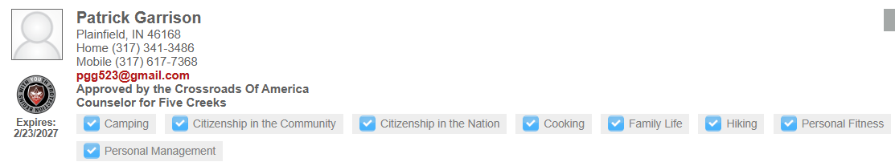

Available: 12:15 – 3:30pm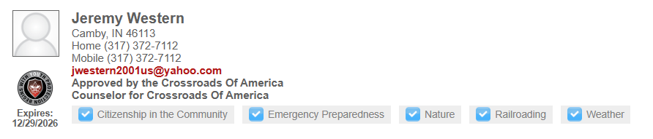

Available 3:30 – 4:30pm