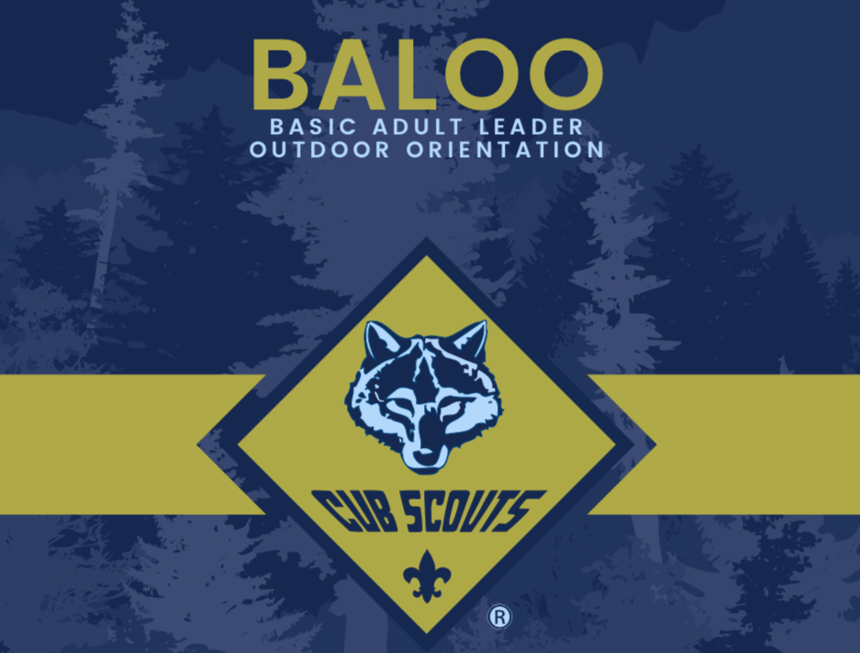

BALOO (Basic Adult Leader Outdoor Orientation)
Presented by White River & Bear Creek Districts
Open to leaders in all districts

Course Overview
BALOO is an introduction to the Cub Scout outdoor program for leaders who want to add camping experiences to their Pack. The training combines an online prerequisite with an overnight, hands-on outdoor experience.
Scouting America’s Cub Scout–level camping policies are covered, along with practical tools and skills to help units plan and deliver successful Pack and WEBELOS den camping activities.
Requirement: A minimum of one BALOO-trained adult must be present for any Pack overnighter or WEBELOS den overnighter.

Training Format
- Online prerequisite course (completed prior to arrival)
- In-person, overnight practical experience
- Participants are required to stay overnight to complete the course

Topics Covered
- Health & Safety – risk reduction and unique situations
- Large Group Games – tips, tricks, and activity ideas
- Outdoor Ceremonies – planning and recognition

Location
Camp Kikthawenund
7651 W 500 N
Frankton, IN 46044

Schedule Snapshot
- Check-in begins Saturday morning
- Training runs through Sunday at midday
(Specific dates and times will be provided on the registration page.)

Meals
- Breakfast is not provided on Saturday morning
- All remaining meals are included

Registration Details
- Advance registration required
- Course size is limited
- Registration deadline, fees, and payment cutoffs are listed on the registration page

Online Prerequisite
Participants must complete the BALOO Prerequisite Training (V2) at my.scouting prior to attending the in-person course.

This flyer is intentionally date-neutral. Refer to the registration page for current course dates, costs, deadlines, and availability.

