Eastern Division
BALOO (Basic Adult Leader Outdoor Orientation)

Presented by White River and Bear Creek Districts—Open to leaders in ALL Districts

Saturday, July 26, 2025 to Sunday July 27, 2025
8:00 am on Saturday to noon on Sunday

CAMP KIKTHAWENUND
7651 W 500 N
Frankton, IN 46044

Register at
Breakfast is not supplied on Saturday morning. All other meals are provided.
Course will start Saturday morning with check-in at 8:00 and course starts at 8:30 a.m.
Cost for the course is $40 or $45 if paid after Thursday, July 17, 2025.
Sunrise on Saturday is about 6:32 am and sunset is about 9:08 pm

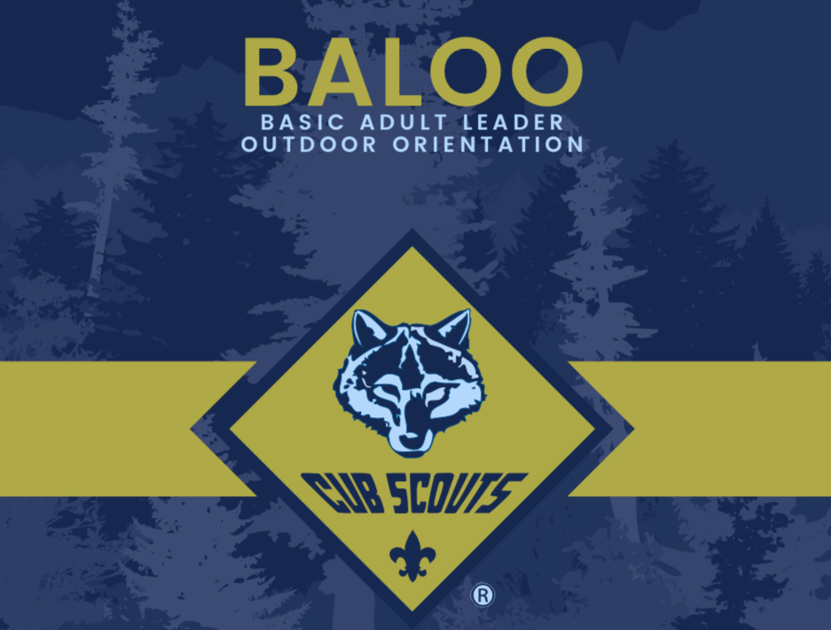
BALOO (Basic Adult Leader Outdoor Orientation)
This course is designed as an introduction to the Cub Scout outdoor program for leaders interested in adding a camping component to their Pack activities. BALOO training consists of an online pre-requisite component in addition to an overnight, hands-on practical.
Scouting America’s Cub Scout level camping policies will be taught along with the discovery of the necessary tools to help units carry out a successful camping experience.
-Completion of this course is mandatory for a MINIMUM OF ONE adult on a Pack
overnighter or Webelos Den overnighter.
-There is an online component to this training that needs to bE
completed before ATTENDING the training.

BALOO Course Description:
Complete online prerequisite course at my.scouting prior to arrival at this training. The online course is called BALOO Prerequisite Training V2

Topics covered at the in-person portion:
Health and Safety: Unique Situations; Risk reduction
Large Group Games: Tips and Tricks; ideas
Outdoor Ceremonies: Recognition; Planning

Participants are required to stay overnight as a part of this course.

Registration closes on July 19, 2025 at 11:59 p.m., seven days before this course
Course will be limited to 30 participants.

