JOIN US FOR WINTER BREAK DAY CAMP AT
LOCATED AT CAMP BELZER
6102 Boy Scout Road
Indianapolis, IN 46064

LIMITED SPACE AVAILABLE
The Skip + Alex Lange Innovation Center at Camp Belzer is proud to offer Winter Break Day Camp for the second season in a facility that boasts a variety of creative and physical activities.
Day Camp programs include:
- Makers Space
- Discovery Space with robotics and programming
- Adventure Space Playground (outdoor) weather-dependent
- Climbing and Boulder Walls
- Sky Trail Adventure Course
- Archery & Laser Shot
- And a variety of games to keep kids active during winter break.

Make the most of your Winter Break at the Skip + Alex Lange Innovation Center.

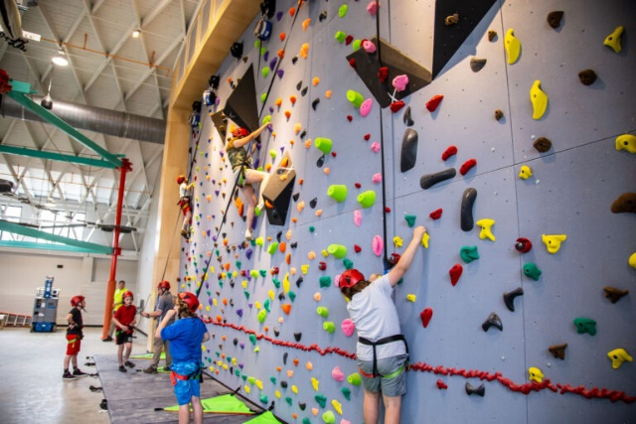
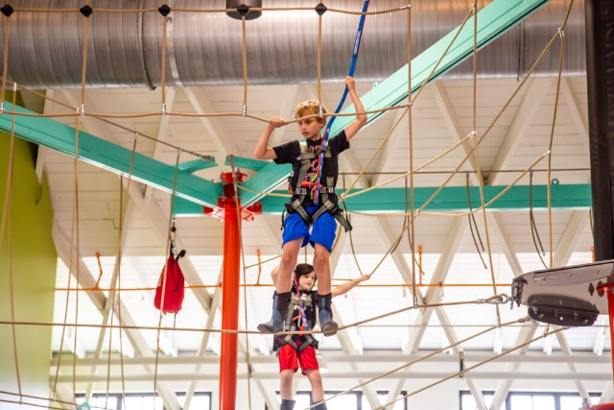

Winter Break camps are open to all kids ages 5 to 11 years old.
DATES
December 26 - 28, 2023

CAMP FEE
 | BSA Member Rate | Non-Member Rate
Three Days | $150 | $195

Register by November 30, 2022, for a discount.

REGISTER AT
https://scoutingevent.com/160-winterdaycamp

