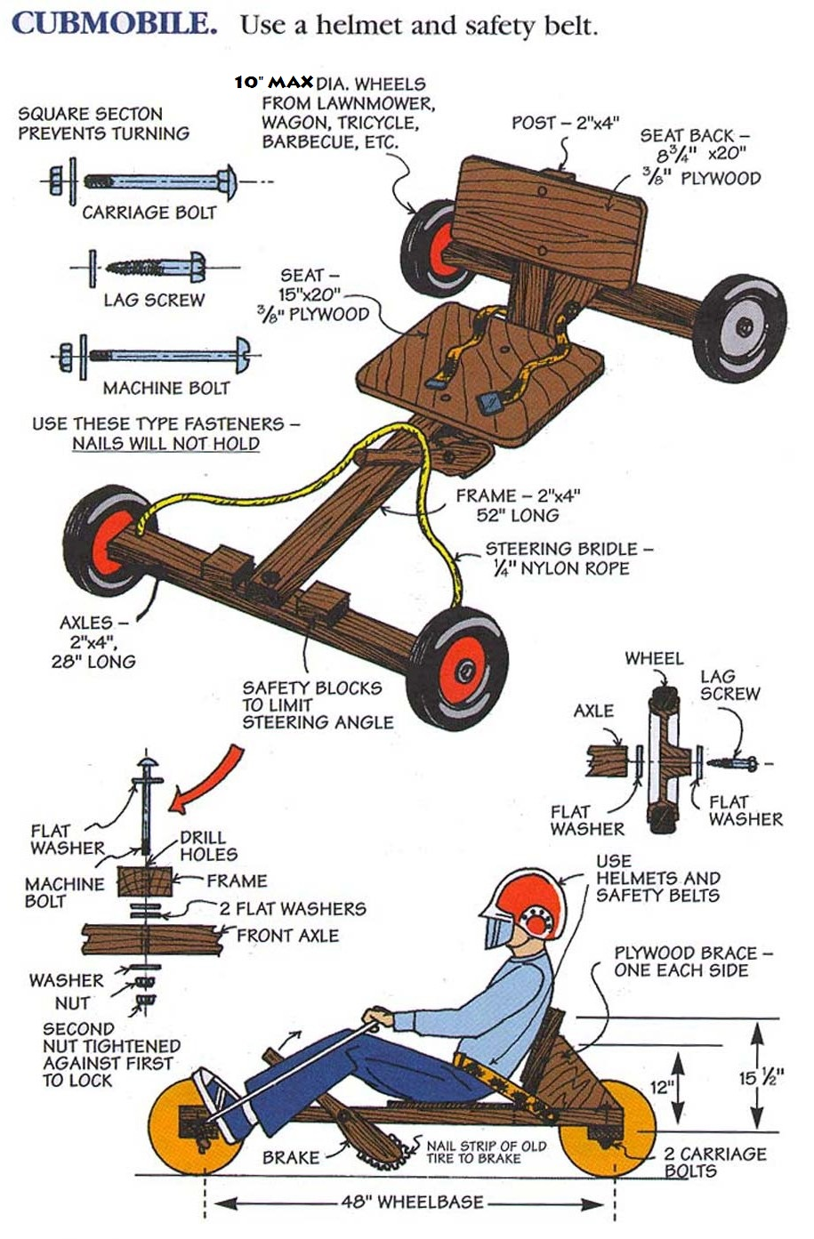

***CUBMOBILE RULES & GUIDELINES***

1. Wheels must not exceed 10 inches in diameter,wheel chair wheels are not recommended. Spoke wheels are not allowed unless they have a hub covering them, **This will be enforced for safety**! We highly recommend wheels with bearings be used. Plastic mower wheels without bearings will many times not even get the Cubmobile all the way down the hill.
2. All wheels may only be equipped with solid rubber tires.
3. Car frame is made from 2-by-4 construction lumber.
4. The overall length of the car is a maximum of 5 feet, the wheelbase a maximum of 4 feet.
5. Use roundhead ¼-inch bolts to hold frame. Screws are a second choice. Nails are not suitable because they may work loose.
6. Cars must be equipped with an **adequate safety belt (automobile seat belt is highly recommended, No waist belts, plastic clips, or rope allowed)** securely fastened to the main frame of the car.
7. All cars must have a seat with braced backrest, so the Scout can comfortably steer with their feet. At Car inspection scouts need to attend for proper fit for steering and safety belt check.
8. Steering is done with the feet, which is placed on the front axle, and by the hands holding a rope fastened to the front axle. The rope should not be too long. Rope should rest on middle of scout’s upper leg otherwise rope is too long!
9. If threaded axles are used, the nuts must be secured with cotter pins or wire.
10. Cars must be equipped with a handbrake with its rubbing surface faced with a rubber material such as a strip of an old tire. This will stop the car when dragged on the ground.
11. **During the race, the 2-by-4-inch blocks fastened no more than a 1/16th inch from the centerboard will limit the turning radius. (Very important to test this before the race!) At car check in this will be tested with a gage before car can be entered!**
12. The maximum weight of the Cubmobile may not exceed 45 lbs.
13. All participants **must** **wear a helmet and shoes that cover the whole foot.** Gloves and kneepads are recommended as well.
14. Each Scout will be allowed 2 competitive runs. Winners are based on fastest run of each Scout.
15. If a Cubmobile stops for any reason before the finish line, it is considered an incomplete race and the participant is not given a timed score.
16. A Cubmobile may not be pushed by any means during a race. When the driver touches the ground for any reason, their run is ended at that point and is not given a timed score.
17. Cubmobiles that are damaged during the race may be repaired in the “pit”, however, major modifications will not be allowed after registration and will need to be re inspected by an event judge.
18. **The ruling of the judges is final on all matters concerning the event.**
19. Have Fun!

**Saturday, September 20th, Registration – 8:00 AM,**

**1st Race @ 9:30 AM**

**Main & Indiana Streets, Warsaw, Indiana**

## Registration Form

|  |  |  |  |  |  |
| --- | --- | --- | --- | --- | --- |
| Unit #: |  | | Leader: |  | |
|  | |  |  | |  |
| Contact Phone #: | |  | E-Mail Address: | |  |

Cubmobile*

|  |  |  |  |  |
| --- | --- | --- | --- | --- |
| 1) |  |  | 2) |  |
|  |  |  |  |  |
| 3) |  |  | 4) |  |

Cubmobile*

|  |  |  |  |  |
| --- | --- | --- | --- | --- |
| 1) |  |  | 2) |  |
|  |  |  |  |  |
| 3) |  |  | 4) |  |

Cubmobile*

|  |  |  |  |  |
| --- | --- | --- | --- | --- |
| 1) |  |  | 2) |  |
|  |  |  |  |  |
| 3) |  |  | 4) |  |

* There may be four registered Scouts per Cubmobile

|  |  |  |  |  |
| --- | --- | --- | --- | --- |
| # Scouts Registered: |  | X $7 per racer = |  | Total Registration |

**(Registration is $10 per Scout after September 14th)**

Make checks payable to the Anthony Wayne Area Council, BSA (AWAC). **No Refunds**.

AWAC Account #6578

Send To: AWAC, 8315 W. Jefferson Blvd., Fort Wayne, IN 46804-8306

1. Recommended that no more than 4 registered Scouts to use the same Cubmobile.
2. Registration is $7 per Scout through September 14, $10 late registration after the 14th. **No refunds**.
3. There are 7 divisions of racers based on weight. Scouts with different weights can use the same Cubmobile, recommended up to 4 per Cubmobile.
4. No rain date at this time. Plan to race rain or shine.

Weight Classes:

Flyweight – 49 lbs. & Under

Bantamweight – 50 to 59 lbs.

Featherweight – 60 to 69 lbs.

Middleweight – 70 to 79 lbs.

Welterweight – 80 to 89 lbs.

Heavyweight – 90 to 99 lbs.

Unlimited – 100+ lbs.

Have Fun!