INTRODUCTION TO OUTDOOR LEADERSHIP SKILLS

An in depth training for Scoutmasters and Assistant Scoutmasters
What is Introduction to Outdoor Leadership Skills?
Why should I attend this training?

Introduction to Outdoor Leadership Skills (IOLS) is designed to give adults a look through scouts’ eyes as we share exciting skills such as Orienteering, Pioneering, Cooking, Fire Building, Flag Ceremony, Outdoor Ethics, Camping and Hiking Techniques, and more. One of the key points of scouting is teaching you the basic skills any scout needs to know to “Be Prepared” in the great outdoors

This course is the second half of the Scoutmaster Training Program, allowing you to be trained as a Scoutmaster or Assistant Scoutmaster. Both IOLS and Scoutmaster Specific can be offered this weekend as part of the course. Please consider taking this course to strengthen your scouting knowledge, build new connections and contacts, and fine tune your outdoor leadership skills.

When & Where
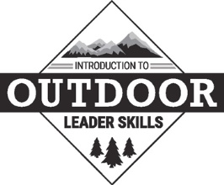
Begin: Saturday April 9th @ 7:30AM (Central Time)
(Please eat before you arrive)
End: Sunday, April 10th @ 2PM (Central Time)
Old Ben Scout Reservation
5735 E 175 N, Winslow IN 47598

Cost: $30
Deadline: April 4th, 2022
(Includes meals on Saturday & Sunday)

Field Uniform | Scouts BSA Handbook | Notebook & Pen | Appropriate Clothing | Water Bottle
Flashlight | Sleeping Gear | Tent | Small Backpack | Rain Gear
Insect Repellent | Personal Hygiene Kit | Shower Shoes | BSA Medical Form  Parts A & B

For more information, contact:
Adam White (812)618-8234 – adambsa383@twc.com
To Register, go to www.scoutingevent.com/156-2019FALLIOLS
Online Payment with Registration Preferred

