Buffalo Trace Council
Woods of Webelos
November 9th-November 10th, 2019

Old Ben Scout Reservation, Cato, Indiana

LEADER’S GUIDE

Greetings Cubmasters and Webelos Den Leaders and
Welcome to the 2019 Webelos Campout.

This year’s Webelos campout will be held at Old Ben Scout Reservation. This event is open to all Cub Scout Packs in the Buffalo Trace Council!
Address: Old Ben Scout Reservation Please use Google Maps for exact location. This address 53745 E. County Road 175N is sometimes incorrect on mapping programs. Winslow, IN 47598
The mission: Woods of Webelos is an excellent opportunity for Webelos to interact with Scouts from local troops and begin to understand what Scouting is about. The Webelos will camp, eat, play, learn, and have fun with the Scouts the entire weekend. The weekend will be packed with activities including wood Into the woods, Into the wild, knot tying, cooking, first aid, archery, BB Gun, patrol games, flag ceremonies, and a campfire program. Many of the skills that will be taught can be used to fulfill adventure requirements. We are planning a weekend of fun and adventure and look forward to seeing you there.
Questions: Please contact event chair Kevin Audette at 815-451-6881 or scoutdad22@gmail.com
1. Registration: There will be no unit on-site registration. Registration must be accomplished on or before the registration deadline of October 30th, 2019. If you are unable to accomplish this, the unit MUST contact the chair or designated representative on or before the deadline date. Only den leaders or Cubmasters are to submit their den rosters at check-in on Saturday morning. (If your pack is not attending, but you wish to attend with your son, you may submit a roster individually.)
2. Behavior Guidelines: Participants are to follow the Scout Oath and Law.
The following are prohibited:
-Alcoholic Beverages
-Willful property damage
-Willful injury to another person
-Adult interference with any staff member (bullying, harassing, arguing, etc.)
There is a NO TOLERANCE Policy. Violation of these prohibitions will be investigated and reviewed by the members of the camp administration and the District Executive and may result in immediate expulsion of said person(s).
3. Wildlife Guidelines: Participants are not to bother any of the natural wildlife found in the camp area. Scouts and leaders are expected to follow the Outdoor Code.
4. Youth Protection: it is BSA policy that all adults working with the youth must have a current Youth Protection card.
5. Personal Items: Please mark all personal items! There are always a lot of backpacks, jackets, water bottles, flashlights, etc. in lost & found which are unable to be returned.
6. Unit Rosters: At check-in, please provide A COPY of the unit roster with all attendees listed!
7. Attendees & Pets: All attendees MUST be registered members of the BSA or a direct Parent/Guardian: No siblings, friends, or other family members. NO pets. Service animals are allowed, but you need to let us know no later than the registration deadline. Your service animal must be easily identified as such.
8. Uniforms are required for certain events: Scouts will be required to wear their Class A uniforms during opening and closing ceremonies, dress accordingly for all other activities.
Camp Courtesy
Campsites will be assigned by the size and needs of the unit.
General Rules
- No sheath knives, fireworks, alcoholic beverages, or firearms
- No electronic games or equipment. Radios, games, DVD, boom boxes, power tools, and generators are not permitted. Please leave these at home. Powered wheelchairs or other devices for persons with disabilities are allowed. Wagons and carts are permitted to move gear to/from campsite.
- Leave no Trace Guidelines will apply at all times
- Lights out and quiet time at 10:00 P.M. Saturday evening. No further camp work permitted.
- Fires are permitted as long as no county burn order is active.
- Early departure (Saturday night) must be declared at registration. Scoutmasters should notify staff of any unscheduled departures.
- Exit packet will be exchanged at the conclusion of the event for Den Leader/Webelos Exit Survey
- All medical incidents other than minor cuts and scrapes must be reported to event headquarters.
- All units must pre-register and pay the camp fees no later than October 30th, 2019.

After unloading people and equipment, all vehicles except for staff vehicles must park in designated, off-site parking areas. This is to limit congestion and enhance safety. The “no vehicle rule” will be enforced.

Woods of Webelos Schedule- All Times CDT
Saturday November 9th
7:00-8:15 Arrival and camp setup
8:15-8:30 Opening Ceremony
8:30-9:15 Patrol breakout/Patrol games/Adult meeting
9:15-9:30 Shooting Sports Safety meeting
9:40-10:30 Round Robin session 1
10:40-11:30 Round Robin session 2
11:40-12:30 Round Robin session 3
12:30-1:00 Lunch (served in the program locations)
1:10-2:00 Round Robin session 4
2:10-3:00 Round Robin session 5
3:10-4:00 Round Robin session 6
4:10-5:00 Round Robin Session 7
5:00-5:15 Flag Lowering
5:15-6:50 Dinner
7:00-8:00 Catholic services/Non-Denominational services
8:15-9:30 Campfire/Awards
10:00 Lights out
Sunday November 10th
6:30-6:45 Opening Ceremony
6:45-7:30 Breakfast
7:30-9:00 Camp tear down/ departure
SCHEDULE SUBJECT TO CHANGE. BE SURE AND ATTEND THE SATURDAY MORNING ADULT MEETING FOR THE FINAL SCHEDULE.

PLANNED WOODS OF WEBELOS ACTIVITIES
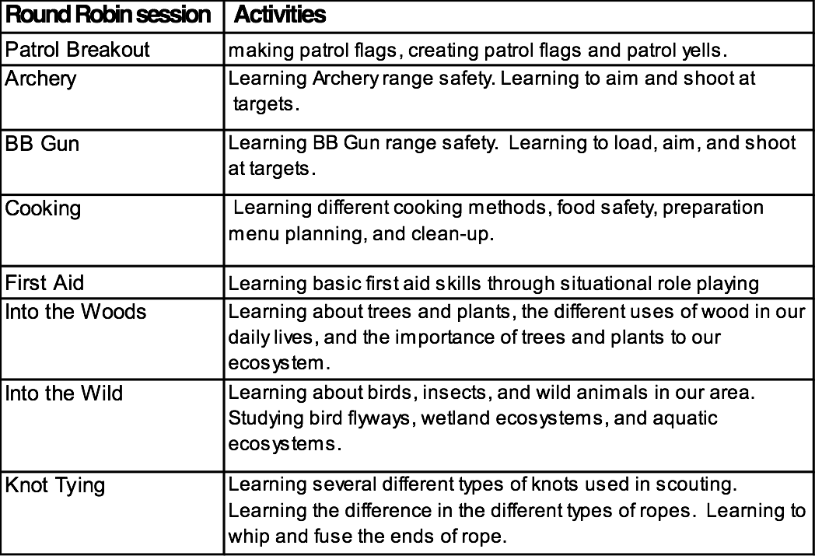
Each session will last approximately 50 minutes. During check-in each leader will be given information as to the adventure requirements that will be worked on during the day. It will be up to each Leader to decide what requirements have been earned based on each Scout’s participation in the program.

REGISTRATION
Each unit participating in Woods of Webelos must complete the online registration and submit payment no later than October 30th, 2019. If paying by check make the check payable to: Buffalo Trace Council

The registration fee for each Scout is as follows:
* We are asking each Webelos Scout to have a parent or guardian along with them for the weekend. The cost listed above is per person. We are asking that adults pay as well to cover the cost of food and program for the weekend. Due to the expected turn out for this event we are asking for just the Scout and guardian, no siblings please.
* There will be no adult training provide during this event. Woods of Webelos is designed as a youth program and as such an integral part of the process is having parents/guardians as part of the process. In an effort to ensure that all Webelos have an enriching experience we ask that adults please stay with their youth during the program.
The fee covers camping fee, lunch and dinner on Saturday, and breakfast on Sunday. There are no refunds. Fees must be received no later than October 30th, 2019. Late additions cannot be accepted.
At check-in you will be required to turn in the following:
1. Unit Roster with every participant, both youth and adult
2. Additionally you will be required to provide a copy of the Annual Health and Medical Record Parts A & B for each participant both youth and adult. A copy of the Medical Record is available online at www.scouting.org for your convenience. The health and medical records will be returned to you upon checkout.
HOLD HARMLESS AGREEMENT/TALENT RELEASE AGREEMENT
By attending this event, you agree to the following:
You understand that participation in the activity involves a certain degree of risk. You have carefully considered the risk involved and have given consent for yourself or your child to participate in the activity. You understand that participation in the activity is entirely voluntary and requires participants to abide by applicable rules and standards of conduct.
In case of emergency involving your child, you understand every effort will be made to contact you. In the event you cannot be reached, you herby give your permission to the medical provider selected by the adult in charge to secure proper treatment, including hospitalization, anesthesia, surgery, or injections of medication for your child. Medical providers are authorized to disclose to the leader in charge examination findings, test results, and treatment provided for the purposes of medical evaluation of the participant, follow-up and communication with the participant’s parents or guardian, and/or determination of the participant’s ability to continue in the program activities.
You herby assign and grant to Buffalo Trace Council-Boy Scouts of America the right and permission to use and publish the photographs/film/video/electronic representations and or sound recordings made of you this date by the Buffalo Trace Council-Boy Scouts of America, and you herby release Buffalo Trace Council-Boy Scouts of America from any liability from such use and publication. You herby authorize the reproduction, sale, copyright, exhibit, broadcast, electronic storage and/or distribution of said photographs/film/video/electronic representations and/or sound recordings without limitation at the discretion of the Buffalo Trace Council-Boy Scouts of America and you specifically waive any right to any compensation you may have for the foregoing.

