White River Trails District
2020 Fall Camporee

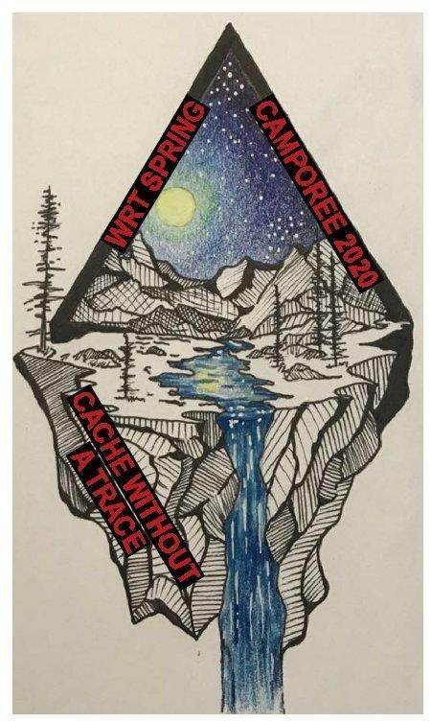

Friday, Oct. 23rd– Sunday, Oct. 25th, 2020
West Boggs Park
16117 US 231
Loogootee In. 47553

The 2020 Fall Camporee’s theme is Cache without a trace.
It will incorporate Geocaching and Leave No Trace.

COVID Precautions:
There will be no walk-up registrations due to the current COVID stipulations limiting gatherings of more than 250 people. Please register everyone planning on attending. Each scout and scouter must be present during registration to take temperature. If the scout/scouter/cub/cub-parent has a fever that person will need to be turned away to keep risks of transmission low. One person per tent, unless they are family. Masks are required when you cannot maintain a 6’ distance.

It is recommended that units have dedicated cook teams to prep, cook and serve to limit the amount of people touching serving utensils. Please also have plenty of sanitizer on hand.

Water will not be on at the campsites and you will need to be prepared to clean latrines periodically.

Scout leaders:
Please ensure your units are monitoring their temps 2 weeks prior. Prior to coming to West Boggs, it is highly recommended to take everyone’s temp. Anyone showing up with a fever will not be permitted to stay. The unit will be responsible for providing the transportation to get that scout back home.

SPL / Scoutmaster Meeting:
We will give the final/amended program and discuss safety at the SPL/Scoutmaster meeting. All unit representatives need to be present.

BSA REGISTRATION: Each youth must be a registered member of the Boy Scouts of America in order to participate in the events. A minimum of two adult leaders per unit must be present in camp at all times. Youth Protection training, which must be current within the past two years, is required for all adults in attendance. Webelos are welcome to attend but must have a parent in attendance.

FEES AND REGISTRATION: Advance registration is required. Payment of $15 (early bird fee) per person is due by 11:59 pm on Sunday, Oct. 18th, 2020. No Walk-ins.

PARK ENTRANCE FEES: Park entrance fees will be waived for this event.

Registration for the 2020 Fall Camporee will close on
Sunday, Oct. 18th at 11:59 pm.

CHECK-IN PROCEDURE: Units may check in at any time between 6-8pm on Friday in the Bittersweet Shelter house. Proceed to the camping area, located across from Bittersweet Shelter House. Signs will be posted to help guide you to the camping area. Upon arrival at the check-in station, a completed unit roster, TEMPS, the Participant Health Screening Checklist (PHSC) per attendee, and any additional registration fees are required. The PHSC will be retained by the district executive. If you need copies, please make them before you arrive. The unit roster form is the last page of this booklet.

The number of campsites assigned to your unit will be determined by the number of Scouts/adults who are registered for the event. We expect to use one campsite per 10 campers (2 adults to 8 scouts per campsite). Parking on the grass or main road is not permitted (just for unload and reload times). An overflow parking area is available near our camping sites.

MEALS: All meals will be prepared at units’ campsites by designated food preparers.

FIREWOOD: You can bring firewood into West Boggs Park if one of the following applies:
1. It is kiln-dried scrap lumber.
2. It is from your home or other location in Indiana and has the bark removed.
3. It is purchased from a department store, grocery store, gas station, etc., and bears a USDA compliance stamp.
4. It is purchased from a local firewood vendor outside the property and has a state compliance stamp with it.
5. It is purchased from the property’s camp store and has a state compliance stamp.

We have been asked to do a service project, which will be announced at the leadership meeting on Friday night. Please bring gloves.

TRASH DISPOSAL: Trash will need to be placed next to the road for pick up on Saturday, and Sunday before leaving the campsite.

RESTROOMS: We have access to the restrooms close to our camping sites. Bathroom #1 is at Bittersweet Shelter house, Bathroom #2 located down from the campsite next to the boat ramp.

CAMP GAMES (Geocache MB): Saturday night we will have a nighttime scavenger hunt that pertains to geocaching. Each scout will need to bring a compass, flashlight and Scout essentials. The scavenger hunt will be strictly done by using a compass, so be sure to sharpen up your Map and Compass skills. This will be a challenging event. Come prepared to have fun.

COMMUNICATIONS MB: We had several Scouts in the District work on the Communications MB. We will have a few opportunities for Scouts to sign-up and help plan and lead one of the events (Saturday games, campfire, Flag raising and lowering and Sunday Chapel.)

2020 Fall CAMPOREE SCHEDULE

Friday, Oct. 23rd
6-8pm Check-in, Temps, and Campsite Setup
9:00pm SPL & Scoutmaster Meeting
11pm Taps

Saturday, Oct. 24th
7am Reveille
7 – 8:30am Breakfast in campsites
8:45am Opening Flag Ceremony
9pm – 12:00pm Geocaching class
12:00-1:30 pm Lunch in campsites
1:30-4:00 pm Leave No Trace class
4:30 pm Flag lowering
4:45- 7:30pm Troop dinner and free time
8:00-9:30 pm Scavenger hunt
9:30pm-10:4 9:30 pm-10:45 pm Closing campfire and awards
11:00pm Taps

Sunday, Oct. 25th
7-8:30am Breakfast in campsite
8:30am Chapel Service (Bittersweet Shelter House)
9:00am Check out begins
11:00am Check out ends (all units must exit the campground

2020 White River Trails District Fall Camporee
Unit Participation Roster

Unit Leader Contact
Name: ___________________________________ Troop #__________
Email Address: ___________________________________ Crew #__________
Phone Number: (_____) ______-_________
Adult Leaders/Parents Attending:
_______________________________ _______________________________
_______________________________ _______________________________
_______________________________ _______________________________
_______________________________ _______________________________

Scouts: (Please Highlight any who would like to assist for Communications)
_______________________________ _______________________________
_______________________________ _______________________________
_______________________________ _______________________________
_______________________________ _______________________________
_______________________________ _______________________________
_______________________________ _______________________________
_______________________________ _______________________________
_______________________________ _______________________________
_______________________________ _______________________________
_______________________________ _______________________________
Total Fees Due:
_____Participants x $15 (Early Bird Fee) = $_________
Total Due = $_________

