Foxfire District Pinewood Derby Car Rules
- Material: Race cars shall be constructed for this event from the parts contained in the Official Grand Prix Pinewood Derby Kit as sold by the Scout Service Center, [for the District in which the race is run]. Materials from the kit may be supplemented but not replaced.
- Weight: Race cars may weigh no more than five (5) ounces (total weight) as determined on the official scales during race day inspection.
- Wheels and Axles: The car shall roll on the wheels from the kit. The wheels shall turn about the axle nails from the kit. The axle nails shall be firmly affixed to the wood of the car body. The axle dimensions may not be changed. The outside surface of the axle head (the non-contact surface) may not be changed substantially, such as, by polishing. It must be obvious to the judges that the wheels and the nails from the kit are being used.
- Size: Race cars may be no longer than 7 inches, nor wider than 2 3/4 (2.75) inches, nor taller than 3 inches, as determined by the official gages during race day inspection. Underside clearance of at least 3/8 (0.375) inches and inside wheel to wheel clearance of at least 1 3/4 (1.75) inches is recommended, so that the car will run on the racetrack. Adequate clearance is the responsibility of the race car builder.
- Weights and Attachment: Weight may be added to the car and will be considered part of the car for purposes of all measurements. “Weight” is considered to be any material on the car that is not provided in the kit. All weight must be securely fastened to the car, e.g., by permanent glue, nails or screws, but not by “sticky substances”, e.g., tape, or tack spray. Weights shall be passive, i.e. non-movable, non-magnetic, non-electric, non-sticky, etc.
- Wheels: Wheel treatment (hub and tread smoothing and polishing) may not result in substantial removal of mass nor in reducing the tread (track contact) width from the original kit wheels. Wheel tread surface must be cylindrical. The words “Official B.S.A. Made in U.S.A.” and other lettering on the wheels shall remain intact and clearly visible to the inspector. Some of the original “tread marks” on the wheel face must be intact, i.e. apparent to the inspector.
- Unacceptable Construction: The following may NOT be used in conjunction with the wheels or axles: hubcaps, washers, inserts, sleeves, bearings.
- Gravity Powered: The race car may not be constructed or treated in such a way that the track’s starting mechanism imparts momentum to the car. (For instance, this provision disqualifies cars with sticky substances on the front of the car and protrusions which may catch on the starting pin or cross the finish line prior to the wood front of the car.)
- Lubricants: Only dry lubricants must be used and at the time of inspection and racing.
- Staging: The entire car must stage behind the starting pin.
- Body: The car body may have no moving parts.
- Design: The car must have been made during the current year (year in which derby is being held) – Cannot use previous years cars – Pinewood Derby Car kits supplied by the pack
- Judge: The designated official has final say on all rule issues and violations.

Foxfire District Pinewood Derby Car Rules
- Material: Race cars shall be constructed for this event from the parts contained in the Official Grand Prix Pinewood Derby Kit as sold by the Scout Service Center, [for the District in which the race is run]. Materials from the kit may be supplemented but not replaced.
- Weight: Race cars may weigh no more than five (5) ounces (total weight) as determined on the official scales during race day inspection.
- Wheels and Axles: The car shall roll on the wheels from the kit. The wheels shall turn about the axle nails from the kit. The axle nails shall be firmly affixed to the wood of the car body. The axle dimensions may not be changed. The outside surface of the axle head (the non-contact surface) may not be changed substantially, such as, by polishing. It must be obvious to the judges that the wheels and the nails from the kit are being used.
- Size: Race cars may be no longer than 7 inches, nor wider than 2 3/4 (2.75) inches, nor taller than 3 inches, as determined by the official gages during race day inspection. Underside clearance of at least 3/8 (0.375) inches and inside wheel to wheel clearance of at least 1 3/4 (1.75) inches is recommended, so that the car will run on the racetrack. Adequate clearance is the responsibility of the race car builder.
- Weights and Attachment: Weight may be added to the car and will be considered part of the car for purposes of all measurements. “Weight” is considered to be any material on the car that is not provided in the kit. All weight must be securely fastened to the car, e.g., by permanent glue, nails or screws, but not by “sticky substances”, e.g., tape, or tack spray. Weights shall be passive, i.e. non-movable, non-magnetic, non-electric, non-sticky, etc.
- Wheels: Wheel treatment (hub and tread smoothing and polishing) may not result in substantial removal of mass nor in reducing the tread (track contact) width from the original kit wheels. Wheel tread surface must be cylindrical. The words “Official B.S.A. Made in U.S.A.” and other lettering on the wheels shall remain intact and clearly visible to the inspector. Some of the original “tread marks” on the wheel face must be intact, i.e. apparent to the inspector.
- Unacceptable Construction: The following may NOT be used in conjunction with the wheels or axles: hubcaps, washers, inserts, sleeves, bearings.
- Gravity Powered: The race car may not be constructed or treated in such a way that the track’s starting mechanism imparts momentum to the car. (For instance, this provision disqualifies cars with sticky substances on the front of the car and protrusions which may catch on the starting pin or cross the finish line prior to the wood front of the car.)
- Lubricants: Only dry lubricants must be used and at the time of inspection and racing.
- Staging: The entire car must stage behind the starting pin.
- Body: The car body may have no moving parts.
- Design: The car must have been made during the current year (year in which derby is being held) – Cannot use previous years cars – Pinewood Derby Car kits supplied by the pack
- Judge: The designated official has final say on all rule issues and violations.

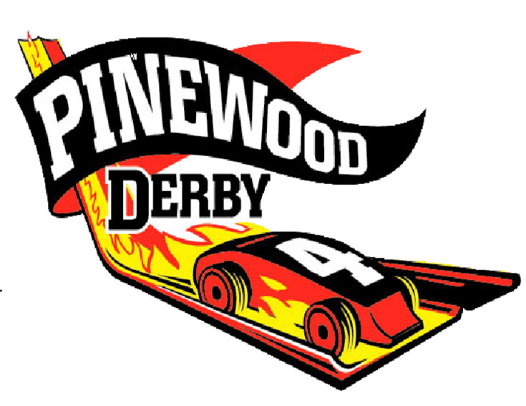
This race is open to all Cub Scouts.
Awards for fastest cars in each of the following ranks: Lions, Tigers, Wolves, Bears, and Webelos.
There will also be awards for:
Feb.
rd
23
Foxfire District

2019
* Best Paint * Best Design * Most Unique
*Most Patriotic * Best Cub Scout Theme

Top Three Fastest Cars Win:

Trophy & $100 Day-Camp Campership
st
1
Where: Holy Angels Catholic School Gym
720 Kensington Place. Aurora, IL 60506
Trophy & $75 Day-Camp Campership
nd
2
When: Weigh-in 10am-11:45am
Trophy & $50 Day-Camp Campership
rd
3
First Race at Noon
Entry Fee: $7
Registration: on line at___or day of during weigh-in See back for Derby Car Rules.
This race is open to all Cub Scouts.
Awards for fastest cars in each of the following ranks: Lions, Tigers, Wolves, Bears, and Webelos.
There will also be awards for:
Foxfire District
Feb.
rd
23

* Best Paint * Best Design * Most Unique
*Most Patriotic * Best Cub Scout Theme
2019

Top Three Fastest Cars Win:

Trophy & $100 Day-Camp Campership
st
1
Where: Holy Angels Catholic School Gym
720 Kensington Place. Aurora, IL 60506
Trophy & $75 Day-Camp Campership
nd
2
When: Weigh-in 10am-11:45am
Trophy & $50 Day-Camp Campership
rd
3
First Race at Noon
Entry Fee: $7
Registration: on line at___or day of during weigh-in See back for Derby Car Rules.

