Event Guide
(revision December 3, 2024)
Chippewa District Activities Committee
Presents
KLONDIKE DERBY 2025
Saturday February 1, 2025
Cantigny Park
1S151 Winfield Rd.
Wheaton, IL 60189
Register On-Line at
www.ChippewaDistrict.org
Event Check-in 8:00 am
Competition 9:00 am – 3:00 pm
Awards Ceremony 3:30 pm

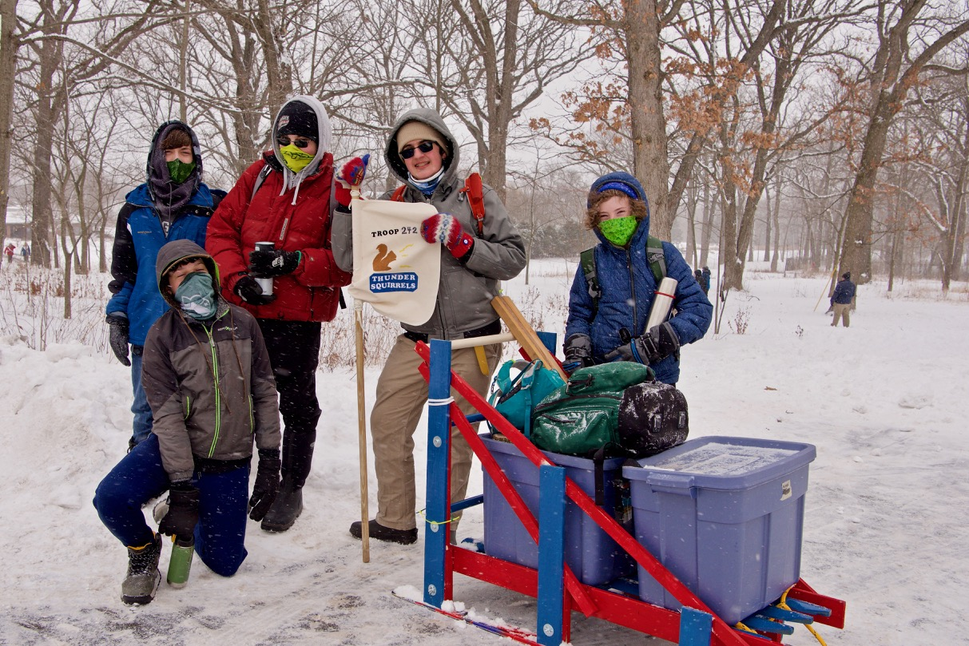

WHAT IS THE KLONDIKE DERBY

The Klondike Derby is a day-long annual event hosted by The Chippewa District Activities Committee for Scouts BSA, Venturing, and Sea Scouts units and older Webelos Cub Scouts. Youth compete as patrols in several outdoor skill events. A score is given at each station. Scores are tallied at the end of the day and ribbons are awarded to the top scoring patrols. Cub Scouts receive separate awards from older Scouts..

Scouts compete as a patrol of 5 – 8 youth. Each patrol brings a “Klondike sledge” which is styled after the type of sledge (sled) used by gold miners in the Klondike Gold Rush from 1896 – 1899. Each sledge must carry specific equipment needed to complete the competition. Sledge designs and the equipment list are described later in this guide.

Local Troops run the competition stations, which are given names themed around historic American Gold Rushes. The station activities are designed to last 20 - 30 minutes each and will accommodate approximately 2 -4 patrols at a time. Stations planned for this year include:
First Aid Bear Bag
Team Building Log Sawing
Sled Race Signaling
Tomahawk Throw Knot Tying
Lashings Fire Building
Tug of War Orienteering

Limited camping at Cantigny Park is available, but has been reserved for units operating event stations, filled on a first come RSVP basis.

.

KEY CONTACTS

Kathy Hall, Sr. District Executive, 630-797-4625, katherine.hall@scouting.org

Rich Tatara, Event Chair, 630-280-4905, rmtatara428@gmail.com

KLONDIKE DERBY LOCATION

Cantigny Park
1S151 Winfield Rd.
Wheaton, IL 60189

Enter via the main gate and identify yourself to the security guard as a participant in the Scouts event. Scouts and leaders will be able to enter the park without charge. Proceed forward to the main visitor center parking lot.

The Visitor Center will be generally open without restrictions. However, only Patrol leaders or designated adult leaders will be able to enter the Medill Room for registration purposes.

Please be prepared to be outside all day.

KLONDIKE TIMETABLE

December 1 On-Line Registration Opens
January 27 Event Go/No-Go Decision Date
January 29 Registration Ends

February 1st Saturday
8:00 A.M. Check in opens
8:45 A.M. Patrols proceed to assigned
starting station
9:00 A.M. Events begin
11:20 A.M. First Lunch Period
11:40 A.M. Second Lunch Period
12:00 Noon Third Lunch Period
12:20 P.M. Fourth Lunch Period
12:40 P.M. Fifth Lunch Period
1:00 P.M Sixth Lunch Period
3:00 P.M. Events Close - Scoresheet Turn-in at Visitor Center
3:30 P.M. Awards Ceremony– Visitor Center

REGISTRATION

This event is open only to Scouts who are registered in Three Fires Council. Units may only participate in the event by registering on-line. Day-of-event entries are strongly discouraged to enable planning for food and beverages. The main registration site is: www.ThreeFiresCouncil.org, then select the calendar. Make sure you select the Chippewa District calendar filter. As an alternative, you can navigate to registration via www.chippewadistrict.org/

Leaders will register for the event as a patrol. A troop or pack may register more than one patrol.

A patrol should consist of up to 6 Scouts BSA youth or up to 8 Webelos scouts. Adult leaders may accompany the patrols, but the youth should be leading/guiding the patrol.

The on-line registration will simply reserve a patrol for your unit in the competition. You will also be able to indicate the number of additional leaders/adults/scouts you will have in camp for the day (to help us plan the lunch count).

Each troop/pack will be required to provide a final roster to be turned-in at registration the morning of the event. A sample roster list is provided in this packet. Patrols will not be permitted to compete unless a complete roster is presented.

It is allowable to have patrols consist of participants from multiple Troop or Packs and to consist of both boys and girls. Units that do not have enough competitors to fill a patrol are encouraged to contact neighboring troops/packs to identify additional participants to fill a patrol. It is recommended that Webelos compete in a separate patrol because they have separate awards. Only one unit should register a patrol, then supply names for all the scouts participating on the day of the event.

COST

This event is included in the Three Fires Council 2025 Activity Fee. There is no charge for units that register a patrol during the initial on-line registration period (12/1 – 1/2).

Admission includes:
Cantigny Park grounds access
Competition entry
Event patch
Hot chocolate & lemon drink throughout the day
Hot vegetable-based soup at the lunch break

EVENT CHECK-IN

Patrols will check-in at the Cantigny Visitors Center before 8:45 am on the day of the event. Only one patrol leader will be allowed into the building for this purpose. The patrol leader will be required to show the following 2 documents:
- a completed roster form listing all scouts and adults attending (blank form found at the end of this guide)
- Part A & B medical forms for their participants (see below)

MEDICAL FORMS AND TOUR PERMIT

All patrols should bring Part A & B medical forms for their participants. Leaders will produce the forms at check-in, but then retain them throughout the event. A designated medical officer will be stationed in the Visitor Center. Units will not need a separate tour permit for this event. Medical forms can be found here:
https://filestore.scouting.org/filestore/HealthSafety/pdf/680-001_AB.pdf
.

LUNCH PLANNING

Upon check-in, patrols will be assigned a designated lunch break period. Lunch will be served indoors at the Cantigny Education Center. We plan to serve at least 2 types of hot vegetarian-based soup, such as tomato soup and minestrone soup, along with saltine and oyster crackers. Hot and cold beverages and water will also be available, such as hot chocolate and lemon drink. Participants are welcome to supplement the soup with sandwiches or other food brought as part of their event planning. Participants are encouraged to bring their own insulated drink containers to reduce waste.

SLEDGE/SLED REQUIREMENT

Patrols competing in the event must transport their gear on a homemade sledge pulled by the scouts. Most troops/packs already have a sledge that has been passed down from generation to generation. If you need to construct a sledge, plans are included at the end of this guide and may be easily found on-line. If you need to borrow a sledge, this may be arranged but is not guaranteed and we need at least two weeks notice to contact nearby packs and troops who may be able to loan a sledge for this event. If there is little or no snow present for the event, then you must construct an alternate means to move your sledge through the event; some sledge designs have optional wheels built into their sledge, while others could place their sledge on trolleys or wagons. In a pinch, units can use toboggans, plastic sleds or wagons to carry their gear through the competition, but it may be harder to earn Klondike Spirit points during the competition.

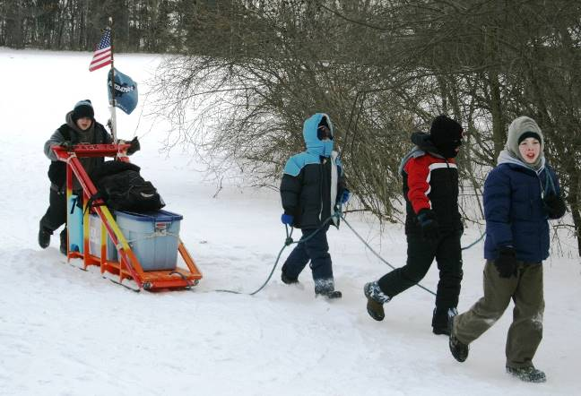

GEAR FOR THE SLEDGE

IMPORTANT!!! There are several things you MUST bring for your sledge, and each competing patrol will be judged on their readiness. Most units place these items in plastic bins on the Sledge. They will be transported on the sledge by the patrol throughout the day.

Here is the list:
- Class A & B Medical Form for each patrol member
- Enough DRY firewood, tinder, and kindling to build a small campfire.
- A Patrol Flag and Cheer
- 6 ft. rope per scout

- One 25 ft. rope per sled
- Blanket and/or tarp
- 3 – 6 Lashing staves/poles
- Compass
- Matches
- First Aid Kit
- Clip Board
- Pencil and Paper
- Water bottle for each Scout
- Hot/insulated beverage container for each scout
- Scout handbook with knot illustrations/instructions

INTRUCTIONS FOR TROOPS RUNNING A STATION

- Your unit should arrive early to complete registration and be prepared for the competition starting sharply at 9:00 am on Saturday morning and run continuously through 3:00 pm (including coverage during lunch period).
- Your event should be operated by both scouts and adults. Some units run their event entirely with adult volunteers so their scouts can participate in the competition. Others have their scouts trade off running the station with members of a competing patrol.
- Your event needs to be scaled so that at least 4 patrols can complete your event within 20 - 30 minutes. Patrols will be assigned to a station for the start of the competition but will then be allowed to travel to any other station as they choose. It is expected that some stations may have a line of patrols waiting to compete, which challenges the patrols to choose their best course to finish all events.
- Your event must include a method of scoring that accounts for demonstrated skill level, especially as it relates to excellence in traditional scout skills. It should also account for the difference in skill level between Scouts BSA and Webelos Scouts. Your scoring could include extra points for spirit and enthusiasm.

WINTER EVENT CLOTHING

The Klondike Derby is an outdoor wintertime event, so participants must dress appropriately to be outside all day. There are many variables affecting the choice of strategy for staying comfortable in cold weather: weather conditions, ground cover conditions, activity level, variability of activity level, etc. It is expected that all participants will be suitably dressed for winter conditions, including long underwear, water repellant pants, warm coat, gloves and hat. In addition, here a few things to do differently for a Klondike Derby:

- Remember, the insulator in all clothing is air. Loose, thick and dry clothes provide more insulation. Thin or tightly drawn clothes provide little insulation. Most mistakes involve forgetting this. Protection from wind by an outer “shell”” is also a key item.

- Add insulation to your legs and head. Most people wear less insulation on their legs and head because they don’t feel cold, but these body parts dump out a huge amount of body heat.

- You need especially thick, loose insulation on your feet. Your summer

shoes/boots don’t have room for this. So, use insulated boots, or else shoes/boots that are 2 or 3 sizes bigger than your summer shoes, and put 2-3 pairs of non-cotton socks on.

- If your fingers get cold, make sure your gloves are thick and loose. Better yet, wear mittens instead of gloves.

- Get moving! Even a small amount of activity will make a big difference.

Cold Weather Clothing & Sleeping Gear Videos

There are many variables affecting the choice of strategy for staying comfortable in cold weather. A few years ago we made two videos that cover these topics specifically for Klondike. They are on YouTube:

Clothing video title: Clothing2.flv
Clothing video link: https://www.youtube.com/watch?v=N2QYjvoburI

Sleeping gear video title: SleepingBag.flv
Sleeping gear link: https://www.youtube.com/watch?v=QrvbBwlepFw

