### The Boy Scouts of America and Windward Ford present:

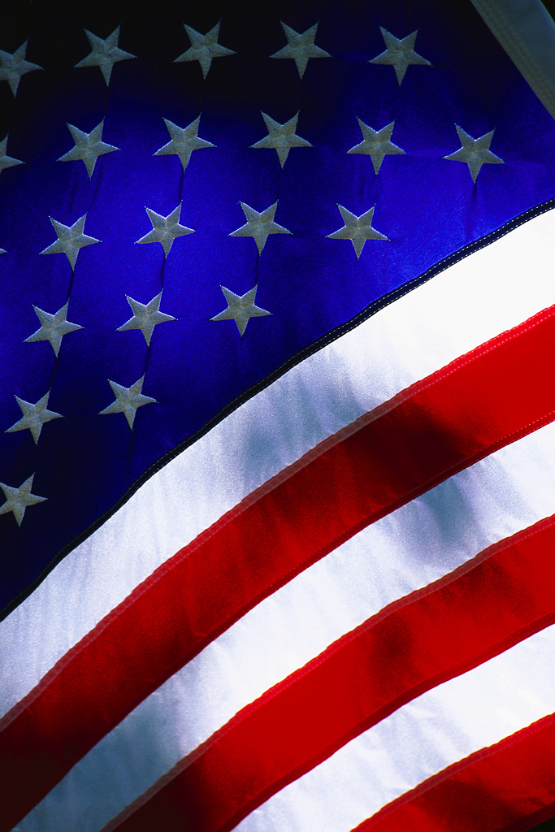

# *The* *Windy 500*

## Saturday, June 24th

## from 1 to 3 PM

## Windward Ford

## 725 Kailua Road, Kailua, HI.

What is the Windy 500? It’s the Windward side’s very own version of the Indy 500—just with pinewood cars and a much shorter track! Send in your entry, get your kit in the mail, and start building! Then on **June 24th** see if you can beat some of Hawaii’s top businesses! Featuring food/refreshments and fun**.** RSVP by **June 3rd**! See back of flyer for entry form! For further information contact Paul Vierling at 808-286-2667 or email him at paulv@hawaiigs.com.



**Windy 500 Pinewood Derby Race**

on June 24th at **Windward Ford in Kailua RSVP: June 3rd, 2017**

**YES! I want to participate in the Windy 500 race!**

**No thanks, donation only**

**Donation ($250 suggested):**

**$______________________________________**

**Payment Method:**

**Cash or Check:** Payable to: **Aloha Council**

**Credit Card:** Visa Discover American Express MasterCard

CC#: _________________________________

Expiration Date: _________ CVS#:_________

Company or Name:

_____________________________­­­­__________________

Address: ______________________________________________

______________________________________________________

Contact _______________________________________________

Email: ________________________________________________

Phone: ________________________________________________

***Please return this form & donation to:***

Adon Construction Inc. 236-1110

45-781 Kamehameha Hwy # A Michael

Kaneohe, HI 96744

Attn: Koolau District (BSA Friends of Scouting)

#### 