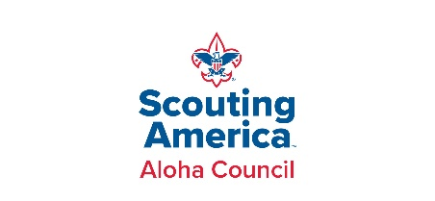**Aloha Adventure Cuboree Packing Checklist**

*October 25–26, 2025 – One-night campout*

**Important Reminders**

* You will be **walking or wagoning your gear into camp**—pack as light as possible.
* Campsites **do not have power**. Bring batteries if needed for medical equipment (e.g., CPAP).
* **No cooking gear needed**—all meals and utensils are provided.
* You may bring a **pop-up canopy**, but remember to share space with other families.

**Required Items**

* Tent (unless canvas tent requested)
* Completed Scouting America Health Form (Parts A & B)
* Scouter Code of Conduct for each adult
* Water bottle or personal cup
* Closed-toe shoes (except in showers)
* Sleeping bag or blankets
* Pillow

**Clothing**

* Lightweight clothing for daytime
* Jacket or sweatshirt for evening
* Extra socks & underwear
* Field Uniform (Class A) for Cub Scout
* Pack T-shirt or other Scouting shirt (if possible)
* Parents: bright Hawaiian shirt to join the festive spirit (optional but lots of fun!)

**Toiletries & Gear**

* Toothbrush & toothpaste
* Soap & towel
* Shower shoes (flip-flops/slides)
* Flashlight or headlamp (with extra batteries)

**Cub Scout 6 Essentials**

* First-aid kit (Cub size)
* Water bottle (See ‘required’ items)
* Flashlight (with extra batteries)
* Trail food/snack
* Sun protection: hat, sunscreen, sunglasses
* Whistle

**Optional / Helpful Items**

* Sleeping pad, cot, or air mattress
* Camping chair
* Hat
* Bug spray
* Personal snacks
* Small backpack or day pack
* Light rain jacket
* Extra blanket
* Small stuffed animal or “buddy”
* Wagon (to help carry gear)

**Provided at Camp**

Plates and utensils *(please bring your own water bottle)*

Program/activity materials