CAMP THUNDER
Summer Camp 2026
LEADER GUIDE
━━━━━━━━━━━━━━━━━━━━━━━━━━━━━━
A Scouting America Camp

Week 1 | Week 2 | Week 3
June 7–13, 2026 | June 14–20, 2026 | June 21–27, 2026

Youth Fee | Adult Fee
$375 per Scout | $150 per Adult Leader

Be Prepared. Be Bold. Be Scout Strong.
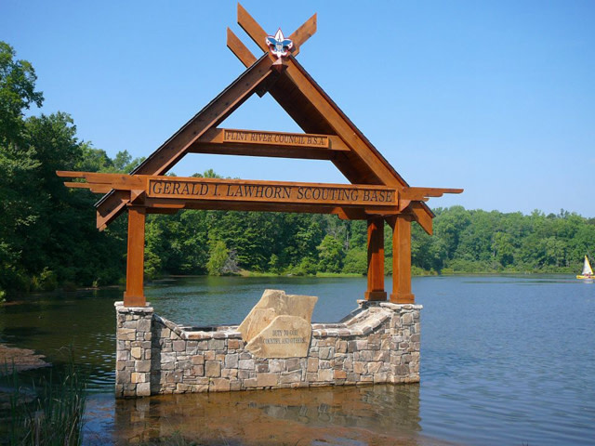

WELCOME FROM CAMP DIRECTOR

Dear Scoutmasters, Assistant Scoutmasters, and Troop Leaders,
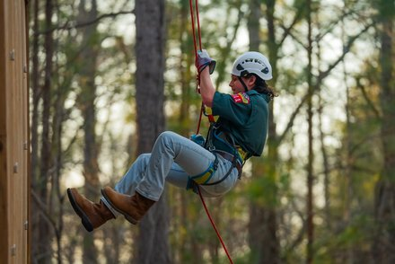
Camp Thunder — Rappelling & High Adventure

Welcome to Camp Thunder — where adventure awaits, lifelong friendships are forged, and the values of Scouting come alive under the open sky. We are thrilled to have your troop join us for Summer Camp 2026, and we want to make this the best week of your Scouts' year.

This Leader Guide has been prepared to give you everything you need to plan, prepare, and participate in a successful camp experience. Please read it thoroughly and share relevant sections with your Scouts and their families. The more prepared you and your troop are before arriving, the smoother and more enjoyable your week will be.

Camp Thunder is operated by Scouting America and is staffed by trained, enthusiastic professionals dedicated to delivering the highest quality program. Our staff is here to support you — please do not hesitate to reach out to any staff member or the Camp Director at any time during your stay.

We look forward to welcoming your troop to Camp Thunder. Get ready for an unforgettable summer!

Yours in Scouting,
Camp Thunder Director
Camp Thunder | Scouting America

TABLE OF CONTENTS

1. Welcome & Camp Overview
2. Important Dates & Session Information
3. Fees & Payment Information
4. Pre-Camp Checklist for Leaders
5. Getting to Camp (Directions & Check-In)
6. Check-In & Check-Out Procedures
7. Health & Medical Requirements
8. Camp Facilities & Housing
9. Daily Schedule & Program Overview
10. Merit Badges & Program Areas
11. Camp Policies & Rules
12. Youth Protection & Safe Scouting
13. What to Bring (Packing List)
14. Food Service & Dietary Needs
15. Emergency Procedures
16. Leader Responsibilities
17. Frequently Asked Questions
18. Contact Information

SECTION 1: CAMP OVERVIEW

About Camp Thunder
Camp Thunder is a Scouting America resident camp offering week-long summer camp sessions for Boy Scouts (Scouts BSA). Our camp provides a full complement of Scouting program opportunities, from merit badge advancement to high-adventure activities, aquatics, shooting sports, and Scout skills. Set in a beautiful natural environment, Camp Thunder offers an authentic outdoor experience that brings the Scouting program to life.

We serve Scouts of all experience levels — from first-year campers through Eagle Scouts — and our program is tailored to meet each Scout where they are in their Scouting journey. Whether your Scouts are working on first-year skills or knocking out Eagle-required merit badges, Camp Thunder has something for everyone.

Our Mission
The mission of Camp Thunder is to serve others by helping to instill values in young people and, in other ways, to prepare them to make ethical and moral choices over their lifetime by instilling in them the values of the Scout Oath and Law.

2026 Session Dates

Session | Dates | Arrival Day | Departure Day
Week 1 | June 7–13, 2026 | Sunday, June 7 | Saturday, June 13
Week 2 | June 14–20, 2026 | Sunday, June 14 | Saturday, June 20
Week 3 | June 21–27, 2026 | Sunday, June 21 | Saturday, June 27

NOTE: All sessions run Sunday arrival through Saturday departure. Check-in begins at 1:00 PM on Sunday. Troops should not arrive before 1:00 PM.

SECTION 2: FEES & PAYMENT INFORMATION

2026 Fees

Participant Type | Fee | Notes
Youth (Scouts) | $375 per Scout | Covers all program fees, meals, and facility use
Adults | $150 per Adult Leader | Covers meals and facility use for the week
Late Fee | +$25 | Registrations received after deadline

Payment Schedule
- A deposit of $50 per Scout is due at time of registration to hold your troop's spot.
- 50% of the total balance is due 60 days prior to your session start date.
- Full payment is due 30 days prior to your session start date.
- Troops with outstanding balances at check-in may not be permitted to register Scouts for program activities.

Refund & Cancellation Policy
- Deposits are non-refundable after the registration deadline.
- Cancellations made more than 30 days before the session begin date will receive a full refund minus the deposit.
- Cancellations made 15–30 days before the session will receive a 50% refund.
- No refunds will be issued for cancellations made fewer than 14 days before the session.
- Scouts who leave camp early due to illness or injury may be eligible for a partial refund — contact the Council Service Center for more information.

Financial Assistance
Camperships (financial assistance) are available to Scouts who demonstrate financial need. Applications must be submitted to your local Council Service Center by the appropriate deadline. Contact your Council for more information and application forms.

SECTION 3: PRE-CAMP CHECKLIST FOR LEADERS
Use the checklist below to ensure your troop is fully prepared before arriving at Camp Thunder. Completing these steps in advance will make check-in faster and your week more enjoyable.

90+ Days Before Camp
- Register your troop and pay deposit through the Council registration system.
- Secure adult leadership (minimum two-deep leadership required at all times).
- Confirm all attending adults have current Youth Protection Training (YPT).
- Begin communicating camp dates and information to Scout families.

60 Days Before Camp
- Collect completed BSA Annual Health & Medical Record (Parts A, B, and C) from all participants.
- Register individual Scouts for merit badge and program sessions.
- Submit any dietary restriction or food allergy information.
- Confirm all adults are registered members of Scouting America and have current background checks on file.
- Make 50% payment per the payment schedule.

30 Days Before Camp
- Complete final payment.
- Review and share packing list with all Scouts and families.
- Verify all medical forms are complete (including physician signature on Part C).
- Confirm transportation arrangements to and from camp.
- Hold a pre-camp meeting with your Scouts and parents/guardians.
- Review the Scout Oath and Law and camp rules with your Scouts.

1 Week Before Camp
- Compile all medical forms in a folder, organized by Scout name.
- Print and review this Leader Guide.
- Confirm your troop's campsite assignment (check the Council website or contact Camp Thunder).
- Ensure all Scouts and leaders have proper Scout uniform and appropriate clothing.
- Confirm medications are properly labeled (prescription medications must be in original containers).

SECTION 4: GETTING TO CAMP

Physical Address & GPS
Camp Thunder at Lawhorn Scouting Base is located at:

506 Thundering Springs Road, Molena, GA 30258
GPS Coordinates (main gate): 32°57'43.8"N, 84°29'53.3"W

NOTE: IMPORTANT: If you see Camp Thunder signage, follow the signs. Some GPS units may route you past the camp entrance onto a dirt road. Use the GPS coordinates above if your device is not finding the address correctly.

Directions to Camp Thunder
From I-75 South (heading north toward Atlanta):
- Take I-75 north to Macon. Take exit 156 for I-475 West.
- Take exit 5 for GA-74 West / Thomaston Road.
- Follow GA-74 West toward Thomaston (approximately 32 miles, then approximately 14 more miles).
- Turn left on Lawrence Road, then take an immediate right onto Thundering Springs Road.
- Continue 1/2 mile into Lawhorn Scouting Base.

From I-75 North (heading south from Atlanta):
- Take I-75 south to McDonough (exit 216).
- Take GA-155 West to Griffin, then take US-19 South.
- At the first traffic light in Zebulon, turn right on GA-18 West.
- Continue through Concord and Molena to GA-74. Turn left on GA-74 East (approximately 2 miles).
- Turn right on Lawrence Road, then take an immediate right onto Thundering Springs Road.
- Continue 1/2 mile into Lawhorn Scouting Base.

From I-85 South (heading north from Alabama):
- Take I-85 north to LaGrange (exit 18).
- Take GA-109 East to Woodbury.
- Continue on GA-74/18/109 (approximately 4 miles). Keep right for GA-74 toward Thomaston (approximately 2 miles).
- Turn right on Lawrence Road, then take an immediate right onto Thundering Springs Road.
- Continue 1/2 mile into Lawhorn Scouting Base.

Estimated Travel Times

Departing From | Approx. Travel Time
Atlanta Airport (ATL) | 1 hr 30 min
Columbus, GA | 1 hr 10 min
Macon, GA | 1 hr 35 min
Birmingham, AL | 3 hr 30 min
Valdosta, GA | 3 hr 40 min
Charlotte, NC | 5 hr 35 min
Nashville, TN | 5 hr 40 min
Jacksonville, FL | 5 hr 40 min
Savannah, GA | 4 hr 20 min
Tampa, FL | 7 hr 25 min
Orlando, FL | 7 hr 15 min
Miami, FL | 10 hr 55 min

Parking
- Vehicles must be parked in designated parking areas only.
- Vehicles are NOT permitted in the camping areas or near program areas.
- Troop trailers may be driven to the campsite for unloading during check-in, then must be moved to the trailer parking area.
- Accessible parking is available near the camp entrance — please notify the camp office in advance if needed.

Transportation & Arrival
- Troops are responsible for their own transportation to and from camp.
- All Scouts must be accompanied by a registered adult from their unit upon check-in.
- Scouts may NOT be dropped off without an adult leader present.
- For troops using chartered buses or shared transportation, please notify the camp office in advance.

SECTION 5: CHECK-IN & CHECK-OUT PROCEDURES

Check-In Overview
Check-in takes place on Sunday afternoon at the designated check-in area near the main camp entrance. Please plan to arrive during your assigned check-in window. Your cooperation in arriving at your assigned time will help prevent backups and make the process smooth for everyone.

Check-In Window | Troop Numbers (Example)
1:00 PM – 2:00 PM | Troops 001–100
2:00 PM – 3:00 PM | Troops 101–200
3:00 PM – 4:00 PM | Troops 201 and above

NOTE: Your specific check-in window will be confirmed in your pre-camp correspondence. If you need to adjust your arrival time, contact the camp office in advance.

Check-In Process
The following steps will occur at check-in. Having your materials organized in advance will significantly speed up this process:

- Step 1: Check in at the Welcome Table — provide your troop number and unit leader name.
- Step 2: Submit all BSA Annual Health & Medical Records to the Health Lodge — a medical recheck will be performed by camp health staff.
- Step 3: Submit all prescription medications to the Health Lodge in original, labeled containers.
- Step 4: Collect your troop's check-in packet, campsite assignment, and program schedules.
- Step 5: Proceed to your assigned campsite for setup.
- Step 6: Attend the mandatory Leader Orientation at 5:00 PM at the Dining Hall.

Medical Recheck
All participants (youth and adult) will receive a brief medical recheck conducted by the camp health officer upon arrival. Please ensure all health forms are complete and legible before arriving. Scouts or adults with incomplete forms or missing Part C physician signature may not be permitted to participate in program activities until forms are completed.

Check-Out Procedures
- Check-out takes place on Saturday morning beginning at 7:00 AM following breakfast.
- All campsites must be cleaned and inspected by a staff member before departure.
- Leaders must return all borrowed camp equipment and key fobs (if applicable) to the camp office.
- Prescription medications will be returned to unit leaders at the Health Lodge during check-out.
- Scouts may NOT leave camp with anyone other than a registered leader or pre-approved adult. Photo ID is required.
- Complete and sign checkout paperwork at the camp office before departing.

NOTE: Early departures must be arranged in advance with the camp director. Early-departing Scouts must be signed out at the camp office and picked up by a parent/guardian or pre-approved adult.

SECTION 6: HEALTH & MEDICAL REQUIREMENTS

BSA Annual Health & Medical Record
ALL participants — Scouts and adult leaders — must have a completed BSA Annual Health & Medical Record on file with the camp health officer. This is a non-negotiable requirement for participation.

Part | Required For | Physician Signature?
Part A: Informed Consent & Authorization | All participants | No
Part B: General Health History | All participants | No
Part C: Pre-Participation Physical | All participants (required for resident camp) | YES — Required

- Part C must have been completed within the last 12 months prior to the start of your camp session.
- The BSA Annual Health & Medical Record form is available on the Scouting America website and through your Council.
- Make two copies of all health forms: one for the camp health officer, one to retain in your troop records.

Medications
- ALL prescription medications must be turned in to the Health Lodge at check-in, in the original labeled container.
- Medications will be administered by the health officer or designee on the schedule indicated by the prescription.
- Over-the-counter medications (Tylenol, Benadryl, etc.) kept by the Scout must be noted on their health form with parental authorization.
- Scouts requiring self-carry medications (EpiPens, inhalers) must have a note from their physician on file and must register these at the Health Lodge at check-in.
- Prescription medications will be returned to unit leaders at check-out.

Health Lodge
The Camp Thunder Health Lodge is staffed 24 hours a day during the camp session. The health officer is a trained medical professional (RN, EMT, or equivalent). In the event of a medical emergency, the health officer will coordinate with local emergency medical services. The nearest hospital to Camp Thunder will be noted in your check-in packet.

Leaders should report any illness, injury, or medical concern to the health officer immediately, regardless of perceived severity. It is always better to have something checked out than to wait.

Homesickness
Homesickness is normal, especially for first-year campers. The best approach is to keep Scouts busy and engaged. Camp staff are trained to handle homesickness positively. Leaders should communicate with the program director if a Scout is struggling. In almost all cases, Scouts feel much better by the second or third day. Calling home is generally discouraged during the first 24–48 hours, as it can intensify homesickness rather than relieve it.

SECTION 7: CAMP FACILITIES & HOUSING

Campsites
Troops are housed in designated campsites throughout the camp. Each campsite includes tent platforms or areas, a dining fly or shade structure, bear boxes or food storage, and latrine/restroom access nearby. Specific campsite assignments are made prior to camp based on troop size and availability.

- Troops are expected to maintain a clean and orderly campsite throughout the week.
- Campsite inspections are conducted daily — keep your site Scout-ready!
- Do not move or remove any camp equipment from your campsite without permission.
- All food must be stored properly to prevent attracting wildlife.

Sleeping Arrangements
- Youth sleep in youth areas only. Adults sleep in adult sleeping areas within the campsite.
- Two-deep leadership must be maintained at all times, including overnight.
- Co-ed troops must have separate, adequately separated sleeping and latrine facilities for male and female participants.
- Scouts and leaders may bring their own tents or use camp-provided tents (if available — check with the camp office).

Dining Hall
Camp Thunder operates a central dining hall that serves all campers three meals per day. Hot, nutritious meals are served cafeteria-style. Troops are assigned dining hall seating and meal times. Please arrive to meals on time as a group, in Scout uniform (or neat, clean attire), and demonstrate the courteous behavior expected of Scouts.

Other Facilities
- Shower/latrine facilities are conveniently located throughout the camp.
- Camp office and trading post are centrally located.
- The Health Lodge is clearly marked and accessible at all times.
- Program area facilities (archery range, rifle range, waterfront, etc.) are located throughout the camp — maps are provided in your check-in packet.
- A camp-wide map will be included in your troop's check-in materials.

SECTION 8: DAILY SCHEDULE & PROGRAM OVERVIEW

Sample Daily Schedule

Time | Activity
7:00 AM | Reveille / Wake Up
7:30 AM | Flag Ceremony & Morning Assembly
7:45 AM | Breakfast
8:30 AM | Campsite Clean-Up / Morning Inspection
9:00 AM | Period 1 — Merit Badge / Program Sessions
10:00 AM | Period 2 — Merit Badge / Program Sessions
11:00 AM | Period 3 — Merit Badge / Program Sessions
12:00 PM | Lunch & Rest Hour
1:30 PM | Period 4 — Merit Badge / Program Sessions
2:30 PM | Period 5 — Merit Badge / Program Sessions
3:30 PM | Period 6 — Open Program / Free Time
5:30 PM | Retreat / Flag Lowering
6:00 PM | Dinner
7:00 PM | Evening Program / Campfire
9:00 PM | Cracker Barrel (select nights)
10:00 PM | Lights Out for Youth

NOTE: The exact daily schedule may vary slightly by week and will be distributed at check-in. Evening programs vary by night and include campfires, Order of the Arrow ceremonies, special events, and troop time.

SECTION 9: MERIT BADGES & PROGRAM AREAS


Merit Badge Registration
Merit badge and program session registration is completed online through the Council registration system prior to arrival. Visit www.flintrivercouncil.org to register. Scouts should select sessions carefully based on rank, ability, and interests.

- Blue cards (merit badge applications) must be pre-signed by the Scoutmaster and brought to camp.
- At the end of the week, counselors will sign completed blue cards and note incomplete requirements for partials.
- Classes requiring TWO periods need two consecutive period blocks — plan your Scout's schedule carefully.
- Eagle-required merit badges are marked with ★.
- 'A' and 'B' are separate sections of the same class — Scouts register for ONE section only.

NOTE: Buckskin is Camp Thunder's First-Year Camper Program covering Scout through First Class rank requirements. New Scouts are strongly encouraged to enroll in Buckskin rather than individual merit badge sessions.

Period Times

Period | Time
1st Period | 8:30 AM
2nd Period | 9:30 AM
3rd Period | 10:30 AM
4th Period | 11:30 AM
5th Period | 2:00 PM
Evening Program | 7:00 PM

  Aquatics — Canoes & Waterfront |   RATA — Shotgun Shooting

GENERAL & HANDICRAFT
Class # | Title / Badge(s) | Periods | 8:30 | 9:30 | 10:30 | 11:30 | 2:00 | 7:00 Eve
SC2660 | American Business | 1 |  | A
SC2632 | Automotive Maintenance | 1 | A
SC2643 | Citizenship in the Nation ★ | 1 |  |  | A
SC2644 | Citizenship in the World ★ | 1 |  |  | A
SC2645 | Communication ★ | 1 |  |  |  |  | A
SC2650 | Cooking ★ | 1 |  |  |  | A
SC2676 | Disabilities Awareness | 1 |  | A
SC2633 | Electricity | 1 |  | A
SC2646 | Emergency Preparedness ★ | 1 | A
SC2634 | Farm Mechanics | 1 |  |  | A
SC2647 | First Aid ★ | 1 |  | A
SC2659 | Home Repairs | 1 |  |  |  | A
SC2682 | Inventing | 1 |  |  | A
SC2685 | Journalism | 1 | A
SC2614 | Leatherwork & Wood Carving | 1 |  |  |  |  |  | A
SC2670 | Metalwork | 1 |  |  | A
SC2635 | Plumbing | 1 |  |  |  |  | A
SC2673 | Theater | 1 |  |  |  |  | A
SC2636 | Welding | 2 | A | A | B | B

  Welding Merit Badge | 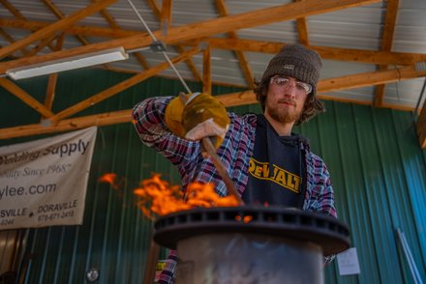  Metalwork — Blacksmithing

COPE / CLIMBING
Class # | Title / Badge(s) | Periods | 8:30 | 9:30 | 10:30 | 11:30 | 2:00 | 7:00 Eve
SC2629 | Climbing | 2 | A | A
SC2630 | COPE | 2 |  |  | A | A

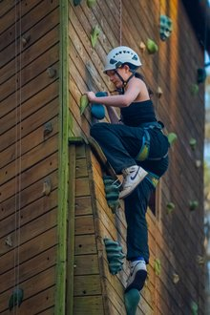  Climbing Wall | 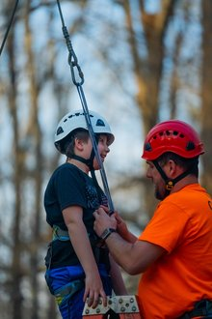  COPE — Staff Guidance | 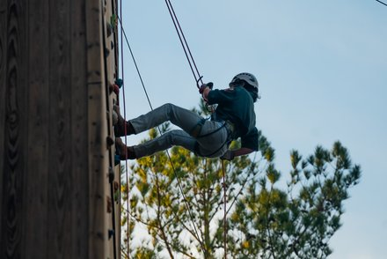  Rappelling at Camp Thunder

AQUATICS
Class # | Title / Badge(s) | Periods | 8:30 | 9:30 | 10:30 | 11:30 | 2:00 | 7:00 Eve
SC261 | Canoeing | 2 | A | A
SC262 | Kayaking & Stand Up Paddle Board | 2 | A | A
SC263 | Lifesaving ★ | 2 |  |  | A | A
SC265 | Motorboating | 1 |  | A
SC266 | Rowing | 1 | A
SC267 | Small-Boat Sailing | 2 |  |  | A | A
SC268 | Swimming ★ | 1 |  |  |  |  | A

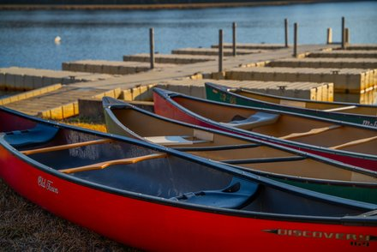  Canoes at the Waterfront | 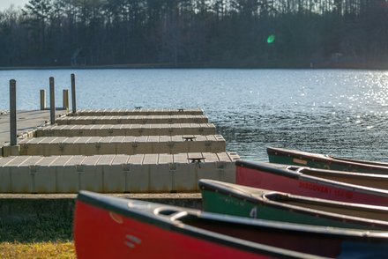  Dock & Marina — Thundering Lake

RATA (RANGE & TARGET ACTIVITIES)
Class # | Title / Badge(s) | Periods | 8:30 | 9:30 | 10:30 | 11:30 | 2:00 | 7:00 Eve
SC2654 | Archery | 2 | A | A | B | B
SC2655 | Rifle Shooting (Option A — Modern Cartridge) | 2 | A | A | B | B
SC2656 | Shotgun Shooting | 2 | A | A | B | B

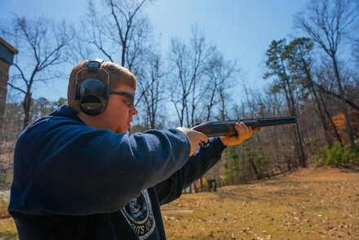  Shotgun Shooting Range | 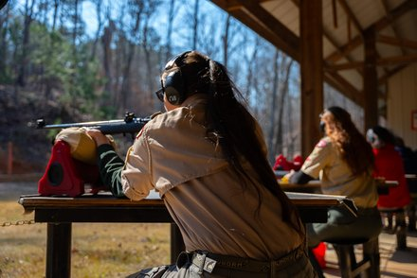  Rifle Shooting in Scout Uniform

NATURE
Class # | Title / Badge(s) | Periods | 8:30 | 9:30 | 10:30 | 11:30 | 2:00 | 7:00 Eve
SC2641 | Archaeology | 1 | A
SC2661 | Animal Science | 1 |  | A
SC2637 | Environmental Science ★ | 1 |  |  | A
SC2668 | Fish and Wildlife Management | 1 | A
SC2639 | Fishing | 1 |  | A
SC2669 | Fly Fishing | 1 |  |  | A
SC2662 | Forestry & Plant Science | 1 |  |  |  | A
SC2680 | Geology | 1 |  |  |  | A
SC2640 | Mammal Study & Nature | 1 |  |  |  | A
SC2671 | Reptile and Amphibian Study | 1 |  | A
SC2642 | Weather | 1 |  |  |  | A

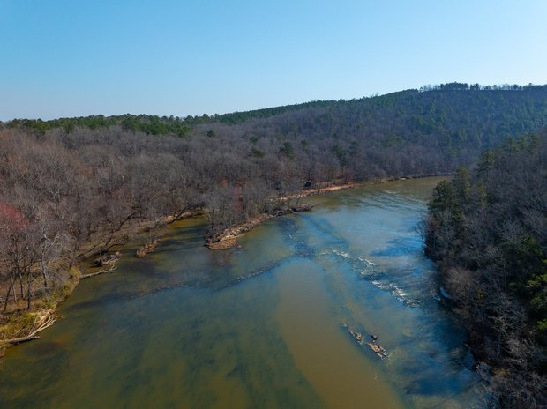
Flint River — Nature & Ecology at Lawhorn Scouting Base

STEM
Class # | Title / Badge(s) | Periods | 8:30 | 9:30 | 10:30 | 11:30 | 2:00 | 7:00 Eve
SC2663 | Architecture | 1 | A
SC2616 | Art & Photography | 1 | A
SC2619 | Chemistry | 1 |  | A
SC2665 | Chess | 1 |  |  |  |  |  | A
SC2675 | Crime Prevention & Fingerprinting | 1 |  |  |  |  | A
SC2620 | Digital Technology | 1 | A
SC2677 | Drafting | 1 | A
SC2678 | Electronics | 1 |  | A
SC2679 | Engineering | 1 | A
SC2613 | Game Design | 1 |  | A
SC2615 | Moviemaking | 1 |  | A
SC2684 | Radio | 1 | A
SC2624 | Robotics | 1 |  |  |  | A

OUTDOOR SKILLS
Class # | Title / Badge(s) | Periods | 8:30 | 9:30 | 10:30 | 11:30 | 2:00 | 7:00 Eve
SC2664 | Basketry | 1 |  |  |  |  |  | A
SC2667 | Fire Safety | 1 |  |  | A
SC2653 | Geocaching & Orienteering | 1 | A
SC2681 | Golf | 1 |  |  | A
SC2651 | Pioneering | 1 |  | A
SC2617 | Pottery | 1 |  |  | A
SC2672 | Search and Rescue | 1 |  |  |  | A
SC2652 | Wilderness Survival | 1 |  |  |  |  | A
SC2688 | Wood Carving | 1 |  |  |  |  |  | A
SC2626 | Buckskin (1st Year Camper Program) | 2 | A | A

★ = Eagle-required merit badge A / B = separate sections of the same course Two-period classes require two period blocks

First-Year Camper Program — Buckskin
Camp Thunder's Buckskin program is a dedicated First-Year Camper experience designed to help new Scouts earn their Scout, Tenderfoot, Second Class, and First Class rank requirements in a fun, active, hands-on environment. Leaders of first-year Scouts are strongly encouraged to enroll them in Buckskin. Buckskin meets during the first two periods each day (8:30–10:30 AM).

SECTION 10: CAMP POLICIES & RULES

General Conduct
As a Scouting facility, the foremost rules for personal and group behavior are the ideals found in Scouting. All participants — Scouts and adults alike — are expected to live by the Scout Oath, Scout Law, and Outdoor Code throughout their stay at Camp Thunder. Beyond these foundational ideals, the following rules are enforced at Camp Thunder:

Camp Rules
- All cars must be parked in designated parking areas. Only specially authorized vehicles are allowed in campsites or on camp roads.
- No UTVs or ATVs are permitted on camp property.
- Closed-toed shoes must be worn at all times while at camp. Sandals are permitted only at the shower/bathhouse facilities.
- Throwing rocks is strictly forbidden.
- No flames, fires, or fuels of any kind are permitted inside tents.
- No personal skateboards, inline skates, or mountain boards are permitted.
- No bike riding is allowed outside of the mountain biking program. Personal bikes must be checked in at the mountain biking pavilion upon arrival at camp.
- Personal firearms and bows are not permitted on camp property.
- Sheath knives are not permitted. (Pocket knives are permitted for Scouts who have earned their Totin' Chip.)
- No alcoholic beverages or illegal substances are allowed on camp property at any time.
- No fireworks of any kind are permitted on camp property.
- All guests must check in at the camp office upon arrival.
- No underage or non-registered youth are permitted in camp. Please do not bring younger siblings to camp.
- No running in camp.
- Please show RESPECT for others at bathhouses and shared facilities.
- Bullying, hazing, harassment, or disrespectful behavior of any kind will not be tolerated and may result in immediate dismissal from camp without refund.

Golf Cart Usage Policy
Personal golf carts and motorized utility vehicles are not permitted at Camp Thunder. However, camp staff maintain golf carts for operational use. If a participant requires the use of a golf cart due to a documented, ongoing physical disability or mobility limitation, the following applies:

- A written request must be submitted to the Camp Director prior to arrival, along with supporting medical documentation.
- All operators of golf carts on Scouting America camp properties must have completed the required Scouting America training prior to operating any camp vehicle.

Required Training for Golf Cart Operation on Scouting America Properties:
- Hazardous Weather Training (my.scouting.org) — current within 2 years
- Safe Swim Defense (my.scouting.org) — if operating near aquatic areas
- Safety Afloat (my.scouting.org) — if operating near aquatic areas
- Scouting America Concussion Awareness Training (my.scouting.org)
- Per NCAP Standard PD-106: All operators of motorized vehicles on council/camp properties must hold a valid driver's license and complete a property-specific vehicle orientation conducted by the Camp Ranger or Camp Director prior to operating any motorized vehicle on camp property.
- A signed Camp Thunder Vehicle Use Agreement form must be completed and on file with the Camp Director before operation is permitted.

NOTE: Golf cart accommodations for participants with disabilities are subject to approval by the Camp Director on a case-by-case basis. Approved operators must follow all camp road rules, observe a maximum speed of 5 MPH, and never transport more passengers than the cart is designed to carry. Contact the Camping Department in advance if you anticipate needing this accommodation.

Troop Discipline & Adult Supervision
The Camp Thunder staff's role is to provide the summer camp program and the camp infrastructure needed to ensure a safe and enjoyable stay at camp. As with any troop outing, the adults of each troop are responsible for the behavior of their Scouts.

Please help the staff focus on program by actively supervising your Scouts and being available to address discipline issues should they develop. Occasionally, issues arise between Scouts of different troops. We ask that the adults of the troops involved take an active role in mediating any differences prior to requesting assistance from Camp Thunder staff.

Camp Thunder management is always willing to assist in resolving an issue, but only after a reasonable attempt to resolve the matter has been made by the adults of the troops involved. Repeated or serious behavioral issues that cannot be resolved at the troop level will be addressed by the Camp Director, and may result in a Scout or adult being asked to leave camp.

Buddy System
The buddy system is in effect at all times. Scouts should never be alone. Pairs of Scouts must always remain within sight of others. The buddy system is strictly enforced at the waterfront and all program areas.

Uniform Policy
- The official BSA field uniform (Class A) is required for flag ceremonies, meals, and evening programs.
- Activity uniform (Class B — troop T-shirt or Scout T-shirt) is appropriate during merit badge sessions and free time.
- Closed-toed shoes are required throughout camp (sandals permitted at shower facilities only).

SECTION 11: YOUTH PROTECTION & SAFE SCOUTING

Youth Protection Training
Youth Protection is the cornerstone of everything we do in Scouting. All adults (18+) participating at Camp Thunder must have current Youth Protection Training (YPT) on file with Scouting America. YPT must have been completed within the past two years. Adults with expired YPT will not be permitted to remain at camp.

NOTE: YPT can be completed online at my.scouting.org. It takes approximately 90 minutes and must be renewed every two years.

Two-Deep Leadership
At least two registered adult leaders must be present with any group of Scouts at all times. This includes at camp, on hikes, and during all activities. One-on-one contact between an adult and a Scout is never permitted. There are no exceptions to this rule.

Mandatory Reporting
All adults at camp are mandatory reporters. Any suspected abuse, neglect, or inappropriate behavior involving a minor must be reported immediately to the Camp Director. The Camp Director is required to notify the appropriate authorities and the Scouting America Scout Executive. Do not investigate suspected abuse yourself — report it immediately.

Social Media & Photography
- Photography of Scouts by adults must follow all BSA guidelines — photos are for positive program documentation only.
- Adults should never photograph or video Scouts in situations that could be embarrassing or inappropriate.
- Posting photos of other people's children on social media should be done with caution and respect for family privacy preferences.
- Camp Thunder staff members will follow all applicable social media and photography policies as directed by Scouting America.

SECTION 12: WHAT TO BRING — PACKING LIST

Required Items
- Completed BSA Annual Health & Medical Record (Parts A, B, and C)
- BSA Field Uniform (Class A) — shirt, pants/shorts, belt, socks, and hat
- Activity uniform (Class B — troop T-shirts or Scout T-shirts, at least 4)
- Sturdy, closed-toed shoes (at least 2 pairs) — boots recommended for hikes
- Rain gear / poncho
- Sleeping bag rated for cool nights (temperatures can drop)
- Pillow
- Personal tent (or confirm camp tent availability)
- Mess kit (plate, bowl, cup, utensils) if doing patrol cooking — check with your Scoutmaster
- Water bottle (large, refillable — at least 32 oz) and hydration pack recommended
- Daypack / backpack for carrying supplies
- Flashlight or headlamp with extra batteries
- Sunscreen (SPF 30 or higher) and insect repellent
- Personal first aid kit
- Toiletries: soap, shampoo, deodorant, toothbrush, toothpaste, comb
- Towels (2–3) and washcloths
- Swimsuit (modest, BSA-appropriate) and water shoes
- Pocket knife (for Scouts with Totin' Chip)
- Compass
- Notebook and pencils for merit badge sessions
- Spending money for trading post (optional) — recommend $20–$40
- Medications in original labeled containers (turn in at Health Lodge at check-in)

Items NOT to Bring
- Valuables or irreplaceable items — camp is not responsible for lost or stolen items
- Expensive electronics
- Large amounts of cash
- Alcohol, tobacco, or vaping products
- Sheath knives, firearms, or fireworks
- Candy and open food (attracts wildlife — if brought, store in provided containers)

SECTION 13: FOOD SERVICE & DIETARY NEEDS

Dining at Camp Thunder
Camp Thunder provides three nutritious meals per day in the central Dining Hall. Meals are prepared by trained staff and are designed to fuel active Scouts throughout the day. All meals are served family-style or cafeteria-style. Please be on time for meals — latecomers may have limited options.

- Breakfast is typically served at 7:45 AM following morning assembly.
- Lunch is served at 12:00 PM.
- Dinner is served at 6:00 PM.
- Cracker barrel (light evening snack) is provided on select evenings.

Dietary Restrictions & Allergies
Camp Thunder is committed to accommodating dietary needs. We can typically accommodate the following:
- Vegetarian and vegan diets
- Gluten-free diets
- Common food allergies (peanut, tree nut, dairy, egg, etc.)

All dietary restrictions and food allergies MUST be submitted in writing via the registration system no later than 30 days before your session. Last-minute requests may not be accommodated. For severe/life-threatening allergies, leaders should also speak directly with the camp director and food service manager upon arrival.

NOTE: Scouts and leaders with severe food allergies should bring their EpiPen or other emergency medication and register it with the Health Lodge at check-in.

SECTION 14: EMERGENCY PROCEDURES

Emergency Communication
In the event of any emergency, contact camp staff immediately. Emergency procedures will be reviewed at the mandatory Leader Orientation on Sunday evening. Every leader should know the location of the camp office, Health Lodge, and nearest phone or radio access point.

- Camp emergency number will be provided in your check-in packet.
- Cell phone signal may be limited — the camp office has landline and radio access.
- Emergency services (911) are accessible by staff at all times.
- The nearest hospital will be identified in your check-in packet.

Emergency Signals
Camp Thunder uses an audible signal system for emergencies. Signals will be reviewed at Leader Orientation. When an emergency signal is sounded:
- All activity stops immediately.
- Scouts report to their unit leader.
- All units assemble at the designated emergency assembly area (identified at check-in and on your camp map).
- Leaders take attendance and report numbers to staff.
- No one moves until cleared by the camp director.

Severe Weather
- In the event of severe weather (lightning, tornado, high winds), staff will direct all participants to designated shelter areas.
- All waterfront and outdoor activities are suspended immediately when lightning is detected within 10 miles.
- Scouts must stay in or near their campsites or shelter areas until the all-clear is given.
- Do not shelter under trees.

Lost Scout Procedures
If a Scout cannot be located, notify camp staff immediately. Do not organize an independent search. Camp staff will initiate the appropriate lost Scout protocol, which includes securing all program areas, conducting a systematic search, and if needed, contacting local law enforcement. The best prevention is consistent use of the buddy system.

SECTION 15: LEADER RESPONSIBILITIES

The Role of the Troop Leader at Camp
Camp Thunder staff provides programming, facility management, and support — but the troop's adult leaders are responsible for the overall conduct, supervision, and well-being of their Scouts. Your role at camp is not to sit back and relax (though there is time for that!) but to actively support your Scouts and be a positive example of Scouting values.

Key Leader Responsibilities
- Maintain two-deep leadership at all times within your troop.
- Ensure all Scouts are at scheduled activities and accounted for during all activity periods.
- Conduct daily campsite inspections and encourage Scouts in maintaining a clean camp.
- Attend all mandatory leader meetings and the nightly leader cracker barrel (if scheduled).
- Know where your Scouts are at all times. Enforce the buddy system.
- Report any disciplinary issues, medical concerns, or unsafe conditions to camp staff immediately.
- Manage homesickness, conflicts, and behavioral issues within your troop using Scouting values.
- Serve as positive role models — follow all camp rules, wear proper uniform, and demonstrate Scout spirit.

Leader Meetings
A mandatory Leader Orientation will be held Sunday evening at 5:00 PM in the Dining Hall. Attendance by at least the Scoutmaster or designated troop leader is required. Daily leader meetings may be held at the camp commissioner's campfire or via posted daily bulletin. Leaders are encouraged to introduce themselves to the Camp Director and program staff early in the week.

Leaving Camp During the Week
Adult leaders may leave camp during the week, but two-deep leadership must be maintained at all times. If your departure would reduce the troop to fewer than two registered adults, you must arrange for coverage before leaving. Notify the camp office any time adult leadership numbers change. Scouts may not leave camp without a parent/guardian or pre-approved adult, and must be signed out at the camp office.

SECTION 16: FREQUENTLY ASKED QUESTIONS
Can parents visit during the week?
Visitors are generally welcome on Wednesday evening and must check in at the camp office. All visitors must show photo ID. Visitors are not permitted to stay overnight unless they are registered leaders. Unannounced visits during the week outside of visitor hours are discouraged, as they can disrupt the program experience.

What if my Scout gets sick at camp?
The Health Lodge is staffed 24/7. Any Scout feeling ill should report to their troop leader, who will escort them to the Health Lodge. Parents/guardians will be notified for anything beyond routine illness. Scouts with contagious illness may need to be sent home to protect the health of the camp.

Can my Scout call or text home?
Cell phone use is allowed but should be limited. Encouraging Scouts to enjoy the camp experience rather than staying connected digitally is strongly recommended. If a Scout is homesick, calling home in the first 24–48 hours often makes it worse. Staff can help mediate.

What if a Scout doesn't finish a merit badge?
If a Scout does not complete all requirements for a merit badge, the counselor will note which requirements were finished on the blue card as a partial. The Scout can complete the remaining requirements at a future time with another counselor.

Is the camp Wi-Fi accessible?
Limited Wi-Fi may be available in the camp office area for leaders who need to access registration or communication systems. Wi-Fi is not available in campsites or program areas.

What if there is a family emergency at home?
Contact the camp office immediately. Staff will assist in reaching the Scout's family or leader through camp communication channels. In a true emergency, family may contact the camp office directly.

Can my Scout bring a fishing pole?
Yes! Personal fishing equipment is welcome. Scouts should check the merit badge program schedule for Fishing, and open fishing is often available during free time. Check with camp staff regarding any camp-specific fishing regulations.

SECTION 17: CONTACT INFORMATION

Camping Department — Reservations & General Information

Phone | 770-227-4556
Email | greg.joiner@scouting.org
Mailing Address | 1361 Zebulon Rd, Griffin, GA 30224
Website | www.flintrivercouncil.org

NOTE: The most current camp information and all appendix documents are available at www.flintrivercouncil.org. Always check the website for the latest updates before camp.

Camp Thunder — Physical & Summer Address

Physical Address (GPS/Driving) | 506 Thundering Springs Rd, Molena, GA 30258
Daytime Phone (during camp season) | 334-401-8206
Summer Mail Address (May 29–June 23) | Troop # and Scout's Name Camp Thunder at Lawhorn 506 Thundering Springs Rd Molena, GA 30258

NOTE: When sending mail to a Scout at camp, be sure to include the Troop number and Scout's full name on the envelope. Mail sent during the summer mail window (May 29–June 23) should use the summer address above.

Camp Thunder Key Staff

Position | Name | Phone | Email
Council Program Specialist & Program Director | Greg Joiner | 762-247-0900 | greg.joiner@scouting.org
Camp Director | Vacant | — | —
Camp Ranger | Brian Stokes | 706-575-4453 | george.stokes@scouting.org
Health Officer | Vacant | — | —
Business Manager | Vacant | — | —

NOTE: Vacant positions will be filled prior to the 2026 camp season. Updated staff contact information will be posted at www.flintrivercouncil.org. For any questions in the meantime, contact Greg Joiner directly.

Before Camp
For questions about registration, payments, health form requirements, or program offerings, contact Greg Joiner, Council Program Specialist & Program Director, by phone at 762-247-0900 or by email at greg.joiner@scouting.org. You can also visit the Flint River Council website at www.flintrivercouncil.org for the latest camp information, appendix documents, and registration details.

During Camp
Once camp is in session, the best way to reach camp staff is by calling the Camp Thunder daytime phone at 334-401-8206. For urgent matters, always call rather than email, as staff are focused on delivering the best program possible and may not be monitoring email in real time.

━━━━━━━━━━━━━━━━━━━━━━━━━━━━━━━━━━━━━━━━━━━━━━
Camp Thunder | Scouting America | Summer Camp 2026
On my honor, I will do my best.
━━━━━━━━━━━━━━━━━━━━━━━━━━━━━━━━━━━━━━━━━━━━━━

