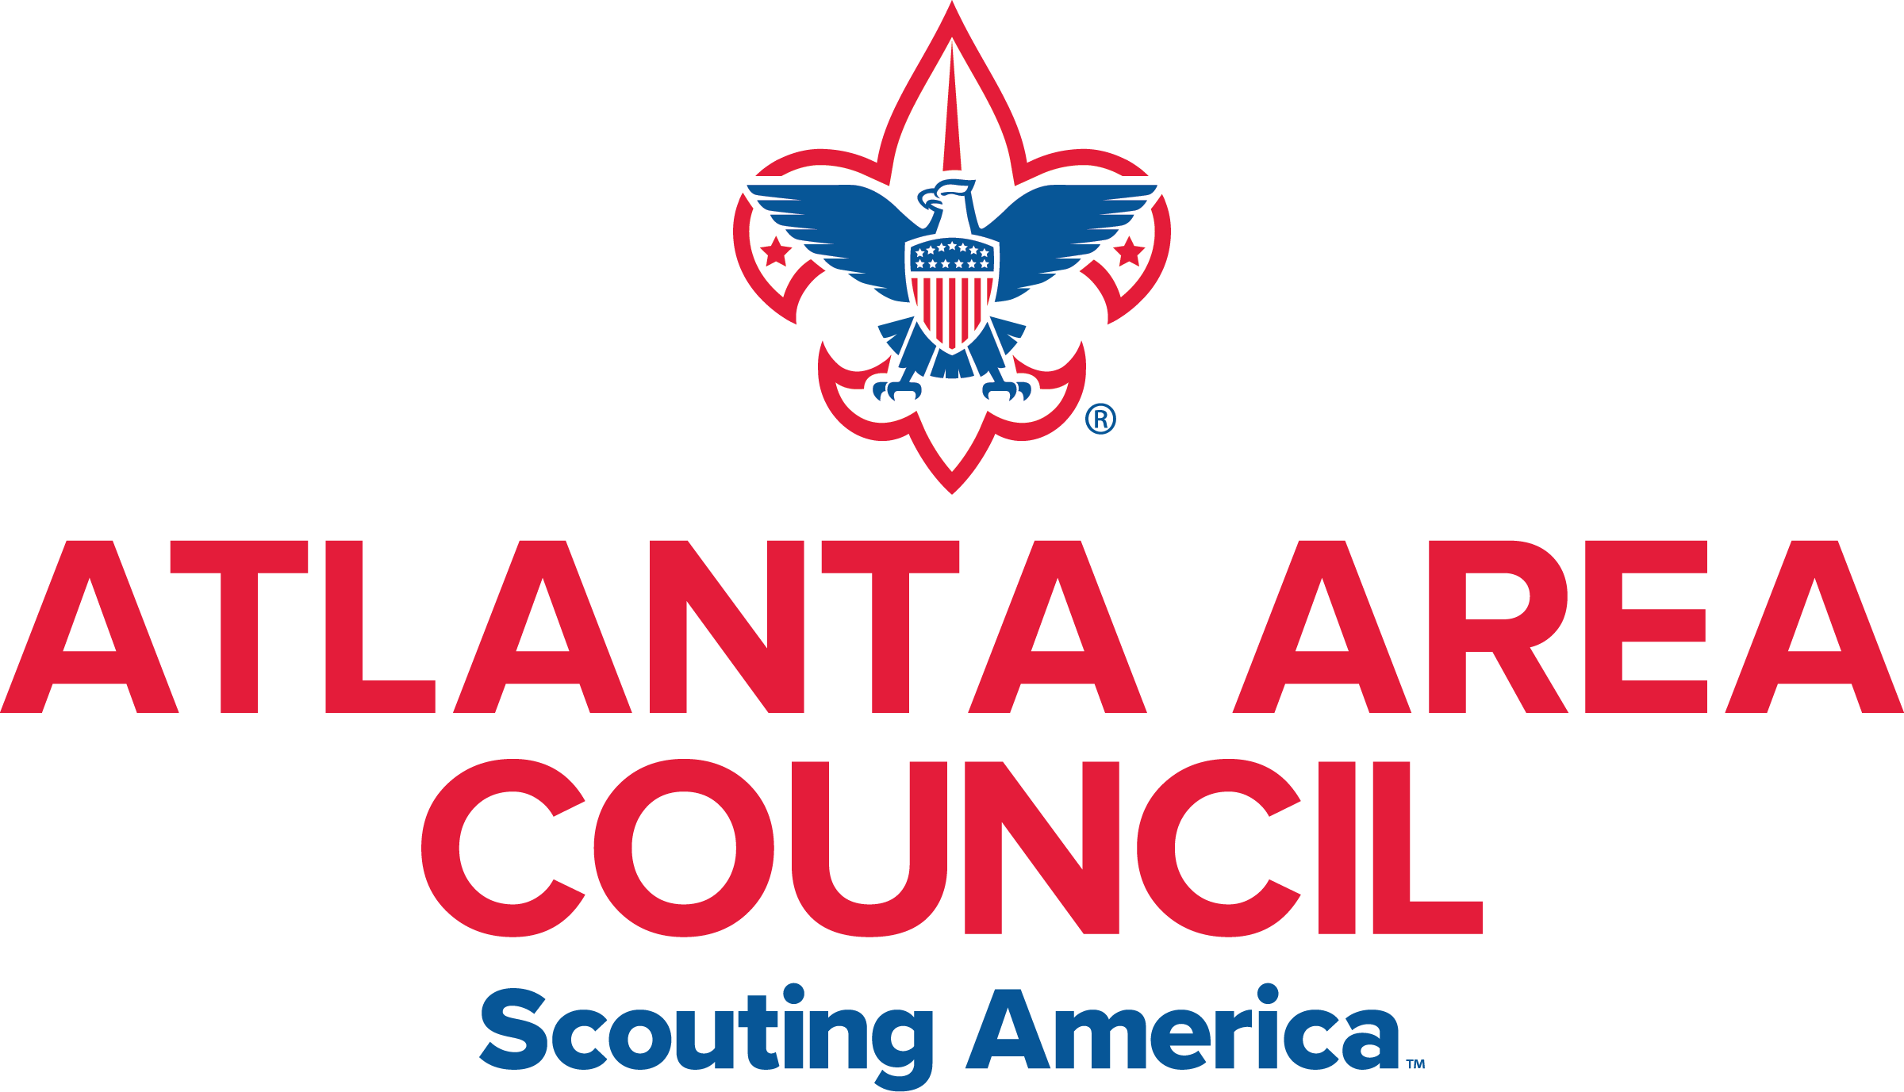

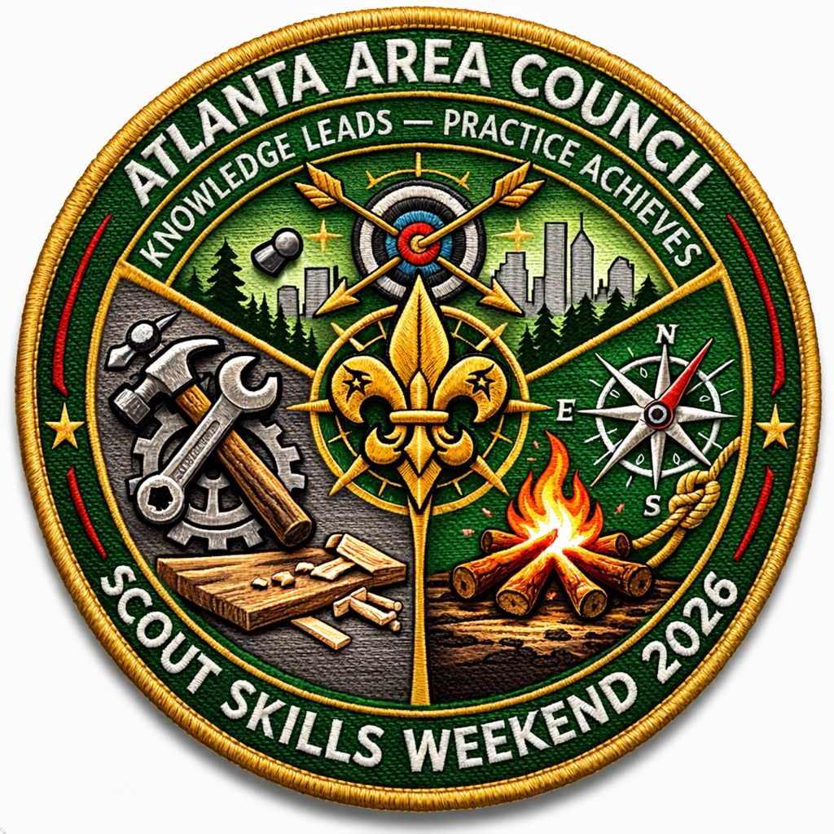
Guidebook
September 11-13, 2026

Welcome to Scout Skills Weekend!

Dear Scouts, Scouters, Families, and Friends,
On behalf of the entire Scout Skills Weekend staff, we are excited to welcome you to an outstanding weekend of adventure, learning, and fun! Whether you are just beginning your Scouting journey or continuing to build upon the skills you've already learned, we are glad you are here and look forward to sharing this experience with you.
This weekend has been designed with three important goals in mind:
First Year Scout Skills
For our newest Scouts, this is an opportunity to build the foundations of Scouting. Through hands-on instruction and practical experiences, you will work on essential outdoor skills such as camping, knots, fire safety, cooking, first aid, navigation, and teamwork. These skills will help prepare you for future adventures and advancement along the Scouting trail.
Range & Target Activities
For Scouts interested in precision sports and outdoor marksmanship, Scout Skills Weekend offers opportunities to work on the Archery, Rifle Shooting, and Shotgun Shooting Merit Badges. Under the supervision of trained and certified instructors, Scouts will learn the fundamentals of range safety, proper equipment handling, shooting techniques, and responsible sportsmanship. These challenging and rewarding programs help build focus, discipline, confidence, and respect for safety while allowing Scouts to make progress toward some of Scouting’s most popular merit badges.
Trade Skills Merit Badges
Skilled trades play a vital role in our communities and provide valuable opportunities for service and careers. Throughout the weekend, participants will learn from experienced volunteers and professionals as they explore practical skills, craftsmanship, problem-solving, and the satisfaction that comes from creating and building something with their own hands.
STEM Merit Badges
Science, Technology, Engineering, and Mathematics are shaping the future, and Scouting provides exciting opportunities to explore these fields. Our STEM merit badge sessions will challenge Scouts to think critically, innovate, experiment, and discover how technology and engineering impact the world around us. We hope these experiences inspire curiosity and perhaps even future educational and career paths.

Make the Most of Your Weekend
As you participate in classes and activities, we encourage you to:
- Be prepared and arrive ready to learn.
- Ask questions and stay engaged.
- Try new things and challenge yourself.
- Help fellow Scouts succeed.
- Live the Scout Oath and Scout Law in everything you do.
- Have fun and make new friends.
Remember that every skill you learn, every challenge you overcome, and every new friendship you make helps build confidence, character, and leadership.
A Special Thank You
Events like Scout Skills Weekend are only possible because of the dedication of many volunteers, merit badge counselors, instructors, youth leaders, and support staff who generously give their time and talents. We thank them for their commitment to providing a safe, educational, and memorable experience for every participant.
We are honored that you have chosen to spend your weekend with us. We hope you leave with new knowledge, new skills, new friends, and a renewed excitement for the adventures that await you in Scouting.
Welcome to Scout Skills Weekend—we're glad you're here!

Yours in Scouting,
The Scout Skills Weekend Staff
Prepared. Engaged. Inspired.
"Knowledge Leads, Practice Achieves."

Scouting Atlanta - Scout Skills Weekend
Questions – cficik@gmail.com

Table of Contents

What is the First Year Scout Skills (FYSS) Weekend? 4
Registration 4
Cost 4
Location 4
Requirements Covered 4
Completion Reports 5
Schedule 6
Check in & Check Out 5
Parking 7
Dietary or Physical Limitations 7
Housing/Tent Areas 7
Meals 7
What to Bring 8
Gear Packing List 8
Uniform 8
BSA Annual Health & Medical Record 8
CPAP Machine Policy 8
Youth Protection 9
Inclement Weather 9
Electronic Devices/Personal Items 9
Cancellation & Refund Policy 9
Frequently Asked Questions (FAQ) 9

What is the Scout Skills Weekend?
Scout Skills Weekend is a hands-on outdoor learning experience designed to help Scouts build confidence, develop practical skills, and explore new interests. Participants can strengthen their First Year Scout skills, work on Range &Target, Trade Skills Merit Badges through interactive instruction and hands-on activities, and earn STEM-related merit badge requirements while learning from experienced volunteers and subject matter experts. Whether attending their first Scouting event or expanding their knowledge, Scouts will enjoy a fun, challenging, and rewarding weekend focused on learning, leadership, advancement, and living the Scout Oath and Scout Law.

Registration

First Year Program:
Any youth that has not participated in a first-year summer camp program should attend Scout Skills and register for the First Year Program.
We encourage troops to send adults to actively work with their Scouts during the weekend. This includes observation, assistance with safety, discipline, and active participation. This is an excellent opportunity for adult leaders to forge a bond with their new Scouts that will last throughout the Scouts’ career and life.

Merit Badge Program:
Scouts interested in earning merit badges and exploring new areas of interest are encouraged to participate in the Merit Badge, STEM, and Trade Skills programs offered during Scout Skills Weekend. These programs provide hands-on learning opportunities led by experienced counselors and subject matter experts, allowing Scouts to work on advancement requirements while gaining practical knowledge and skills.
We encourage troops to send adult leaders to support their Scouts throughout the weekend. Adult participation helps ensure a safe, positive, and engaging learning environment while providing opportunities to observe instruction, assist with supervision, and encourage Scouts as they work toward their goals. Scout Skills Weekend is also an excellent opportunity for leaders to strengthen relationships with their Scouts, support their growth and advancement, and share in the excitement of learning new skills together

All adults must be registered adult leaders, in a paid leadership role.
Note: Merit badge counselor does not count as a leadership role.
All participants must register online at https://www.scoutingatl.org/scoutskills.

Cost
- Scout Registration - $80
- Adult Attendee - $20
There are no late registrations or walk-in registrations allowed.
All registered participants (Scouts) will receive a patch and a tee-shirt to be worn throughout the weekend, including during mealtime.

Location
The event will be held at Woodruff Scout Camp,31 Woodruff Dr, Blairsville, Ga 30512. Google Maps Link. Upon arrival, every person must Check-in at the Main Pavilion to turn in paperwork and receive the full packet of info for the weekend.

First Year Program Requirements Covered & prerequisites
The following is a list of BSA Advancement Requirements that are included in the program. Actual requirement completion may vary based on weather and other factors.
Scout | Second Class | First Class
4a, 4b – Knots | 1b – Leave No Trace | 3a, 3b, 3c, 3d – Knots and lashings
5 – Pocketknife | 2a, 2b, 2c, 2d – Cooking and Fire | 4a, 4b – Orienteering Course and GPS
Tenderfoot | 2f, 2g - Knots | 5a – Nature
3a, 3b, 3c – Knots | 3a, 3c, 3d – Compass | 5b, 5c, 5d – Weather
3d – Knife, saw and ax | 6a, 6b, 6c, 6d, 6e - First Aid | 6c, 6d - Canoe and paddle
4a, 4c – First Aid and prevention | 8a, 8b - Citizenship | 7a, 7b, 7c, 7f - First Aid
4b – Poisonous plants
5a, 5b, 5c, 5d – Hiking | Totin’ Chip and Firem’n Chit | Prerequisites
7a – Citizenship |  | Outdoor Code
8 – EDGE method |  | Leave no Trace Principles

Trade Skills Merit Badge Prerequisites:

STEM Merit Badge Prerequisites:

Completion Reports
The instructor(s) will log all completions and submit them to the Council office. Please allow at least a week after the course for the data to be entered into our system.
To pull past reports please log in to your AtlantaBSA.org account, same account you registered for the event, then follow these steps.
- Select “Events” on the far left of the screen
- Select "My Past Events"
- Select "First year Scout Skills"
- Select "Past"
- Select the date you attended
- Scroll down to "Registration"
- Click on "Reports" button
- Select "Completion Report, PDF"

Check in & Check Out
- Check-in will be at the Main Pavilion at 5:30 PM – 7:30 PM Friday night. During check-in, attendees will get their campsite assignments, t-shirts, submit any missing paperwork, and receive the full packet of info for the weekend’s events, including schedule, meal, and parking information.
- Sunday Checkout will start at 12:30 PM at the Main Pavilion. Participants must check out with event staff before leaving camp.

Schedule

Merit Badge Program (Range & Target, STEM, Trade Skills) Schedule
Friday Night
Registration and Check-In | 5:30 PM - 7:30 PM | Main Pavilion
Staff Introductions | 7:30 PM- 7:45 PM | Carlock
Merit Badge Prerequisites | 7:45 PM - 9:00 PM | Carlock
Cracker Barrel | 9:00 PM- 10:30 PM | Carlock
Adult Leader Meeting | 10:00PM-10:30PM | Carlock (Back side)
Quiet Time | 10:30 PM | All Campsites
Saturday
Reveille | 7:00 AM | All Campsites
Flag Raising | 7:15 AM - 7:30AM | Main Field
Breakfast | 7:35 AM - 8:15 AM | Carlock
Block A | 8:30 AM – 12:45 AM | Program Area
Lunch | 12:45 AM – 1:30 PM | Program Area
Block B | 1:30 PM – 5:45 PM | Program Area
Flag Lowering | 6:00PM | Main Field
Dinner | 6:10 PM – 8:00 PM | Carlock
Campfire | 8:15 PM | Main Arena
Cracker Barrel | 9:00 PM – 10:00 PM | Carlock
Quiet Time | 10:30 PM | All Campsites
Sunday
Reveille | 6:45 AM | All Campsites
Flag Raising | 7:15 AM - 7:30AM | Main Field
Breakfast | 7:35 AM - 8:30 AM | Carlock
Block C | 8:30 AM - 12:45 AM | Program Area
Closing Assembly | 12:45 AM – 1:00 PM | Main Field
Break Camp, Clean up | 12:00 PM - 12:30 PM | All Campsites
Dismissal & Checkout | 12:30PM - 1:30PM PM | Main Pavilion

First Year Program Schedule
Friday Night
Registration and Check-In | 5:30 PM - 7:30 PM | Main Pavilion
Staff Introductions | 7:30 PM- 7:45 PM | Main Pavilion
Forming Patrol | 7:45 PM - 9:00 PM | Main Pavilion
Cracker Barrel | 9:00 PM- 10:30 PM | Main Pavilion
Quiet Time | 10:30 PM | All Campsites
Saturday
Reveille | 7:00 AM | All Campsites
Flag Raising | 7:15 AM - 7:30AM | Nunn Building
Breakfast | 7:35 AM - 8:15 AM | Main Pavilion
Adventure 1 | 8:30 AM – 10:30 AM | Program Areas (Mountaineering)
Rotation/Break | 10:30 AM – 10:45 AM
Adventure 2 | 10:45 AM – 12:45 AM | Program Areas (Mountaineering)
Lunch | 12:45 AM – 1:30 PM | Program Areas (Mountaineering)
Adventure 3 | 1:30 PM – 3:30 PM | Program Areas (Mountaineering)
Rotation/Break | 3:30 PM – 3:45 PM
Adventure 4 | 3:45 PM – 5:45 PM | Program Areas (Mountaineering)
Flag Lowering | 6:00PM
Dinner & Cleaning Requirements | 6:00 PM – 8:00 PM | Main Pavilion
Campfire | 8:15 PM | Main Arena
Cracker Barrel | 9:00 PM – 10:00 PM | Main Pavilion
Quiet Time | 10:30 PM | All Campsites
Sunday
Reveille | 6:45 AM | All Campsites
Flag Raising | 7:15 AM - 7:30AM | Nunn Building
Breakfast & Cooking Requirements | 7:35 AM - 8:45 AM | Main Pavilion
Interfaith Service | 9:00 AM – 9:30 AM | Program Areas (Mountaineering)
Leave No Trace (LNT) & Outdoor Code | 9:30 AM - 11:45 AM | Program Areas (Mountaineering)
Closing Assembly | 11:45 AM – 12:00 PM | Nunn Building
Break Camp, Clean up | 12:00 PM - 12:30 PM | All Campsites
Dismissal & Checkout | 12:30 PM | Main Pavilion

Map
https://www.scoutingatl.org/files/20059/woodruff-map

Parking
Parking is limited to designated areas at Woodruff Scout Camp. There will be staff to direct adult drivers to long-term parking over the weekend. Please be courteous of pedestrian traffic during the weekend. Attendees will not be allowed to drive on base. Only authorized vehicles with a pass on the windshield will be allowed to drive around during the weekend.

Dietary or Physical Limitations
If you have a dietary or physical limitation, we ask that you please bring that to our attention now. Please ensure dietary requirements are part noted as part of your registration to ensure we can accommodate your request.

Housing/Tent Areas

Unit Registration:
Units registering and attending together will be assigned a campsite. Proper leadership from the unit is required for the weekend. We recommend that Scouts bring the appropriate camping gear. Everyone will need to bring their own tent or hammock.

Provisional Registration:
Individual scouts not attending with their unit will be considered provisional and assigned to our provisional camping area. . We recommend that Scouts bring the appropriate camping gear. Everyone will need to bring their own tent or hammock.

Meals
All meals will be provided. Please bring a mess kit, re-useable water bottle and hot beverage cup. If you have any dietary restrictions, please use the Dietary Restrictions Form. We will make every effort to accommodate your dietary restriction. To ensure we can accommodate requests, dietary requirements must be submitted as part of your registration.

What to Bring
REFERENCE: Scouts BSA Handbook, chapter 9, Camping
- Overnight gear, outdoor essentials, and appropriate clothing are the heart of camping equipment. Carry a light load of only what you need to keep yourself safe and make a good camp; leave all unnecessary items at home. “Be Prepared”
- Use lightweight backpacking tents for two only - no wall or large recreation types.

Gear Packing List
All your equipment should be able to fit into one backpack or duffle bag. We will live in a camp setting while on course. Camp latrines and water are close by. Check weather and plan accordingly.
Due at Check-In  - Completed Medical Forms A&B  - YPT Certificate (required for adults)  Outdoor Essentials  - Pocketknife  - First-aid kit  - Clothing for the season*  - Extra clothing  - Rain gear  - Water bottle  - Flashlight  - Matches and fire starters  - Sun protection  - Insect repellent  - Map and compass  - Backpack  - Sleeping bag  - Sleeping pad  - Tent or Hammock | Dining Items  - Mess Kit (plate, bowl, knife, fork, spoon)  - Reusable Water Bottle  - Drinking Cup for hot drinks  Additional Items  - Personal Hygiene & Toilet articles  - Medications  - Camp stool/chair  - Pen/pencil & pad (for notes)  - Scouts BSA Handbook  Optional Items  - Alarm clock/Watch  - Moccasins or slippers to wear at your campsite  - Religious book  - Sunglasses  - Personal size blanket  - Camera

Uniform
The official BSA uniform will be worn during portions of the weekend. An “activity uniform” consisting of your uniform pants, socks, belts, and an activity shirt will be worn at other times. Comfortable “camp clothes” may be worn in camp sites during off hours. We will be providing an activity shirt as part of the registration. We encourage all our participants to wear their activity shirt during the weekend.

BSA Annual Health & Medical Record
A current part A and B of the BSA Annual Health & Medical Record will be required at check-in and returned at check-out. All medical forms will be returned to the participants Sunday at checkout. Those not retrieved on Sunday will be shredded. Forms can be found here: https://filestore.Scouting.org/filestore/HealthSafety/pdf/680-001_AB.pdf

CPAP Machine Policy
There is no electricity in the participant campsites. All CPAP/BiPAP machines must be powered by APPROVED batteries. Approved batteries include OEM (Official Equipment from the Manufacturer) and portable power station (e.g., Jackery, Goal Zero). All other types of batteries, for example, a car battery, are prohibited. We will not provide resources for CPAP/BiPAP machines.

Safe Guarading Youth (New YPT)
All adults attending must have a current Safe Guarding Training, and a printed copy of the certificate is required at check-in and must be registered adult leaders in a paid leadership role. (Merit Badge counselors do not count towards this requirement). As we all know, Youth Protection is part of the adult registration process. If you do not have a current (un-expired YPT certificate), please log into my.Scouting.org and take the online course. It takes about 65 minutes to complete.

Inclement Weather
In the case of inclement weather, the following shelters will be available: restroom or any permanent building near your current location.

Electronic Devices/Personal Items
We ask that participants limit their use of electronic devices while attending the course, using them only between dinner and lights out. There are limited locations to recharge devices, and Scouts are advised to bring their own portable chargers.
We encourage all personal items be in locked container, or on-person during the event. We are not responsible for the loss or damage of electronic devices/personal items.

Cancellation & Refund Policy
Cancellations must be directed to the AAC program office by phone or email. Cancellations requested before August 28, 2026 (Midnight), will receive a 100% refund of the registration fee. No refunds are given if a cancellation is requested after August 28, 2026.
Substitutions are not allowed. If you wish to switch a participant, please cancel the attendee, and submit a registration for the new participant. Fees applied will be based on the registration date.
No-shows, or registrants who do not submit a written explanation for cancellations, will not be eligible for a refund. Refunds cannot be deferred or transferred to other programs.

Frequently Asked Questions (FAQ)
- I have a CPAP, can I get electricity to my tent? There are no electrical outlets in campsites. See CPAP Machine Policy.
- Can I bring a hammock instead of a tent? Yes, tree straps required.
- Can I bring my own food? No, unless you have special dietary requirements.
- Are siblings allowed? Non-Scouting siblings are not allowed. Only registered participants.
- Are pets allowed? No, pets are not allowed, except for service animals.
- What are our break times? Please refer to the weekend schedule. Each morning will begin with a Flag ceremony, with lights out by 11PM each night. Schedule is subject to change.
- What are the bathroom facilities arrangements? Bathroom accommodations will be provided for individual use. Restrooms and port-a-let will be available.
- Where is the medical office? Medical is located at event HQ.
- Do I need to really need to bring a chair? Yes, pack a lightweight portable chair for use at the campsite, etc.
- Do I need a mess kit? YES, we will be using mess kits for meals. Please bring a mess kit, reusable water bottle and a hot beverage mug or tumbler.
- What are the leadership requirements for troop attendance at this event? The weekend is an individual registration event. We encourage troops to send adults to actively work with their Scouts during the weekend. All adults must register and have a current YPT.
- How do I obtain my Scouts completed requirements? To reports please log in to your AtlantaBSA.org account, same account you registered for the event, then follow the steps listed in the section Completion Reports.

