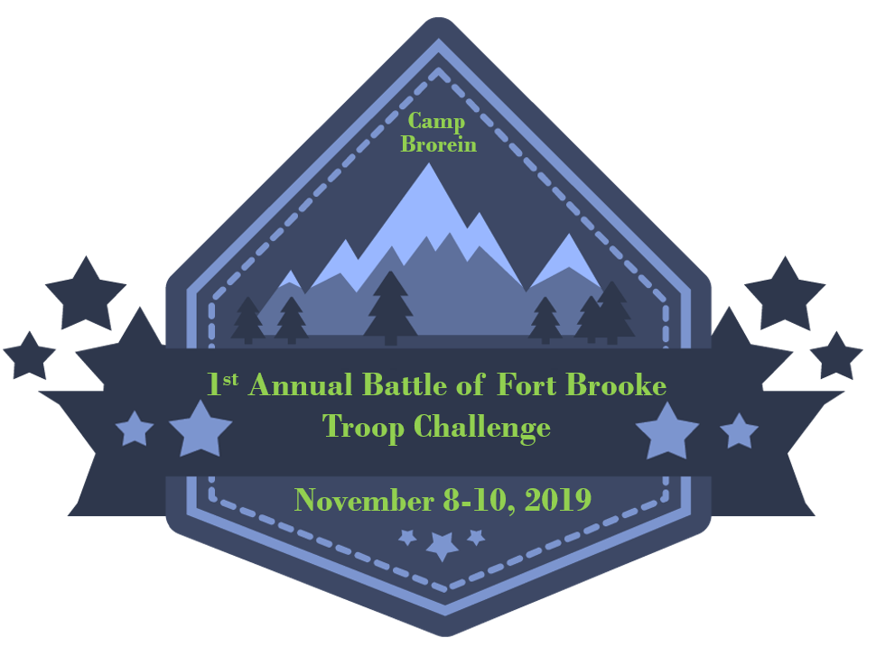

**Leader Guide Camp Owen J. Brorein**

16901 Boy Scout Rd., Odessa, Florida 33556

November 8-10, 2019

Camp Director: Tom Knotts

[Backcountrylove@gmail.com](mailto:Backcountrylove@gmail.com)

Staff Advisor: Austin Gary

[Austin.gary@scouting.org](mailto:Austin.gary@scouting.org)

*INTRODUCTION*

This Leaders Guide contains the information your Troop will require to have a successful and fun time at this year's Battle of Fort Brooke Troop Challenge. Be sure to read all the information carefully, as we expect all participants to act in accordance with the best of our Scouting traditions. If we need to make any changes, the Troop Representatives will be notified in advance.

*Please note*: NO ALCOHOL or TOBACCO of any kind (including e-cigs). Smoking will ONLY be permitted in the parking lot away from Scout's view.

This policy will be strictly enforced, and violations will result in being asked to leave.

*TROOP REPRESENTATIVE* Registration will be online only. The registration, roster and t-shirt forms (available through email and also on the District Facebook Page) will need to be turned in to the Camp Director. You may also make other arrangements to submit forms, such as email. Troops need to register as units only. In the event a unit does not wish to register but Scouts would like to attend, they can be added to another unit’s roster and registered that way. Please ensure an email address is included on the roster so the assigned Troop Representative can get all necessary information.

Note: Remember to please make sure all trash is removed, and your used site looks better than how you found it. ***LEAVE NO TRACE!!***

*REGISTRATION FEES, REFUNDS & CANCELLATION POLICY* Please see Web Site

*PERMISSION AND MEDICAL FORMS:* The permission form is integrated with the required medical forms for any BSA event. Please have these forms readily available if needed. Each unit is REQUIRED to have a medical form with sections A, B and photo release form signed and dated for each individual adult and child attending the event. This form can also be located on the National Council website- <http://www.scouting.org/filestore/HealthSafety/pdf/parts_ab.pdf>

*WHAT TO EXPECT AT CHECK IN:* Check-in will start Friday evening at 5:00 p.m. Please do not arrive prior to this time. If you arrive prior to 5:00 p.m. on Friday you will be asked to wait outside the gate. Check-in will be done by Troop. The following information must be submitted by the Troop Representative at registration:

• Updated Troop Roster

• Any changes to the original roster submitted with registration fee

• Medical forms for ALL attendees

• Any other missing information from registration.

*NOTE: PLEASE BE SURE THE UNIT REPRESENTATIVE HAS ARRIVED BEFORE OTHERS TO ENSURE PROPER NUMBERS AND CAMP PLACEMENT.*

*NO VEHICLES LEFT IN CAMP.*  Vehicles are not to be left in camping area. One vehicle per unit will be allowed at the unit camp site during unloading and check-in. Any vehicles that are left IN camp after 8 pm (unless other arrangements have been made with the Camp Director) may be towed at the owner’s expense. This policy will remain in place for the duration of the Battle event. The safety of our members is top priority and any violation of safety rules will not be tolerated. The unloading process may vary by camp.

*CAMPING:* Camping areas will be assigned by the Camp Director. Any special needs should be sent to the Camp Director before the event.

*CAMPFIRES* will be dependent on weather and only in approved fire rings.

*FIRST AID:* Medical emergencies should be directed to the First Aid Station (Trading Post) during the Event. After hours, contact the Camp Director at (813) 293-4474. . Minor first aid needs should be handled at the Troop’s campsite, if you have supplies.

*PATCHES:* All patches will be distributed at the Sunday Flag Ceremony. Please make sure all trash is removed, and your used site looks better than how you found it. *LEAVE NO TRACE*.

*WHAT TO WEAR:* A Scout Field (Class A) uniform for opening/closing ceremonies and Scout’s Own Service; an Activity uniform (Class B) (Scout T-shirt) for daytime events. Closed toe shoes are REQUIRED for all participants.

*WHAT TO-BRING CHECKLIST*

NOTE: This is a very general list to serve as a guide for packing. Not all items may be needed.

COMFORT

 Tent  Tarp (Ground cloth)  Sleeping Bags & Camp Pillows  Air Mattresses or Foam Pads  Flashlights w/ Extra Batteries  Camp Lantern, Fuel & Mantles (Optional)

*COOKING / DINING*

 Eating Utensils (i.e. Disposable Knives, Forks, Spoons, Plates, Cups, etc.) (Mandatory)  Cooking Utensils (i.e. Pots, Pans, Spoons, Spatulas, Knives, Coffee Pot, etc.)  Charcoal Briquettes (& Starter)  Groceries  Waterproof Matches  Camp Grill (Optional)  Camp Stove (Recommended)  Firewood  Ice Chest (w/ Ice or Blue Ice)  Dish Washing Detergent (Small Biodegradable)  Pot Scrubber Brush (Optional)  Water Jugs and/or Canteen  Paper Towels  Dish Towels  Trash Bags  Campfire Bucket (Optional)

*HYGIENE / SAFETY / CLOTHING*  First Aid Kit  Insect / Mosquito Repellent  Sunscreen (SPF 30+)  Toothbrush / Toothpaste  Toilet Paper (and Other Personal Toiletries)  Bath Soap & Shampoo  Sunglasses  Tennis, River and/or Hiking Shoes  Clothes For 3 Days

 Towels  Sweatshirt and/or Jacket Hat

*OPTIONAL ACCESSORIES*  Camera & Film  Books (Tree / Bird Identification or Other)  Binoculars  Rope or Nylon Cord  Folding Chairs  Tent Broom  Outdoor Games  Notebook and Pen

*MANDATORY ACCESSORY:*  ScoutsBSA Handbooks

*GROUP SAMPLE SCHEDULE – ACTUAL SCHEDULE WILL BE PROVIDED PRIOR TO CAMPOUT*

*Friday Evening*:

5:00 PM – gates open for check in and camp set up

8-9:00 PM - Competition Team Sign in/up

8-10:00 PM - Troop Individual event prep time

9:00 PM – Leaders Meeting at Cavitan ( large pavillion near waterfront )

11:00 PM – Lights out

*Saturday*:

7-8:00 AM Breakfast - Troops provide their own breakfast

8-9:00 AM Competition Sign up

9 AM - Opening Ceremony – Change into Activity uniforms (T-shirts) and get ready for the day

9:15 AM – Events start - See event schedule for exact times

12-1:00 PM – Lunch at Troop sites. All activities shut down

1:00 PM – All activities re-open

6:00 PM – Dinner at Swed Hall - Potluck Dinner including all Troops - Cook-off competition foods will be served with other sides provided by troops

8 PM – Flag Retirement Ceremony at Council Ring

9 PM - Gathering time and Fires in the parade field - Troops are encouraged to come with skits, songs, jokes and stories.

11:00 PM – Lights out

*Sunday*:

7-8:00 - Breakfast

8:00 AM – Opening ceremony - Activity Field

8-9:00 AM - Pack up Sites

9:00 AM - Interfaith Service - Chapel

9:30 AM - Awards Ceremony - Activity Field

12:00 PM – Camp is empty

*Activities*:

Tug-o-War - Troop 140 - Team of 6

Orienteering Course - Troop 329

DodgeBall BattleShip - Troop 4

Ground is Lava - Troop 313 - Team of 8

Egg Drop - Troop 19 - 2 entries max per troop

Obstacle Course - Troop 140- Teams of 6

Hatchet Throwing Competition - Troop 22 - Singles and Doubles event -

3 teams max per troop - per Singles/Doubles competition

Stretcher Relay - Troop 217 Teams of 2 - 3 teams max per troop

Canoe Relay - Troop 2019 - Team of 2 - 3 teams max per troop

Atomic Pile Course - Troop 4 - Teams of 5

Gaga Pit Competition - Troop 19

*Fort Brooke Competitions:*

GateWay Challenge - All Troops

Survival Style Puzzle - Team of 3 - 2 Teams per Troop

Dutch Oven Dinner - 1-2 entries per Troop

Dutch Oven Dessert - 1-2 Entries per Troop

Most Creative Camp Dish - 1 Entry per Troop

***Cooking Competition and Pot Luck Dinner***

Camp meals will be the responsibility of each troop to feed themselves.

The dishes being entered into the cooking competition will be due at Swede Hall by 5pm on Saturday. After the judging has taken place the food will be added to the potluck dinner. Troops are asked to bring any additional sides to provide enough food to feed their own Troop. This will provide enough to be shared between all troops. We will say grace and eat dinner in Swede and the pavilions near the lake. Drinks will be provided by the camp. Mess kits are required.

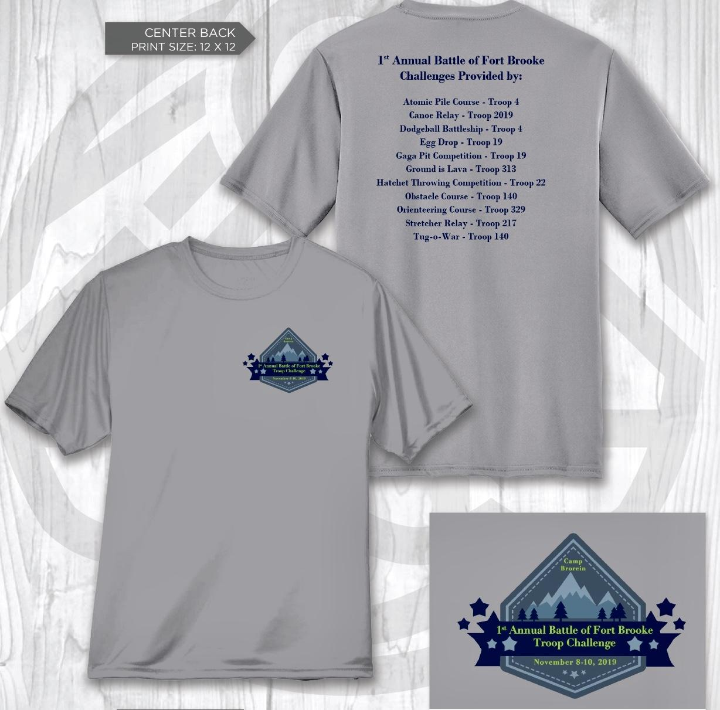

***Emergency Parking Contact Info***

Please place a copy of this in ***EVERY*** car being parked at Camp Brorein

Place in view on front dash in window

Car Owner’s Name:

Car Owner’s Contact Number (Cell phone):

Troop attending event with:

Troop’s Scoutmaster: