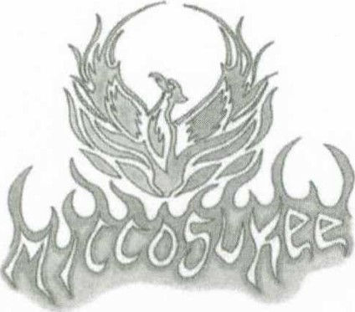Miccosukee District
2018 Recognition Nomination Form

The Miccosukee District celebrates all adults involved in the Scouting program by graciously accepting nominations at various levels: Pack, Troop, Crew, & Ship Leadership. This consolidated form can be used for a single nomination at any level. (PLEASE, ONLY ONE NOMINATION PER FORM)

Nominations due by March 15th

Nominations will be reviewed by the District Awards Committee, and presented at the District Awards Dinner on April 6, 2019 at Camp Soule. Be sure the nominee’s name is legible & spelled correctly as to appear on the award. Submit completed awards via email to bsatrainingchair@gmail.com or mailed to Ryan Cooper at the GTBAC Lewis Hill Service Center, 13228 N Central Ave, Tampa, FL 33612.

Name of Person Being Nominated (PRINT CLEARLY) ___________________________________________________

Position in Unit _________________________________________________ Unit Number ____________________

Phone Number of Person Being Nominated ______________________ Email ______________________________

Unit Leadership Awards
This award recognizes registered Unit Leaders for their accomplishments and dedication to Scouting. Please place an X in only one of the following. Describe your nomination rational on the following page.

Venturing/Ship Boy Scouting
_____ Crew Advisor/Skipper of the Year _____ Scoutmaster of the Year
_____ Associate Advisor/Mate of the Year _____ Assistant Scoutmaster of the Year
_____ Committee Member of the Year _____ Committee Member of the Year
_____ Unit Pillar* _____ Unit Pillar*
_____ Unit Commissioner _____ Unit Commissioner

Cub Scouting Cub Scouting
_____ Cubmaster of the Year _____ Tiger Den Leader of the Year
_____ Assistant Cubmaster of the Year _____ Den Leader of the Year
_____ Committee Member of the Year _____ WEBELOS Den Leader of the Year
_____ Unit Pillar* _____ Unit Commissioner

*The Unit Pillar is a registered adult who has continued to render invaluable service to his/her Unit - a “true scouter who signed up for their own son, but is still here for yours.” This individual currently has no youth registered with his/her unit.

Page 1 of 2 – completion of all pages required for nomination. ₂₀₁₈

Spark Plug Award
Each unit in Miccosukee District may designate one adult to receive the Spark Plug Award. The recipient may be anyone involved in the unit’s operation or program. Recipients typically have contagious enthusiasm and they are that spark that gets the unit going. This is a great opportunity to recognize a new leader or parent that has potential to become an integral part of Scouting. Each unit should receive one Spark Plug Award. Please place an X in only one of the following.

_____ Boy Scout Troop Spark Plug _____ Cub Scout Pack Spark Plug _____ Venture Crew Spark Plug

Describe below the nominee’s service and merits for this award. List their accomplishments in Scouting and other service. Attach additional sheets, if necessary. (Not required for Unit Spark Plug Award)

Name of Person Submitting the Nomination______________________________________________________

Unit Number _______ Position ____________________________ Email ____________________________

Daytime Phone ___________________________________ Evening Phone ____________________________

Page 2 of 2 – completion of all pages required for nomination. ₂₀₁₈

