

GREATER TAMPA BAY AREA COUNCIL
Expedition Summit- Venture Crew Challenge
Leader's Guide

Questions? Contact us!
Camp Chair- Mark Knowlton, markknowlton04@msn.com, 813-743-1741
Program Chair- Dennis Godber, drebdog@yahoo.com, 813-895-0892
Council Professional – Cassie Riddick, cassie.riddick@scouting.org. 813-557-3866
Camp Ranger- Mason Knowlton, mason.knowlton@scouting.org, 863-632-0389

TABLE OF CONTENTS

Introduction 1
Location 1
Event Date 1
Storm Date 1
Theme 1
Fees 1
Event T-shirts (Optional) 1
Event Patches 2
Registration Dates 2
Late*/On-Site Registration 2
Greater Tampa Bay Area Council Refund Policy 2
Leadership 2
Friday Check-In 3
Vehicle Use & Parking Policy 3
Friday Night Program - Arrival at Camp 3
Campsites, Adirondacks, and Tents 3
Swim Tests 4
Behavior 4
Medical & Photo Release Forms 4
First Aid 5
Security 5
E-mergencies 5
Trash 5
Environmental Impact 5
Saturday Night Program 5
Insurance 5
Uniform 6
Event Schedule 7
Program Schedule 8
Map and Directions to Flaming Arrow Scout Reservation 9
Map of Flaming Arrow 10
Unit Swim Classification Record 11

Introduction
This Leader's Guide contains the information your unit will need to have a successful and exciting time at the 2026 Venturing Expedition event. Be sure to read all the information before you register your unit for this event. Schedules, available activities, meals, and other details listed in this guide are subject to change.
This event depends on the support of volunteers, including adults from your unit. In addition to program support, we also expect all adults to maintain awareness of youth behavior and to always maintain safety and discipline.

Location
Flaming Arrow Scout Reservation, 1201 Boy Scout Camp Rd, Lake Wales, FL 33898.

Event Date
November 6th-8th, 2026.
Check-in begins at 4:30 pm on Friday. Friday night program begins at 9:00 pm. Departure will be completed by 1:00 pm on Sunday.

Theme
Expedition Summit- Crew Challenge! This event is focused on high adventure and fellowship. Open to all Crews, Ships and Scouts BSA 14+.

Fees
The basic registration fee is $50 per participant and $29 per leader. The fee includes meals and one event patch. For participants, it also includes all high adventure activities. A few activities may have additional fees, which can be paid for at camp.
Staff members pay a fee of $20, this includes meals and a patch. To apply to be on staff, please contact a leader on the cover page for instructions. Staff members will have separate accommodation and will be expected to arrive earlier and stay later than participants.

Event T-shirts (Optional)
T-shirts are an optional purchase and can be pre-ordered when you register for $18 each (an extra charge applies for XXL or larger sizes, see the registration site for the amount). T-shirts will be given to your Unit Coordinator at check-in. The Unit Coordinator will be responsible for handing them out.

Event Patches
One participant patch is included with your fee. Additional patches may be pre-ordered when you register for $3.00 each. No additional patches will be available on-site.

Registration Dates
Participant registration is only available ONLINE. Participants may register by unit or individually. Individual registrants will still be assigned camping spots by unit.
Early Registration for Staff ONLY | Online Registration  OPENS for participants | Online Registration  CLOSES for participants w/T-Shirt orders | Late Registration* CLOSES w/o T-Shirt orders
Open | July 15th, 2026 | October 12, 2026 | October 23, 2026

Late*/On-Site Registration
Late registration will be available for an extra $5 per registrant after regular registration closes. Late staff registrants are exempt from the extra fee. Late registrants will not be able to order T-shirts.
There will be no on-site registration. All participants must be registered in advance of the registration deadline. If you have a Scout who is registered but unable to attend, you can exchange their position with another Scout from your unit.

Greater Tampa Bay Area Council Refund Policy
See the policy on the registration website.

Leadership
Two-deep leadership is required for each unit. Coordinate with other units in your district if you need additional leadership to meet this requirement. One possible solution is to camp with another unit. We will have an option for provisional scouts; they will be assigned to a crew to participate with and camp with during the event.

Camp Additional Opportunities
We will be sharing the camp with 2 other training/events. These events include Wilderness First Aid and Climbing/COPE Level 1. If you are interested in taking these training courses, you can register with the link below.

Wilderness First Aid: https://scoutingevent.com/089-100211
COPE Level 1: https://scoutingevent.com/089-100209

Friday Check-In
On Friday night, units will park in the Flaming Arrow parking area. Each Unit Coordinator will meet with event staff for check-in at Saunders Hall. When the unit arrives, please have the following information with you for faster check-in: (1) Medical Forms part A&B for all attending with the unit (leaders and scouts) (2) unit Swim Classification record for all participating in Aquatics activities, (3) an updated unit roster identifying any registrants who will NOT be attending and who will be taking their place if applicable. The Unit Coordinator will be given any pre-ordered T-shirts at this time.
Provisional Troop – If you are registering as a provisional scout (your unit is not attending or does not have the required 2 deep leadership. You can check in with your parents/guardian but must wait until the Provisional Scoutmasters arrive.

Vehicle Use & Parking Policy
On Friday night and Sunday afternoon, personal vehicles may be used to efficiently move gear to and from your unit's campsite. However, once the event program has begun, no personal vehicles can be in the camping area. Trailers may be left along the road adjacent to your campsite, but tow vehicles must be removed. Acceptable tow vehicles will need to have a high ground clearance. All personal vehicles must be in the parking area no later than 10:00 pm on Friday night and must remain there until 10:30 am on Sunday. If you have mobility issues, please notify the registrar in Saunders Hall when you arrive for arrangements.
During load-in and load-out, you must operate your vehicle with the driver's side window open, radio off, emergency blinkers on, and observe the posted camp speed limit. Anyone failing to operate their vehicle in this manner will not be permitted to stay in camp and will not receive a refund.

Friday Night Program - Arrival at Camp
Arriving on time for Friday night's program is critical to the success of the weekend's high adventure programs. We will start Friday Night with high adventure programs. If you are not able to come Friday night that is acceptable but there will not be any makeup time for Friday night’s program.

Campsites, Adirondacks, and Tents
Campsites will be allocated based on the preregistered numbers submitted during registration. Smaller units will be placed together in camp sites based on their registration (Family, Boy, Girl). Standard sites DO NOT have tents or cots, please be prepared and bring your own equipment – all units and provisional scouts. Site assignments will not be provided until arrival. Units sharing sites are expected to be courteous in sharing common areas such as pavilions and tables.

Swim Tests
The swim classification of individuals participating in a Scouting America activity is a key element in both Safe Swim Defense and Safety Afloat. All persons participating in SA aquatics activities are classified according to swimming ability. The classification test procedures have been developed and structured to demonstrate a skill level consistent with the circumstances in which the individual will be in the water.
Every unit is required to perform swim tests in advance, using the attached Unit Swim Classification Record. These tests MUST be administered according to the Guide to Safe Scouting and Aquatics Supervision manual. Scouts may use their swim checks from summer camp if they have their buddy tags; however, all scouts must be included in the Unit Swim Classification Record.
If you have a Scout who has not completed a swim test prior to arrival, we will do our best to administer a swim test to that Scout. However, if scheduling does not permit this, the scout or venturer may not be able to participate in any water or aquatic based activities. No refunds will be offered if this occurs.

Behavior
Scouts and adults are expected to conduct themselves in accordance with the Scout Oath and Scout Law at all times and to follow all policies of Scouting America, including the Guide to Safe Scouting and Youth Protection Policies.

Medical & Photo Release Forms
All registrants (leaders, scouts and staff) must submit properly completed Parts A and B of the SA Annual Health and Medical Record Form signed by the participant and parent(s) or legal guardian(s). This form can be found on National's website: http://www.scouting.org/filestore/healthsafety/pdf/680-001_AB.pdf.
No Scout will be allowed to participate in this event without a properly signed permission photo release form. Occasionally we may use pictures from an event to promote Scouting. We need your permission to do so. The photo release consent is located within Part A of the SA Annual Health and Medical Record Form.

First Aid
Medical emergencies should be directed to the Health Lodge during the event. The location of the Health Lodge will be announced during Friday night's meeting. After hours, contact one of the camp directors or staffers. Minor first aid should be handled at your campsites if you have supplies.

Security
Please ensure all vehicles are locked and secure. All valuables should be stored in a locked and secure container, preferably inside a vehicle. Greater Tampa Bay Area Council and event staff will not be liable for stolen or missing items.

Emergencies
See: https://tampabayscouting.org/council-emergency-procedures

In case of emergency - call 911
Then contact Ranger Mason at 863-632-0389

Emergency Procedures   |  | Incident Reporting  

Trash
All units should follow Leave No Trace principles, including the proper removal of all trash at the end of the event. All trash is to be properly bagged and placed in trash receptacles or hauled out. Bring your own garbage bags. We ask that you remind your Scouts to use good judgment. Please note that we have 2 trash containers – one for trash and one for recycling.

Environmental Impact
No digging of any kind will be allowed in the camping area. Guide ropes and small stakes are acceptable. No ground fires of any kind will be allowed!

Saturday Night Program
We will have a campfire or similar program on Saturday. Details will be announced at the event. Scouts may wish to bring portable chairs for the campfire as other seating will not be available.

Insurance
Accident insurance coverage is included in your registration fee. All hospital or medical charges incurred are the primary responsibility of the individual.

Clothing Requirements
Closed toe shoes are a requirement for our Climbing, and COPE courses. Any participant must be wearing closed-toed shoes to participate in the COPE and Climbing portions of the event. Crocs do NOT count as closed toed shoes.

Event Schedule
*This schedule is subject to change without prior notice. *

Friday
Start | End | Program | Location
4:30 pm | 7:00 pm | Participants arrive, register, set-up camp | Saunders
7:15 pm | 8:00 pm | Leaders Meeting | Saunders
8:45 pm | 9:45 pm | Night Climb | Climbing
10:00 pm | 10:30 pm | Cracker Barrel | Wood Hall

Saturday
Start | End | Program | Location
7:00 am | 8:00 am | Breakfast | Wood Hall
8:00 am | 12:00 pm | Morning Program | Various
12:00 pm | 1:00 pm | Lunch | Sites & Wood Hall
1:15 pm | 5:45 pm | Afternoon Program | Various
6:00 pm | 7:00 pm | Dinner | Wood Hall
7:00 pm | 7:35 pm | Evening Programs | Various
7:35 pm | 9:30 pm | Night Program | Various
9:30 pm | 10:30 pm | Campfire | Council Ring

Sunday
Start | End | Program | Location
7:15 am | 7:45 am | Breakfast | Wood Hall
8:00 am | 10:30 am | Morning Program | Various
10:30 am | 1:00 pm | Checkout | Sites and Saunders

Program Schedule
*This schedule is subject to change without notice*

Night Climb and High COPE
Soar high! Try your luck with our High COPE course at night, ziplining at night in the dark, and leap of faith in the dark! We will also open our Climbing and Rappelling walls on Friday Night.

Realistic First Aid Scenarios
Ouch! Try your luck with realistic first aid scenarios
Finders Keepers! The legendary Golden Arrow has been lost! Perform a search and rescue to find the lost golden arrow.

Water Sports
Tread Water! Can you stay up on the skis. Try your chance of skiing on our famous Ski Lake here at Flaming Arrow.

Aquatic Challenges
Boat On! Take your crew on an amazing boat relay and challenges on the water.
Boats may include kayaking, paddleboarding, sailing, rowing, motorboating, and canoeing.

Target Sports
Bullseye! Take on challenges in different Range and Target activities. Some of the activities include Axe and Knife Throwing, and many others.
*Black powder
*Cowboy Action
*These are additional charges that can be paid for at camp

Sport Challenges
Play Ball! Take your team and play some sports! Volleyball on the beach, tug-o-war, kickball, obstacle course.

Map and Directions to Flaming Arrow Scout Reservation
Flaming Arrow Scout Reservation
1201 Boy Scout Road
Lake Wales, FL 33898
Google Maps: http://g.co/maps/8y737
Bing Maps: http://binged.it/IX0QBZ
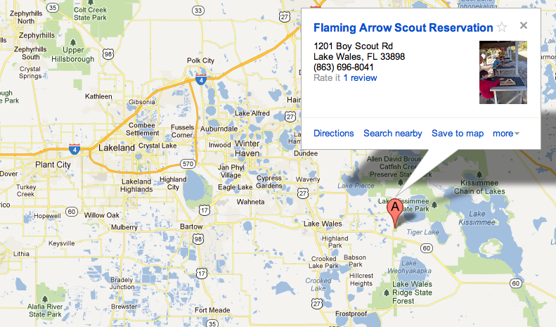

Map of Flaming Arrow
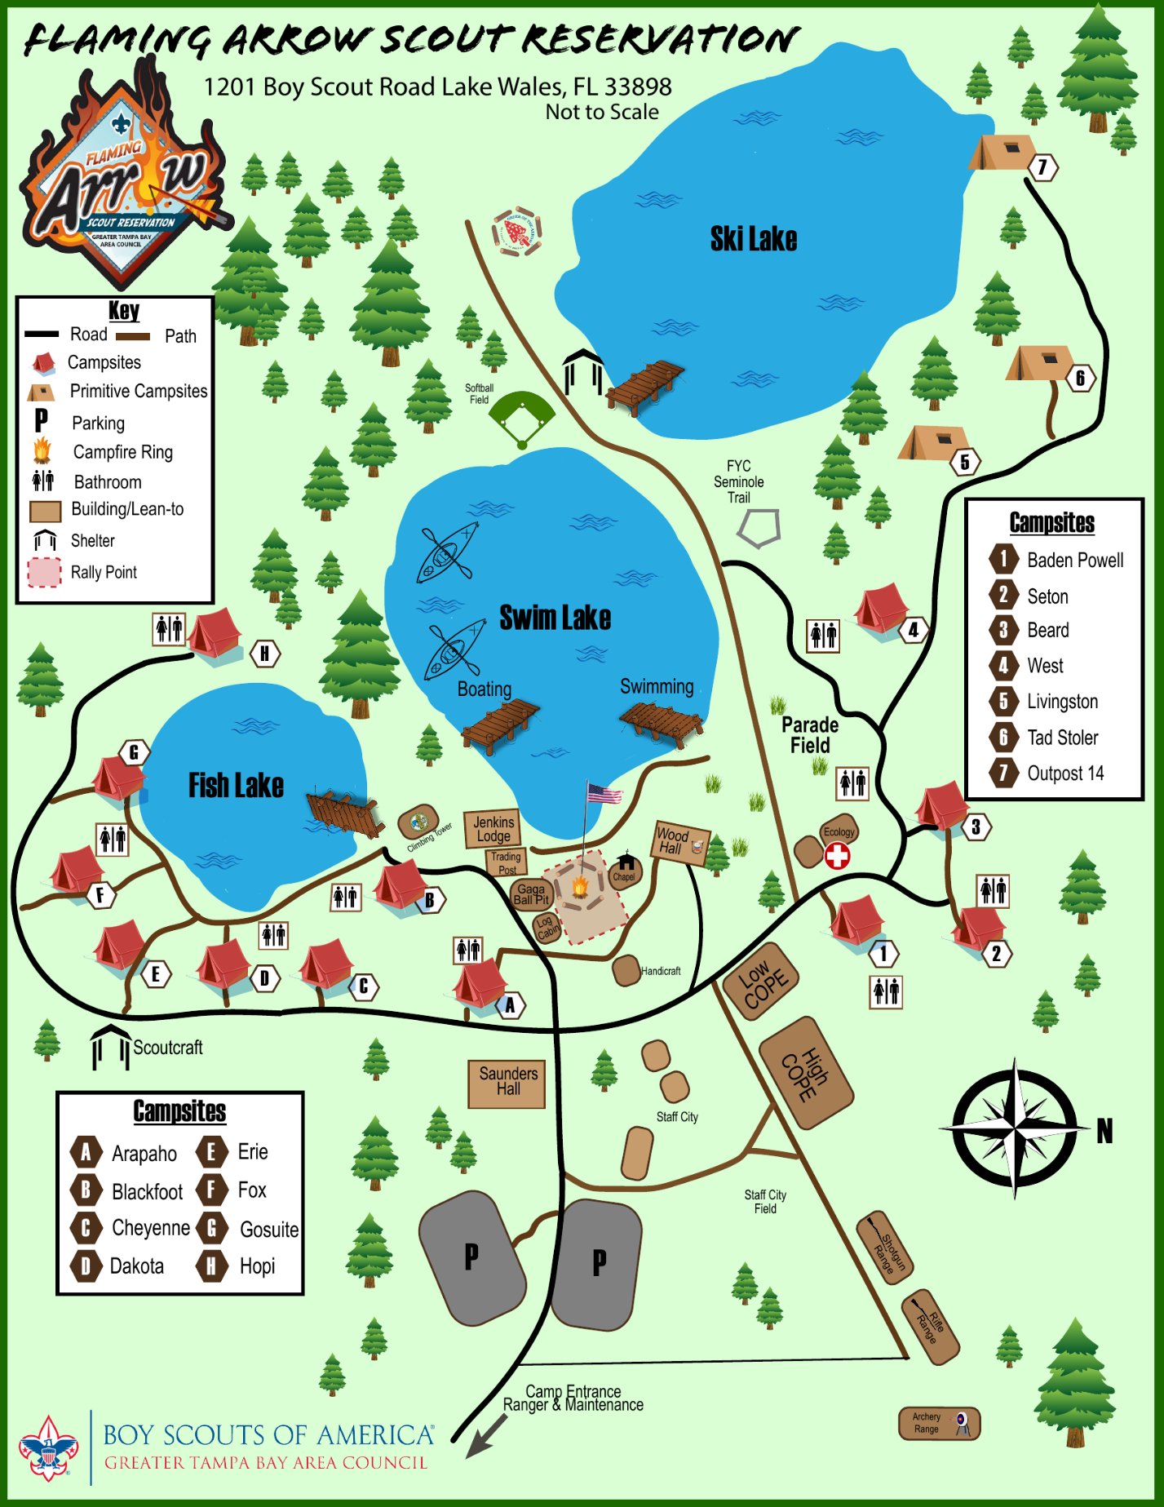

Unit Swim Classification Record
This is the individual's swim classification as of this date. Any change in status after this date would require a reclassification test by the event directors. Swim tests should be given every year at the beginning of the swim season. Refer to the Guide to Safe Scouting for test administration. Please refer to http://www.scouting.org/filestore/Outdoor%20Program/Aquatics/pdf/430-122.pdf for the procedure, and who is qualified to conduct the test.
Special Note: When swim tests are conducted prior to the event, the event directors reserve the authority to review or retest all participants at all times to assure that standards are being maintained. (Please copy and bring completed form to event.)
Unit Number ___________________ Date(s) of Swim Test _____________________
 | Classification
Full Name (Please Print) | Non-Swimmer | Beginner | Swimmer
1
2
3
4
5
6
7
8
9
10
Swim Test Administered By:
Print Name _______________________ Signature __________________________
Certification _______________________ Expiration __________________________

