**GREATER TAMPA BAY AREA COUNCIL**

**AquaCamp 2025**

**Leader's Guide**

**Questions? Contact us!**

Program Director – Bill Bode, [bodebil@gmail.com](mailto:bodebil@gmail.com), 813-382-9262, Aquatics Chair –

Council Professional – Matt Hall, [matt.hall@scouting.org](mailto:matt.hall@scouting.org), (813) 557-3866

Facebook website: AquaCamp2025

TABLE OF CONTENTS

Introduction 1

Location 1

Event Date 1

Storm Date 1

Theme 1

Fees 1

Event T-shirts (Optional) 1

Event Patches 2

Registration Dates 2

Late*/On-Site Registration 2

Greater Tampa Bay Area Council Refund Policy 2

Leadership 2

Friday Check-In 3

Vehicle Use & Parking Policy 3

Friday Night Program - Arrival at Camp 3

Campsites, Adirondacks, and Tents 3

Swim Tests 4

Behavior 4

Medical & Photo Release Forms 4

First Aid 5

Security 5

Emergencies 5

Trash 5

Environmental Impact 6

Saturday Night Program 6

Insurance 6

Scouts Own 6

Uniform 6

Event Schedule 8

Merit Badge Class Schedule 9

Map and Directions to Flaming Arrow Scout Reservation 10

Map of Flaming Arrow 11

Unit Swim Classification Record 12

Merit Badge Pre-requisites 14

## Introduction

This Leader's Guide contains the information your unit will need to have a successful and exciting time at the 2025 AquaCamp event. Be sure to read all the information before you register your unit for this event. Schedules, available merit badge/activity sessions, meal plans, and other details listed in this guide are subject to change.

This event depends on the support of volunteers, including adults from your unit. In addition to program support, we also expect all adults to maintain awareness of youth behavior and to maintain safety and discipline at all times.

## Location

Flaming Arrow Scout Reservation, 1201 Boy Scout Camp Rd, Lake Wales, FL 33898.

## Event Date

September 26-28, 2025.

Check-in begins at 4:30 pm on Friday. *Friday night program begins at 7:00 pm.* Departure will be by 1:00 pm on Sunday.

## Storm Date

If severe weather is forecast, event organizers reserve the right to reschedule the event for the weekend of October 24-26, 2025.

## Theme

AquaCamp! This event is an aquatics-focused merit badge and activity award weekend, although land-based merit badges and activities will also be offered.

## Fees

Please refer to the event registration page for event pricing.

## Event T-shirts (Optional)

T-shirts are an optional purchase and can be pre-ordered when you register. An extra charge applies for XXL or larger sizes, see the registration site for the amount. T-shirts will be given to your Unit Coordinator at check-in. The Unit Coordinator will be responsible for handing them out. Staff T-shirts are also available.

## Event Patches

One participant patch is included with your fee. Additional patches may be pre-ordered when you register. No additional patches will be available on-site.

## Registration Dates

Participant registration is only available ONLINE. Participants may register by unit or individually. Individual registrants will still be assigned camping spots by unit. Youth will select their desired merit badge/activity sessions at the time of registration, subject to availability. Staff & merit badge counselors will need to contact the leaders on the cover page to register.

| **Early Registration for Staff & Merit Badge Counselors ONLY** | **Online Registration  OPENS for participants** | **Online Registration CLOSES for participants w/T-Shirt orders** | **Late Registration* CLOSES w/o T-Shirt orders** |
| --- | --- | --- | --- |
| Open | May 1, 2025 | August 29, 2025 | September 10, 2025 |

## Late*/On-Site Registration

Late registration will be available for an extra $5 per registrant after regular registration closes. Late staff registrants are exempt from the extra fee. Late registrants will not be able to order T-shirts.

There will be no on-site registration. All participants must be registered in advance of the registration deadline. If you have a Scout who is registered but unable to attend, you can exchange their position with another Scout from your unit. Class assignments will not be changed.

## Greater Tampa Bay Area Council Refund Policy

See the policy on the registration website.

## Leadership

Two-deep leadership is required for each unit. Coordinate with other units in your district if you need additional leadership to meet this requirement. One possible solution is to camp with another unit.

Senior Patrol Leaders are responsible for their respective troops.

## Friday Check-In

On Friday night, units will park in the Flaming Arrow parking area. Each Unit Coordinator, Senior Patrol Leader (SPL), and his/her Scout buddy will meet with event staff for check-in atSaunders Hall. The Unit Coordinator will be given any pre-ordered t-shirts at this time. The SPL will receive a packet with all materials for the weekend.

At check-in, the unit should provide the following information discussed elsewhere in this guide (1) medical forms Parts A&B for all leaders, scouts and staff; and (3) unit swim classification record for all scouts participating in Aquatics merit badges and awards. Units should also provide an updated unit roster identifying any registrants who will not be attending and if applicable, scouts who will take their place.

## Vehicle Use & Parking Policy

On Friday night and Sunday afternoon, personal vehicles may be used to efficiently move gear to and from your unit's campsite. However, once the event program has begun, **no personal vehicles can be in the camping area**. Troop trailers may be left along the road adjacent to your campsite, but tow vehicles must be removed. Acceptable tow vehicles will need to have a high ground clearance. All personal vehicles must be in the parking area no later than 10:00 pm on Friday night and must remain there until 10:30 am on Sunday. If you have mobility issues, please notify the registrar in Saunders Hall when you arrive for arrangements**.**

During load-in and load-out, you must operate your vehicle with the **driver's side window open, radio off,** emergency blinkers on, and observe the posted camp speed limit. Anyone failing to operate their vehicle in this manner will not be permitted to stay in camp and will not receive a refund.

## Friday Night Program - Arrival at Camp

Arriving on time for Friday night's program is **critical** to the success of the weekend's aquatic merit badge programs. Safety Afloat and Safe Swim Defense will be covered for all youth participants, leaders, and adults, as this is a core requirement of all aquatic activities. The program will start promptly at 7 pm on Friday night.

**If you cannot make the Friday night program, you must provide written proof of completion of Safety Afloat and Safe Swim Defense. Any Scout who doesn't attend the Friday night program and doesn't have proof of completing these requirements will not be allowed in the water and will be moved into land-based merit badges. No refunds will be offered if this occurs. Adults must also have proof of training so that they can assist on the waterfront as lookouts.**

## Campsites, Adirondacks, and Tents

Campsites will be allocated based on the preregistered numbers you submit. Smaller units will be placed together in camp sites. Standard sites will NOT have tents or cots. Units will need to bring their own equipment as most sites will not have tents. Site assignments will not be provided until arrival – all units and provisional scouts should bring their own tents.

Units sharing sites are expected to be **courteous** in sharing common areas such as pavilions and tables.

## Swim Tests

The swim classification of individuals participating in a Boy Scouts of America activity is a key element in both Safe Swim Defense and Safety Afloat. All persons participating in BSA aquatics activities are classified according to swimming ability. The classification test procedures have been developed and structured to demonstrate a skill level consistent with the circumstances in which the individual will be in the water.

In order to provide a more streamlined event, each unit is **required** to perform swim tests in advance, using the attached **Unit Swim Classification Record**. These tests **MUST** be administered according to the Guide to Safe Scouting and Aquatics Supervision manual. Scouts may use their swim checks from summer camp if they have their buddy tags; however, all scouts must be included in the Unit Swim Classification Record.

In the event that you have a Scout who has not completed a swim test prior to arrival, we will do our best to administer a swim test to that Scout. However, if scheduling does not permit this, we may need to move that Scout into a land-based merit badge class. **No refunds will be offered if this occurs.**

## Behavior

Scouts and adults are expected to conduct themselves in accordance with the Scout Oath and Scout Law at all times and to follow all policies of the Boy Scouts of America, including the Guide to Safe Scouting and Youth Protection Policies.

## Medical & Photo Release Forms

All registrants (leaders, scouts and staff) must submit properly completed Parts A and B of the BSA Annual Health and Medical Record Form signed by the participant and parent(s) or legal guardian(s). This form can be found on National's website: <http://www.scouting.org/filestore/healthsafety/pdf/680-001_AB.pdf>.

No Scout will be allowed to participate in this event without a properly signed permission photo release form. Occasionally we may use pictures from an event to promote Scouting. We need your permission to do so. The photo release consent is located within Part A of the BSA Annual Health and Medical Record Form.

## First Aid

Medical emergencies should be directed to the Health Lodge during the event. The location of the Health Lodge will be announced during Friday night's meeting. After hours, contact one of the camp directors or staffers. Minor first aid should be handled at your campsites if you have supplies.

## Security

Please ensure all vehicles are locked and secured. All valuables should be stored in a locked and secured container, preferably inside a vehicle. Greater Tampa Bay Area Council and event staff will not be liable for stolen or missing items.

## Emergencies

See: <https://tampabayscouting.org/council-emergency-procedures>

**In case of emergency - call 911   
Then contact Ranger Mason at 863-632-0389**

|  |  |  |
| --- | --- | --- |
| **Emergency Procedures**  P128C1T2#yIS1 |  | **Incident Reporting**  P131C3T2#yIS1 |

## Trash

All units should follow Leave No Trace principles, including the proper removal of all trash at the end of the event. All trash is to be properly bagged and placed in trash receptacles or hauled out. Bring your own garbage bags. We ask that you remind your Scouts to use good judgment.

## Environmental Impact

No digging of any kind will be allowed in the camping area. Guy ropes and small stakes are acceptable. No ground fires of any kind will be allowed!

## Saturday Night Program

We will have a campfire or similar program on Saturday. Details will be announced at the event. Scouts may wish to bring portable chairs for the campfire as other seating will not be available.

## Insurance

Accident insurance coverage is included in your registration fee. All hospital or medical charges incurred are the primary responsibility of the individual.

## Scouts Own

A Scout is Reverent. All Scouts and leaders are encouraged to participate in our Scout's Own service on Sunday morning. Please wear your field uniform.

## Uniform

There are two uniforms for this event.

### Field Uniform

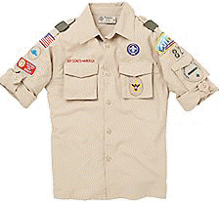 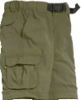 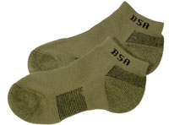 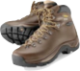

The BSA Field uniform consists of a BSA uniform shirt, BSA Pants/Shorts, BSA belt, BSA socks, and closed-toe shoes. It should be worn:

* While in transit to and from camp for the event
* For the duration of the Friday night program
* At Saturday dinner meals
* At the Scout's Own service

### Activity Uniform (Aquatics Style!)

 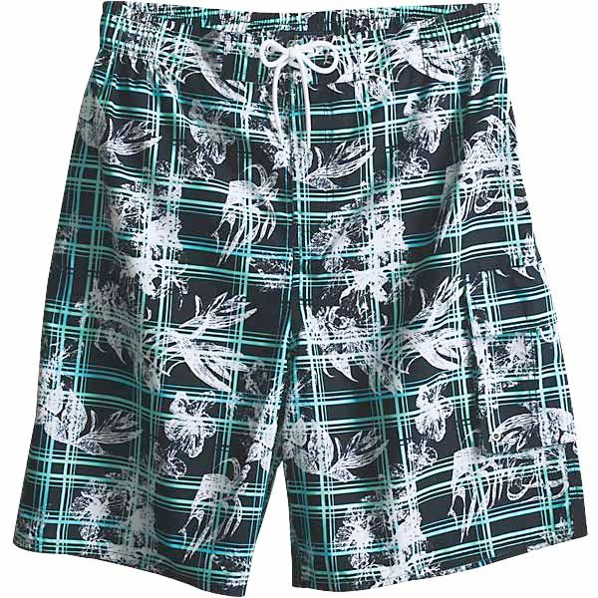 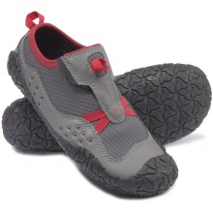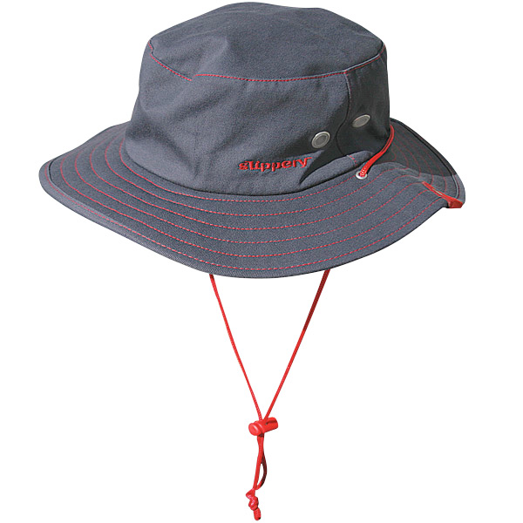

The Activity uniform for this event for scouts participating in Aquatics programs consists of a rashguard/swimming shirt (UV-protective preferred) or Scouting t-shirt, swim trunks, and closed toe shoes. It should be worn at all times that the Field Uniform is not required. It is highly recommended that a full brim hat, sunglasses, and sunblock also be worn during the day. For Scouts taking canoeing, kayaking or other boating activities, the shoes should be shoes that can (and will) get wet.

Scouts participating solely in land-based activities may wear a traditional activity uniform consisting of a Scouting T-shirt, shorts, and closed toe shoes with socks.

**Closed toe shoes are a requirement any time Scouts are moving from one program area to another.**

# Event Schedule

This schedule is subject to change without prior notice.

### Friday

|  |  |  |  |
| --- | --- | --- | --- |
| Start | End | Program | Location |
| 4:30 pm | 6:30 pm | Participants arrive, register, set-up camp | Saunders |
| 7:00 pm | 9:00 pm | Safety Afloat, Safe Swim Defense followed by a Cracker Barrel | Wood Hall & Jenkins |
| 9:00 pm | 10:00 pm | Cracker Barrel | Wood Hall |

### Saturday

|  |  |  |  |
| --- | --- | --- | --- |
| Start | End | Program | Location |
| 7:15 am | 8:00 am | Breakfast (1st Shift) | Wood Hall |
| 8:00 am | 8:45 am | Breakfast (2d Shift) | Wood Hall |
| 9:00 am | 1:00 pm | Morning Merit Badges | Various |
| 1:00 pm | 1:45 pm | Lunch | Sites & Wood Hall |
| 2:00 pm | 6:00 pm | Afternoon Merit Badges | Various |
| 6:15 pm | 7:00 pm | Dinner (1st Shift) | Wood Hall |
| 7:00 pm | 7:45 pm | Dinner (2d Shift) | Wood Hall |
| 8:00 pm | 10:00 pm | Campfire | Council Ring |

### Sunday

|  |  |  |  |
| --- | --- | --- | --- |
| Start | End | Program | Location |
| 7:15 am | 7:45 am | Breakfast (1st shift) | Wood Hall |
| 8:00 am | 8:30 am | Breakfast (2d Shift) | Wood Hall |
| 8:00 am | 8:30 am | Scouts Own (attend 1st shift breakfast if desired) | TBD |
| 8:30 am | 12:00 pm | Merit Badges | Waterfront |
| 10:30 am | 1:00 pm | Checkout | Sites and Saunders |

# Merit Badge Class Schedule

This schedule is subject to change without notice. Class sizes as are listed below.

|  | | **Saturday** | | **Sunday** |
| --- | --- | --- | --- | --- |
| **Program** | | **9 AM – 1 PM** | **2 PM - 6 PM** | **8:30 AM - 12:00 PM** |
| A  Q  U  A  T  I  C  S | Canoeing* | 40 | | |
| Kayaking* | 20 | | |
| Lifesaving* | 30 | | |
| Swimming* | 50 | | |
| Motorboating* | 12 | 12 |  |
| Rowing* | 12 | 12 |  |
| Snorkeling BSA* | 40 | 40 |
| Water-Sports* | 8 | |  |
|  | Small Boat Sailing* | 12 | | Knots & makeup |
|  | Paddle Boarding BSA* | 6 | 6 | 6 |
|  | Emergency Preparedness* | 20 | 20 |  |
|  | First Aid* | 20 | 20 |  |
|  | Citizenship in the World | 36 |  |  |
|  | Communications | 15 |  |  |
|  | Citizenship in Society | 30 |  |  |
|  | Citizenship in the Nation | 30 |  |  |

*See Prerequisites and other requirements.

# 

# Map and Directions to Flaming Arrow Scout Reservation

Flaming Arrow Scout Reservation  
1201 Boy Scout Road  
Lake Wales, FL 33898

Google Maps: <http://g.co/maps/8y737>

Bing Maps: <http://binged.it/IX0QBZ>

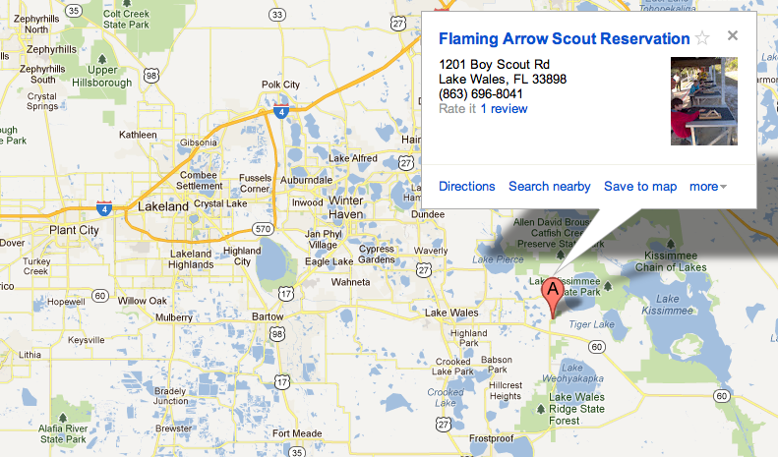

# Map of Flaming Arrow

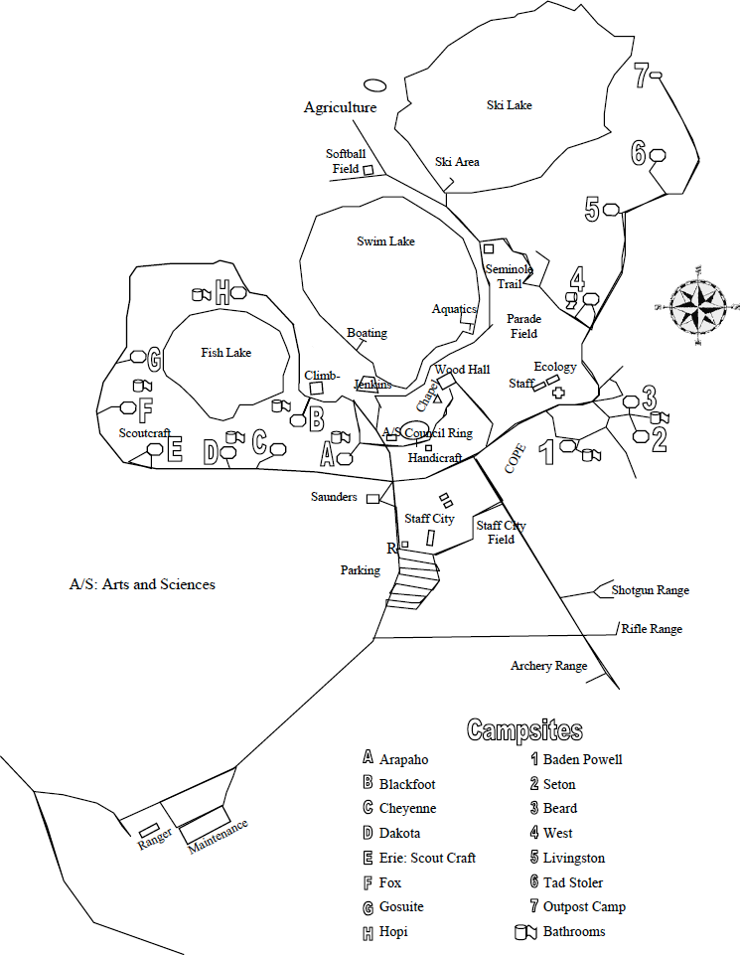

# Unit Swim Classification Record

This is the individual's swim classification as of this date. Any change in status after this date would require a reclassification test by the event directors. Swim tests should be given every year at the beginning of the swim season. Refer to the Guide to Safe Scouting for test administration. Please refer to <http://www.scouting.org/filestore/Outdoor%20Program/Aquatics/pdf/430-122.pdf> for the procedure, and who is qualified to conduct the test.

Special Note: When swim tests are conducted prior to the event, the event directors reserve the authority to review or retest all participants at all times to assure that standards are being maintained. (Please copy and bring completed form to event.)

Unit Number ___________________ Date(s) of Swim Test _____________________

|  | **Classification** | | |
| --- | --- | --- | --- |
| **Full Name (Please Print)** | **Non-Swimmer** | **Beginner** | **Swimmer** |
| 1 |  |  |  |
| 2 |  |  |  |
| 3 |  |  |  |
| 4 |  |  |  |
| 5 |  |  |  |
| 6 |  |  |  |
| 7 |  |  |  |
| 8 |  |  |  |
| 9 |  |  |  |
| 10 |  |  |  |

Swim Test Administered By:

Print Name _______________________ Signature __________________________

Certification _______________________ Expiration __________________________

# Merit Badge Pre/Postrequisites

This section details what requirements must be completed in advance in order for the Scout to earn the listed merit badge. For Aquatics merit badges and activity awards, Safe Swim Defense requirements, Safety Afloat requirements, and basic weather hazard considerations will be covered at the Friday night program. If you cannot attend the Friday night program, you must provide written proof of having completed these requirements. Prior successful completion of the BSA Swimmer test is also a prerequisite for all Aquatics merit badges and activity awards.

Each Scout must be familiar with the corresponding merit badge booklet prior to attending.

Scouts are not guaranteed completion of any badge. Eagle-required badges often have requirements that must be completed at the unit level after the class. Where possible the classroom instruction will provide instruction for help complete them at the unit level.

### 

### Canoeing

Study requirements 1, 3-6 and be prepared to discuss in class.

### Kayaking

Study requirements 1, 3, 4, & 5 and be prepared to discuss in class.

### Lifesaving

Must have previously earned the Swimming merit badge (requirement 2.a).

### Motorboating

Each Scout must be at least 13 years of age.

### 

### Rowing

Study requirements 1 & 3 and be prepared to discuss in class.

### Small Boat Sailing

Study requirements 1 & 4 and be prepared to discuss or complete in class. Scouts should learn the knots covered in Requirement 7 in advance and be prepared to demonstrate and complete *after* regular class session (either Saturday evening or Sunday morning) as there is inadequate time to cover these in class. Small boat sailing is a challenging class and scouts will receive a partial if pre-requirements are not adequately prepared or if scouts are not able to meet the on-water requirements.

### Swimming

Study requirement 1.b and be prepared to discuss in class.

### Water-Sports

Each Scout must have water skied or wake-boarded before and be able to stand freely. Study requirements 1 & 2 and be prepared to discuss in class.

### Snorkeling BSA

Each Scout must be familiar with the BSA Snorkeling Safety Pamphlet. Each Scout must bring his or her own mask, snorkel and fins.

**BSA Stand Up Paddleboarding**

Each Scout must be familiar with the BSA Stand Up Paddleboarding Pamphlet

**Citizenship in the World**

 Be prepared to discuss their research for prerequisites 3, 4, 5, 6, and 7

**Emergency Preparation**

Emergency Prep instruction will not cover the following requirements during Aqua Camp class time:  1, 2(c), 8b, 9a

1. Scouts may bring proof of earning First Aid merit badge.

2(c). Must be completed at home with family after class.

8(b). Individual scout emergency service pack and family emergency kits should be compiled at home *after* class using counselor provided checklists.

9(a). Scouts will go home with a counselor approved checklist to conduct a home inspection after learning all course material.

*\*\*\*\*\*To complete the above requirements, scouts will be provided with counselor contact information for follow up after camp. 2-deep leadership will be maintained for all scout-counselor communications.\*\*\*\*\*\**

6. This requirement will be met during class; however, scouts must research this information in advance and be prepared to discuss/explain as indicated below:

(a.1) Describe the National Incident Management System (NIMS).

(a.2) Describe the Incident and the Incident Command System (ICS).

(b) Identify the local government or community agencies that normally handle and prepare for emergency services similar to those of the NIMS or ICS.

(b.1) Explain to your counselor how the NIMS/ICS can assist a Boy Scout troop when responding in a disaster.

(c) Find out who is your community’s emergency management director and learn what this person does to prevent, protect, mitigate, respond to, and recover from emergency situations in your community.

**First Aid**

For requirement 5(a), Scouts must bring a personal or home first aid kit. Requirement 5(b) to be completed at troop level after the class.