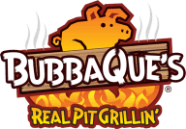
Lunch Menu

Red Ticket Items ($6 each)
Chopped Chicken Sandwich on a bun………………………. $6
Pulled Pork Sandwich on a bun………………………………… $6

Green Ticket Items ($4 each)
Mac-N-Cheese side………………………………………………….. $4
Baked Beans side……………………………………………………… $4
Corn Bread side……………………………………………………….. $4
Banana Pudding side………………………………………………… $4

Drinks (varies)
Sodas……………………………………………………………………….. $2
Sports Drinks……………………………………………………………. $3

More drinks and other snacks can be purchased in the Trading Post

