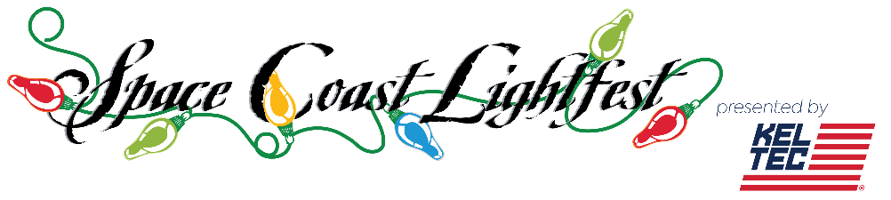
This Photo by Unknown Author is licensed under CC BY-SA
Lightfest is opened nightly from Nov 13th thru Jan 2nd from 6:30pm to 10:00pm at Wickham Park in Melbourne, Florida. Enter off Wickham road onto Leisure Way. It is a drive through event except on Dec 3-5th when it will be walking only. Private Hayrides by reservation only (except Dec 3-5th & Dec 25th).
SPECIAL EVENTS CALENDAR
11/19: First day - Open to all cars from 6:30-10:00pm.
11/20: 5K Run - Sign up today to be among the first to see our new lights.
11/27: Activities with Santa - Join Santa for crafts and carols.
All kids under 12 will get a free popcorn, the first 100 kids get a free
wooden kit from Lowes.
Sponsored by Olive Branch.

12/1: Teacher Appreciation - Show ID for discount.
Sponsored by Lauren Merrell

12/3-5: Stroll Weekend—NO CARS.
12/3-4: Scout Campout - For all Scouts and youth groups.
12/6: Parks & Recreation Appreciation - Show ID for discount.
12/7: Pet Night - Tonight we celebrate all types of pets. Bring your
unusual pets tonight! *Pets are welcome nightly*
Sponsored by Animal Hospital of Central Brevard.

12/8: First Responders and Medical Appreciation night
Show ID for discount. Sponsored by KelTec.

12/8: Military Appreciation night Show ID for discount.
12/12:Horse night - Step off 6pm Please be on time for step off.
1/2: Last Night for 2021.

Questions contact Sally at 321-720-4109 or fnnayllas@aol.com
Event online sign up links
5K

Private Hayrides https://scoutingevent.com/083-46302
Private Parties https://scoutingevent.com/083-46329
Stroll Vendor sign up https://scoutingevent.com/083-46327
Campout https://scoutingevent.com/083-46310
Horse Night https://scoutingevent.com/083-46298
Stroll
https://scoutingevent.com/083-46325

Drive through tickets
https://scoutingevent.com/083-46134
www.spacecoastlightfest.com

