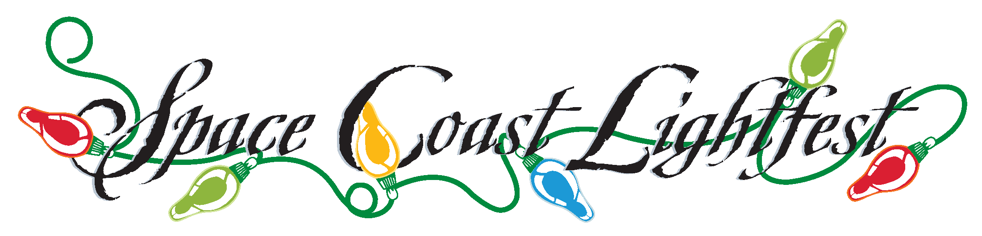
Welcome to your party at Space Coast Lightfest. We look forward to offering you a wonderful experience. Please fill this out and return to us so that we can make sure we meet all your needs.
Name: ______________________________________
Party Date __________ Location ____________________
How many people do you expect to attend your party ______________
(You will be expected to pay your balance due either before the party online or you can give your final payment to your party hostess.)
Party Costs: $250 first 20 guests. Amount Paid _____________
Guests over 20 is $5.00 each. Amount paid _________ Amount Due_____
What time will your party start ______
What time are you planning on arriving _______________
Your party will include Hot Chocolate, Smores, hayride, and a visit from Santa.
Hayride time___________ Santa Time _____________
Special needs or notes: ___________________________________
Other items available upon request: You can book and pay online or you can let your party host know if you want any of the add ons.
Popcorn Machine includes all you can eat popcorn and seasoning. $75
Hot Chocolate Stand (see attached photo) $75
Includes Hot Chocolate toppings: sprinkles, cinnamon, whipped cream,
Candy canes, marshmallows, you can request other toppings.
Mirror Me Photo Booth $400
We look forward to seeing you at Lightfest please let us know if there is any way we can help you make your party amazing!!
Marsha: 321-412-7200, mahumasukawa@aol.com
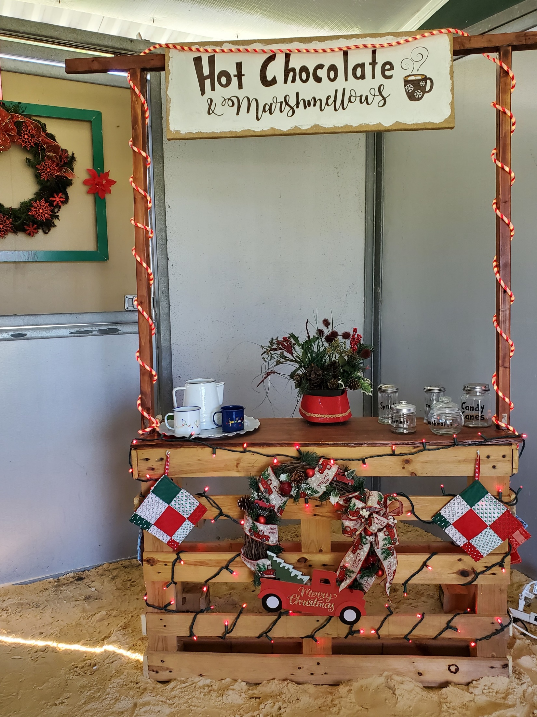
Popcorn rental includes: Machine, Popcorn, seasoning, bags. All you can eat.

Hot Chocolate Booth Rental includes: Toppings of your choice ie whipped cream, sprinkles, candy canes, cinnamon, and your ideas. As well as the booth to use for serving.

Photobooth rental: Mirror Photobooth
- Unlimited pictures printed/emailed
- Props
- Christmas Background
- Your company logo (or saying on pictures)

