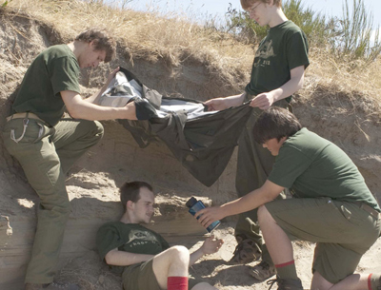
Wilderness First Aid Training

Wilderness First Aid (WFA) is the assessment of and treatment given to an ill or injured person in a remote environment where definitive care by a physician and/or rapid transport is not readily available. Participants will learn how to assess, treat, and (when possible) contain emergencies within the scope of their training. One of the first things you’ll learn to do is establish control. Emergencies may be charged with emotion and confusion. Emergencies call for a leader to be directive, at least until the scene is safe and the patient is stabilized. This and many other important information and skills will be covered in this training. Youth and adult Scout leaders age 14 and over are invited to participate and earn their certification. This course is 16-hours plus scenario time, and requires participation in full to qualify as Wilderness First Aid trained. Class size limited to 24 participants.

Prerequisites: Current CPR and AED certification. If certification is needed, an approved online course can be taken prior to the training. ECSI, Emergency Care and Safety Institute, gives a discount to BSA members. Go to ecsinstitute.org>Courses and Materials>Online Catalog>Redeem an Access Code(enter code BSAC39)>CPR and AED Interactive, 7th Edition. Required skills testing will be done on site at an extra charge of $3. *It is very important to complete all these steps, and with ECSI only to receive an electronic certificate of CPR/AED course completion. Bring a copy of the certificate provided when online course is finished as proof of completion with you to the course. If online CPR/AED course is completed with a company other than ECSI, you will not receive credit for course completion after required skills testing. If CPR/AED certification is current, bring a copy of your certificate from any one of the organizations recognized by the American Camp Association. The complete list can be found at https://www.acacamps.org/resource-library/accreditation-standards/first-aid-cpr-recognized-certifications.

Dates: Saturday, January 19, through Sunday, January 20, 2019 at Camp LaNoChe.
Beginning at 8am Saturday to about 3pm Sunday. Sign in will start at 7:30 am Saturday. Early arrival Friday night is acceptable for overnight stay, but registration will not begin until Saturday morning.
Registration will close Wednesday, January 16 at 11:59pm No walk-ins will be accepted

Location: Camp LaNoChe at the Leonard and Marjorie Williams Scout Reservation
41940 Boy Scout Rd, Paisley, FL 32767 Site 19

Cost: $78 – Follow the link below and click on the blue Register button. To register for onsite CPR/AED skills testing, click on that button during registration. Cost includes snacks, breakfast Sunday, lunch Saturday and Sunday, dinner Saturday, handouts, field guide, and emailed certificates (wallet and standard). *Please fill in dietary restrictions including food allergies and sensitivities in special needs section when you register, so the QM staff can be prepared.

What to bring: This is a camping experience, and participants will be sharing hard-roof shelters with bunk beds – one for men, one for women, one for male youth, one for female youth. Pitching a personal tent is also an option. Please bring along with other needed items, a mug, camp chair, flashlight, a pen or pencil, paper for note-taking, and a copy of your up-to-date BSA health form. If electricity required for CPAP, etc., please state in special needs portion of online registration.

Eligible participants: BSA registered adults and youth over age 14. Class size limited to 24 participants.
https://scoutingevent.com/083-WFA2019

Contact Cindy Miller, BSA Council 083 ECSI Education Center Coordinator at
cmill112@hotmail.com with questions.

