BREVARD AREA SCOUTING
FALL CAMPOREE
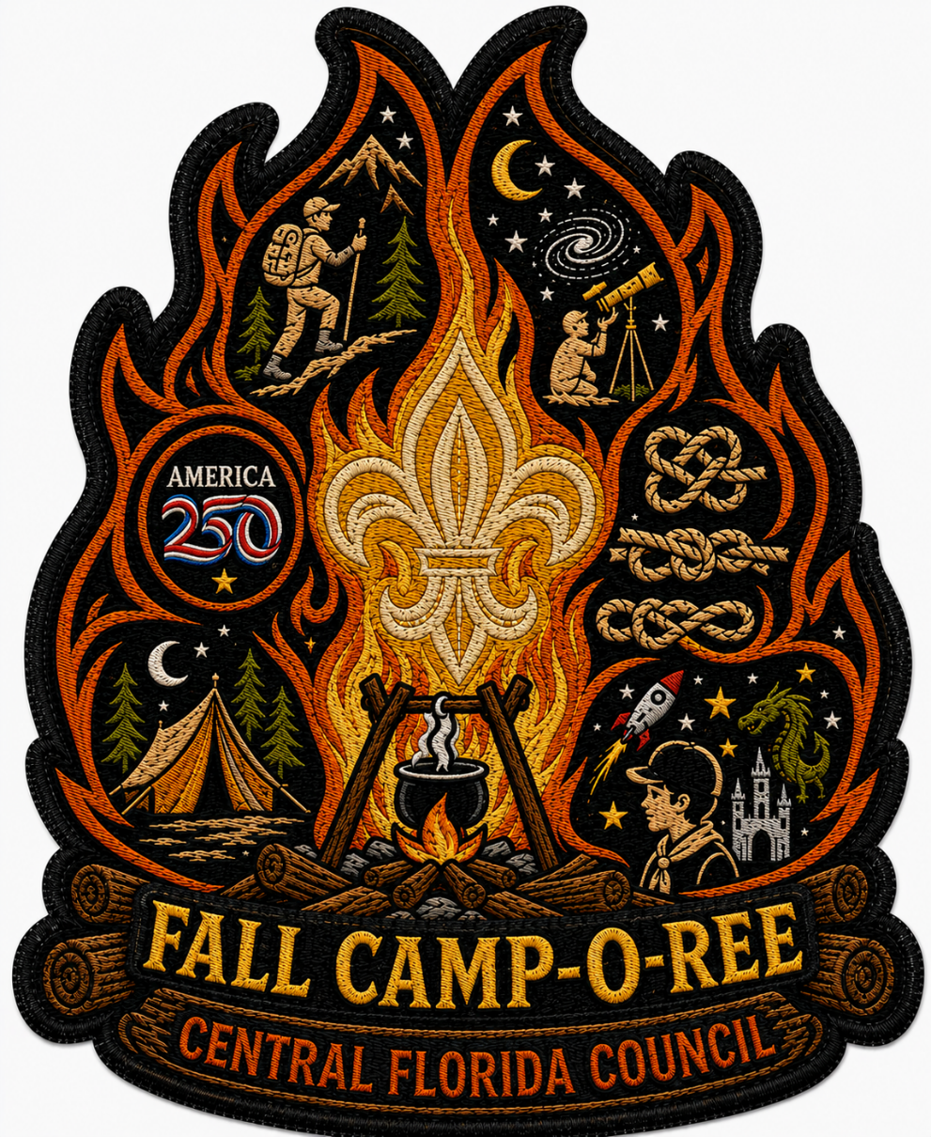

December 11-13, 2026
KARS Park
Audobon Rd., Merritt Island, Fl 32953

LEADERS GUIDE (Draft)
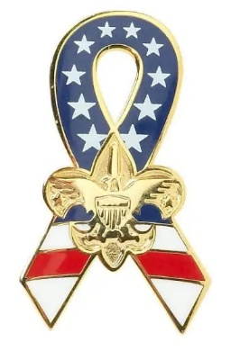
REGISTRATION
Participation is open only to Scouts BSA, Sea Scouts, Venturers,
and registered Scouters.
Registration is available through the Councils online registration system.
https://scoutingevent.com/083-ChallengerFallCam
CHECK-IN PROCEDURES
Check-in begins at 5:00 PM Friday. Check-in will be at the Area 3 Pavilion in the group camping area of KARS park. All registered scouters listed on the adult roster who will be staying at camp more than 24 hours must have a current Safeguarding Youth Training and current registration, certified by unit.
PARKING AND TRANSPORTATION
Only one vehicle per unit towing trailers or carrying unit gear will be allowed in camp for up to disconnect the trailer or unload gear and return to parking lot. This needs to be completed as quickly as possible. Please only park in the designated areas.
INFORMATION / LOST AND FOUND
Staff will man the pavilion throughout the weekend for your safety needs, information, and questions concerning general assemblies, flag ceremonies, events, Etc. Lost and found will be located in the pavilion throughout the weekend. Any unclaimed gear will be brought to the following Roundtable meetings. Gear still not claimed after two months will then be donated.
HEALTH FORMS
A copy of your Scouting America Health and Medical Form, Parts A & B (one for everyone in your group including scouts and adults) must be completed prior to arrival. These forms must be collected and retained by a responsible adult in your group. Any sickness and/or health incident must be reported to the weekend health officer.
PATROL AND BUDDY SYSTEM
Scouts will be expected to attend sessions and activities as patrols. While away from their campsites, scouts must follow safeguarding youth guidelines for buddy system. Additional, event-specific, guidance will be addressed at the leader gathering and assemblies.
LEADER’S MEETING
Each Scoutmaster, Senior Patrol Leader, or his/her designated representative MUST attend the Leader Meeting on Friday evening. Questions about Check-In materials received, or the schedule of activities can be resolved at this time. Any additional information on activities will also be presented at this meeting.
LIGHTS OUT
Lights out will be at 10:30 pm Friday and Saturday nights. There should be no activities planned after this time. A Scout is courteous.

TRASH
Each patrol will have its own plastic bags for garbage. Each patrol is to take its garbage out of camp as they are checked out and deposit it at the dumpster. Campsites will be inspected at the end of the event.
DRINKING WATER
The site has potable water, so each patrol should bring water containers that can be filled. Water faucets are located throughout the site
BATHROOMS & PORTABLE LATRINES
Safeguarding youth policies will be enforced. Please be good stewards of the facilities.
CAMPING
All sites will be assigned at check in. Please refrain from walking through or entering another unit’s site unless invited.
FOOD
Troops will need to supply their own meals. There will be a Friday night Cracker Barrel provided by the camporee for the unit leadership or their designees. The order of the arrow chapters will have a concession stand open Friday night and all day Saturday beginning at 10 AM. Units may be able to submit preorders for onsite dining at November Round table.


Units are encouraged to collect contributions to the World Friendship Fund ahead of the camporee. Special recognition will be awarded to the unit who raises the most funds.
Camporee Schedule
FRIDAY
5:00 PM-8:00 PM Arrival, Check-in and Camp Set-up
7:00 PM Key Staff Meeting
8:00 PM-8:30 PM SPL/ Scoutmaster orientation and cracker barrel
11:00 PM Lights out
SATURDAY
6:30 AM Reveille
6:30-8:00 AM Breakfast and cleanup – Activity setup
8:00 AM Opening gathering and orientation
8:15 AM Midway opens
8:00 AM- 12:00 PM Staff Tasks (booth support)
11:45 AM Midway closes
12:00-1:00 PM Thank you lunch
1:00-1:30 PM Staff Tasks (afternoon activity setup)
1:30 – 4:30 PM Afternoon activities
4:30 PM Activity shutdown and scoring
5:00 PM Closing gathering
5:30 PM Dinner
7:00 PM Closing campfire and awards
8:00 PM Flag retirement
8:45 PM Key Staff Meeting
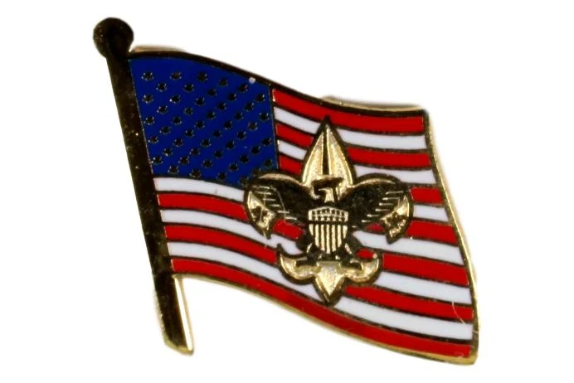
11:00 PM Lights Out
SUNDAY
6:30 AM Reveille
6:30-7:45 AM Breakfast and cleanup
8:00 AM Scouts Own Service and awards
8:45 AM Units depart
Key staff departs as possible (revelry!)
Theme

We are celebrating the semi-quincentennial (250th anniversary) and promoting patriotism. Scouts will theme their menus, campsites, and activities based on the period of the American Revolution and other Americana.
Morning Activity Stations:
- Messengers of peace project – Invasive Species Removal (1 hr)
- American Heritage Merit Badge (1.5 hr)
- Sons of the American Revolution discussion (30 Minutes)
- American Legion – Boys/girls state (30 Minutes)
- VFW – Flag etiquette (30 minutes)
- FIT Army ROTC Fitness (30 Minutes)
- VA Service project (15 minutes)
- Scout Skills in various unit sites
- America 250th Anniversary Challenge
- Flag retirement service project

Afternoon Activities:
Patriot Day (troop visits), Games, and competitions

Patriot Display:
Each unit is invited to create an informational board about a person, document, or event of the American Revolution or war for independence. This should help us get an appreciation for our nation’s early history and foundation for our country.

AOL/Troop Open House:
As this event overlaps with AOL Adventure Weekend, it is a great opportunity to show off our units! After lunch, units are invited to set up displays and activities to introduce area AOLs to what troops have to offer and connect ahead of crossover. This is also an opportunity to share good ideas among unit leader and scouts. This is also a good chance to schedule den visits to troop meetings.
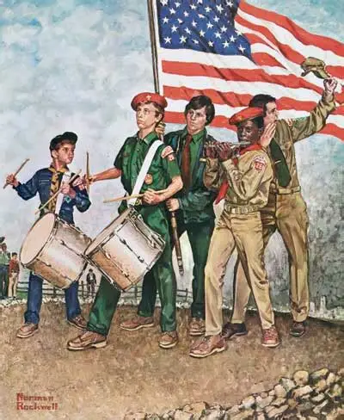

Competitions
Best All-Around Troop
- Patriotic display
- Campsite theme
- Campsite inspection (safety)
- Camp fire performance
- Valley Forge feast competition

Campfire Performance:
Each patrol will be encouraged to perform a skit or song during campfire. A panel of OA chapter leaders will select the best skits and songs based on their judgment.

Culinary Competition:
In lieu of a regular “cast iron chef”, we will instead give the patrols a chance to show off what they learned about the food ways of the patriots at Valley Forge. A list of ingredients available to the soldiers and officers during that encampment will be provided. Units can submit a soldier or officer dish for consideration. We will judge on overall taste, presentation, complexity, and explanation of the dish’s origins.

Inter-patrol competitions:
Scout patrols will be challenged with various activities related to skills needed during the war for independence and other historic periods utilizing what they learned in the morning. Competition details will be distributed at the leader’s meeting Friday night. Adult leaders from units are asked to help administer the afternoon competitions as needed.

Recreational games:
The district will provide some games and equipment for the scouts to utilize in the afternoon and make friends from across our scouting area. Units are encouraged to bring any additional games or activities to share.



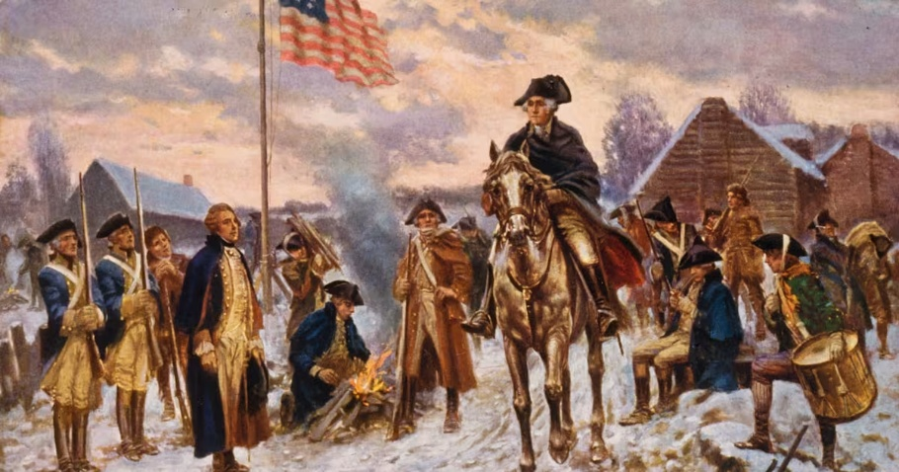
Cast Iron Patriot Challenge

Introduction to Valley Forge
The winter of 1777-78 was a pivotal moment in American history, as the Continental Army, led by George Washington, faced one of its toughest challenges at Valley Forge. The harsh conditions, lack of supplies, and scarcity of food made this period a test of endurance for the soldiers.
The decision to winter at Valley Forge was strategic, as it allowed the army to be close to the British forces in Philadelphia while also being protected by the Schuylkill River. However, the location proved to be challenging due to the harsh winter conditions, insufficient shelter, and inadequate supplies. The soldiers faced extreme cold, snow, and ice, which further exacerbated the difficulties of the encampment.
Food Supplies and Rations
The Continental Army’s supply chain was underfunded and disorganized, leading to chronic food shortages. The soldiers’ diet consisted of meager rations, which were often spoiled or contaminated. The standard ration included salted meat (usually beef or pork), bread, vegetables, and cheese. However, these items were not always available, and the soldiers often went hungry.
Cooking and Food Preparation
Cooking at Valley Forge was a challenging task, as the soldiers had to gather firewood and build fires in the harsh winter conditions. The lack of cooking utensils and equipment made food preparation even more difficult. The soldiers used cast-iron pots and kettles to cook their meals, which often consisted of stews and soups made with salted meat and vegetables. The food was often boiled to make it more palatable and to kill bacteria.
Alternative Food Sources
Due to the food shortages, the soldiers had to rely on alternative food sources to sustain themselves. Hunting and fishing were common practices, as the soldiers would hunt wild game such as deer, rabbits, and squirrels to supplement their diet. Foraging for wild fruits and berries was also a common practice, as these items provided essential vitamins and minerals. The soldiers also relied on local farmers for food supplies, which were often donated or purchased.
https://www.americanrevolution.org/recipes/
Campsite Inspection
Unit: _____________________________ District:_______________________________
SITE SELECTION AND TENT PLACEMENT (15 points total) _____
• Unit within designated site. Avoids dangerous conditions and hazards. (5) _____
• Tents properly erected; trim, securely anchored. (5) _____
• Cover for dining facilities properly erected, securely anchored, accessible. (5) _____
FIRE, FIREWOOD, AND WOOD TOOLS (15 points total) _____
• Fire site a safe distance from tents, etc.; adequately contained. (5) _____
• Adequate fire buckets and/or other fire fighting equipment available. (5) _____
• Wood tools properly stored. (5) _____
HEALTH AND SAFETY (50 points total) _____
• Proper disposal of garbage. (5) _____
• Food adequately protected from contamination and spoilage. (5) _____
• Dish washing practices result in clean pots, plates, etc. (5) _____
• Cooking equipment stored off ground and clean. (5)
• Tripping hazards marked or blocked. (5) _____
• Location of adequate first aid kit visible to all. (5) _____
• Campsite is clean and in order. (5) _____
• Personal equipment neat and stored properly. (5) _____
• American and troop flags properly displayed. (5 each) _____
PATROL ORGANIZATION AND OPERATION (20 points total) _____
• Evidence of separate patrol sites. (5) _____
• Patrol menu posted in Patrol site and kept dry. (5) _____
• Patrol duty roster posted in patrol site and kept dry. (5) _____
• Conduct in keeping with the Scout Oath or Law. (5) _____
TOTAL POINTS _______ / (100)

