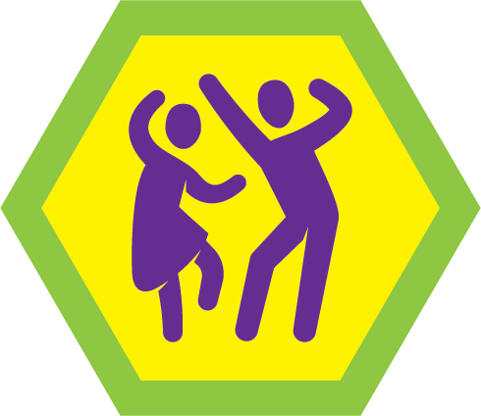
Dance Test Lab Opportunity at Roundtable (September/October)
Location: Camp Ithiel (Trailblazer Basement)
Register soon as spots are limited to 12 scouts. A waitlist will be implemented should all slots become registered. Obtain your Scoutmaster approval before attending.
Please read the merit badge pamphlet before attending.
- Prior to the class, Scouts should review the requirements: Dance | Scouting America
- Pre/Post class Requirements:
4. Research TWO of the types of dance you learned about in requirement 3 by doing the following for EACH type of dance you chose:
- Give a brief history, including its origin, how it came to be in the United States if it originated elsewhere, and where in the world/country it is most often performed.
- Name/describe different variations of this style of dancing, if any.
- Name some specific types of dance steps/moves particular to this type of dance. Does this dance tell a story through movement? If so, please describe.
- Include information on at least one person who became well-known performing, teaching, or choreographing this type of dance.
- Note if anyone with a physical disability (such a person with hearing or sight impairment or a person who uses a wheelchair) could participate in this type of dancing. What accommodations would that person need to participate?
- Locate and share a place near you/in your state where you could watch or participate in this type of dance as a part of a performance, competition, or class. Find out when and where this is offered and what the cost would be to watch or participate.
- Watch a performance of this type of dance and discuss with your counselor. (While viewing an in-person performance is preferable, a recorded performance may also be permitted.)
6. Careers. Do ONE of the following:
- Explore careers related to Dance. Research one career to learn about the training and education needed, costs, job prospects, salary, job duties, and career advancement. Your research methods may include — with your parent or guardian’s permission — an internet or library search, an interview with a professional in the field, or a visit to a location where people in this career work. Discuss with your counselor both your findings and what about this profession might make it an interesting career.
- Explore how you could use knowledge and skills from dance to pursue a hobby. Research any training needed, expenses, and organizations that promote or support it. Discuss with your counselor what short-term and long-term goals you might have if you pursued this.

Scouts may submit any questions on the above to: nrmanvel@gmail.com
Scouts MUST copy their parents and leader.
- Since this is a Test Lab opportunity, you will need to complete survey
Dance Test Lab: Nicole Walls

