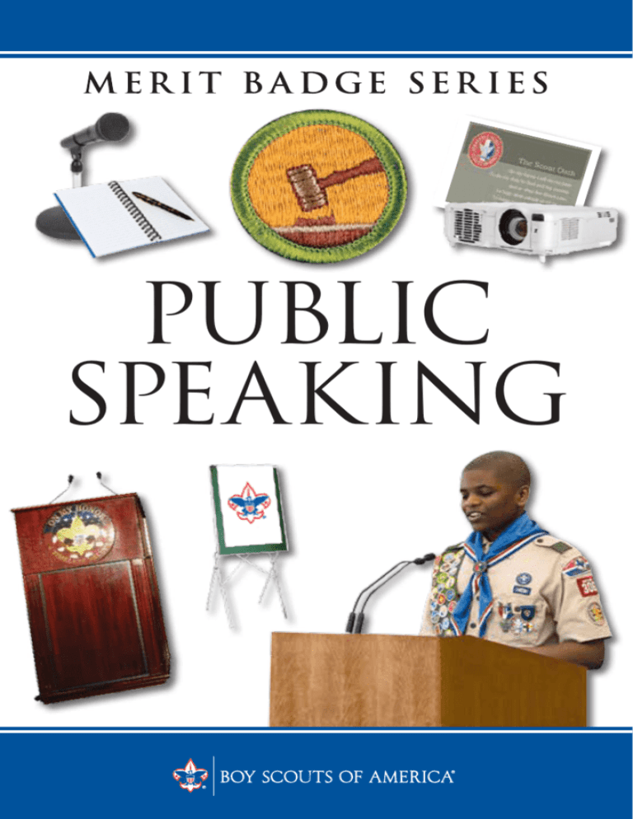
Public Speaking Merit Badge Opportunity at Roundtable (August)
Location: Camp Ithiel (Trailblazer Basement)
Register soon as spots are limited to 10 scouts. A waitlist will be implemented should all slots become registered. Obtain your Scoutmaster approval before attending.
Please read the merit badge pamphlet before attending.
- Prior to the class, Scouts should review the following: Public Speaking Pamphlet
- Prior to the class, Scouts should print the following workbook and bring it to class: Public Speaking Workbook
- Pre class Requirements:
1. Prepare to give a three- to five-minute introduction of yourself to an audience such as your troop, class at school, or some other group.
2. Prepare a three- to five-minute talk on a topic of your choice that incorporates body language and visual aids.
4. Select a topic of interest to your audience. Collect and organize information about the topic and prepare an outline. Write an eight- to 10-minute speech, practice it, then deliver it in a conversational way.

Scouts may submit any questions on the above to: swabjocky1@gmail.com
Scouts MUST copy their parents and leader.
- We encourage digital blue cards, you will need to work with your leaders to connect the Merit Badge Counselor in Scoutbook
Public Speaking MBC: Gordon Tyson

