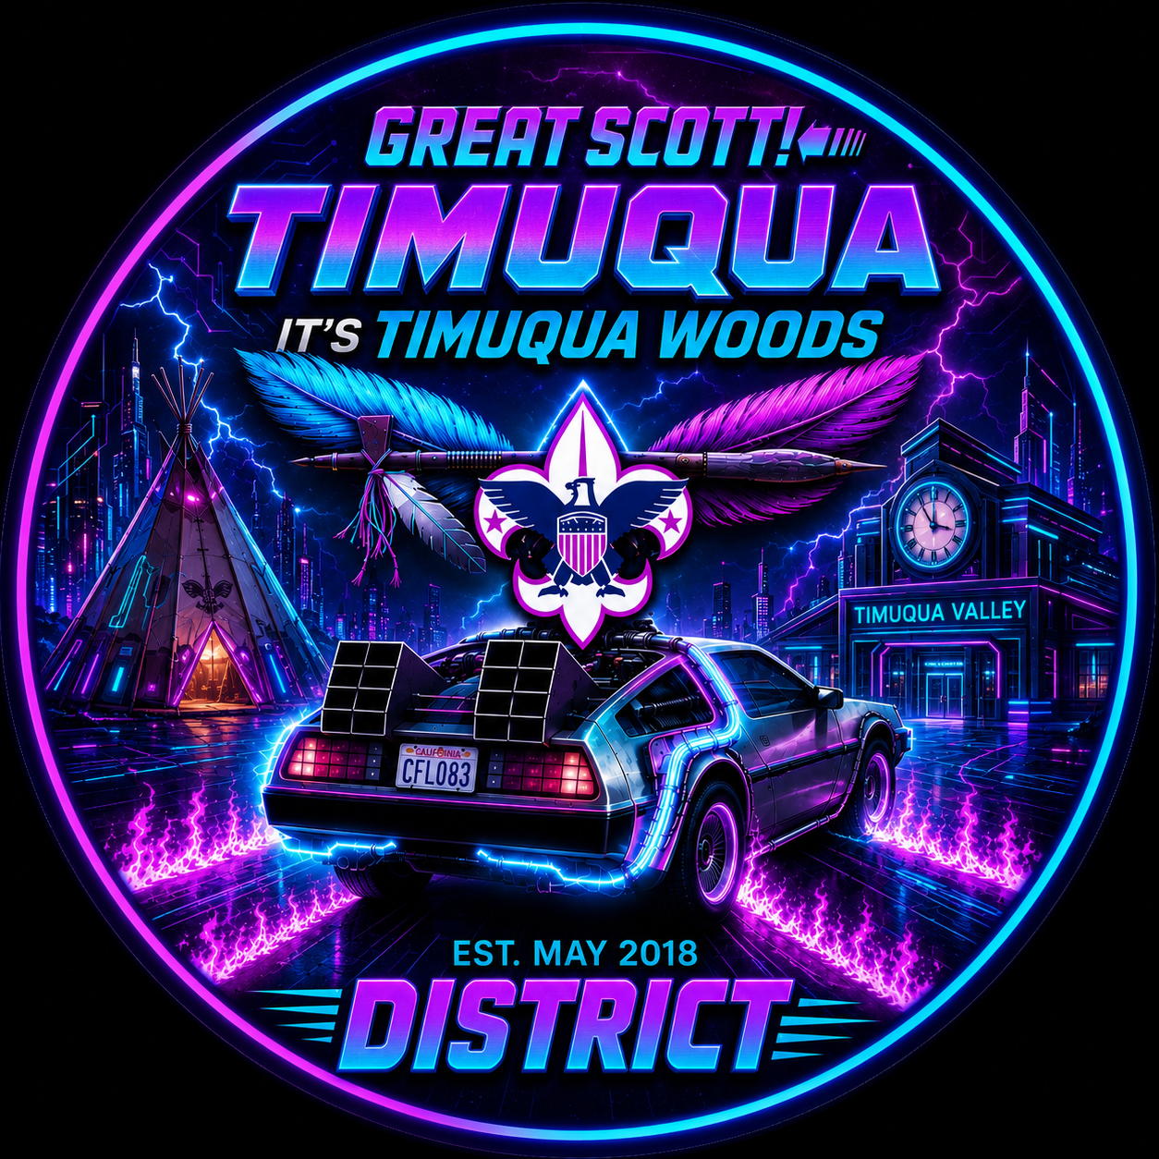

Great Scott!

Get ready to travel Back to the Future at Webelos Woods! Join fellow Scouts for a time-traveling adventure packed with patrol challenges, leadership missions, outdoor skills, and exciting activities led by the local troops of Timuqua. From the past to the future, Scouts and families will discover teamwork, problem-solving, and the excitement of the Scouts BSA experience while making memories that will last through time itself!
TIMUQUA WOODS
Welcome to Timuqua Woods — a time-traveling Scouting adventure inspired by the legendary Back to the Future universe! Throughout the weekend, Scouts will journey across timelines while using the Patrol Method to complete missions, solve problems, build leadership skills, and survive exciting outdoor challenges.
From the Old West to the Future, every activity is designed to test teamwork, communication, leadership, and Scout skills while creating unforgettable memories across time itself.
Local troops from Timuqua District will serve as guides through the timeline, helping Webelos and AOL Scouts discover the exciting future waiting for them in Scouts BSA. Parents and leaders will also participate in special informational sessions designed to help prepare for the transition into troop life.

Campsite Theming

“Your Patrol’s Timeline Depends On It!”
At registration, each unit will be assigned a specific time period to represent during Timuqua Woods. From the Wild West of 1885 to the far future of 2045, your mission is to fully transform your campsite into your assigned era!
Timeline assignments will be emailed to the unit’s registration contact within one week of registering for camp, giving your patrol time to prepare for its journey through history.
Units are encouraged to carry their timeline theme throughout the entire weekend adventure. Theming and spirit will be judged in the following categories:
- Campsite decorations and atmosphere
- Gateway design
- Costumes and era-inspired outfits
- Cooking competition presentation and creativity
- Patrol flags
- Patrol yells, chants, and cheers
- Overall patrol spirit and teamwork
This is your chance to prove your patrol belongs in the space-time continuum! Creativity, Scout spirit, teamwork, and immersive storytelling are highly encouraged.
So fire up the Flux Capacitor, grab your hoverboards, and prepare to travel through time… because when Timuqua Woods hits 88 miles per hour, anything is possible!
ARRIVAL, PARKING, & EQUIPMENT

“Your Adventure Through Time Begins Here!”
Because every troop travels through time differently, units may arrive Friday evening or Saturday morning. Please review the General Schedule for your official timeline coordinates.

Time Traveler Check-In
Upon arrival at camp, all vehicles must report to the Time Traveler Check-In Station. Travelers arriving outside the designated timeline should report directly to Headquarters for updated instructions from the Time Control Staff.
Drivers must turn in a roster showing all passengers aboard their “time machine.” Each vehicle entering camp must have its own roster listing ONLY the Scouts and adults traveling in that vehicle.
Camp staff will direct each unit to its assigned campsite and parking area.
If parents are dropping off Scouts, please coordinate arrival times carefully. Scouts may not be left unattended at camp. Even Doc Brown can’t repair every timeline mistake!

Campsite Assignments
Campsites are assigned based on registration preferences and arrival order on a first-come, first-served basis. Units may unload gear in designated camping areas. One tow vehicle and trailer may remain in camp throughout the weekend expedition. Accessibility vehicles must be identified during registration.

Parking Regulations
All additional vehicles must remain in designated parking areas only. Reducing vehicle traffic improves safety, protects the campsite, and preserves the outdoor adventure experience.
Remember… roads are for time travel, not traffic jams!

WHAT YOU’LL RECEIVE AT CHECK-IN

“Everything Needed for Your Journey Through Time!”
Each unit will receive the following mission materials upon arrival:
- One official Leader’s Guide per unit
- Patrol schedules and scoring sheets
- Invitation to the Friday Night Leadership Briefing
- Campsite check-out checklist and evaluation forms
A Scout is Clean! Help preserve the timeline by leaving your campsite better than you found it before returning home.

FEES & REGISTRATION

“1.21 Gigawatts of Adventure Included!”
The cost of Timuqua Woods is included in yearly council registration fees. Food costs are the responsibility of each unit. Scouts are encouraged to fully use the Patrol Method by planning, preparing, and cooking meals together as a team.
All participants must register online before the event. Registration closes 7 days prior to departure through time. Late registrations must be approved by the Event Chair and may not be accepted after the deadline.

DESTINATION: PRINCESS PLACE PRESERVE

“The Timeline Base Camp”

Camp Guidelines
- Waste water must be disposed of following Scouting America policies
- Ground fires are not permitted
- Fires are only allowed in designated campfire areas or approved above-ground fire pits
- Follow all posted firewood and fire safety instructions
- Units may use camp stoves, backpacking stoves, gas grills, or other portable cooking equipment
- Units must provide their own fuel and fire safety equipment
- All Scouting America fire safety policies will be enforced
- Drinking water must be brought by each unit, as camp water is non-potable

CHECK-OUT PROCEDURES

“Returning Safely to Your Home Timeline”
Units may depart Saturday evening or Sunday morning depending on travel schedules. Please review the General Schedule for approved departure windows.
Before departure, units must:
- Clean and restore their campsite
- Remove all trash and equipment
- Complete campsite check-out forms
- Submit evaluation forms
An adult or youth leader must report to the Check-Out Tent with completed paperwork before departure through the time portal.

SAFEGUARDING YOUTH TRAINING

“Protecting Scouts Across Every Timeline”
All adult leaders staying longer than 24 hours must have current Safeguarding Youth Training (SYT). Certification must remain active throughout the entire mission and should be verified by unit leadership before arrival.
All troop adults attending must be registered and SYT trained. Attendance is limited to registered leaders, parents, and guardians accompanying participating Scouts. Younger siblings are not permitted on this mission.

MEDICAL INFORMATION & MEDICATIONS

“Keeping the Space-Time Continuum Safe!”
All troops must bring completed Medical Forms (Parts A & B) and copies of insurance cards for every participant attending Timuqua Woods.
Troops are responsible for safely storing and administering all required medications for youth time travelers throughout the expedition.

TIME TRAVELER CODE OF CONDUCT

“The Laws of Time Travel”
To prevent damage to the timeline, all participants must:
- Follow Safeguarding Youth policies and the Guide to Safe Scouting
- Live by the Scout Oath and Scout Law in every era
- Practice Leave No Trace ethics
- Follow all fire safety regulations
- Respect all laws and weather restrictions
- Avoid tobacco use within view of Scouts
Failure to follow these rules may result in individuals or units being sent home early… permanently removed from the timeline.

UNIFORMS

“Dress Like You Belong in Every Era!”
Field uniforms are encouraged during:
- Flag ceremonies
- Campfire programs
- Scout’s Own services
Activity uniforms may be worn during missions, patrol competitions, and games. Costuming can be work to any and all activities.

ELECTRONICS & COMMUNICATIONS

“Future Technology Used Responsibly”
Like Doc Brown’s inventions, electronics can be powerful tools when used wisely. Units are encouraged to establish technology rules to ensure devices enhance rather than distract from the adventure.
Remember… the best memories are made outside the screen!

PHOTOGRAPHY & SOCIAL MEDIA

“Documenting the Timeline”
Scouts and leaders are encouraged to capture and share memories from their journey through time at Timuqua Woods. Please use all technology responsibly and in accordance with Scouting values.

THE PATROL METHOD

“Every Time Machine Needs a Crew!”
Each patrol is encouraged to create:
- A patrol flag
- A patrol yell
- A themed activity uniform
Teamwork, patrol spirit, and leadership are the keys to surviving every timeline adventure!

LEADERSHIP MEETING

“The Friday Night Time Traveler Briefing”
Each troop should send at least one youth leader and one adult leader to the official Friday Night Briefing. Packs should send at least one adult representative.
Topics will include:
- Timeline updates and activity changes
- Patrol competition details
- Campfire participation and skits
- Weather alerts and safety updates

CAMPFIRE PROGRAM

“Stories From Across Time”
Songs, skits, stories, and laughter are timeless Scouting traditions. Every unit is encouraged to perform a song, skit, or story from any point in history.
Webelos and AOL Scouts will prepare campfire material during activity rotations, but units are welcome to arrive with prepared performances ready for the stage.
Because when this campfire hits 88 miles per hour… you’re going to see some serious fun!

Leadership Meeting

“The Friday Night Time Traveler Briefing”
On Friday evening, each troop should send at least one youth leader and one adult leader to the official Time Traveler Briefing. Packs should send at least one adult representative.
During the briefing, we will review:
- Timeline updates and activity changes
- Patrol competition details and mission locations
- Campfire participation and skit assignments
- Weather alerts and safety information

TIMUQUA WOODS

“The Ultimate Journey Through Time!”

Friday — “Synchronizing the Timeline”
5:00 PM – 9:00 PM Time Traveler Check-In & Campsite Setup 9:00 PM Time Traveler Leadership Briefing (Location Provided at Check-In) 11:00 PM Quiet Time Across the Timeline / Lights Out

Saturday — “88 Miles Per Hour of Adventure!”
7:00 AM – 8:00 AM Wake-Up & Breakfast in Your Timeline 8:00 AM – 8:30 AM Opening Flag Ceremony & Timeline Activation 8:30 AM – 9:15 AM Time Mission 1 9:20 AM – 10:05 AM Time Mission 2 10:10 AM – 10:55 AM Time Mission 3 11:00 AM – 11:45 AM Time Mission 4 11:45 AM – 12:45 PM Lunch & Temporal Recharge 12:45 PM – 1:30 PM Time Mission5 1:35 PM – 2:20 PM Time Mission 6 2:25 PM – 3:10 PM Time Mission 7 3:15 PM – 4:00 PM Time Mission 8 4:00 PM – 5:00 PM Closing Flag Ceremony & Timeline Updates Leader Challenge 5:00 PM – 6:30 PM Dinner Across the Decades (Cooking Competition Entries Due by 6:00 PM) 6:30 PM – 7:30 PM Troop Visitations 7:30 PM - 9:00 PM Campfire Through Time 11:00 PM Lights Out Across the Space-Time Continuum
Sunday — “The Final Journey Home” 7:00 AM Wake-Up & Breakfast 9:00 AM Scouts’ Own & Closing Ceremony 10:00 AM Check-Out & Return to Your Home Timeline

“Your future is whatever you make it… so make it a great campout!”

Adventure Opportunities Across the Timeline

“Your Future Advancement Starts Here!”
Throughout Timuqua Woods, Scouts will have opportunities to work on portions of Webelos and Arrow of Light adventures during activities both before and throughout the weekend.
Just like Marty McFly had to be present in the correct timeline to change the future, Scouts must be actively participating in activities in order to receive credit toward adventure requirements. Attendance alone does not guarantee completion.
Leaders and staff will be observing participation, teamwork, leadership, and engagement during missions across the timeline. Some adventures may only be partially completed during camp and may require additional work with the den after returning to your home timeline.
So grab your hoverboard, fire up the Flux Capacitor, and get ready to learn, explore, and adventure through time!

RANK | ADVENTURE | REQUIREMENTS
WEBELOS | Stronger, Faster, Higher | 1,5 (before camp with leader) 2 (camp activities) 4, (campsite with leaders)
WEBELOS | Aware and Care | 1 and 2 morse code activity
WEBELOS | Let’s Camp | 1, 4, (before camp with leader) 2, 3 (at camp with patrol) 5,6,7(camp activities)
AOL | Bobcat | Req 7 (at camp)
AOL | First Aid | Req 2, 3, 4, 5, 6, 7 (camp activities)
AOL | Personal Fitness | 1, 4 (Before Camp) 3 (camp activities)
AOL | Outdoor Adventurer | 2, 4, (before camp with leader) 5, 6, 7 (at camp with leader)
