

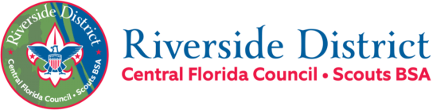
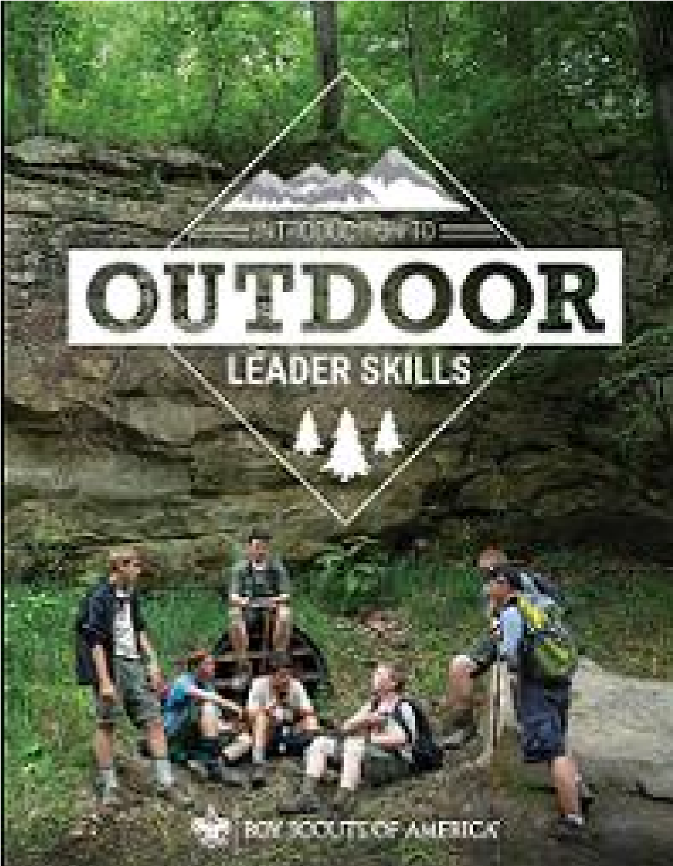

Fall
202
6

IOLS Participant Guide

Introduction to Outdoor Leader Skills
October 17 7:15 am – October 18 at 11:30 am
Location: Camp Chance / Jake’s Lake
Address: 6360 Ranch Road, Cocoa, Florida
Required Training for Scoutmasters, Assistant Scoutmasters, and Crew Advisors.
Recommended Training for All Scouts BSA Leaders & for ALL Webelos and Arrow of Light (AOL) Leaders. Also recommended for anyone wishing to take the Wood Badge Training Course.
Registration
Participants must register online prior to October 7, 2026. Please indicate any physical limitations, special dietary, or medical needs at registration. All course subject materials will be provided, and each participant will receive a course patch. There is no course registration fee or meal fee.
Meals/Menu
Your Troop Guide will contact you prior to the course to help you plan and coordinate your Patrol meals (Lunch & dinner on Sat and breakfast on Sun).

Saturday | Breakfast | Eat a good breakfast before you come to the course on Saturday.
 | Lunch | Food for a simple and quick lunch be provided.
 | Dinner | You will cook a foil packet dinner in your Patrols.
 | Cracker Barrel | Provided by Quartermaster Staff.
Sunday | Breakfast | You will be cooking breakfast in your Patrols.
If you have special dietary needs, a shopping list will be provided for you to shop for the specific ingredients and supplies you will need to prepare your meals with your Den (lunch and dinner on Saturday, and breakfast on Sunday morning).
The Course leadership will contact you prior to the course to help you plan and coordinate your Den meals (Lunch & dinner on Sat and breakfast on Sun).
Welcome Message
Welcome to Introduction to Outdoor Leadership Skills (IOLS) and thank you for your commitment to delivering a great Scouting Program! As Baden-Powell said, “Scouting is fun with a purpose.” This course is a fun-filled program of hands-on skills training in the outdoors, designed to help you master basic camp skills required for Tenderfoot to First Class. We will provide you a practical introduction to the Patrol Method and an introduction to the Scouting skills necessary to lead Scouts in an outdoor settings. Our Instructors and Staff will help you learn to set up camp, cook, how to tie knots and lashings, how to read a map, use a compass, and how to work with wood tools. They will also discuss hiking and backpacking techniques, plant and animal identification, outdoor ethics, and campfire program planning. Each session will bring to life the pages of the Scouts BSA Handbook to help you deliver the promise of Scouting to yourself and to the youth you serve. Given the compressed timeframe, you will likely not master all of these skills, but you will be on your way to being more confident in your skill set and become aware of areas where you may need to obtain additional experience. This course will also give you the opportunity to work with the other Scout Leaders from your area, meet new friends, reinforce skill techniques with fellow Unit Leaders, and have fun in the outdoors. We hope this memorable outdoor learning experience will give you the confidence and basic skills to bring the outdoor program to life in your own Unit!
Pre-Course Requirements
You must complete Hazardous Weather Training and Scoutmaster/Assistant position-specific online courses before October 7, 2026. You can find this training at my.scouting.org.
Check-In
7:15 -8:00 am Saturday 10/17/2026
Please eat breakfast before you arrive and allow yourself time to enjoy the opening gathering time. Training to begin promptly at 8:00 am.

Health and Safety
Bring your BSA Annual Health and Medical records (med forms) parts A and B. Include any allergies, meds, and a copy of your insurance card, front and back.
During the course, report any injuries or first aid needs to our Medical Officer.
We will be collecting BSA Med Forms (A/B)
We ask that you practice good handwashing and bring hand sanitizer to keep on you or near you. We will also have hand sanitizer available if you forget.

Camp Chance Rules and Waivers
Both documents are attached to the course registration page.
- Please read over the document: “Jake’s Lake Rules”.
- A camp waiver is required for EVERY PERSON on site, no exceptions. Please sign and return the document: “Release, Hold Harmless and Indemnification Agreement.” This MUST be completed and submitted by October 7, 2026, as a requirement to use the facilities.
Submit completed Agreement form to Jeff Cunningham: ghotifun@netsync.net
Dress Code
Please arrive to course in your Class A Uniform. Class A Uniforms will be worn during check-in, dinner, campfire, and closing ceremony.
Class B Uniforms will be worn during the day on Saturday.
What to Bring
REFERENCE: Boy Scout Handbook, Camping Overnight gear, outdoor essentials, and appropriate clothing are the heart of camping equipment. Carry a light load of only what you need to keep yourself safe and make a good camp; leave all unnecessary items at home.

PERSONAL OVERNIGHT CAMPING GEAR
■ Boy Scout Handbook
OUTDOOR ESSENTIALS | PERSONAL EXTRAS (OPTIONAL)
■ Pocketknife  ■ First-aid kit  ■ Extra clothing  ■ Rain gear  ■ Water bottle filled with potable water  ■ Flashlight | ■ Watch  ■ Camera and/or film  ■ Notebook or paper  ■ Pencil or pen  ■ Sunglasses  ■ Small musical instrument  ■ Swimsuit
■ Matches and fire starters  ■ Sun protection  ■ Map and Orienteering compass  ■ Clothing for the season (warm/chilly weather)  ■ Backpack  ■ Rain cover for backpack | ■ Sleeping bag, or two or three blankets  ■ Sleeping pad  ■ Ground cloth  Camp Chair (folding)
CLEANUP KIT | EATING KIT
■ Soap  ■ Toothbrush,Toothpaste  ■ Dental floss  ■ Comb  ■ Washcloth, Towel | ■ Utensils  ■ Plate, bowl, cup  ■ Bowl  ■ Cup
Check-Out
No later than 12:00 pm Sunday 10/18/26 (we will break camp 11:00 – 11:30am)
Prior to check-out, Patrols will be responsible for cleaning the pavilion and the bathrooms. Clean-up checklist as defined by BSCO is as follows:
- Leave No Trace
- Sweep pavilion, kitchen, bathrooms.
- Clean toilets and sinks
- Empty trash cans. Take trash with you. There is no dumpster on site.
Note: If you need to leave the event at any time prior to Sunday’s check-out, please inform your Troop Guide, or the SPL.

BSA Guidelines
As always, we will follow the BSA Guide to Safe Scouting. The link to the online version is below. It is always good to be familiar with this information.
https://www.scouting.org/health-and-safety/gss/toc/

See you there!

