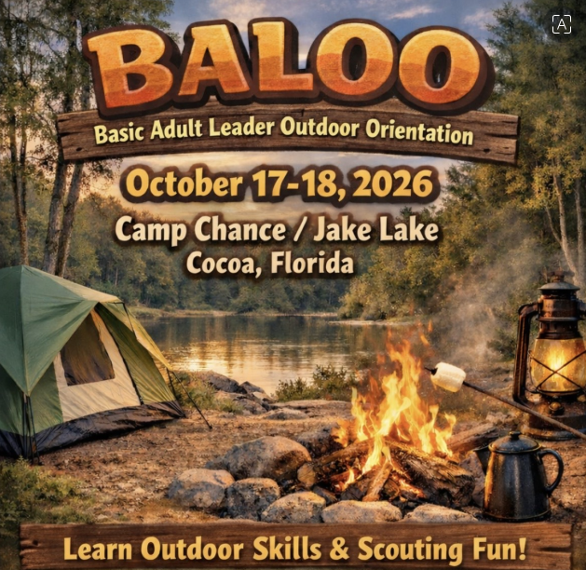

Participant Guide

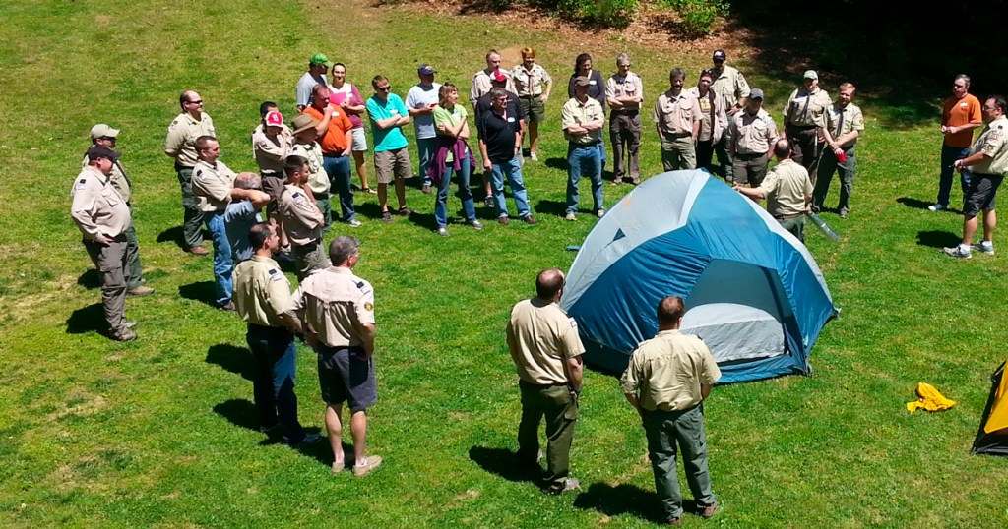
Basic Adult Leader Outdoor Orientation

October 17 7:15 am – October 18 at 11:30 am
Location: Camp Chance / Jake’s Lake
Address: 6360 Ranch Road, Cocoa, Florida
Completion of BALOO training is mandatory for a minimum of one adult leader on any Cub Scout Pack overnighter. This requirement ensures that Packs conduct outdoor activities in a way that is safe, age-appropriate, and aligned with Cub Scout camping policies.
Required for Cub Scout Pack overnighters
Combination of online and in-person training
Designed for new and experienced leaders
Registration
Participants must register online prior to October 7, 2026. Please indicate any physical limitations, special dietary, or medical needs at registration. All course subject materials will be provided, and each participant will receive a course patch. There is no course registration fee or meal fee.
Meals / Menu
Saturday | Breakfast | Eat a good breakfast before you come to course on Saturday.
 | Lunch | You will be cooking a foil packet lunch in your Dens.
 | Dinner | Food for a simple and quick supper will be provided.
 | Cracker Barrel | Provided by Quartermaster Staff.
Sunday | Breakfast | You will be cooking breakfast in your Patrols.

If you have special dietary needs, a shopping list will be provided for you to shop for the specific ingredients and supplies you will need to prepare your meals with your Den (lunch and dinner on Saturday, and breakfast on Sunday morning).
The Course leadership will contact you prior to the course to help you plan and coordinate your Den meals (Lunch & dinner on Sat and breakfast on Sun).

Welcome Message

Welcome to Basic Adult Leader Outdoor Orientation-BALOO and thank you for your commitment to delivering a great Scouting Program! As Baden-Powel said, “Scouting is fun with a purpose.” This course is a fun-filled program of hands-on skills in the outdoors, designed to help you master basic camp skills .

What You Will Learn in BALOO

BALOO provides a broad introduction to the skills and considerations involved in Cub Scout Pack camping. Course content focuses on planning and delivering outdoor activities that are safe, organized, and enjoyable for Cub Scouts and their families.

Topics covered during BALOO training include:

Planning and leading successful Cub Scout Pack campouts
Campsite selection and proper campsite setup
Health and safety considerations for Cub Scout camping
Campfire programs, outdoor ceremonies, and large group games
Basic outdoor skills, equipment use, and camping preparation
Cooking and food safety in a Cub Scout camping environment
And Much More!!!

Participants take part in hands-on activities and group experiences that model how Cub Scout leaders can deliver engaging outdoor programs while following camping guidelines.

BALOO is an introduction to the Scouting skills necessary to lead Cubs in an outdoor setting. Our Instructors and Staff will help you learn to set up camp, cook, how to tie basic knots, how to read a map, use a compass, and how to have fun in the Great Outdoors. Given the compressed time-frame, you will likely not master all of these skills, but you will be on your way to being more confident in your skill set and become aware of areas where you may need to obtain additional experience. This course will also give you the opportunity to work with the other Cub Leaders from your area, meet new friends, reinforce skill techniques with fellow Unit Leaders, and have fun in the outdoors. We hope this memorable outdoor learning experience will give you the confidence and basic skills to bring the outdoor program to life in your own Unit!

Pre-Course Requirements

You must complete Hazardous Weather Training and BALOO Prerequisite Training. Without both of these you will not be a certified as “a BALOO trained leader”. You can find the online prerequisite training at my.scouting.org.
Log in to my.scouting.org
Click on “My Training”
In the “Training Courses by Program” menu, click on “Cub Scouting”
At the top, click on “Catalog”
Scroll down and click on “BALOO Prerequisite Training v2”
This Prerequisite course is 35 minutes long
You can email your Certificate of Completion for the BALOO Prerequisite Training by October 7, 2026 to Jeff Cunningham: ghotifun@netsync.net

Check-In

7:15 -8:00 am Saturday 10/17/2026
Please eat breakfast before you arrive and allow yourself time to enjoy the opening gathering time. Training begins promptly at 8:00 am.
Health and Safety
Bring your BSA Annual Health and Medical records (med forms) parts A and B. Include any allergies, meds, and a copy of your insurance card, front and back.
During the course, report any injuries or first aid needs to our Medical Officer.
We will be collecting BSA Med Forms (A/B)
We ask that you practice good handwashing and bring hand sanitizer to keep on you or near you. We will also have hand sanitizer available if you forget.

Camp Chance Rules and Waivers
Both documents are attached to your course registration confirmation email.
- Please read over the document: “Jake’s Lake Rules”.
- A camp waiver is required for EVERY PERSON on site, no exceptions. Please sign and return the document: “Release, Hold Harmless and Indemnification Agreement.” This MUST be completed and submitted by October 7, 2026, as a requirement to use the facilities.
Submit completed Agreement form to Jeff Cunningham: ghotifun@netsync.net
Dress Code
Please arrive at the course in your Class A Uniform. Class A Uniforms will be worn during check-in, dinner, campfire, and closing ceremony.
Class B Uniforms will be worn during the day on Saturday.

What to Bring
REFERENCE: Guide to Safe Scouting:
https://www.scouting.org/health-and-safety/gss/gss03/
Camping Overnight gear, outdoor essentials, and appropriate clothing are the heart of camping equipment. Carry a light load of only what you need to keep yourself safe and make a good camp; leave all unnecessary items at home.
Suggested BALOO Training Gear List
• Tent with groundcloth • Camp chair
• Sleeping bag • Notebook, pen, pencil
• Sleeping pad or mattress, pillow • Sunglasses
• Sturdy shoes • Camera
• Hat or cap • Rain gear
• Change of clothes • Cub Scout Six Essentials
• Coat or jacket • First Aid Kit
• Sleeping attire • Trail Food
• Mess kit (cup, bowl, plate, knife, fork, spoon) • Water Bottle
• Insect repellent • Sunscreen
• Soap, washcloth, towel • Flashlight
• Whistle
Check-Out

No later than 12:00 pm Sunday 10/18/26 (we will break camp 11:00 – 11:30am)
Prior to check-out, Patrols will be responsible for cleaning the pavilion and the bathrooms. Clean-up checklist as defined by BSCO is as follows:
- Leave No Trace
- Sweep pavilion, kitchen, bathrooms.
- Clean toilets and sinks
- Empty trash cans
- Take trash with you. There is no dumpsters on site.
Note: If you need to leave the event at any time prior to Sunday’s check-out, please inform your Course Leadership.
Scouting America Guidelines
As always, we will follow the Scouting America’s Guide to Safe Scouting. The link to the online version is below. It is always good to be familiar with this information.
https://www.scouting.org/health-and-safety/gss/toc/

