Life to Eagle Seminar

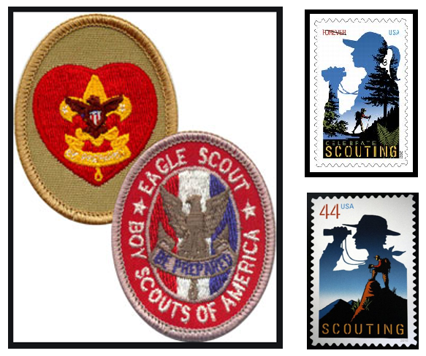
APRIL 11, 2026 (Saturday) The First Presbyterian Church
9:30 am to 12:00 pm 15 Church St, Kissimmee FL 34741

Open to all Star and Life Scouts, their parents, Scoutmasters, Assistant Scoutmasters, Advancement Chairs, and Eagle Mentors.

There is no cost for this event, but registration is required to attend.

Class A uniform is mandatory for the scouts, bring a water bottle, pen, and notebook/paper to take down notes.

If you have any questions, please email Theresa Martinez at:
osceoladvancementchair@gmail.com.

