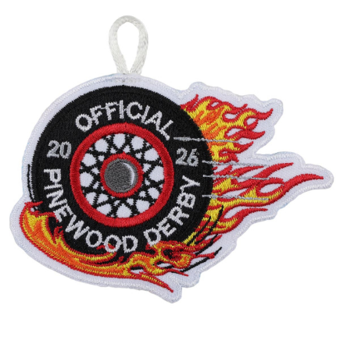
2026 PINEWOOD DERBY RULES – changes from prior year are highlighted and underlined
- Car Specifications: Width (including wheels): - 2-3/4"; Width of body at each axle - 1-3/4"; Length no more than - 7"; Weight - Not over 5 Ounces; Bottom clearance between car and track - 3/8"
- Cars must be primarily made of Official Pinewood derby wood. You cannot use splinters and have most of the car made from a 3D printer.
- The car must have been made during the current year (year in which the derby is being held) - Cannot use previous years’ cars.
- Wheel bearings, washers, and bushings are prohibited. The car shall not ride on springs.
- Only official Cub Scout Grand Prix Pinewood Derby wheels and axles are permitted.
- Only dry lubricant is permitted.
- Details, such as steering wheel and driver are permissible if these details do not exceed the maximum length, width and weight specifications.
- Pre-cut cars are acceptable. Fully designed pre-built and finished cars are not recommended/encouraged. Parent help is OK, but we encourage you to have your Scout design, decorate and build as much of the car as they can.
- The car must be freewheeling, with no starting or mechanical devices. Each car must pass inspection by the official inspection committee before it may compete.
- If, at registration, a car does not pass inspection, the owner will be informed of the reason for failure and will be given time within the official weigh-in time period to make the adjustment. Inspection committee has final say in if a car is approved. Cars that cannot make the weight may be accepted into the OUTLAW RACE.
- After final approval, cars will not be re-inspected unless the car is damaged in handling or in a race.
- Once a car is approved and registered it may not be handled by anyone except race officials.
- Siblings under 13 are permitted to participate in a Sibling division.
- Siblings 13 and over will participate in the Adult division.
- OUTLAW RACE: No rules (Rule #1 still applies except NO WEIGHT LIMIT). No motors or propulsion allowed.

