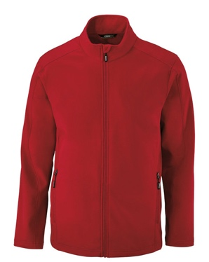

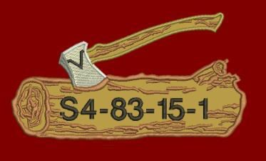***SPRING 2026 WOODBADGE COURSE***

**1968 Wrenfield Lane, Oviedo, FL 32765 (407) 366-0106; cklages@cfl.rr.com**

Example of what back would look like, course nbr in the log

The CORE365 Cruise Two-Layer Fleece Bonded Soft Shell Jacket (88184/88184T) features a inside storm placket with fleece chin guard, center front reverse coil autolock zipper with reflective toggle, and lower front reverse coil zippered pockets with reflective toggles. The shell also has a water-repellent finish. TackleTwill Wood Badge Log and Axe on rear of jacket with course number. Wood Badge Log and Axe, name, and Patrol name embroidered on the front of jacket.

**Name: Date:**

**Address:**

**Phone: Email:**

**Size of Jacket (Circle One): Small ($95.25) Med($95.25) Large($95.25) XLarge($95.25)**

**(price includes tax)**

**2XLarge($97.40) 3XLarge($100.60) 4XLarge($101.65) 5XL ($103.80)**

**Color of Jacket (Circle One): Classic Red Black Classic Navy Carbon**

***Tall offered in a few colors and sizes (large and above) for an additional charge of $5.00***

***Classic Navy Black***

**First Name Embroidered on Front of Jacket:**

**Patrol Name (if known) to go under Wood Badge Log and Axe on Front:**

**Course # for Back of Jacket: 16 – 83 – 26 – 1**

**Course # Location: *In Log***

**Previous Course numbers (Staff - below Log) $7 per line**

**Optional critter character embroidery = +$11.77 (includes sales tax)**

**For Payment and online orders please visit: xxxxxxxx@xxx.org**

**>>>. . (will update after the link is active)**