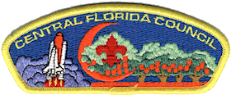
Riverside District Training: 
LIVE: In-Person Position Specific Training for:
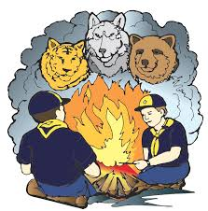
Den Leader, and Pack Committee Member /Chairs
Saturday 12-April-25
8AM to appox. Noon.
Melbourne Church of Christ, 810 Hollywood Blvd. W. Melbourne FL
Sign-up on Council Web Site or contact; Bradj123@bellsouth.net


Bring your laptop and/or cellphone for use during the course, to see firsthand what, where and how of the many resources that are available to support you.


Hands-on activities and sample handouts will be available.

“Every Scout deserves a trained Leader!”

