Riverside DISTRICT’s

CUB FAMILY CAMPOUT

Leaders Guide
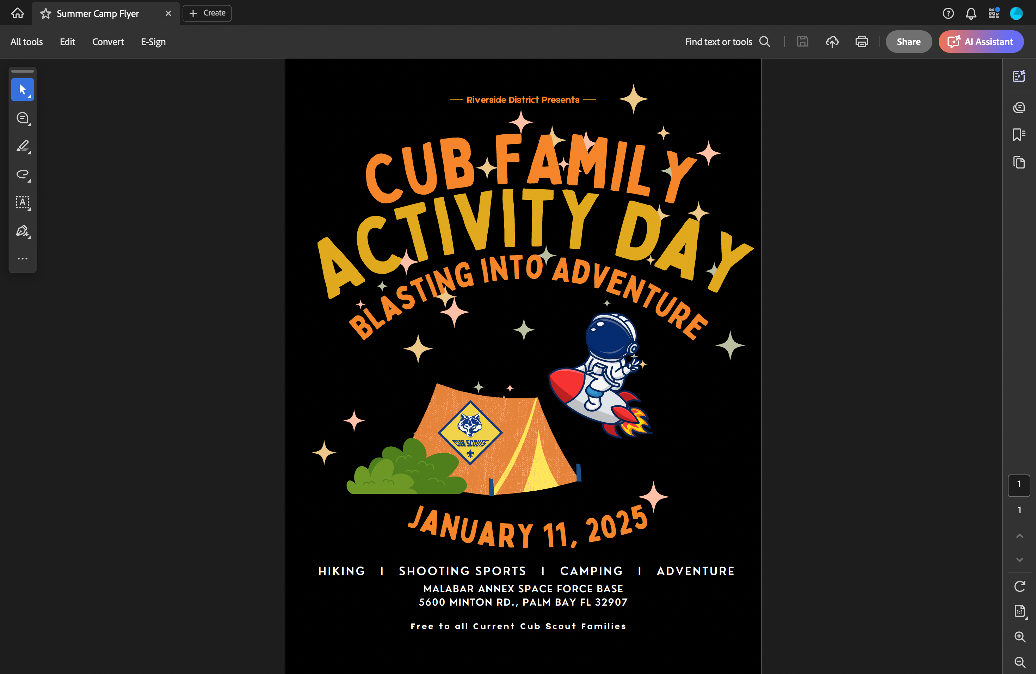

Malabar Transmitter Annex

5600 Minton Rd, Palm Bay

Updated 01/02/25

Table Of Contents

General Schedule 3
CUB ADVENTURE Map 4
Registration 4
Check-In Procedures 4
Rules of the Annex 5
Parking and Transportation 6
Information / Lost and Found 6
Health Forms 6
Buddy System 7
Uniforms 7
Leader’s Meeting 7
Trash 7
Drink Water 7
Bathrooms 7
Pack Rally Locations 7
Activities 8
Thank You 9

General Schedule
Note the gate schedule.

Saturday, January 11th
7:30 am | Main Gate Opens | Main Gate
9:00 am | Opening Flag Ceremony | Flagpole
9:00 am – 12:00 pm | Activities | Activity Field
10:00 am – 11:00 am | Hike Option 1 | See Hike Map
9:00 am – 12:00 pm | Cub Scout Range Time | Ranges
12:00 pm – 1:30 pm | Lunch | On Your Own
1:30 pm – 2:30 pm | Hike Option 2 | See Hike Map
1:30 pm – 4:00 pm | Activities | Activity Field
1:30 pm – 4:00 pm | Cub Scout Range Time | Ranges
4:00 pm – 4:30 pm | Closing Flag and Unit Awards | Campsite
7:00 pm – 7:45 pm | Evening “Campfire” | Stage
5:00 pm | Main Gate Closes | Main Gate
10:30 pm | Lights Out | Campsite

CUB ADVENTURE Map
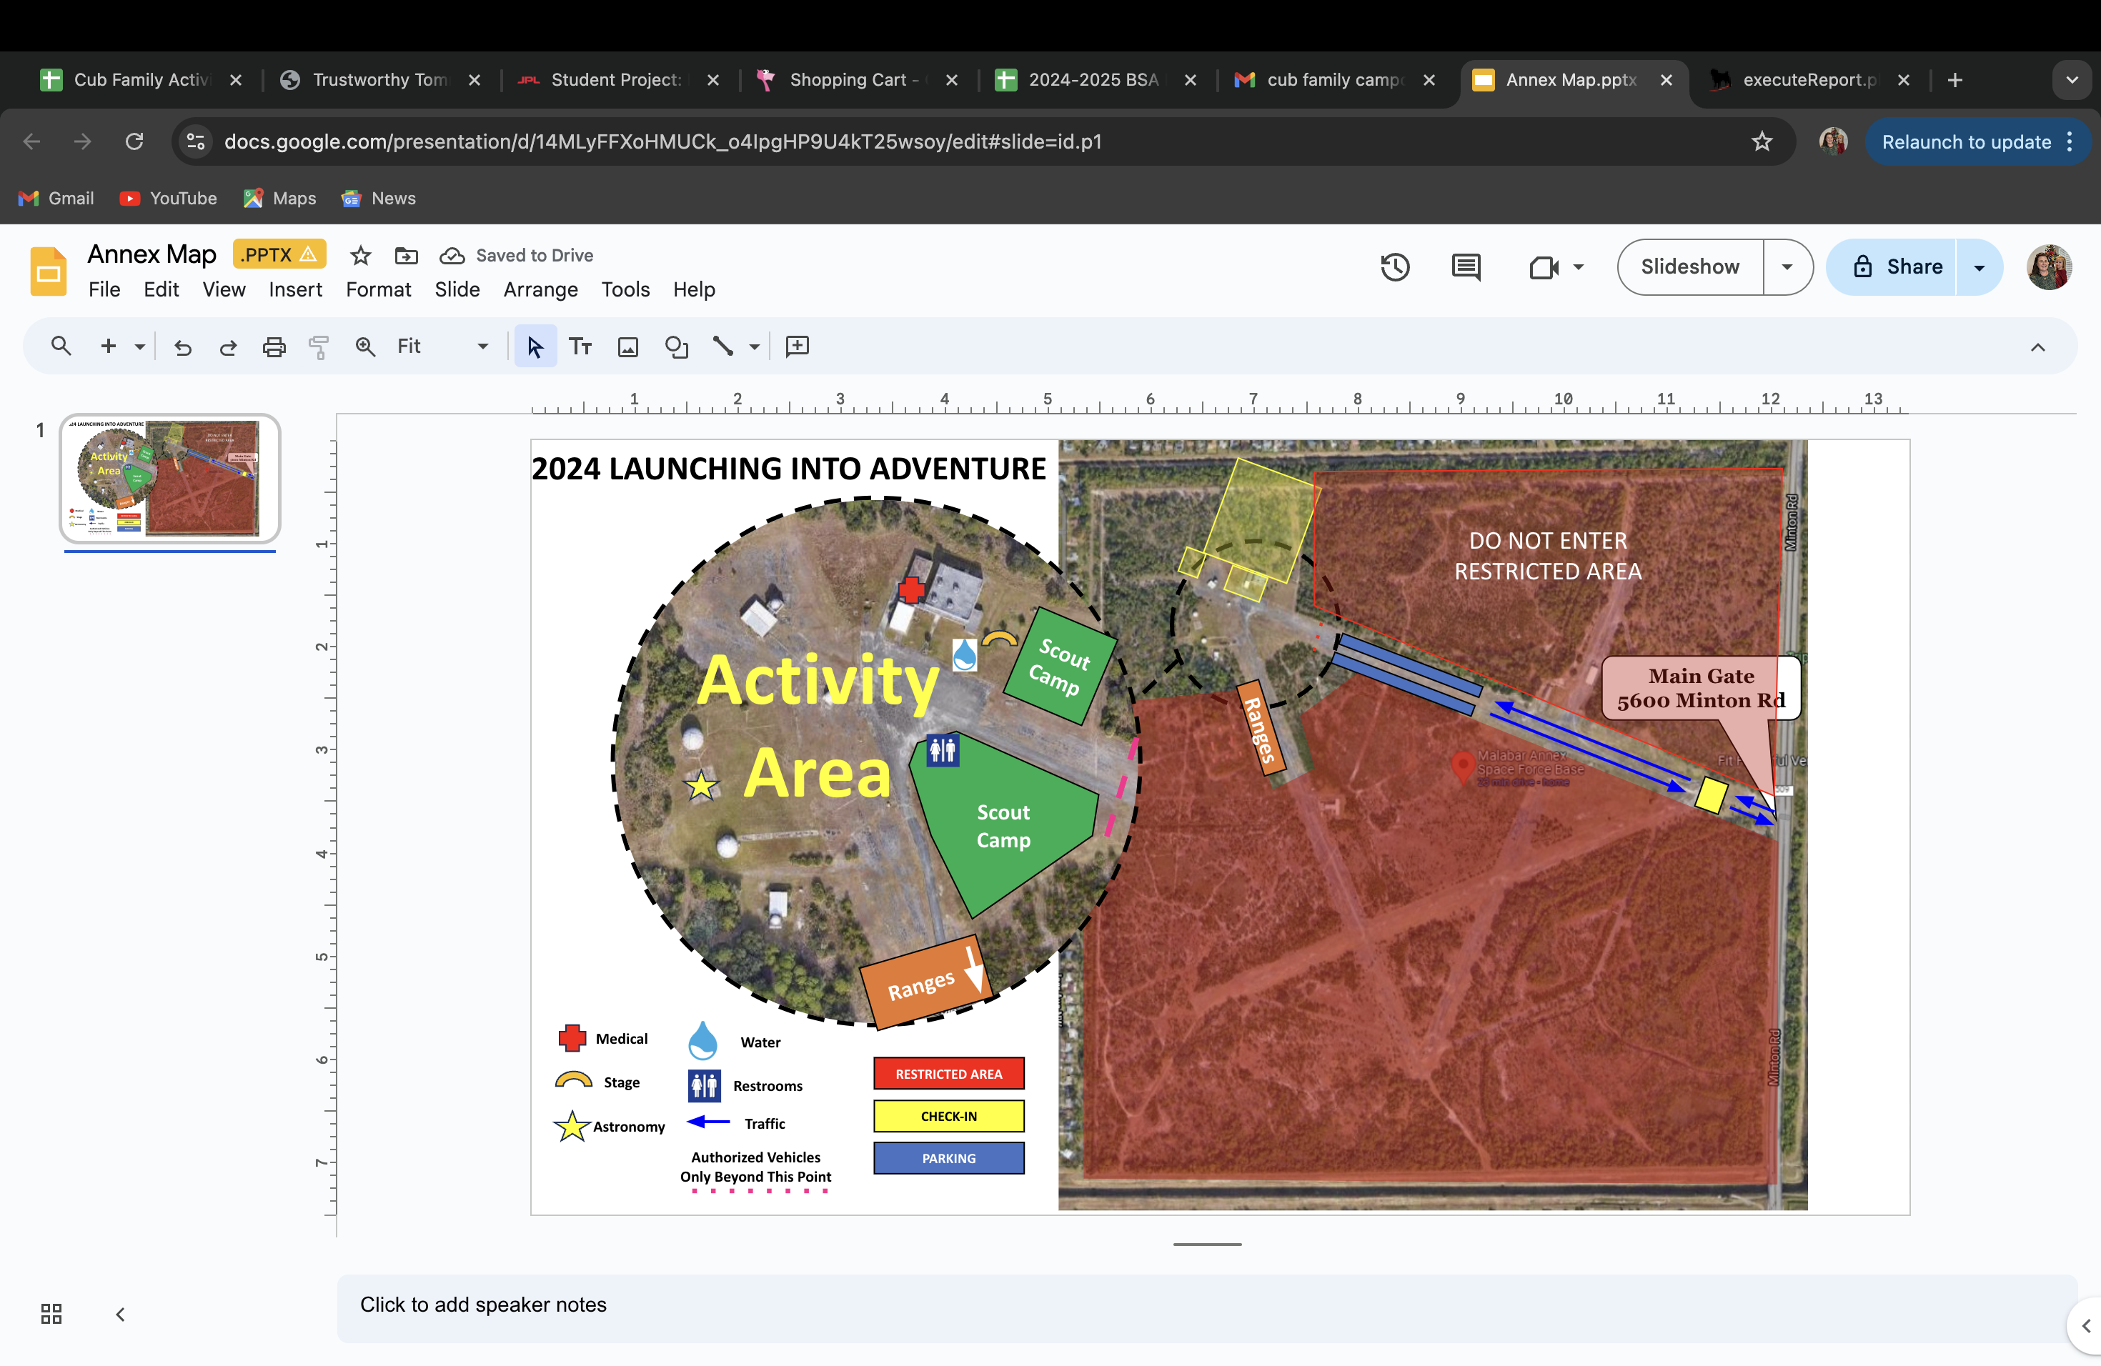

Registration
Registration is open: Check the Riverside Facebook Page, The Council Calendar, Your Pack Leaders, or the Cub Family Campout Chair
This event is FREE, but registration closes January 7th. There will be no walk-ins. You must be registered by January 7th! The only exceptions will be scouts that have joined at a school night on/after that date. We must know who is on site for insurance purposes.
It is required that all units attending choose an activity to host, or one will be chosen for you by January 7th information meeting. You will find a description of some planned events for the Cub Activities, below or via social media. Once you decide on your activity, please contact Stephen Gerrish; sgerrish@gmail.com. Thank you for your support in making this a great event.

Check-In Procedures

Saturday, January 11th: Gate will open at 7:30 am and close promptly at 5:00pm
Only pre-registered participants will be let into the Annex by the front gate staff. As units arrive, the first person of every unit will be given their respective packet. Inside each packet you will find:
- Any updated information post release of this guide
- Honor Unit Form
- Rank Advancement/Elective Guide
- Map and Rules
- Event Survey
- Checkout Procedure
When you arrive, you will be directed to the parking area. It may be helpful to have a cart to transport your gear to if you are cooking lunch. The walk will not be far.
The gate will close at 5pm.

Rules of the Annex
Welcome to the Malabar Transmitter Annex! The use of this property is a privilege. Remember a Scout is Obedient, and all Rules will be strictly enforced.
- Do not venture or explore areas that are off limits to scouts.
- Per BSA Policy; No smoking, illegal drugs or alcohol will be allowed at any event.
- Drone flying is not allowed at the Annex.
- No pets allowed. Only ADA service animals as identified as stated on ADA.gov are allowed
- The Annex has many wild animals that can be dangerous. Do not approach/feed animals. Food needs to be properly stored. No dumping of food in the woods.
- No bike riding of any kind, kid powered or electric.
- Camping areas must stay free of trash and debris that can blow around into other camping areas. All sites must be cleaned, and all garbage disposed of before leaving camping area on Saturday.
- All tents and canopy’s must be securely tied down. It gets windy.
- No digging and no stakes longer than 10in
- Vehicles are only permitted on runways unless dropping off a trailer. Any damage to the ground (i.e. ruts) caused by vehicles is the responsibility of the driver or unit and must be repaired prior to check out.
- Do not use a port-a-let that is in a campsite or marked for a specific unit. Units have paid for their own port-a-let in their site.
- Use of LAN line phones in Building 65 are off limit
- Trash must fit in a 33gal. bag. If your tent or camping equipment breaks, please take it home with you.
- A list of all attendees and visitors must be maintained in case there is an emergency or an accident, so pre-register.

Fires
- Open fires, campfires (ground or raised), burn barrels, etc. are not allowed. Deep frying is not allowed.
- Camp stoves may be used for food preparation only and must be off the ground and must be placed on a table or stand so bottom of grill is 29 inches off the ground
- Raised, standing height, charcoal grilles are allowed. No accelerants (i.e. lighter fluid) are allowed. All ash and unburnt coals must be taken with you and not dumped.
- Any other possible source of heat generation that could result in a fire must be approved by the Annex POC.
- All groups must supply their own fire extinguishers that are up-to-date, readily available, co-located with each stove/grill, and be visible to inspectors.
- Failure to have proper fire extinguishers will result in all cooking to stop until a proper extinguisher is available.

Parking and Transportation
Once you have checked in at the gate, please proceed to the parking area. This area is marked on the map. There will not be any variations of parking other than those directed. The Annex rules are very strict as to where we are allowed to park.
You will be asked to go to your unit’s camping area, unload your gear and then move your car to the parking area. Do not leave your vehicle while you set up your tent and gear. Please unload your car and move it so other vehicles can drop gear. This process may be terminated at any point due to safety concerns or abuse. There will be no parking at campsites. The walk from the parking area and the camping area will not be far. All cars must be parked in the parking area by 8pm to reduce white light for our movie night.
Once your vehicle is parked in parking area there should be minimal moving of the vehicle during the event. You will not be able to drive to your campsite, should you leave the event early, so the use of a cart is highly recommended. This event will be people powered on Saturday!

Information / Lost and Found
Building 65 will be for Staff, Medical, and limited games. You are NOT allowed to use the restrooms in Building 65 during this event, as to not destroy the septic system. Please use the port-a-lets. All Lost and Found items should be returned here. We will do our best to get the misplaced items back to their owners. All remaining items will be brought to January Roundtable; after this time, the items will find other homes.

Health Forms
All units are required by BSA to have health forms on hand for all scouts. We will not be collecting them, but trust that you will have them on hand. Medical will be based in Building 65 on the West Wing in case of an emergency.

Buddy System
Leaders, please make sure you stress this to all scouts attending. There are lots of places to explore and vast fields to run in. The staff will be making sure that no scout is alone.

Uniforms
Please come to the Flag Ceremony in Class A, Field Uniforms. For Activities, Class B Uniform!

Leader’s Meeting
A Leader’s Meeting will be held on Wednesday night at 7pm via Google Meet. A meeting notice will be emailed to all packs attending. Event information will be provided, so the event adventures are enjoyed.

Trash
Each unit must bring their own trash can. Trash bags will be collected after closing flag. There is an Annex dumpster that is not ours and will be clearly marked NO TRASH. There should not be any waste thrown in these trash cans that does not fit in a 33-gallon bag. If equipment breaks, please take it home with you. A scout is Clean; do your best to keep the areas free of garbage and flying debris. We share this site with wildlife, and we don’t want to interfere with them.

Drink Water
Please make sure you remind, remind, remind your scouts and families to bring water bottles and drink often. Each unit should have water available. Every unit should plan to bring water to the activities that they are hosting. If you do not have a water dispenser of some kind, please let us know. There will be centralized water stations at Near Building 65. There will be a water hose supply for units to use near the stage at Building 65.

Bathrooms
There will be port-a-lets provided by the event. The bathrooms at Building 65 will NOT be opened to scouts for this event. Please be respectful of all attendees and keep public port-a-lets clean.

Pack Rally Locations
Packs can choose an area to set up as their rest area and cooking location as required. You are welcome to bring pop ups to set up and are required to bring your own chairs. Lunch will be on your own and you may cook onsite if you choose to. Please make sure you use approved heating equipment. Fires are not allowed. Please stay within the areas noted on the map. We have more than enough green space to accommodate everyone comfortably.

Activities
Indoor Activities
These activities are open to both Cub Scouts and can be done on your own.
Hiking
Hiking will be offered at 2 times 10am and 1:30pm. Hiking will be lead by one of the staff. The approved hiking path shown on page 13 please meet at the green start location. Please make sure to stay on this general path.
Geocaching
Geocaching sites are also on your own and the current active locations are showing on page 14. Please remember to only take one item from the geocache and then leave something behind.

Ranges
Archery, BB’s, and Slingshots available for all! Test your skill on each of our ranges.
Scouts must have closed toed shoes and are encouraged to bring your own safety glasses to all shooting sports.
Be sure to follow all the Range Master’s directions.
Games and Activities
Over 15 different Cub Friendly games are being planned for our Cub Adventure. Each Pack will man an activity for our event (and is a requirement for the Honor Pack Award). We plan on there being un-staffed (easy) and fun activities available. These games will have instructions available, and will be pretty straight-forward. Some planned games/activities are: Lunar Rovers, Make an Alien, Glider Toss, stomp rockets, rain gutter regatta and other fun events, along with our Ranges.
We have indoor crafts and outdoor games.

Honor Unit Award
The requirements for this award are found in the forms section of the leader’s guide. This award is open to Packs and Troops. All units have an opportunity to earn the Unit Award. To earn this award all you must do is have fun and participate! Please note that the Honor Unit Award will be awarded at the closing flag or January Roundtable.

Thank You
Thank you very much to all the organizations who help make Launching into Adventure a success.
Patrick Space Force Base – Malabar Transmitter Annex
 | Thank You for your continued support and for the use of this incredible property, we could not have done this event without you! A very special Thank You goes out for their continued support.

Hiking Path
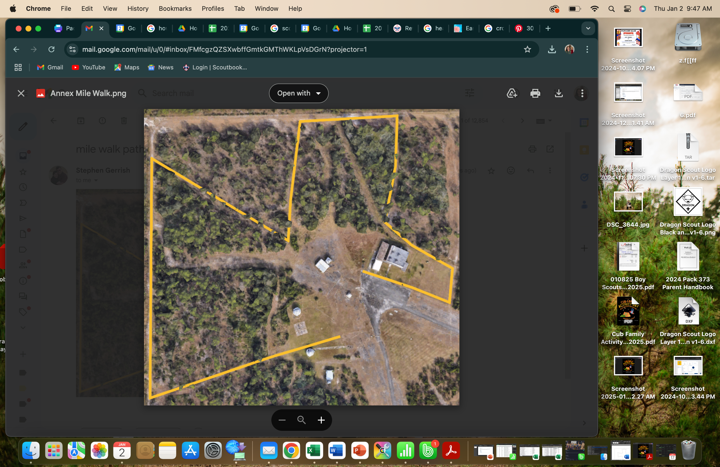
Hiking will be offered at 10am and 1:30pm. Below is a rough plan of the hike, it is one mile and will be verified prior to the event. The path may change as required. Please make sure to follow your hiking guide as you go along the path below. Make sure to remember the outdoor code and Leave No Trace.

Geocaching
Geocaching is a worldwide game Global Navigation Satellite Systems (GNSS), of which the Global Positions System (GPS) is one. You may use an GNSS receiver you which to locate hidden “cashes” around the Space Force Malabar transmitter Annex. All geocaches have a form clearly identifying them as official Space Force geocache, and a space vehicle name for that specific geocache.
The map of the sites and a list of the caches is below. A number have been destroyed in the fire so please see the list of known active caches.
The geocache containers are about 5.5” tall plastic cylinders. If it contains goodies (known as swag), please only take an item if you leave something in it’s place.
PLEASE PLACE THE CACHE BACK WHERE YOU FOUND IT!!!!!!
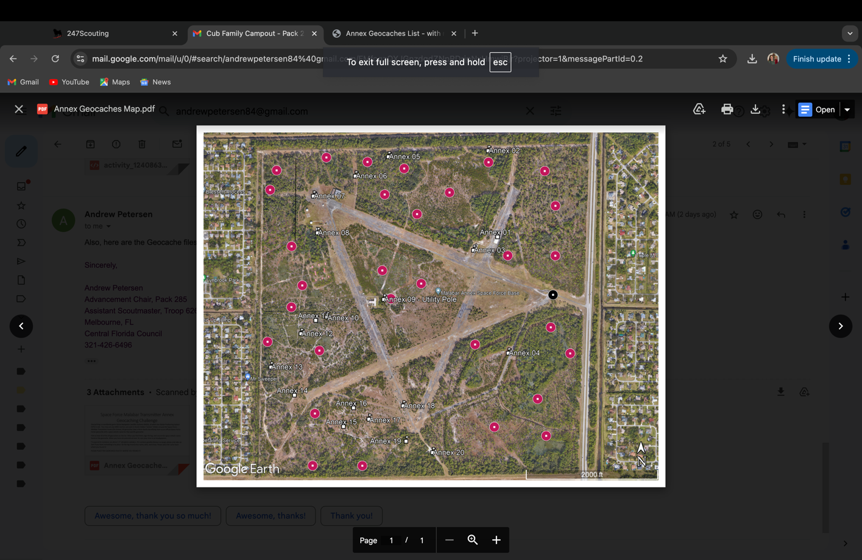
Geocaching will be unit led please selected a unit leader to guide your scouts to the locations. Remember your outdoor code and Leave No Trace as you search.

 |  | Coordinates
Cache # | Clue | Latitude | Longitude | Space Vehicle
1 | By a ramp | 28°01’26.5”N | 80°40’34.5”W
2 | Near the base of a tree | 28°01’39.4”N | 80°40’36.1”W
3 | Need power? | 28°01’24.5”N | 80°40’38.6”W
5 | Let’s Get to the root of this | 28°01’38.5”N | 80°40’53.0”W
6 | Between two trees | 28°01’35.6”N | 80°40’58.6”W
7 | One person’s trash… | 28°01’32.6”N | 80°40’05.7”W
8 | The itsy-bitsy spider will be sad. | 28°01’27.1”N | 80°40’05.0”W
19 | Near a vent | 28°00’55.9”N | 80°40’50.0”W
20 | Tall pine | 28°00’54.2”N | 80°40’45.5”W

