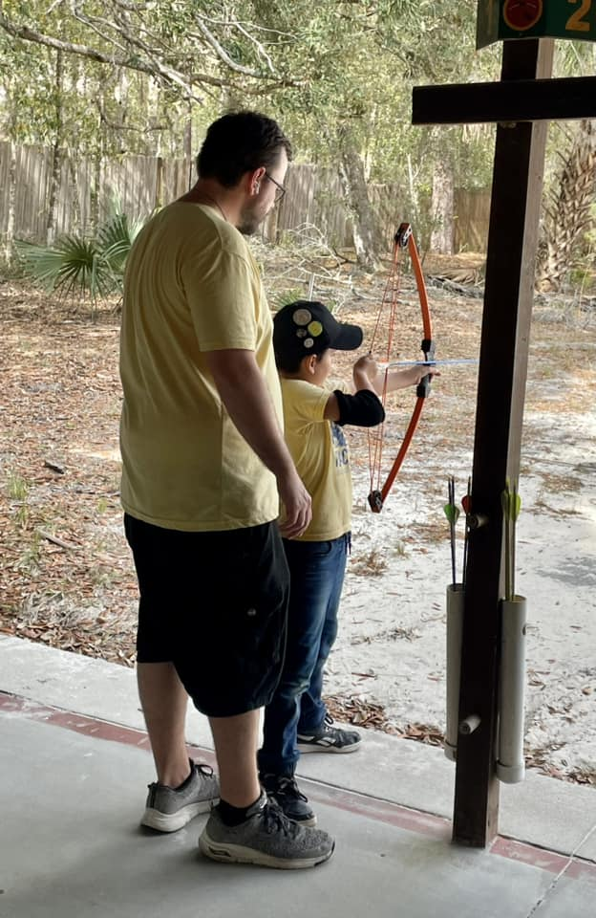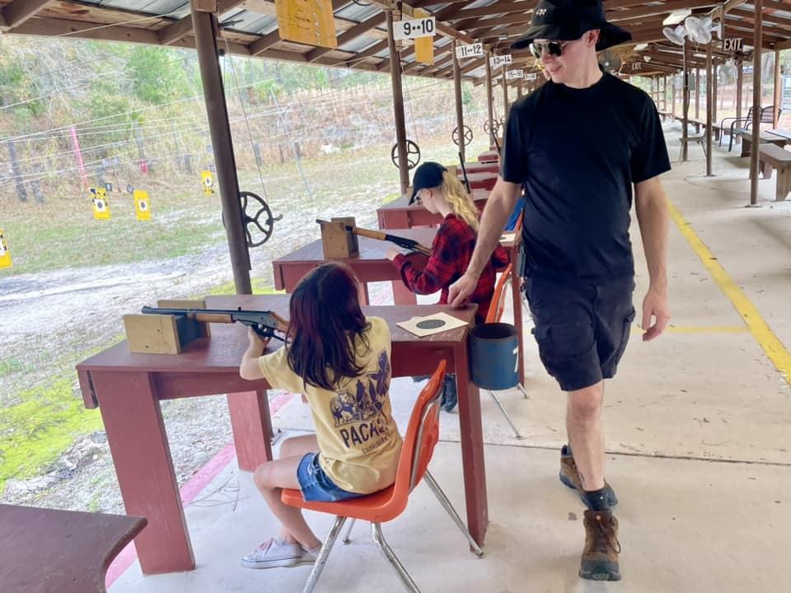 **Seminole District Shooting Sports Day**

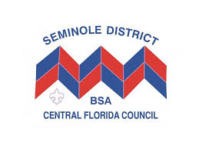

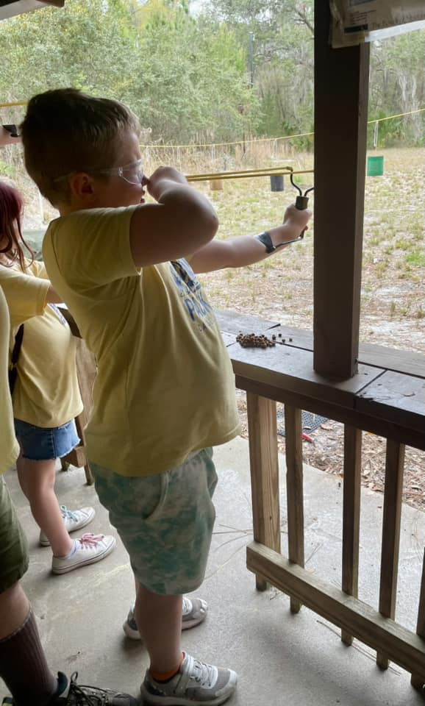

When: Saturday September 21st, 2024, 9am – 1pm

Where: Seminole State College Gun Range

2450 Gun Range Rd, Geneva, FL 32732

Cost: FREE!!!

Activities Include:

BB Guns (Tigers – AOL) / Archery / Sling Shots

Bounce House

Global Eats Food Truck will be on Site

or bring your own bagged lunch!

Volunteer or Questions Contact: [canatsey86@gmail.com](mailto:canatsey86@gmail.com)