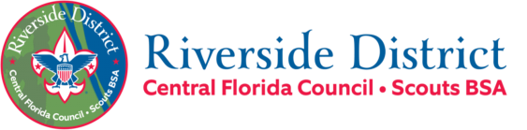
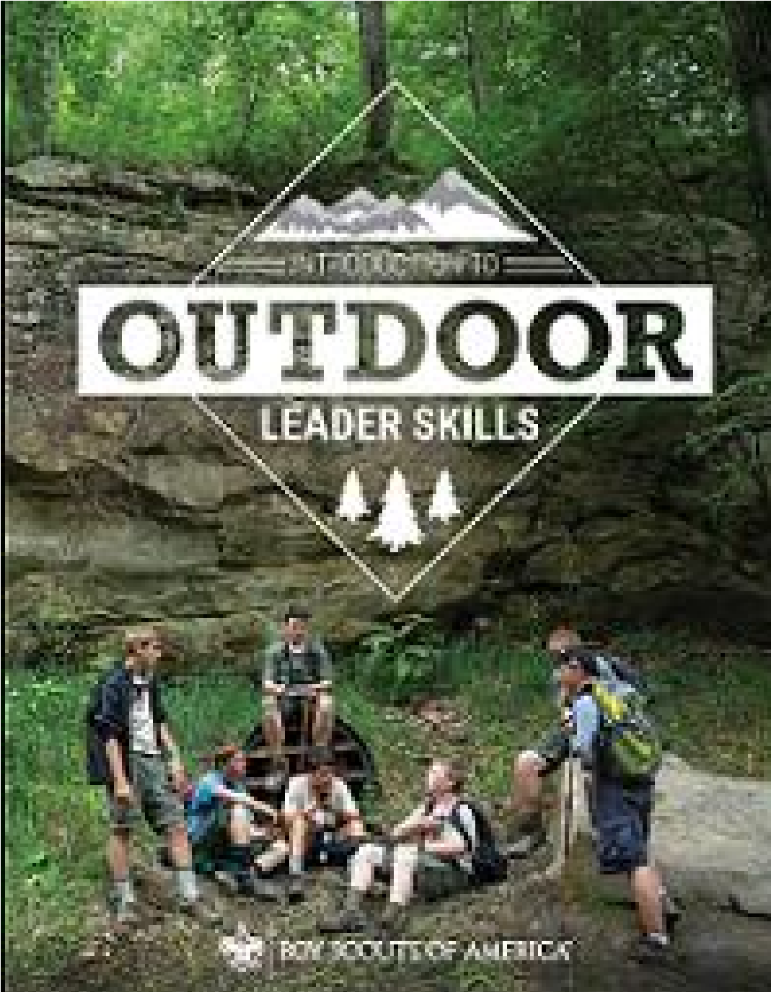

Fall
202
3

IOLS Participant Guide

Introduction to Outdoor Leader Skills
Sat. 21-Oct 8:00 am –-> Sun. 22-OCT-23 at approx. 12:00 pm
Location: Camp Chance / Jake’s Lake
Address: 6360 Ranch Road, Cocoa Florida 32927
Required Training for Scoutmasters, Assistant Scoutmasters, and Crew Advisors.
Recommended Training for All Scouts BSA Leaders & for ALL Webelos and Arrow of Light (AOL) Leaders. Also recommended for anyone wishing to take the Wood Badge Training Course.

Registration & Fee’s
Participants must register online prior to the event. Please indicate any physical limitations, special dietary, or medical needs registration. All course subject materials will be provided, and each participant will receive a course patch. There is no course registration fee.
Meal options are available – see below.
Registration Option 1:
- No meal fees.
- Bring your own food and beverage.
- A shopping list will be provided for you to shop for the specific ingredients and supplies you will need to prepare your meals with your Patrol (dinner on Saturday night, and breakfast on Sunday morning).

Registration Option 2:
- $25 meal fee.
- Fee includes ingredients and supplies to prepare your meals with your Patrol (lunch & dinner on Saturday night, and breakfast on Sunday morning).

Welcome Message
Welcome to Introduction to Outdoor Leadership Skills (IOLS) and thank you for your commitment to delivering a great Scouting Program! As Baden-Powel said, ‘Scouting is fun with a purpose.’ This course is a fun-filled program of hands-on skills training in the outdoors, designed to help you master basic camp skills required for Tenderfoot to First Class. We will provide you with a practical introduction to the Patrol Method and an introduction to the Scouting skills necessary to lead Scouts in an outdoor setting. Our Instructors and Staff will help you learn to set up camp, cook, how to tie knots and lashings, how to read a map, use a compass, and how to work with wood tools. They will also discuss hiking and backpacking techniques, plant and animal identification, outdoor ethics, and campfire program planning. Each session will bring to life the pages of the Scouts BSA Handbook to help you deliver the promise of Scouting to yourself and to the youth you serve. Given the compressed timeframe, you will likely not master all these skills, but you will be on your way to being more confident in your skill set and become aware of areas where you may need to obtain additional experience. This course will also give you the opportunity to work with the other Scout Leaders from your area, meet new friends, reinforce skill techniques with fellow Unit Leaders, and have fun in the outdoors. We hope this memorable outdoor learning experience will give you the confidence and basic skills to bring the outdoor program to life in your own Unit!

Pre-Course Requirements
It is highly suggested that you complete Hazardous Weather Training and Scoutmaster/Assistant position specific online courses before course. You can find this training at my.scouting.org.
COVID-19 Pre-Event Screening Checklist and Participant at Risk Letter:
- Make sure to print and complete both forms. You will be asked for them during check-in. These forms will be emailed to you before the course.
- Important Note: Please go through each point of the checklist at home BEFORE you come to course. If you answer "yes" to any of the screening questions, please let us know, and stay home. This is not because we don't care about you, but rather, it is because we do care about you. We want you to be able to take care of yourself.

Check-In
7:30 - 8:00 am Saturday 10/21/23
Please eat breakfast before you arrive and allow yourself time to enjoy the opening gathering time. Training to begin promptly at 8:00 am.
When you arrive, we will check your temperature with a touchless thermometer. If your temperature is 100.4 or greater, you will not be allowed to participate in the training course.
We will be collecting BSA Med Forms (A/B), the Participant at Risk Letter, and the Pre-Event Screening Checklist at this time so please come prepared.

Health and Safety
Bring your BSA Annual Health and Medical records (med forms) parts A and B. Include any allergies, meds, and a copy of your insurance card, front and back.
During the course, report any injuries or first aid needs to our Medical Officer.
Please bring your own face coverings to wear during the course (make sure to bring a spare or two). We will have spare face coverings on hand for those that need them.

We ask that you practice good handwashing and bring hand sanitizer to keep on you or near you. We will also have hand sanitizer available if you forget.

Camp Chance Rules and Waivers
Both documents are attached to the course registration page.
- Please read over the document: “Jake’s Lake Rules”.
- A camp waiver is required for EVERY PERSON on site, no exceptions. Please sign and return the document: “Release, Hold Harmless and Indemnification Agreement.” This MUST be completed and submitted by 12-OCT-23, as a requirement to use the facilities.

Dress Code
Please arrive to course in your Field Uniform. Field Uniforms will be worn during check-in, dinner, campfire, and closing ceremony.
Activity Uniforms will be worn during the day on Saturday.

Meals / Menu
Your Troop Guide will contact you prior to the course to help you plan and coordinate your Patrol meals (Lunch & dinner on Sat and breakfast on Sun).

Saturday | Breakfast | Eat a good breakfast before you come to course on Saturday.
 | Lunch | A simple and quick lunch be provided.
 | Dinner | You will be cooking dinner in your Patrols.
 | Cracker Barrel | Provided by Quartermaster Staff.
Sunday | Breakfast | You will be cooking breakfast in your Patrols.

What to Bring
REFERENCE: Boy Scout Handbook, chapter 9, Camping Overnight gear, outdoor essentials, and appropriate clothing are the heart of camping equipment. Carry a light load of only what you need to keep yourself safe and make a good camp; leave all unnecessary items at home.

PERSONAL OVERNIGHT CAMPING GEAR
■ Boy Scout Handbook
OUTDOOR ESSENTIALS | PERSONAL EXTRAS (OPTIONAL)
■ Pocketknife  ■ First-aid kit  ■ Extra clothing  ■ Rain gear  ■ Water bottle filled with potable water  ■ Flashlight | ■ Watch  ■ Camera and/or film  ■ Notebook or paper  ■ Pencil or pen  ■ Sunglasses  ■ Small musical instrument  ■ Swimsuit
■ Matches and fire starters  ■ Sun protection  ■ Map and Orienteering compass  ■ Clothing for the season (warm/chilly weather)  ■ Backpack  ■ Rain cover for backpack  ■ Sleeping bag, or two or three blankets  ■ Sleeping pad  ■ Ground cloth  Camp Chair (folding) | ■ Gloves
CLEANUP KIT | EATING KIT
■ Soap  ■ Toothbrush  ■ Toothpaste  ■ Dental floss  ■ Comb  ■ Washcloth  ■ Towel | ■ Utensils  ■ Plate, bowl, cup  ■ Bowl  ■ Cup

Check-Out
No later than 12:00 pm Sunday (we will break camp 11:00 – 11:30am)
Prior to check-out, Patrols will be responsible for cleaning the pavilion and the bathrooms. Clean-up checklist as defined by BSCO is as follows:
- Leave No Trace
- Sweep pavilion, kitchen(?), bathrooms.
- Clean toilets and sinks
- Empty trash cans
- Take trash with you. There is no dumpster on site.
Note: If you need to leave the event at any time prior to Sunday’s check-out, please inform your Troop Guide, or the SPL.

BSA Guidelines
As always, we will follow the BSA Guide to Safe Scouting. The link to the online version is below. It is always good to be familiar with this information.
https://www.scouting.org/health-and-safety/gss/toc/

Friday Night Camping – May be available.
We may have the option of supporting your early arrival on Friday night, you are on your own for dinner and breakfast on Saturday prior to the course start. Details will be provided closer to the actual event.
See you there!

