Timuqua Spring Camporee Leaders Guide
at
Camp Winona YMCA
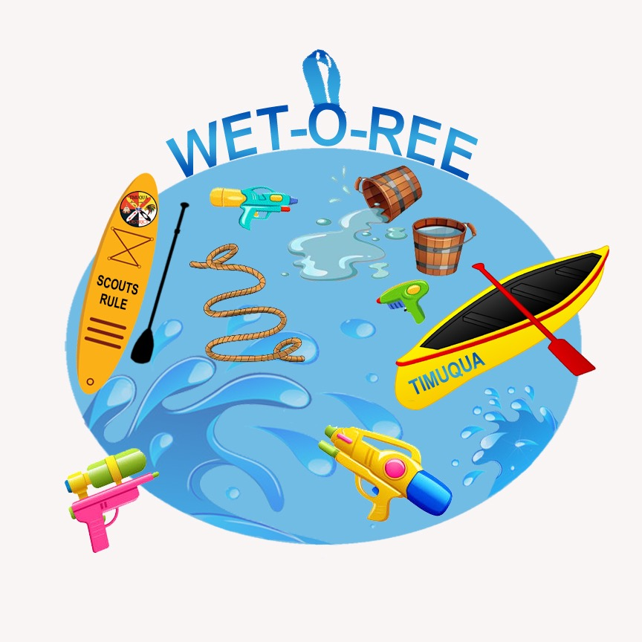
898 Camp Winona Road, Deleon Springs 32130
April 28-30, 2023

| Camporees serve several purposes in Scouting, including:
• The opportunity for patrols to compete while applying leadership, creativity, and Scout skills.
• Providing opportunities for adult leaders to gauge the function of their patrols and youth leadership. Providing examples of engaging outdoor activities that can be shared and recreated.
• The goal for Scouts attending this camporee is that they will have fun while developing their leadership and problem-solving skills and understanding of the patrol method. As a result, they will be more confident and increase their participation in patrol and troop leadership.
Additional Safety Guidelines
• Troops should have First-aid kits available.
• It is highly recommended that scouts pack sunscreen and insect repellant for this camporee (see packing list in Handbook #13, pg. 268)
• In case of severe weather, the Dining Facility will serve as shelter.
Arrival, Parking, and Equipment
As you enter the parking area, there will be a tent with a scout posted. The Scouts directing traffic.
Once check in is complete, your campsite assignment will be provided to you. Campsites will be assigned based on preference indicated on your registration on a first come, first serve basis. Units will be directed to the parking area, where the Scouts and their equipment may be unloaded. One tow vehicle and trailer will be allowed to go to the camping area. That vehicle may stay in the campsite for the duration of the weekend.
All parking shall be in the designated parking area only. Minimizing vehicles in the camping area improves the outdoor experience for all, improves safety, and reduces damage to the unimproved ground.
This Spring Camporee Theme is “Water Games”
Scouts will utilize the Patrol Method while competing in fun and engaging activities that reflect their leadership and problem-solving skills and understanding of the patrol method. As a result, they will be more confident and increase their participation in patrol and troop leadership.
Fees and Costs
The fee for camporee is $0 per participant. Cost of Food per troop, and any troop wanting to use any of the cabins. (contact Walter Ritterbush email: buffalosr398@gmail.com for information first come first serve) Tent camping is free. Cabins sleep 14, cost is ?
Registration https://scoutingevent.com/083-TimuquaDistrictSpringCamporeeWateroree

Camporee Location
The camporee will be held at Camp Winona in Deleon Springs.
• Waste water shall be disposed of on-site following BSA policies.
• Ground fires are permitted only in approved sites. Please follow guidelines posted at firewood stack shelters. Units may provide camp stoves, back packing stoves, gas grills or other portable cooking capabilities. Units will provide their own fuels and fire protection equipment. BSA fire safety standards will be enforced.
Check-In
Since units may have diverse scheduling constraints, units may check in on Friday evening or Saturday morning. See the general schedule. Upon arrival at the camporee site, the unit must send an adult leader to the check-in tent in front of the main building. To participate in camporee, units must have the following:
1. At least one youth leader.
2. At least two-deep adult leadership. All leaders with current Youth Protection training.
3. Current BSA medical forms for all participating youth and adults. Units will keep the forms.
4. Roster of participating youth and adults, including points of contact in case of emergency. Units keep one copy and provide one copy to the camporee registrar at check-in. While a new swim test is not required (last’s year’s Summer Camp swim test should still be valid), please indicate on the Participant form the participant’s swimming status. The Participant form is attached.
5. Planned departure time. Saturday evening or Sunday morning?
At check-in, units will receive the following:
a. A hard copy of the Leader’s Guide.
b. A copy of their patrol(s) schedule for the following day, scoring sheet.
c. Invitation to Cracker-barrel leadership meeting.
d. Two evaluation forms. One should be filled out by the youth, and one by the adults. We encourage feedback and will take completed forms at check-out.
e. Campsite check-out checklist. A Scout is Clean and we want to be good stewards of the camping areas. Units will fill out the form as they prepare for departure.

Check-Out
Since units may have diverse scheduling constraints, units may check out on Saturday evening or Sunday morning. See the general schedule. When ready to depart, the unit must ensure that the campsite is properly cleaned up and all participants, equipment, and trash are taken out. Use the campsite check-out checklist as a guide. Ask the youth and the adults to complete the evaluation forms. To check out, an adult or youth leader must take the campsite check-out checklist and the two evaluation forms to the Check-Out tent.
Youth Protection Training Required for Adults
All registered scouters listed on the adult roster who will be staying at camp more than 24 hours must have a current Youth Protection Training Certificate. Certification is valid for 2 years and must be current through the scouter’s entire time at camp. This requirement is to be verified by the Scoutmaster before camp.
Medical Information Form
Troops must have completed medical forms (Part A&B) along with copies of the front and back of insurance cards for all participants (youth and participants) attending Camporee.
Medications
Troops will be responsible for taking care of any prescription medication required for youth participants.
Code of Conduct
Participation in this camporee requires only a few rules:
• Youth Protection and Guide to Safe Scouting
• The Scout Oath and Scout Law
• Leave-No-Trace Ethics and the Wilderness Code
• Fire Safety, Tote-n-Chip, and Cyber Chip
• Follow applicable laws and restrictions. Use of open flames may be restricted based on local or state-wide weather restrictions.
• Use of tobacco products within view of Scouts is prohibited by BSA rules. Adults needing to partake should retire to their vehicles.
Failure to comply with these rules may result in the individual or the unit being asked to leave the camporee event.

Uniforms Field Scout
Uniforms are encouraged to be worn during arrival and departure, color ceremonies, campfire, and Scout’s Own. Activity uniforms may be worn during patrol competitions, games, and other activities. Appropriate swimwear for boys, Girl’s swimwear one piece bathing suit and with shorts. Arrowmen are encouraged to wear their sashes when appropriate.
Electronic Communications
Like a sharp Scout knife, today’s smart phones can be great tools. We encourage Troops to set their own policy for electronics use and expect unit leaders to monitor smart phone use to ensure that phone use does not detract from the Camporee experience and follows appropriate use.
Photography and Social Media
We encourage Scouts to take pictures while at Camporee and share them on social media. We will also be using the Timuqua Facebook group page where pictures can be shared. Again, we encourage and stress the importance of the appropriate use of technology.
A Special note about the Patrol Method
It is encouraged for each patrol to have a flag, a yell, and an activity uniform of their choosing to show unity as a member of a patrol.
Leadership Meeting and Cracker Barrel
On Friday evening, we encourage all units to send at least one youth and adult leader to the leadership meeting. At this meeting, we will review the following:
• Update of schedules and activities
• Details of patrol competitions and games, including schedules and locations
• Details on campfire participation and unit contributions, skits, etc.
• Weather updates and safety review
Visitors for the day
Are welcome at our camporee It is encouraged to invite that new Webelos, family member, or a friend who may want to join your troop. Visitors must be invited by a unit and should stay with the unit members during their stay. All visitors must check in and check out at the Scoutmaster’s Lodge.

Campfire Program
Singing songs, acting in skits, and telling stories. Scouting campfires are special. They are one of the most memorable parts of Scouting. Each unit is encouraged to offer to lead a song, put on a skit, or tell a funny or solemn story. Youth leaders should obtain approval for their contribution by their Scoutmaster. If a unit wishes to perform at the campfire, they must inform the host unit at the Scoutmaster Lodge by 3:30 pm on Saturday.
A Scout Is Reverent
Duty to God is part of Scouting. Camporee supports individual and unit needs for performing your duty to God. Camporee offers two check-in and two check-out times to accommodate all needs. While some units are very active in their religious activities, there are other Scouts who have little contact with religion. Scout’s Own services are one way to offer an opportunity to all. Therefore, we encourage all units to participate. Scouts are encouraged to wear their full field uniform. Camporee offers a non-denominational, Christian-oriented, simple religious service. Units are invited to conduct their own services should they need special content. If any unit will not participate in a Scout’s Own, we request that they remain in their camp and maintain quiet so as not to disturb others.
Camporee Activities and General Schedule
We encourage maximum participation in this year’s Spring Camporee! There will be times for challenges, times for fun and games, times for ceremonies, and time for just relaxing. Here is the general schedule showing the major activities. Final details will be provided at Friday’s Leader Meeting and Saturday’s Opening Ceremony

Water-o-ree Schedule
Friday, April 28, 2023
• 4:30-8:30 pm Arrival and Check-In
• 9:00-9:30 pm Leader Meeting and Cracker-Barrel (SM, first ASM, and SPL required) at the Head quarts Facility.
• 11:00 pm. Taps, Quiet time
Saturday, April 29, 2023
• 6:30 am Reveille
• 6:30-8:00 am Breakfast and Cleanup
• 7:30-8:30 am Arrival and Check-In available
• 8:00-8:30 am Colors, Opening Ceremony, and Announcements
• 9:00am-12:00 pm Patrol Activities
• 12:00-1:00pm Lunch and Break
• 12:45 pm Patrol Leaders Meeting at the Flagpole
• 1:00-3:30 pm Patrol Activities
• 3:30 pm Campfire participation due to Staff Member
• 3:30-5:00 pm Scavenger Hunt
• 3:30 Camp Wide Games water front
• 5:00 pm Scoutmaster Stand-Up Paddle Board Race
• 5:00 – 8:00 pm Dinner
• 7:00 - 7:15 pm Cooking competition judging at the Headquarters
• 8:00 - 9:30 pm Campfire and Awards Ceremony
• 9:30pm Patch Trading and OA Cracker Barrel at host troop
• 3:30-5:00 pm Scavenger Hunt
• 9:00 – 9:3030 pm Check-Out and Departure available
• 10:00 pm SPL Meeting Headquarters
• 11:00 Taps, Quiet Time
Sunday, April 30, 2023
• 6:30 am. Reveille
• 6:30-8:30 am. Breakfast and Cleanup
• 8:30-8:45 am. Colors, Announcements, and Closing Ceremony
• 9:00-9:30 am. Scout’s Own Service
• 9:30-11:59 am. Clean up and Pack up, Check-out and Depart

Patrol Activities
Patrols will participate in ten round-robin competitions. There will be awards for each competition and the overall winner. A general description and location of each event is listed below; the activities may be modified. In the case on inclement weather, the waterfront activities will be altered. Any changes or updates to the events, will be discussed at the SM/SPL Meeting. Patrols will be given a sequence in which they must complete the activities.

Patrol Flag Contest
Bring your Patrol Flag to Headquarters at lunch time for a judging contest, (should have name on it and all patrol members on stave}
Scoutmaster Stand-Up Paddle Board Race
Calling all Scoutmasters! Have a little friendly fun at the waterfront and race your fellow Scoutmasters. Troops are encouraged to come cheer on their Scoutmaster. This is a direct competition event with the winner being recognized at the campfire/awards ceremony. In addition, patrols whose Scoutmaster participates in the event will receive additional points toward the overall award.
Scavenger Hunt
The rules of the Scavenger Hunt will be announced at the post lunch Patrol Leader meeting on Saturday. To participate, your Patrol Leaders will need to attend.
Open Invitation Cooking Competition-
Guidelines and Rules: Bring one cooked dish. Be ready to share your recipe! Cooked dishes are to be in the Camp Headquarters at 6:45. Judging will begin promptly thereafter. The Staff will provide the judges. We wish to encourage the use of Dutch oven cooking as well. Meals will be judged based on Presentation, Edibility/Flavor.
NOTE: Each patrol is only allowed one entry for this competition.
Patrol Games:
Walt’s tub challenge Bucket brigade Water Race Jellyfish
Up creek without a paddle Rainy day Sightless sailors Plop Plop Fizz Fizz
Extreme basket weaving Patrol one paddle.
Troop Games:
Scavenger hunt for golden nuggets Cooking contest Patrol flag contest Scoutmaster paddle board

Camp-o-ree Check-Out Form
How many adults _______, youth leaders _______, Scouts _______
- Camp Site Check-Out a
- [ ] All unit equipment removed .
- [ ] All fire areas cleaned up.
- [ ] All trash taken out of camp.
- [ ] Water use areas cleaned up.
- [ ] All campsite equipment (tables, fire rings, logs) replaced where found.
- [ ] All vehicles removed from campsite (except parking lot)
Office
a[ ] All payments complete
b. [ ] Evaluation Forms delivered
c. [ ] Patches picked up
Departure
a. [ ] All scouts have rides, following BSA standards for safety and youth protection

Resource Development
a. Ideas for next camporee __________________________________________________________________________________________________________________________________________________________________________
b. When should the next camporee be? ____________________________________________________
c. Where should the next camporee be? ____________________________________________________
d. Would you help on a future camporee? Name and contact info. __________________________________________________________________________________________________________________________________________________________________________
What can we do differently? _________________________________________________________________________________________________________________________________________________________________________________________________________________________________________________________________________________________________________________________________________________________________________________________________________________________________________

Check in Form
Unit #______________ Boy_______ Girl______ Crew _____ SHIP______
SPL: Swimming Status
Name:_________________________________________ N B S
Patrol Name:
Patrol Leader:
Name: _________________________________ N B S
Scouts: _________________________________ N B S
_________________________________ N B S
_________________________________ N B S
_________________________________ N B S
_________________________________ N B S
_________________________________ N B S
_________________________________ N B S
_________________________________ N B S
Patrol Name:
Patrol Leader:
Name: _________________________________ N B S
Scouts: _________________________________ N B S
_________________________________ N B S
_________________________________ N B S
_________________________________ N B S
_________________________________ N B S
_________________________________ N B S
_________________________________ N B S
_________________________________ N B S
N- Non-Swimmer/ B - Beginner / S – Swimmer Make as many copies as needed.

