Come have a SUPER Time!
Powhatan District Cub Scout Day Camp 2022
SUPERHEROES!

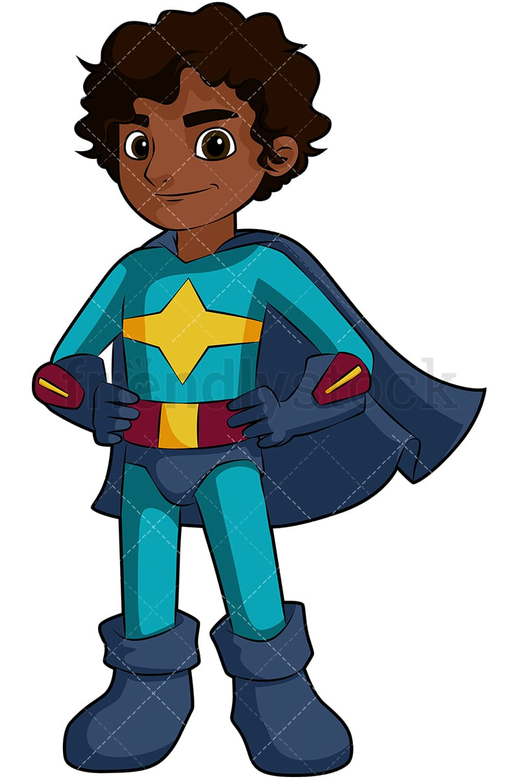

When: Monday June 13 – Friday June 17, 2022
Time: Monday to Thursday, 8:45 am to 4:15 pm, Friday 8:45 am to 1 pm
Where: Algonkian Regional Park, 47001 Fairway Drive, Sterling, Virginia 20165

Why: Because it will be fun!!! Come shoot a bow and sling a shot. Learn new scout skills, and enjoy nature (maybe even fish?). Participate in S.T.E.M. activities and make a memorable craft. Enjoy two afternoons swimming at Volcano Island Water Park! Though not specifically achievement oriented, Cub Scouts can earn advancements, shooting sports awards and other achievements during camp.

Who: Tiger through Arrow of Light Cub Scouts are eligible to attend day camp. Each Tiger Cub must have an adult partner attend camp with them each day. For all other ranks, one adult ‘den walker’ per every five Cubs is required to escort the campers between areas.
How to Register: Through your pack or individually! Powhatan has a hybrid pack registration/parent registration process. Each pack will have a Day Camp Coordinator and you should check with your pack as to your pack’s process. To take advantage of NEW online forms, registration can be done by parents directly. Online registration is NOW open. Check with your Day Camp Coordinator, Cubmaster or Committee Chair to organize den walkers for your Cubs. Register by May 15 for early bird pricing of $190 per Cub (no charge for den walkers).
Sign up now at GoToDayCamp.org by locating Powhatan District Cub Scout Day Camp on the dates of the camp. That link will take you directly to the registration page.

Want a FREE registration? Adult parents/guardians serving full-time (all five days) on Camp Staff get one free registration for their Cub Scout! Youth staff aged 14 or over registered with Scouts, BSA can be recommended to earn a $100 NCAC-BSA Camp credit (i.e., Goshen, NYLT offered by NCAC) OR Service Hours if they serve on staff full-time!

HAVE QUESTIONS? Contact Nicholas Britton, Camp Director at nlbscoutncac@gmail.com, or Nancy Nunan, Program Director at Nancy.Nunan@gmail.com for more information.

