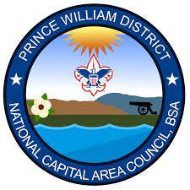
2022 PRINCE WILLIAM DISTRICT
PINEWOOD DERBY
INSPECTION CHECKLIST

Name: | Circle one: Lion / Tiger / Wolf / Bear / Webelos / AOL / Open / Outlaw
Pack: | Car Number:

INSPECTION REPORT:
PASS FAIL

Maximum Overall Width: 2 ¾”
Maximum Length: 7”
Maximum Height: Not to exceed 4”
Minimum Track Clearance: ⅜”
The front of the car does not extend beyond the starting point
Official BSA Pinewood Derby Kit: finished car was not purchased. (Except Outlaw Class Derby Cars)
Springs/Starting Devices: The car is free rolling
Wheels & Axles:
- Official BSA wheels are being used. (Except Outlaw Class)
- All 4 wheels touch track at all times.
- Use precut axle slots
- Wheels are free from alteration
Lubrication: No liquid lubricants are used
Parts Securely Attached: all parts are securely attached to the car
Maximum Weight: car is not to exceed 5.00 ounces
Weight of car:_____________________
Car Numbering: Car Number is assigned and attached to bottom
Inspected by:________________________ Date:______________

