National Capital Area Council
University of Scouting – 2021

Guide to Using Zoom

Table of Contents
Introduction 2
System Requirements 2
Setting up an Account & Downloading the Meeting Client 3
Logging In 5
Joining a Meeting 6
In the Meeting 10
Conclusion 12

Introduction

What is Zoom!

Zoom is an online audio and web conferencing platform. It unifies video conferencing, simple online meetings, and group messaging into one easy-to-use platform. The National Capital Area Council uses use for meetings and the training of youth and adult leaders.

Why use it for Scouting?

Due to the COVID-19 Pandemic, units needed to find a solution to continue their program. Zoom provided the ability to have virtual face-to-face meetings. The use of online video/audio conferencing make meetings and communications easier.

This manual will help you to understand how to use Zoom to for the University of Scouting, as well as Scout meetings. It is by no means a complete guide to Zoom, but it should give you sufficient information to use the basic functionality. For further information, The Zoom website provides videos and an on-line help guide.

Before you jump into using Zoom, here are a few helpful things to know.

- Zoom will work as a web-based application that works in most web browsers; or you can install the Zoom application.

- Zoom is platform independent. This means you can use it with Windows, Mac, Linux, Apple phones, Android phones and even Blackberry phones.

- Zoom offers a few online resources to provide help and insights about their tools and features. Check out the searchable Zoom Help Center if you want to learn how something works, or if you run into any trouble.

For the University of Scouting, we will use Basecamp for messaging information and document sharing. We will also continue to share information, concerning the training through email this year.

System Requirements

Hardware Requirements

- A Broadband Internet connection – broadband wired or wireless
- Speakers and a microphone – built-in or USB plug-in or wireless Bluetooth
- A Webcam

Supported Operating Systems and Browsers:

- MacOS X with MacOS 10.7 or later
- Windows 10, 8, 7, Vista, XP
- Linux
- ChromeOS, through a Web Browser
- Supported Tablet and Mobile Devices
- iOS and Android devices
- Blackberry devices

Supported Browsers:

- Windows: IE 11+, Edge 12+, Firefox 27+, Chrome 30+
- Mac: Safari 7+, Firefox 27+, Chrome 30+
- Linux: Firefox 27+, Chrome 30+

Desktop/Laptops:

- Web-based - The Zoom web client allows joining a Zoom meeting or webinar without downloading any plugins or software. However, the web client has limited features and functions best on Google Chrome.

- Software-based – The Zoom desktop client can be downloaded from Zoom. Once downloaded run the installer application.

Mobile:

iOS (Apple )

- iPhone4 or later, iPad Pro, iPad Mini, iPad 2 or later, iPod touch 4th Generation
- Operating System – iOS 7.0 or later
- Web Browser – Safari5+, Chrome
- Zoom Cloud Meetings app (available on the App Store)

Android

- Operating System – Android 4.0x or later
- Web Browser – Chrome, Edge, Fir
- Zoom Cloud Meetings app (available on Google Play)

Blackberry

- Download the Zoom app from the BlackBerry World.

Setting up an Account & Downloading the Meeting Client

Click here to set up a Zoom account. You can also sign up with a Google or Facebook account, instead of providing your email address.

When you sign up for a Zoom account with your email address, Zoom will send you an activation email. When you receive the activation email, click the link to activate your account. If you use an email address, remember the email you used, as well as your password.

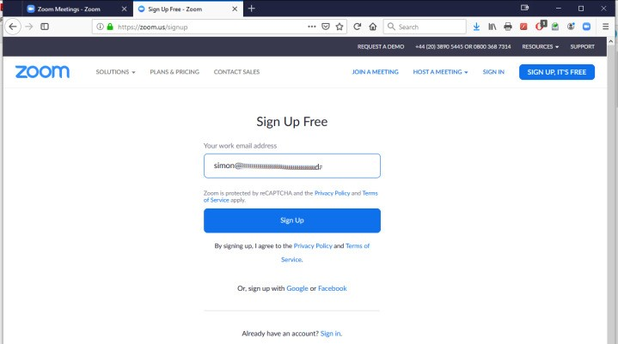

Download and Install the Zoom Meetings Client

You will need to download the Zoom Meetings Client from https://zoom.us. Scroll to the bottom of the page. Click on the Meetings Client link under the Downloads section of the menu.
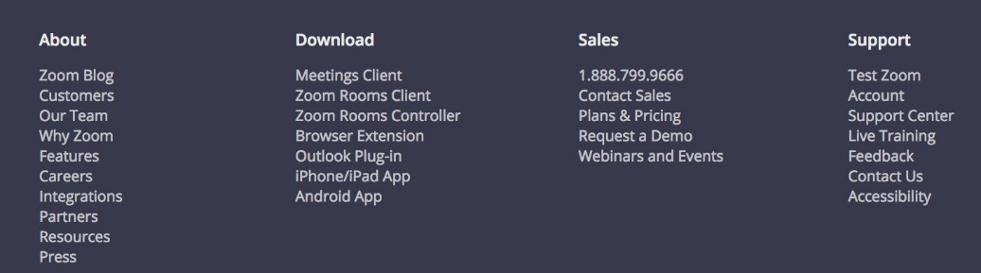

You will be redirected to another webpage to download Zoom Client for Meetings, as well as other Zoom products. Today, we are only going to download Zoom Client for Meetings. Click on the Download button and Zoom will determine your Operating System and download the file for you.

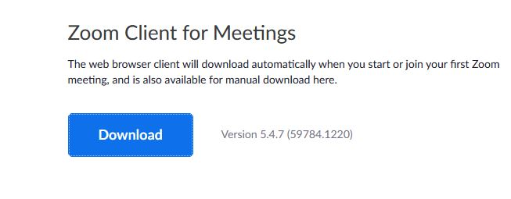

After you click on Download, you should see a pop-up window such as the one below. The graphic below is from the Windows Operating System. Apple and Linux downloads will look different. Click on save file and remember where you downloaded the file to. It will generally appear in your Downloads folder unless you tell it to install elsewhere.
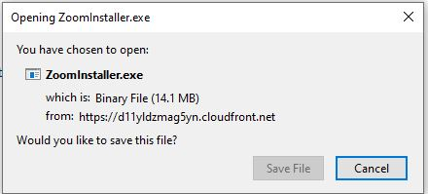

Click on the ZoomInstaller to begin the installation. Follow the on-screen instructions.

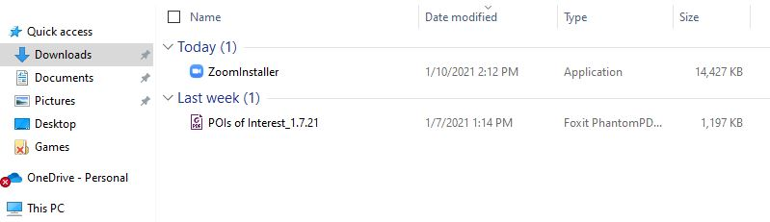

Logging In

Open the Zoom Meeting Client. The icon for Zoom, if you installed a shortcut on
your Desktop will look like this:

Click Sign In.

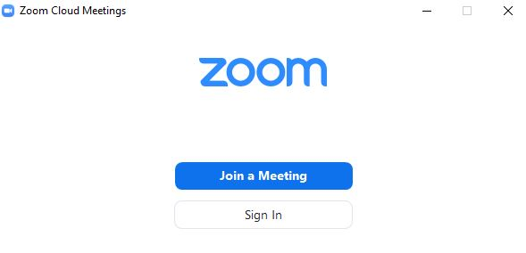
Sign in using your email and password, or with Google or Facebook, if you used that in step 1A..

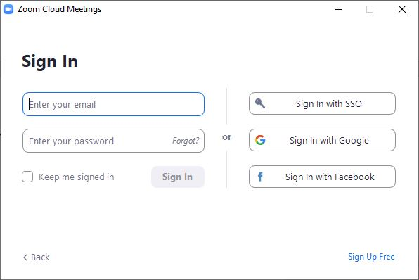

Once signed in you should see a pop-up window like the one below:

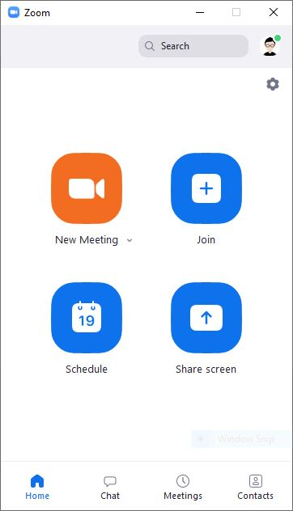

Joining a Meeting

For the University of Scouting, we will provide the Instructors and the Participants with unique links for each course. The links for the courses will be provided in a Basecamp document, as well as in in each Class’s folder. We will also email the link document to everyone at least a week before the University begins. We will also include the Meeting ID number, which you can use from the Zoom application or the Zoom website.

In this section, we will look at how to join a meeting through the Basecamp link, or by using the Meeting ID.

Each meeting has a unique 9, 10, or 11-digit number called a meeting ID that may be needed to join a Zoom meeting, if asked.

Clicking on the link

For the University of Scouting email link or Basecamp document, you will click on the link, for your class. It will open up your Zoom application and take you straight to the class.

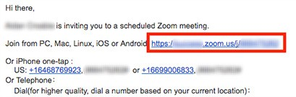

Web Browser

If you don’t use the application, open your internet browser (Edge, Internet Explorer, Firefox etc.)

Go to https://join.zoom.us.

Enter your meeting ID provided in the Basecamp document and click join.
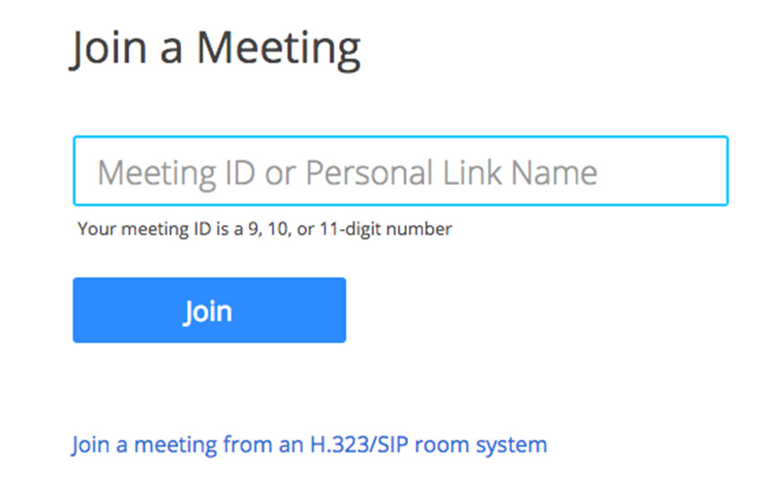

Zoom Application

Open the Zoom desktop client.

Join a meeting using one of these methods:

Click Join a Meeting if you want to join without signing in, Instructors must sign in with their names.

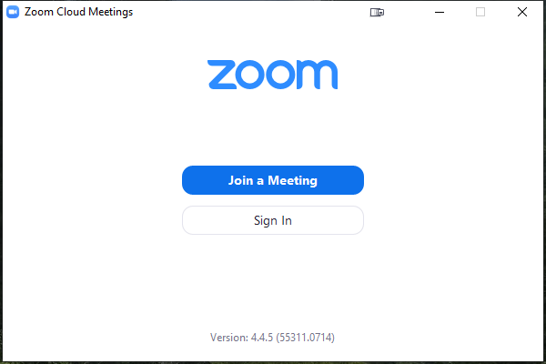

Sign in to Zoom and then click Join

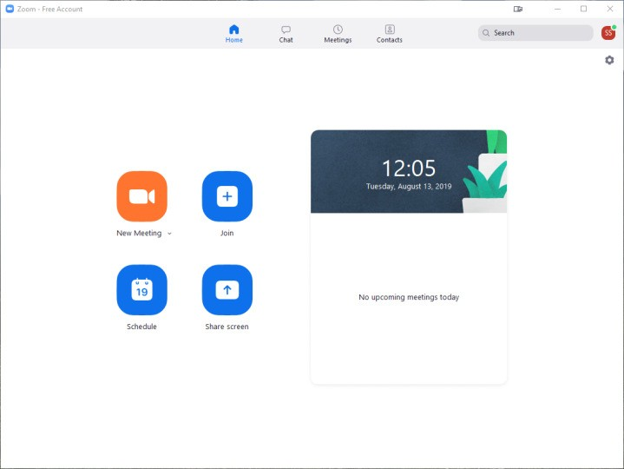

Enter the meeting ID number and your display name.

If you're signed in, you will have a default identity, but you can change your name if you don't want your default name to appear.

If you're not signed in, enter a display name, then click join.

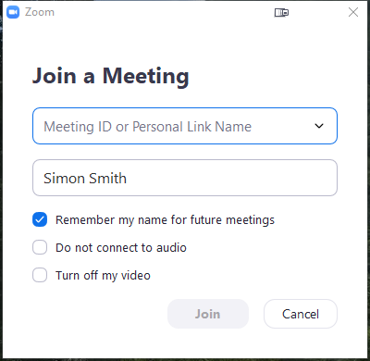

Mobile Devices

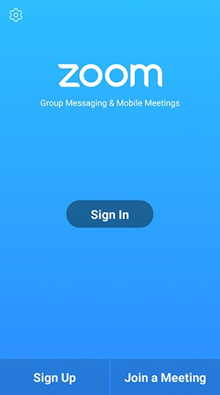
Android

Open the Zoom mobile app.

Sign in, then tap Join a Meeting.

Sign in to Zoom then tap Join.

Enter the meeting ID number and your display name.

If you are signed in, change your name if you do not want your default name to appear. If you are not signed in, enter a display name. Select if you would like to connect audio and/or video and tap Join Meeting.
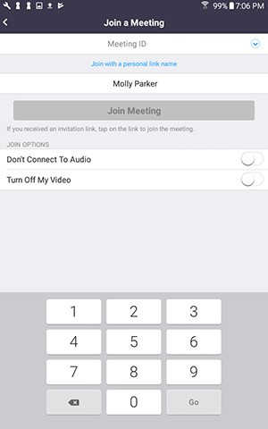

Apple

Open the Zoom mobile app. Sign in, then tap Join a Meeting.

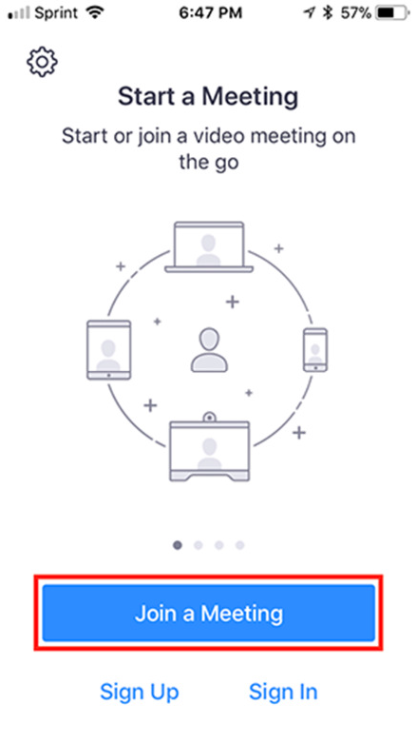
•

Enter the meeting ID number and your display name. If you're signed in, change your name if you don't want your default name to appear.

Select if you would like to connect audio and/or video and select Join.
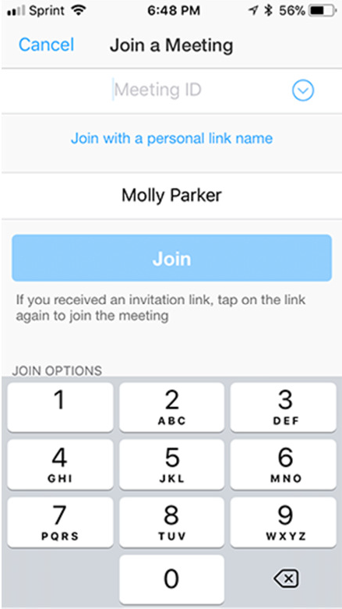

In the Meeting

Once you have started or joined a meeting, you can access the meeting controls located at the bottom of the meeting window (move your mouse in the Zoom window to display meeting controls).

Overview

Host controls allow you, as the host, to control various aspects of the Zoom Meeting, such as managing the participants. Hosts, who are using the desktop Zoom application, and some of the Mobile Device applications, have access to the following controls during a meeting:

- Start closed captioning and assign someone or a third-party to provide closed captioning
- Allow participants to enter the room
- End meeting for all participants
- Make another participant or presenter a co-host
- Start breakout rooms or move participants from one breakout room to another
- Start waiting room (co-hosts can place participants in waiting room or admit/remove participants from the waiting room)
- Record the presentation

The host controls will appear at the bottom of your screen if you are not currently screen sharing.

Mute/Unmute: This allows you to mute or unmute your microphone.

Audio Controls (click ^ next to Mute/Unmute): The audio controls allow you to change the microphone and speaker that Zoom is currently using on your computer, leave computer audio, and access the full audio options in the Zoom settings.

Start/Stop Video: This allows you to start or stop your own video.

Video controls (click ^ next to Start/Stop Video): If you have multiple cameras on your computer, you can select which Zoom is using, access the full video controls, and select a Virtual Background.

Invite: Invite others to join your meeting.

Manage Participants: Opens the Participants window.

Polling: Allows you to create, edit, and launch your polls. The options to create or launch polls will open up the Zoom web portal in your default browser.

Share Screen: Start sharing your screen. You will be able to select the desktop or application you want to share.

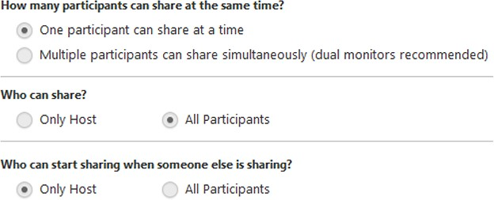
Screen Share controls (click ^ next to Share Screen): Select who can share in your meeting and if you want only the host or any participant to be able to start a new share when someone is sharing.

When you are screen sharing, the controls will appear at the top of your screen, but you can drag it to another location.

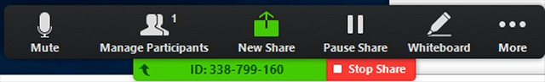

Chat: Access the chat window to chat with the participants.

Record: Start or stop a cloud or local recording.

Closed Caption (only available to the host): If you have enabled closed captioning for your account, click here to access the closed caption options.

Breakout Rooms (only available to the host): Start breakout rooms.

End Meeting (only available to the host): This will end the meeting for all participants. If you want to have the meeting continue, you should give another participant host control before leaving the meeting.

Conclusion

This guide is not a complete guide to Zoom, but it is designed to get you started and able to host or attend an online meeting. The Zoom website zoom.us has extensive online videos and use guides.

Please see the following links here, or on Basecamp for more information:

Zoom’s Official Getting Started Guide
Helpful troubleshooting from Zoom
How To Join a Zoom Meeting

ZOOM for Dummies!
- Downloading Zoom: 1:02
- Starting/Joining a meeting: 1:29
- Microphone and camera issues: 2:50
- Audio and Video features: 4:00
- Gallery v. Speaker view: 5:40
- Snap Camera: 6:34

ZOOM for Beginners | SCREEN SHARE AND MORE
- Recording a Zoom Meeting: 1:20
- Default Recording Setting: 2:15
- Screen Sharing: 3:00
- Moving the Task Bar/ task bar blocking tabs: 4:15
- Screen Sharing Videos: 5:05
- Hiding Meeting Controls: 5:25
- Giving a Participant Screen Share Permission: 5:45
- Waiting Room Permissions: 6:20
- Zoom Time Limit: 7:35
- Viewing Meeting Info (meeting ID, password, link): 8:54
- Expanding gallery view to 49 people: 9:21
- Spotlight your video: 9:47
Sharing Your Screen
Meeting Controls
Breakout Rooms
Zoom Whiteboard
Recording a Zoom Meeting
Polling in Zoom Meeting
Securing Virtual Meetings for Scouting

All the details within this guide are taken from my experiences of using Zoom, as well as best practices from other Adult Scout leaders, and other non-profit organizations. There are other features that I have nor included, but this manual should give you a good basic understanding of the Zoom Conferencing system.

If there are any questions or sections that you would like adding to this guide then please feel free to contact me.

Christopher Cooper
Christopher@Cooper3000.com

