April 22, 2020
50th Anniversary of Earth Day
7:00 PM: William T. Hornaday Gold Medal Keynote
Eagles as the Messenger: How we use Sea Eagles to Monitor the Health of the Planet
sign up to get the ZOOM link (free) for this talk: https://scoutingevent.com/082-earthday
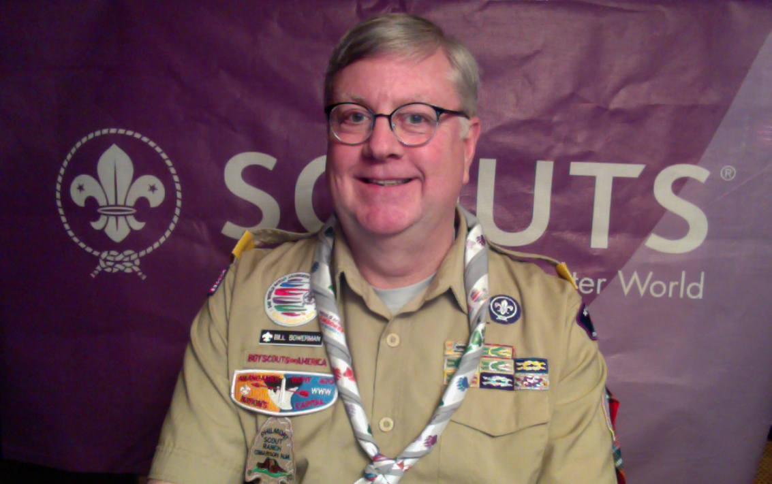
1Dr. William W. Bowerman, Professor and Department Chair of Environmental Science & Technology, University of Maryland

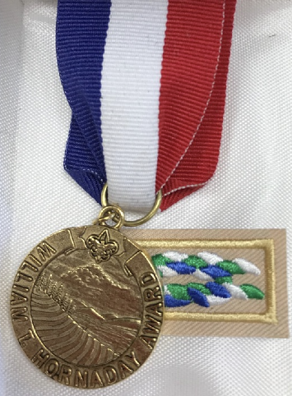
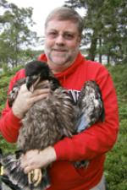
Dr. William W. Bowerman has been awarded the Hornaday Gold Award, one of the rarest awards in Scouting, and is awarded for distinguished and unusual service to natural resource conservation and environmental improvement over a sustained period (at least 20 years). Dr. Bowerman has over 35 years of work on conservation of bald eagles and other birds of prey on five continents. He served for 18 years on the International Joint Commission, Great Lakes Science Advisory Board, including 3 years as United States Co-Chair. Bowerman's Scouting achievements include Eagle Scout, Vigil Honor, NESA Outstanding Eagle Scout Award, and Silver Beaver Award. He has served as an adult leader in Cub Scouts and Boy Scouts, including service at the District and Council levels, currently NCAC's Vice President of Outdoor Adventure. He is a National Fellow of The Explorers Club.

