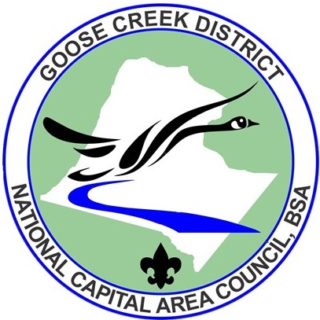
Goose Creek District
2020 Spring Camporee
March 27-29, 2020

Camp Highroad
Middleburg VA

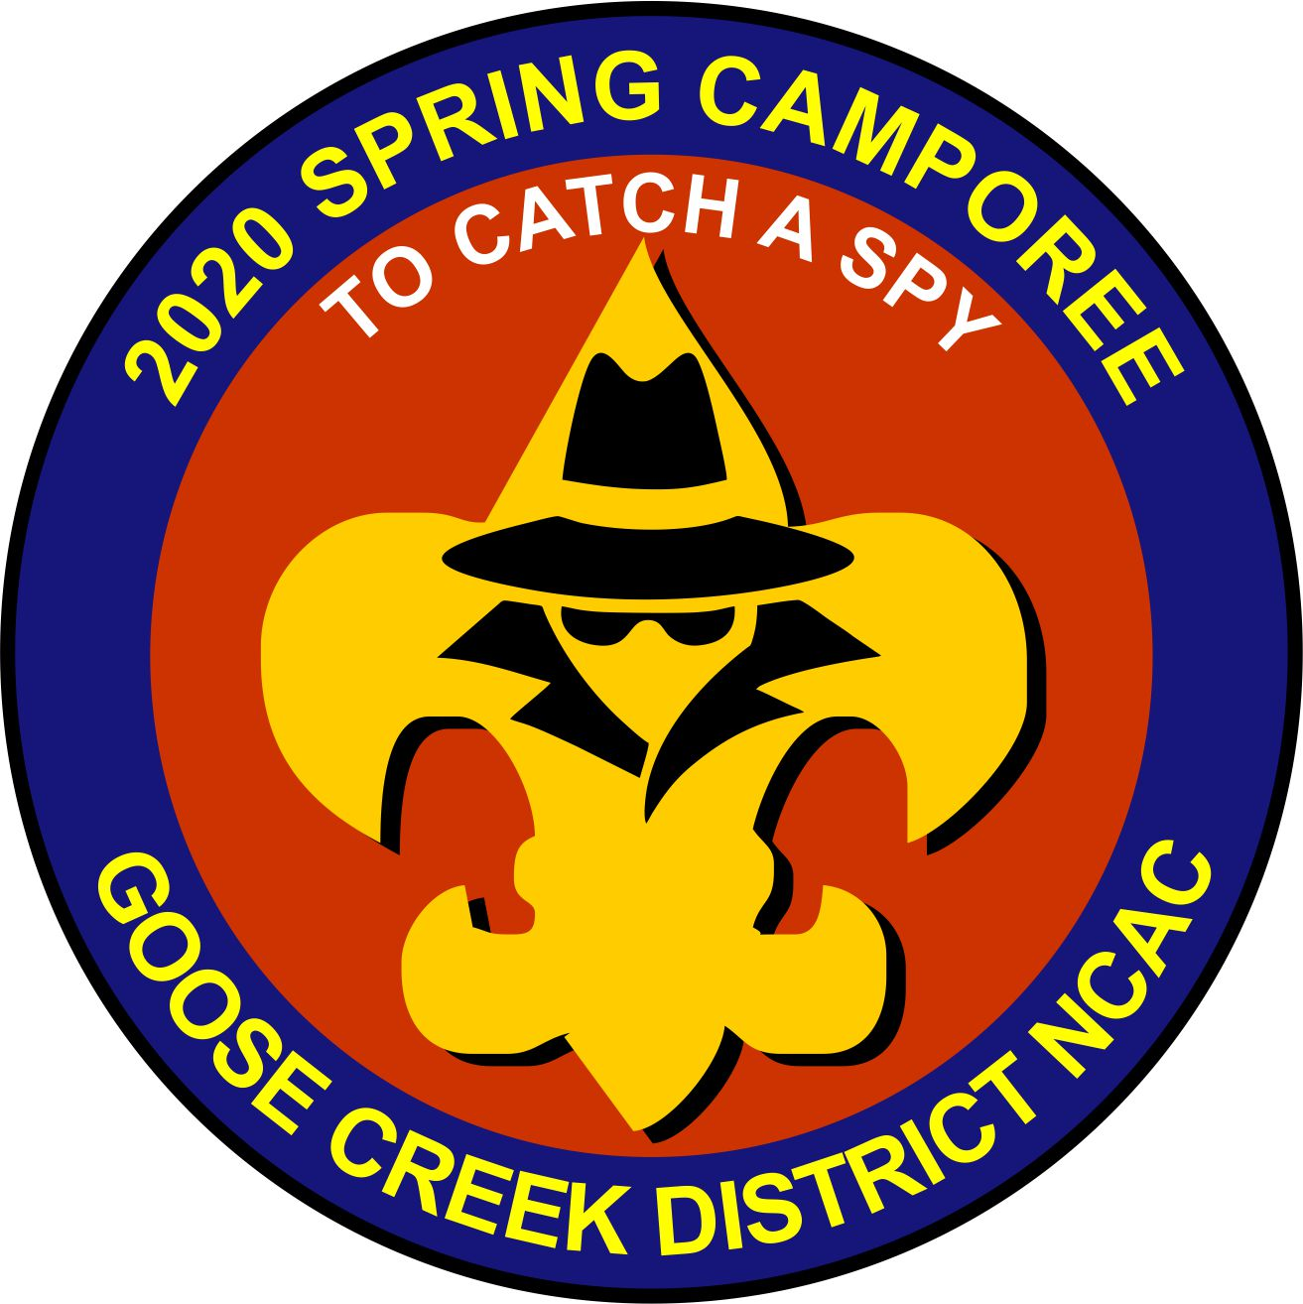

Camporee Leader Guide
FINAL¹ version, 01/26/2020

Camporee Director
Charles Thornton, 571-420-1035, scouterchalis@gmail.com
Table of Contents

Introduction 3
Registration 3
Camporee Administrative Details 3
What to Bring and Not Bring 4
Camporee Safety Requirements 4
Check-In Procedures 4
Camporee Leaders Briefing/Cracker Barrel 5
Camporee Daily Schedule 5
Patrol Challenge Event 6
Adventure Choice Activities 7
Special Program Features 9
Check-Out Procedures 9
Additional Information 9
Emergencies 10
Camporee Staff 10
Camporee Site Map 11
Directions to the Camporee Site 11

Introduction
The 2020 Goose Creek District Spring Camporee will occur at Camp Highroad, Middleburg VA, from Friday, March 27th to Sunday, March 29th, 2020. The Camporee Patrol Challenge theme is, "To Catch a Spy." Scouts will earn up to 10 points at each Patrol Challenge station, plus 10 points for patrol flags & yell and 10 more for skit performances at campfire.

The Camporee consists of two major events followed by evening campfire. The first is a Patrol Challenge of six events, held in the morning and again in the afternoon on Saturday. Patrols will compete and earn points at each Challenge station. The second is an Adventure Choice period, also held in morning/afternoon sessions, for Scouts to be able to explore challenging “High Adventure” program activities that interest them. Each Unit will have assigned periods, one event in the morning and the other one in the afternoon, so that all participants have equal opportunity for full participation.

Evening campfire will include an OA callout, skits and songs performed by the patrols.

This event is designed for Scouts BSA Troops and Venturing Crews.

This Leader Guide has the latest information about all Camporee activities, schedules and requirements. Please share with all your Unit Leaders (Adult and Youth) and parents.

Registration
Prior Registration is required from all Units for all parts of the Camporee. The process is consolidated on this NCAC website:

https://scoutingevent.com/082-29340

- All participants (Youth and Adults) must register and pay the Camporee Fee of $24 each online. REGISTRATION CLOSES 7 PM, 03/22/20. This includes all campsite and facility support costs. Food and camping gear are NOT included; units must bring their own.

- Registration and payment for all Adventure Choice activities (optional) hosted by Camp Highroad will also be processed thru this same NCAC website.

Camporee Administrative Details
- Check-In runs from 4:00 to 8:00 pm on Friday, March 27th and opens again from 7:00 to 8:30 am on Saturday, March 28th. Please arrive early!
- Units may bring trailers but there is no vehicle traffic permitted to the campsites, meaning all vehicles and trailers must remain in the designated parking areas.
- Units will receive their Challenge and Adventure Choice schedule at Check-In.
- Adventure Choice wrist bands will also be issued at Check-In.

What to Bring and Not Bring
Tents: Units will camp in one of three campsite areas in the southern end of Camp Highroad. Bring your own tents and equipment. Tents larger than 4-person are discouraged. Leave No Trace principles apply (no trenches, digging, etc.).
Water: Water is available but not in each campsite. Units should bring their own FILLED water containers from home which may then be refilled at the Camporee.
Firewood: Units MAY BRING THEIR OWN firewood (encouraged). It is also available for purchase from Camp Highroad but must be reserved prior to arrival through the registration site. Cost of firewood purchased from Camp Highroad is $25 per bundle.
Unit Gear: See the Scouts BSA Handbook if you need guidance on Unit Gear. Bring your Unit and patrol flags. Also, each patrol will need a tarp large enough to shelter the entire patrol and enough rope to hold it up. Please see the Stake Out activity below for more clues.
Personal Gear: The Scouts BSA handbook also contains a checklist for personal camping gear. During Saturday’s events, all Scouts should carry a lightweight backpack/day pack with the Ten Essentials (see the Scouts BSA Handbook for a list of these).

Camporee Safety Requirements
- Wood or charcoal fires are permitted but only in designated fire rings.
- Potable water is available but must be hauled to your campsite area.
- Participants should always carry their 10-Essentials - water is a must.
- Patrols require two Adult Advisors to be present at all times.
- The Buddy System is in effect for safety at all times.
- All participants must remain in designated Camporee activity areas. All Lodge, Cabin and Personal Residence areas are off limits.
- Weather: March temperatures will be still be chilly, especially in the evenings. Participants must have appropriate layered clothing and a winter sleeping bag. Check the weather forecast before departing from home.

Check-In Procedures
Regular Check-In is between 4:00 pm and 8:00 pm on Friday and 7:00 to 8:30 am on Saturday morning. Upon arrival at Camp Highroad, have your Unit Adult Advisor and Unit Youth Leader Check-In at the registration table near the Archery Range. Registration packets will include a Camporee patch, wrist bands, patrol challenge passports and further instructions. Please pick these Check-In packets before unloading gear or leaving the parking area.
Check-In will include verifying the following information:
- All Payments are Paid in Full. Please make all your Unit’s Choice payments online prior to the deadline of March 21st, 2020. On-site registration is NOT available.
- BSA Permission Forms are required for each Scout. These forms will remain with the Unit (will not be collected) but must be shown to the GCD registration staff at Check-In.
- Complete BSA Medical Forms must be presented for ALL participants to the Camporee at Check-In. All forms will remain in the Unit Adult Advisors’ possession. In case of emergency, the Camporee staff may request these forms from the Unit Adult Advisor.

Camporee Leaders Briefing/Cracker Barrel
Senior Patrol Leaders/Crew Leaders and Unit Adult Advisors are invited to a Camporee Leader Briefing and Cracker Barrel on Friday night, March 28th at 9:00 p.m. We will provide updates on Camporee events and facilities, weather and scheduling. Last minute information may be handed out. Your top leadership should attend but please, NOT your entire Unit.

Camporee Daily Schedule
Note: Schedule is subject to change. Updates will be provided as necessary.

FRIDAY – March 27, 2020
time | Events | Notes
4:00–8:00 pm | Check-In | Registration Tent
9:00–10:00 pm | Leaders Brief/Cracker Barrel | High Ropes Shelter
11:00 pm | Taps | All Campsites
SATURDAY – March 28, 2020
time | Events | Notes
7:00–8:30 am | Check-In for Arriving Units | Registration Tent
7:00 am | Reveille for Encamped Units
7:00–8:30 am | Breakfast and Clean-up | Campsites
8:30–9:00 am | Opening Assembly  Plan of the Day | Flagpole
9:00–12:00 pm | Patrol Challenge – GROUP A  Adventure Choice – GROUP B
12:00–1:30 pm | Lunch
1:30–2:00 pm | Afternoon Announcements | Flagpole
2:00–5:00 pm | Patrol Challenge – GROUP B  Adventure Choice – GROUP A
5:00–7:30 pm | Dinner and Clean-up | Campsites
7:30–9:00 pm | Campfire, Patrol Skits, Awards, OA Callout | The Pond  Arrowmen: wear your sashes!
11:00 pm | Taps | Campsites
SUNDAY – March 29, 2020
time | Events | Notes
7:00 am | Reveille
7:00–8:30 am | Breakfast & Clean-up | Campsites
8:30–9:00 am | Scouts Own Service | Flagpole
9:00–11:00 am | Break Camp and Check-Out | Camp Site Inspection

Patrol Challenge Event
Organizing Your Patrols
Form the participating Youth from your Unit into patrols. 6 to 10 (max). Scouts each is the best size and provides a fair chance to succeed for all Scouts. Organize your Patrol before arriving at the Camporee. Small patrols will be combined with each other on Saturday.

These Patrols participate in a series of six Challenge events. Each Patrol will have a Passport to carry with them and have their score recorded at the completion of each station. Each Patrol will have a specific rotation schedule (shown on the passport) that must be followed. Each event has a 20-minute time limit and a 10-minute transition time between stations. The six events will come from the eight events listed below:

Take Out the Guard (Tomahawk Throw)
Objective: Throw a tomahawk into a fixed target for score.
Procedure: Designated range, Patrol chooses best throwers. Fixed time.
Rules: Designated Safety area, safety rules briefing req’d.

Fire Control
Objective: Build and light a fire to burn thru a suspended string – timed exercise.
Procedure: Use only supplies provided and 2 matches. Clock starts on command, stops when string parts.
Rules: Patrol can only use tinder and kindling in the vicinity (may be collected beforehand).

Open the Vault
Objective: Scouts demonstrate orienteering skills to obtain code to open the lock.
Procedure: Each Patrol must find stakes in the field with the codes in sequence using orientation skills.
Rules: Pacing and compass skills will be necessary.

Sawmill
Objective: Each patrol cuts through a given diameter log safely. Timed event.
Procedure: In relay fashion, group members each cut through a large diameter log.
Rules: BSA Sawing Safety rules must be followed.
Stakeout
Objective: Timed exercise to properly rig a shelter sufficient for the entire patrol.
Procedure: Patrol uses their own tarp and rope to build sufficient shelter for a stakeout.
Rules: Must be rigged properly to Leave No Trace standards, including height off ground.

Laser Maze
Objective: Each patrol member must pass through a web of rope without touching it.
Procedure: Cooperation and planning is key to getting each scout through.
Rules: No dropping scouts! Proper lifting techniques must be used.

Mystery Event
Objective: Timed event to tie knots of rope inside of a box.
Procedure: Patrol offers 3 most advanced knot makers to take turns for fastest tie.
Rules: Non-participating patrol members are allowed to offer help to the contestants.

Team Ski
Objective: Patrol works together to ski through a zig-zag course.
Procedure: Cooperation is key.
Rules: If size of patrol exceeds ski capacity, non-participants may call verbal assists.

The Top 3 Patrol Challenge finishers will be recognized at the Saturday Evening campfire.

Adventure Choice Activities
NOTE: All Adventure Choice Activities require registration and payment in advance. Be sure to specify these choices when registering online.

NOTE: Campsite and facility support costs are included with the registration fee of $24 per participant. Adventure Choice Activities are optional, with fees described below:

The following no- or low-cost activities are offered to ensure all Participants can engage in some form of fun event during the Adventure Choice period:

Archery Range: Open Ranges available for all Participants. Range Safety Officers have absolute control of the Ranges at all times. Units will be limited in time at the range according to the number of those waiting. A Safety Briefing is required. No cost:

Monkey Bridge: A Monkey Bridge will be erected courtesy of Troop 962 and is available for use by all Units. Two Adult Advisors must be present while Youth are climbing. No cost.

The following Adventure Choice Activities are offered at various (heavily-discounted) fees. Participants MUST REGISTER for these events during your Camporee online registration.

Mountain Boarding: A unique sport using skateboards with big, knobby tires to slide down a grassy hill. Go “off-road” on an all-terrain/high-performance board or jump and navigate a cone course. Instruction, boards and safety equipment are provided. 1-hour. Cost: $10 each

Rock Wall: Learn the basics of climbing and enjoy the challenge! Safety equipment is provided, closed-toed shoes are required. NOTE: This activity is at the northern Main Camp and will require car transportation by Unit. 1-hour. Cost: $10 each

Zip Line: This high-flying adventure activity is 40’ tall and 400’ long. 1.5 hours. Cost: $15 each

Team Challenge Course (Low Ropes): This activity builds communication, cooperation and trust by helping groups face challenges as a team. The course is made up of 20+ low level (max 10ft high) challenge obstacles. A 2-hour experience. Cost: $20 each

High Ropes Course: Includes challenges at 20′, 35′ and 45′, an 800′ long zip line, a giant swing, a pamper pole, and a “vertical playpen!” Each level has four challenges to be overcome before moving up. Requires courage, physical endurance and trust. 3-hours. Cost: $30 each

Camporee Rules
The following rules are to help us have a fun and safe camping experience. It is the responsibility of the Unit Adult Advisor in Charge and the Unit Youth Leader to see that all Scouts know and understand these rules. Please don’t put us in a no-win disciplinary situation.

- Participant Behavior: All participants, both Scouts and Adults, will use the Scouts BSA Oath, Law, Motto, and Slogan to guide their actions. Everyone here is for a fun and safe outdoor adventure. Your actions impact the fun of others. Be a positive impact.
- Two-Deep Leadership: All Units attending the Camporee must comply with the BSA policy requiring “two registered Adult Advisors or Adult and a parent of a participating Scout, one of whom must be at least 21 years of age or older, for all trips and outings.” Advisors must have current Youth Protection Training.
- Buddy System - All Scouts are expected to be in the presence of a buddy at all times. At no time should a Scout be more than 30 feet from another Scout. This goes for Adults as well.
- Vehicles: Speed limit is 10 mph on Camp Highroad grounds. No passengers in the back of an open truck or trailer. Vehicles are limited to the main road or parking areas only. No parking in campsites.
- Fires: Open fires (wood/charcoal) are permitted, but only in designated fire rings. All fires and active (lit) stoves must be attended at all times.
- Firearms: Personal firearms, explosives, and fireworks are prohibited.
- Tobacco: The entire Camporee is tobacco free per BSA policies on tobacco use.
- Conservation: Please conserve our natural resources. No digging, trenching, or raking is allowed. Use Leave No Trace principles. Adhere to the Outdoor Code.
- Knives: No straight or fixed bladed knives are permitted (BSA policy).
- Lights out: Scouts are not allowed out of their campsite after lights out except to use the portable toilets. ALL QUIET PLEASE from 11:00 pm to 6:00 am.
- Electronic devices: No electronics of any type, including cell phones, are to be in Scouts’ possession during the day. At the Unit’s discretion, devices may be permitted in the evening within the Unit’s campsite. Adult public use of cell phones should be restricted to ONE Adult who monitors essential Camporee communications and emergency use only. Adults: do NOT set a poor example, please exert self-control and read personal texts and email in camp only.
- Other vehicles: No personal ATV’s, etc., are allowed at the Camporee.
- Pets: Pets (except for trained service dogs) are not allowed at the Camporee.
- Portable Toilets: Portable toilets will be on site. Please keep them clean and useable for others. If you see a mess, please take a moment to clean it up. There is no cleaning crew.
- Campsite Etiquette: Advisors should remind (and enforce) that Scouts DO NOT cut through other Units’ campsites enroute to their own campsite. “A Scout is Courteous.”
- Off limits area: All participants must stay within the Camporee camping and activity areas only.
- Range Safety: When on the tomahawk, archery and shooting ranges, Scouts and Scouters must adhere to all rules governing the ranges. The Range Safety Officer (RSO) is in charge at all times. Disobeying the RSO is a safety hazard and is cause for removal from the range.

Special Program Features
Evening Campfire – a chance to gather, celebrate Scouting traditions, and have fun. Patrols are encouraged to perform skits and will be awarded 10 extra points. The Goose Creek Chapter of the Order of the Arrow will conduct their Ordeal Call Out during the campfire.
Scout’s Own Service - We will have one large non-denominational chapel service Sunday morning by the Flagpole. All Units are invited to the service. In respect for our Duty to God, please avoid interruptions or loud noises in the vicinity during this time.

Check-Out Procedures
- If your Unit is leaving Saturday evening, staff will be available to assist you until 8:00 pm. Please coordinate this during Check-In.
- Regular Check-Out is Sunday morning after the Scout’s Own Worship Service.
- Final Campsite Inspection: Ensure that all your gear is packed and taken with you and the campsite is patrolled for trash. Bag all trash in sturdy bags and leave them at the entrance to your campground.
- Camporee Evaluation. Please help the Goose Creek District volunteers by providing feedback using the online Survey Monkey evaluation. Details coming soon!

Additional Information
Uniforms
The minimum uniform for all Scouts throughout the Camporee will be the Activity Uniform (a.k.a “Class B”) with Scout pants and a Unit t-shirt or a Scout-themed shirt.
The Scout Field Uniform (a.k.a. “Class A”) is the official dress uniform and is to be worn at the Saturday night Campfire assembly and the Sunday morning flags and Scouts Own Service.

Meals
Units are responsible for all their own meals. Each Scout and Advisor provides their own eating utensils/kit; units bring their own cooking and cleaning supplies.

Cooking
Each Unit must furnish its own food, ice, stove, fuel or charcoal. ABSOLUTELY NO UNATTENDED LIT COOK STOVES! Check stoves and fuel lines for leaks before using.

First Aid
Minor first aid injuries should be handled at the Unit level. For major first aid issues, the CAMP HIGHROAD staff is trained and can help. Report major injuries to CAMP HIGHROAD and Camporee staff immediately. If you are unsure of the level, consider it major and act accordingly. Please have BSA medical forms for each person in an easily accessible place, known to all Unit Advisors.

Medications
Units shall maintain all their Scouts medication and supervise their use. Protect medications from loss by locking them in a container.

Toilets
There are portable toilets in the campsites and program areas. Please keep them clean.

Trash/Sanitation
Please keep your campsite clean and use your own trash bags. Bag all trash in sturdy bags and leave them at the entrance to your campsite by 7 pm on Saturday night and again at check out on Sunday morning. NO FOOD IN TENTS.
.
Flags
Each Unit should bring their flags at the camporee. Each patrol should have a patrol flag displayed during the Patrol Challenge and at all Camporee activities.

Emergencies
If severe weather, Lost Scout or another emergency situation occurs at the Camporee, all Scouts and Advisors will be notified and assemble at the Flagpole. All participants will be accounted for and await further instructions from Camp Highroad and Camporee staff. An emergency recall signal procedure will be announced and demonstrated Saturday morning.

Camporee Staff
Here are names and contact info for the principal Camporee staff for this event:

Charles Thornton | Camporee Director | scouterchalis@gmail.com | 571-420-1035
Steve Wolfson | GCD Program Chair | stevewolfson@verizon.net | 703-431-1033
John Blackwell | ADC – Roundtable | john.blackwell@goosecreekdistrict.org | 301-346-0551
Bob Kellogg | ADC – Roundtable | Rbkell497@gmail.com | 703-431-2720
Jon Stuck | OA Chapter Advisor | Jon.stuck@mac.com

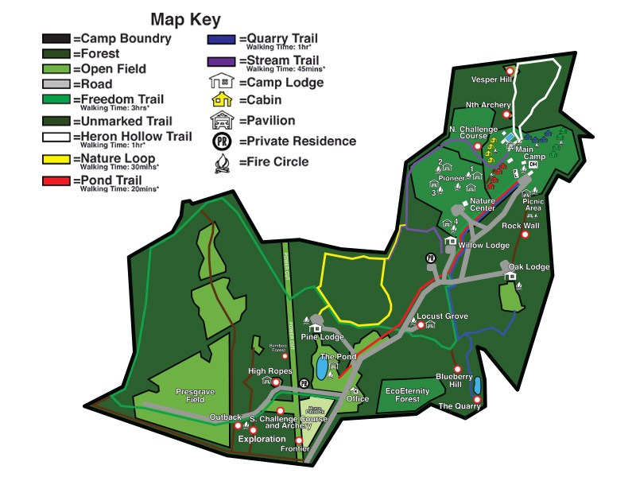
Camporee Site Map

Directions to the Camporee Site

The Camporee site is Camp Highroad in Middleburg VA.

Camp Highroad
21164 Steptoe Hill Road
Middleburg VA 20117
(540) 687-6262

Directions from Leesburg:
Take US-15 south for 4.5 miles, turn right onto State Route 733 and go 4.8 miles, turn right onto State Route 763 and go 0.7 miles, turn right and follow signs into the camp.
21164 Steptoe Hill Rd
Middleburg, VA 20117

