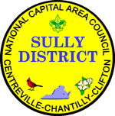
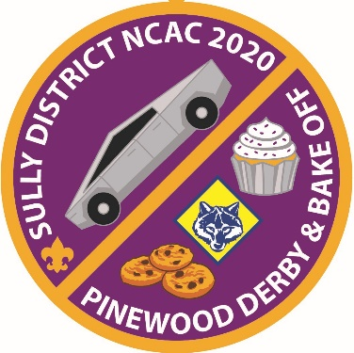
Sully District
Pinewood Derby
& Bake-Off
Sunday, 8 March 2020
St. Timothy Catholic Church Cafeteria, 13807 Poplar Tree Rd., Chantilly, VA 20151
Pinewood Derby Fee $12.00 Bake-Off Fee $12.00 POC: spencerhhorn@outlook.com
Register Online at https://scoutingevent.com/082-SullyPWD

Race Times: 1:00 PM to 4:30PM Bake-Off Times: Check-in: 12:30PM
12:30PM Lion Check-in Judging: 1:15PM
1:00PM Lion Racing (Track 1) & Awards Awards: 2:15PM
1:00PM Tiger Check-in
1:30PM Tiger Racing (Track 2) & Awards Bake-Off Categories: Cakes
1:30PM Wolf Check-in Breads
2:00PM Wolf Racing (Track 1) & Awards Cookies
2:00PM Bear Check-in Pies
2:30PM Bear Racing (Track 2) & Awards Decorative / Creative
2:30PM Webelos Check-in
3:00PM Webelos Racing (Track 1) & Awards
3:00PM Arrow of Light Check-in
3:30PM Arrow of Light Racing (Track 2) & Awards
4:00PM District Championship Check-in
4:10PM District Championship Racing & Awards
PWD Race Procedure Eligibility: Scouts finishing 1st, 2nd, & and 3rd place for their rank (Lion, Tiger, Wolf, Bear, Webelos, Arrow of Light) in a Pack race qualify for the District PWD, and are encouraged to participate. Arrow of Light Scouts who have already crossed over to Boy Scouts are still eligible for this event if they placed at the Pack level while still a Cub Scout. (NOTE: If any placed scouts cannot participate, please choose another scout to compete to encourage maximum participation.)

Bake-Off Procedure Eligibility: Scouts finishing 1st, 2nd, and 3rd place (for each bake-off category) in their Pack competition, qualify to compete at the District level bake-off. Arrow of Light Scouts who have already crossed over to Boy Scouts are still eligible for this event if they placed at the Pack level while still a Cub Scout. (NOTE: If any placed scouts cannot participate, please choose another scout to compete to encourage maximum participation.) This is not a rank-level competition.

