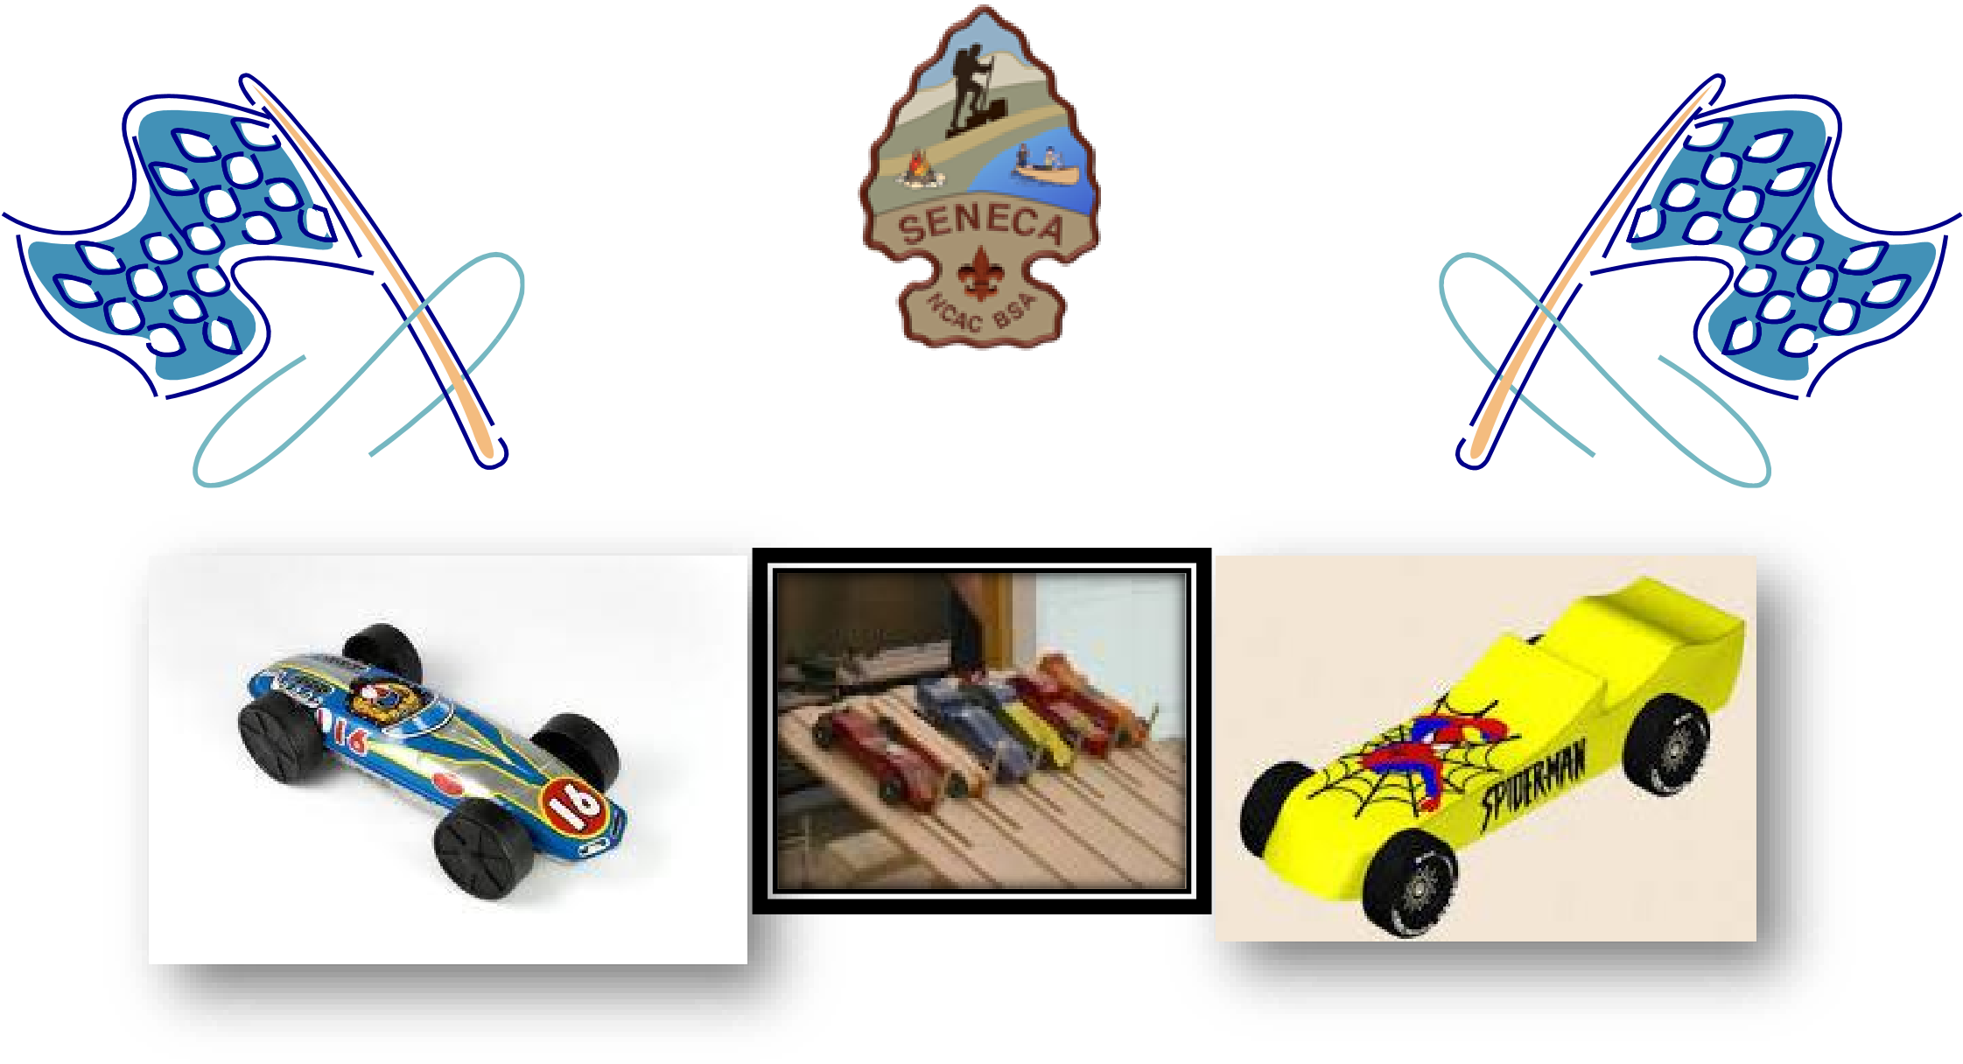
Seneca District Pinewood Derby
Registration Now Open

Bring your car and spend a fast-paced day full of fun, racing, and awards!
Saturday, April 18, 2020 - $35
8:30am-9:30am - Weigh In opens
9:30-9:50am - Registration & Inspection
10am-12:30pm - The race

Epworth United Methodist Church
9008 Rosemont Dr.
Gaithersburg, MD 20877
(lower parking area, lower floor preschool entrance door)

For Information:
Mark Brady at mdbrady1@verizon.net
301-252-4331 (c)

Registration on-line with race rules and car details: https://scoutingevent.com/082-32999

