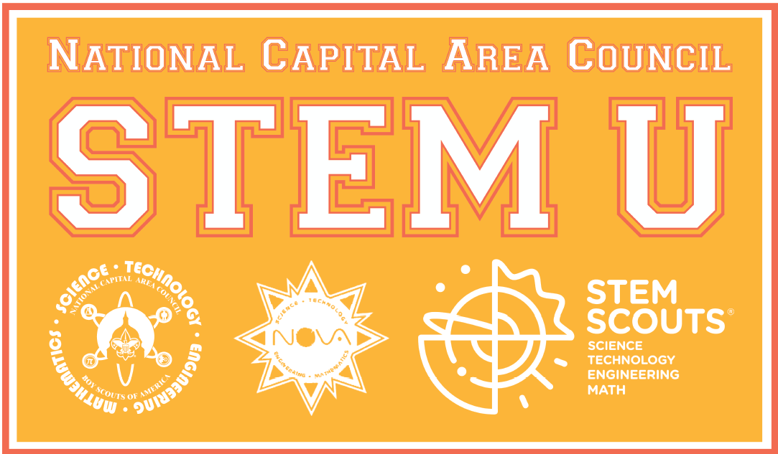
STEM University – STEMU – is a celebration of Science, Technology, Engineering and Math for adult leaders and Scouts in the National Capital Area Council. In 2019 we will have a variety of classes for all Scouts.

YOUTH Classes
STEM Games and Math Puzzles. (ALL Youth, Period 1) STEM is fun! Try out some math puzzles and STEM games. If Scouts BSA, Venturing or Sea Scout youth are working on their Supernova requirement that involves working with your mentor, organize and present a STEM-related program to a Cub Scout meeting, they can ask us (email stem@ncacbsa.org) to host a game in this period. (For Scouts BSA who present an activity will fulfill Dr. Bernard Harris requirement 7 or Thomas Alva Edison Supernova requirement 6; and Venturing or Sea Scout youth would fulfill Dr. Sally Ride requirement 6, or Wright Brothers requirement 6. Cub Scouts who participate in the older Scouts activity would then fulfill Dr. Luis W. Alvarez Supernova Requirement 9 and Dr. Charles H. Townes Supernova Requirement 9)

Einstein Science Fair. (ALL Youth, Period 2) Youth may bring a poster board and share a science project at our annual science fair. See Science Fair Guidelines on our STEMU registration web site. (For Scouts BSA, this is will fulfill Dr. Bernard Harris or Thomas Alva Edison Supernova requirement 5; and for Venturing youth and Sea Scouts, it can fulfill Dr. Sally Ride requirement 4 or Wright Brothers requirement 5)

Meet a STEM Professional (ALL Youth, Period 2) Youth can learn about STEM careers from local scientists, technologists and engineers. (For Cub Scouts this will fulfill Luis W. Alvarez Supernova and for Webelos it will fulfill Dr. Charles H. Townes Supernova Requirement 7; for Scouts BSA it will partially fulfill Dr. Bernard Harris requirement 6B: for Venturing youth and Sea Scouts it will partially fulfill Dr. Sally Ride requirement 5B)

All About the Scientific Method. (Cub Scouts, Webelos, and STEM Scouts in Junior Laboratories, Period 3) Learn about the Scientific Method or scientific process. Use the scientific method in a simple science project. (Science Everywhere Nova 2A, Luis W. Alvarez and Charles H. Townes Supernova requirement 8)

Meet Famous Scientists of the Past (Cub Scouts and Webelos, and STEM Scouts in Junior Laboratories, Period 4) Learn from famous scientists, technology innovators, engineers and mathematicians about their lives and important accomplishments (Luis W. Alvarez Supernova and Dr. Charles H. Townes Supernova Requirement 4)

Up and Away Nova Award (Scouts BSA, Periods 3&4, two-hour class). Check out the newest Nova Award! This award explores the world of fluid dynamics and how it affects your everyday life. Fluid dynamics is the study of how fluids (liquids, gases and plasmas) behave and interact with other materials. PREREQUISITES: Information on the Nova award is here. Requirement 1. Watch/read 3 hours of information on a topic related to fluid dynamics. Bring your two questions to this class. Requirement 2. Show completion of one of the following merit badges: Aviation, Canoeing, Chemistry, Kayaking, Oceanography, Plumbing, Rowing, Scuba Diving or Swimming. Requirement 4. One way to complete #4 is to watch an online tour of a wind tunnel facility https://www.youtube.com/watch?v=bpRc9I8LMXo or https://www.nasa.gov/imagefeature/hypersonic-tunnel-facility
(STEM Scouts in Technology and Research Laboratories, Venturing youth and Sea Scouts may attend but will not qualify for the Nova award)

Period
1 | STEM Games and Puzzles
2 | Einstein Science Fair | Meet a STEM Professional
3 | All about the Scientific Method | Up and Away Nova Award (part 1)
4 | Meet Famous Scientists of the Past | Up and Away Nova Award (part 2)

ADULT Classes
What’s New in STEM. (ALL Adults, Period 1). Learn about the new STEM Nova awards that youth can earn at all levels. The National Capital Area Council is participating in a new program called STEM Scouts. STEM Scouts explore STEM activities and careers in specialized units called laboratories. The activities are designed to be challenging, thought-provoking and most importantly, fun.

Einstein Science Fair. (ALL Adults, Period 2) Adults are invited to enjoy the fair and ask Scouts questions about their work and scientific method.

Meet a STEM Professional (ALL Adults, Period 2) Adults are invited to talk to the youth in this period about their STEM careers.

STEM Scouts – What is it about? (ALL Leaders, Period 2) STEM Scouts re-imagines creative ways to learn about STEM in a new unit-based program.
STEM/Nova Counselor & Mentor Certification Training (ALL Adults, Periods 3 & 4, two-hour class) The BSA STEM/Nova awards program incorporates learning with cool activities and exposure to STEM for youth in all programs. This course is intended to provide you with the basic information you need to conduct successful Nova counseling and Supernova mentoring sessions and activities. Come to this exciting class and discover how the Nova Awards program helps youth be “Prepared for Life.” (This class is not required for STEM Scout Managers)
All About the Science! (Cub Scout and STEM Scout Junior Laboratory Managers, Periods 3 & 4, two-hour class) Cub Scout Leaders, come learn how to carry out simple experiments in physics and chemistry, and learn the scientific principles behind each, in easy-to-understand language. We will cover thrust, friction, buoyancy, combustion, the nature of light, and more.

STEM in Your Unit (ALL Leaders, Periods 3 & 4, two-hour class) This class covers the basic implementation of the STEM program within a unit. This includes the Nova awards associated with Cubs, Scouts BSA and Venturers, processing awards, the use of Gold Cards and how to become a Nova counselor and Supernova mentor. Also presented are numerous practical examples of how to incorporate fun and educational STEM events into a unit's program.

Period
1 | What’s New in STEM
2 | Einstein Science Fair | Meet a STEM Professional | STEM Scouts – What is it about?
3 | STEM in Your Unit  (part 1) | All About the Science! (part 1) | STEM/Nova Counselor & Mentor Certification Training (part 1)
4 | STEM in Your Unit  (part 2) | All About the Science! (part 2) | STEM/Nova Counselor & Mentor Certification Training (part 2)

