Loudoun District

Webelos/AOL-O-Ree

2026


October 10 to 12, 2025
Camp William B. Snyder
Haymarket, VA

Leader’s Guide
2026-05-06

TABLE OF CONTENTS

INTRODUCTION 3
REGISTRATION 3
PLEASE NOTE 4
EVENTS AND ACTIVITIES 4
Arrival 4
Campsite Assignments 4
Opening Ceremony 5
Campsite Road Closure 5
Activity Programs 5
Lunch and Missed Unit Check-in 5
Campfire Auditions 5
Webelos/AOL Challenge 5
Webelos/AOL to Scouts BSA Orientation 6
Evening Flag Ceremony 6
Dinner 6
Campfire 6
Evening Snack 6
Electronics 7
Lights Out 7
Reveille and Breakfast 7
A Scout Is Reverent 7
Clean em’ up and move em’ out 7
IMPORTANT INFORMATION 7
Tents 7
Bathrooms 8
Medications/BSA Health/Medical Records 8
Water 8
Campfires 8
Firewood 8
Equipment 8
Scouts BSA REGULATIONS 8
FAQ’S 9
Registration 9
Check-In 10
Parking 10
Camping 10
Other 11
WEBELOS/AOL-O-REE STAFF 12
APPENDIX A: DIRECTIONS TO CAMP WILLIAM B. SNYDER 13
APPENDIX B: SCHEDULE 14
APPENDIX C: REGISTRATION INSTRUCTIONS 15

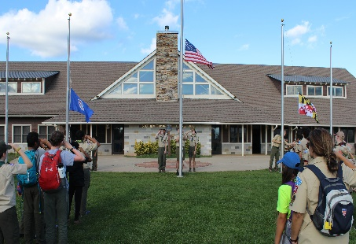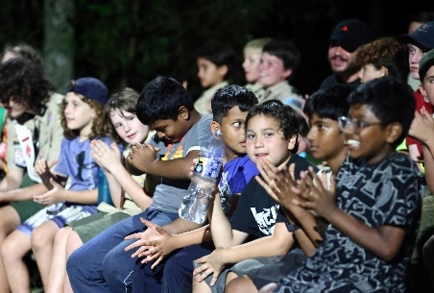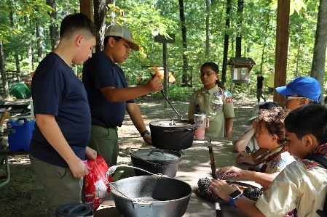

Flag Raising – Saturday morning Campfire – Saturday night Dutch Oven Cooking – Troop 1941

INTRODUCTION
The Webelos/AOL-O-Ree is an overnight camping event designed to introduce Webelos & AOL Scouts and their parents to the Scouts BSA program. The weekend is full of fun and outdoor adventures led by Loudoun District Troops. This is by design; interacting with these Troops provides the Webelos & AOL Scouts, Den Leaders, and parents with opportunities to gauge how each Troop practices the patrol method, meet their Troop leadership and learn about their lifestyle.

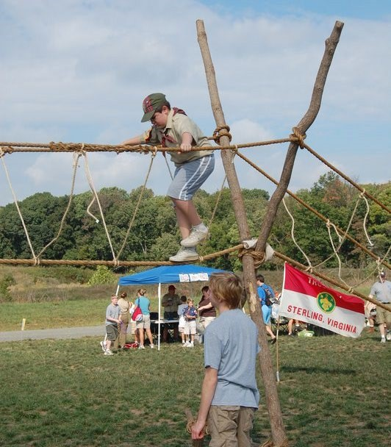
This Guide has sections that apply to Webelos/AOL Scouts and Scouts BSA youth and all Adult Leaders. The Webelos/AOL-O-Ree begins with an opening ceremony Saturday morning and ends Sunday morning after chapel services. (Packs can camp Friday night also if they wish.) The Saturday evening campfire is a special highlight featuring a ceremony by our Order of the Arrow Chapter and skits put on by the Webelos & AOL dens.

REGISTRATION
Participation in the Webelos/AOL-O-Ree is open to all Webelos Scouts. Registration by Unit (Pack/Den) is encouraged to help our administrative efforts, but individual registrations will be accepted. All registrations made in advance by August 23 will receive Early-Bird pricing of $5 OFF for each category. After this date, Regular pricing goes into effect, raising all fees by $5 per person.
Monkey Bridge – Troop 761
To register online, go to: https://scoutingevent.com/082-114067
All Scouts from each Pack will be assigned to the same campsite, regardless of the way they register or when they register. 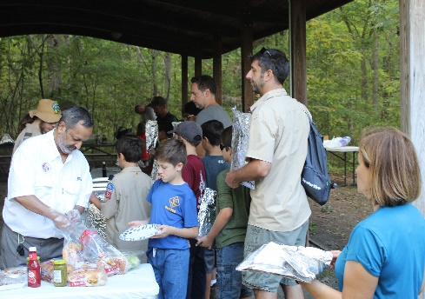
Saturday Foil Dinner – Pack members
Rate A – Camping overnight. The cost is $40 per person ($35 if ‘Early Bird’) and includes dinner Saturday evening and breakfast Sunday. BSA policy permits a Webelos or AOL Scout to participate in overnight camping when accompanied by a parent/guardian. If a parent/guardian cannot attend, another youth's parent (but not the Den Leader) or another adult may substitute at the campout. Responsible adult partners must be at least 21 years of age. An adult cannot be responsible for more than two Webelos or AOL. Pack members may camp one or two nights.

Rate B – Staying through campfire. The cost is $35 per person ($30 if ‘Early Bird’) and includes dinner Saturday evening. At least one adult must attend for every five Webelos/AOL in a Den.
Rate C – Visiting for the day. The cost is $30 per Webelos/AOL ($25 if Early Bird’) to cover the event fee. One adult is required for every five Webelos/AOL. These adults do not pay a registration fee.
Den Chiefs attend this event free of charge.

PLEASE NOTE
The Webelos/AOL-O-Ree is a Rain or Shine event (excluding hurricanes and large tropical storms). NCAC Refund policy is limited and applies to all registration costs (details on the registration site). Siblings and/or friends are not allowed at the Webelos/AOL-O-Ree. Saturday lunch is not provided by the Loudoun District. Scouts and Scouters are responsible for their own Saturday lunch.

EVENTS AND ACTIVITIES

Arrival
We will open the camp entrance at 6:15 AM Saturday morning for those coming in to set up their tents. Scouts should arrive in uniform. When you arrive, one of our greeters will be at the gate to assist with check-in and directions. You will drive to the campsite loop to your assigned campsite and unload your equipment. Pull off the road to unload and do not drive into the campsite. Please drop off your gear immediately and continue to follow the one-way loop road out of the campsite area (do not make a U-turn on the loop road!). Return your vehicle to the parking lot (next to the camp entrance), then walk back to your campsite to set up. Vehicles cannot be left at the campsites. There are no exceptions to this Camp Snyder rule.
Flag ceremony begins at 9:00 AM sharp so plan to arrive by 8:00 AM with enough time to park, set up, and get to the flagpoles by 9. Packs or select members of Packs may arrive Friday evening.
You may leave the camp at any time to go to a school, church, or sporting event. You do not need to check in/out with the Webelos/AOL-O-Ree staff but must coordinate this with your Unit Leader.

Campsite Assignments
Camp Snyder has 14 campsites and we will be using up to five of them (some for the Packs and some for the Scouts BSA Troops). Site assignments will be listed on the maps that will be sent out to the Unit contacts via email about two days before the event. Hardcopy maps will be available on Saturday morning as people come in. We will be making the campsite assignments to get as even a distribution of campers at each location as we can. All members of a Unit, however, regardless of when their registration was received, will be assigned to the same site.
Most campsites will have multiple Units camping there. Make sure you introduce yourselves to each other.

Opening Ceremony
The Webelos/AOL-O-Ree will begin at 9:00 AM with an opening ceremony at the flag poles on the west side of the dining hall. All Scouts should be in uniform. Scouts may change out of their uniform after the ceremony. Maps showing all the activity locations and the latest schedule will be available at this time.

Campsite Road Closure
Because several of the activity areas are in the campsites and Scouts will be traveling on the road between them, we will be closing the road to traffic at 9:00 AM for the rest of the day for safety reasons. Anyone coming in after this time with camping gear or other items will need to drop it off by the Headquarters pavilion (right at the beginning of the camping area), take their vehicle to the parking lot, and then come back to walk the items in.
Anyone who needs to pick a person up during the day please arrange a meeting location outside the camping areas. We suggest the area in front of the Hylton Training Center at the front entrance to Camp Snyder.

Activity Programs
The activity programs will open at 9:30 to 11:30 AM and from 12:30 to 3:00 PM. We will be closing the entry line to the shooting areas a half hour before the end of the activity periods. This will allow time for those already in line to complete the event and for the staff to finish up on time and get their lunch/dinner.
Unlike Day Camp or Goshen, there is no rotation schedule or assignment of activities/times for a Pack. What activities you visit, when you visit them, and how much time you spend there is up to you. Choose activities that interest you and are not crowded and rotate through them all. There are approximately two hours of activities before lunch and two and a half hours after lunch. Budget your time to see and do it all.
Please note that the shooting ranges are very popular and are near the opening ceremony site. This usually makes the ranges crowded right after the opening ceremony. You might want to use that time to go to some of the other activity areas and come back to the shooting ranges later.

Lunch and Missed Unit Check-in
Lunchtime is from 11:30 AM – 12:30 PM. This meal is not provided as part of the program, please bring a lunch or arrange one for your Den. For anyone who missed check-in at the gate, please stop by the Headquarters Pavilion during the lunch period.

Campfire Auditions
The evening campfire is a highlight of the Webelos/AOL-O-Ree and we highly encourage all Dens to participate. We will hold campfire skit auditions during lunchtime for those Dens that would like to perform at the campfire. The purpose of this audition is not to select the skits/songs that will be used (all Dens that want to perform will be allowed to) but to ensure that the Scouts know what they are doing, that there will not be duplicate skits performed, and so that the Campfire Master of Ceremonies knows the order to call the Units up.

Webelos/AOL Challenge
The Webelos/AOL Challenge is a special activity, puzzle, or quiz for the Scouts to do during the activity periods. It takes about 15 minutes. How well the Webelos/AOL Dens do in this challenge determines their placement in the dinner line! Given that we usually have 300+ people to get through the line, the order in which we call Packs can be very important.
The Challenge Event varies each year but is always based on knowledge of the Arrow of Light’s Scouting Adventure requirements, items #1 and #5 (Scout Oath, Law, Motto, square knot, Scout emblem, etc.).

Webelos/AOL to Scouts BSA Orientation
After the activity areas close, we will hold a Webelos/AOL to Scouts BSA Orientation. This orientation is geared for those Webelos & AOL earning the Arrow of Light this year and their parents. The orientation is all about the transition into a Scouts BSA Troop. It will go over how Troops are organized, how to select a Troop, and what the first year in a Troop will be like.

Evening Flag Ceremony
The evening flag ceremony will be held after the activity areas close (uniforms are not required). Since we’ll be going from the ceremony directly to the dinner line everyone should wash their hands before arriving at the flagpoles (outside the dining hall).
If your Den would like to assist in the flag ceremony, please email your request to Joe Kotch at joe.kotch11@gmail.com. Five Dens will be selected and must be in full uniform.

Dinner
Dinner will begin immediately after the evening flag ceremony (around 4:45 PM depending on weather and ability to get all the cooking fires ready on time). The meal will be foil packet meals that you will put together (ground beef, turkey, or veggie burgers (available for vegetarians), carrots, potatoes, onions, peppers, spices) and cook over a charcoal fire back at your campsite. Plates, silverware (okay – plasticware), and drinks will be provided and the cooking fires will be started by our Scouts BSA Troops. Each campsite has a fire circle and two above ground firepits to cook the foil dinners.
Vegetarians – as stated above we have veggie burgers for the foil packets. These will only be given out, however, to those who have the special ‘Vegetarian’ meal tickets that are given out at Unit check-in. There is no cost for the ticket, it’s just our way of making sure that those who reserved the meal get it. Remember to mark the number of vegetarian meals needed on the online registration form.
Halal meat – if your Unit requires Halal meat, please mark this on the online registration form.
We may ask your Unit to purchase it and bring it to the event and we will reimburse you for the cost.
All the food/snacks that we will hand out will already be checked to be peanut free.

Campfire
The Scouts BSA Order of the Arrow (OA) will be hosting our campfire. Any Den wishing to perform a skit or lead a song at the campfire must audition for a position on the schedule (audition times are listed on the event schedule).

Evening Snack
As you exit the campfire Scouts and adults may pick up some snacks (chips, dried fruit snacks, cookies) for the evening.

Electronics
To align with the spirit of the Camporee and enhance the collective experience for all participants, request that the use of cell phones and other electronic devices be limited. The decision regarding specific terms of device usage, including permissible times and contexts, will be left to the discretion of each Unit.

It is important that all members, adults included, exercise discretion and respect the guidelines established by their Unit leaders. This policy minimizes distractions and encourages participation and interaction within the Camporee setting. We trust in the judgment of our Unit leaders to implement this policy in a manner that best suits their group's needs and objectives, ensuring a rewarding experience for all involved.

Lights Out
Quiet time begins at 10 PM for all campsites. All adult leaders are expected to help enforce this.
Remember: If a Webelos Scout or AOL and an adult(s) are sharing one tent, then the adult(s) must be the parent or legal guardian of that Scout. In Scouts BSA, youth and adults must tent separately.

Reveille and Breakfast
Sunday camp breakfast will be at 7:30 AM at the Headquarters Pavillion and will consist of juice, coffee, fruit, muffins, and bagels. If any Unit wants to cook their own breakfast they may do so.

A Scout Is Reverent
Remember that a Scout is reverent and respects the rights of others to observe their religious beliefs. Chapel will be at 8:00 AM. It will be a nondenominational service. Scouts should attend chapel in uniform.

Clean em’ up and move em’ out
You should police your campsite (go around picking up trash) and have it checked by a Scouts BSA Troops before leaving. Remember that a Scout is clean and always leaves a campsite cleaner than they found it. Camp closes at 10:00 AM; everyone must be out by this time.
We will follow the same vehicular traffic rules for leaving the campsite. Please have all your gear packed and ready for loading before going to retrieve your vehicle. Stay on the road, do not pull off to the side, and continue to follow the one-way loop road out of the campsites.
No vehicles will be allowed into the campsites before 7:00 AM. If you need to leave earlier please carry your gear out to the parking area.
A detailed SCHEDULE is found as APPENDIX B at the end of this Guide.

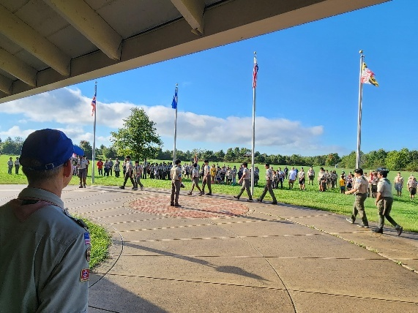
Flag Ceremony

IMPORTANT INFORMATION

Tents
You must bring your own tents. Each campsite has about ten wooden tent platforms. These are available for your use but are not required to be used.

Bathrooms
All bathhouses will be open for the Webelos/AOL-O-Ree. Each bathhouse has clearly marked separate facilities for both male and female Scouts and Scouters (adults). Scouts BSA youth protection guidelines require that adults use only the adult facilities and that Scouts use only the youth facilities.

Medications/BSA Health/Medical Records
Each parent or responsible adult has the responsibility to hold and administer medications to their Webelos/AOL Scout. Each Unit leader should carry a copy of the BSA Annual Health and Medical Record (Parts A and B) for all of his/her Scouts. The Webelos/AOL-O-Ree staff do not need copies.

Water
Each Webelos/AOL-O-Ree participant should bring a personal water bottle/canteen for use during the program. Soda is strongly discouraged; sports drinks should be consumed in a ratio of 1:3 with plain water. Potable water spigots are located along the campsite loop road near campsites.

Campfires
Fires should be attended at all times by an adult and should be extinguished before departing the campsite for events or evening activities. Fire pails are available at each campsite and must be filled with water and located next to each fire ring. State regulations may prohibit open fires if it has been too dry. The Webelos/AOL-O-Ree staff will announce any fire restrictions.

Firewood
Due to local and state laws it is not permissible to bring firewood to the camp. This is to prevent the spread of insect pests and other tree diseases that may be present in the transported wood. You may gather and use any deadfall around the campsites; Camp Snyder usually provides wood piles at the campsite area.

Equipment
Each attendee will be responsible for packing and bringing their own personal gear. This includes uniform, tent, blanket/sleeping bag, ground cloth, rain gear, flashlight, and toiletries. Everyone should be fully prepared for the weather conditions typical for this time of the year. Either rain or shine, hot or cold, be prepared by bringing enough clothing to be as comfortable as possible during the weekend. Hiking boots are preferable to sneakers, especially in wet weather.

Poison Ivy!!!
Poison ivy is prevalent in the woods at Camp Snyder. Den Leaders should ensure everyone knows how to recognize and treat it (recognizing it is a Scouts BSA advancement requirement).

Scouts BSA REGULATIONS
MEMBERSHIP – Scouts eligible for the Webelos/AOL-O-Ree MUST be registered members of a Webelos or AOL Den and meet the Den membership requirements established by Scouts BSA.
LEADERSHIP – Webelos/AOL Scouts are supervised by their Den Leader and other adults in attendance. The welfare of all Scouts is the joint responsibility of the Den Leader and the accompanying adults. All adults must have currently completed BSA Safeguarding Youth Training. Basic Adult Leader Outdoor Orientation (BALOO) training is suggested for all adult leaders but is not required for participation in this District event.
ALCOHOLIC BEVERAGES AND SMOKING – Alcoholic beverages are not permitted at Scouting functions. Anyone found possessing or consuming alcoholic beverages will be required to leave camp immediately.
Smoking is discouraged at Scouting events. If you must smoke you should move to an area away from all Scouts. Smoking includes the use of electronic smoking devices (vaping).
WOOD TOOLS – Webelos/AOL may not use axes but bow saws are permitted. All chopping must be done by adults in an approved ax yard. Knives may be used with adult supervision.
LANTERNS AND STOVES – Propane and butane/isobutane gas-fueled lanterns and stoves are commonly used but must be operated under adult supervision. Liquid-fueled equipment using fuels such as Coleman fuel (white gas) or kerosene are permitted, but it is recommended that the supervising adult be experienced with their operation and maintenance. No flames in a tent. Tent light should be provided by flashlight or battery-powered lanterns.

FAQ’S

Registration
Q. What if I’m not sure which parent will be attending when I’m registering?
A. Our main concern is that there is a commitment of an adult for each camping Webelos/AOL Scout, or one per five Webelos/AOL Scouts visiting during the day. Changing the adult is not a problem as long as another, equally qualified, adult takes their place.
Q. Does the registration fee cover both the Scout and adult?
A. No, this is a per person fee. A Webelos/AOL with an adult camping would be two fees. The only adults who do not have to pay a registration fee are those for Rate C (visiting for the day).
Q. Can one adult be the responsible adult for more than one Webelos/AOL Scout?
A. Yes. If a parent/guardian cannot attend, arrangements can be made by the Webelos/AOL Scout's family for another youth's parent (but not the Den Leader) or another adult relative or friend to
be a substitute at the campout. Responsible adult partners must be at least 21 years of age. One adult cannot be responsible for more than two Webelos/AOL Scouts. The non-related adult cannot share the tent with the Scout.
Q. If we are only visiting for the day must there be an adult for each Webelos/AOL Scout and must the adult register?
A. During the day we require that there be at least one adult for every five Scouts. There is no registration fee for an adult who is just there for the day BUT YOU MUST STILL REGISTER.
Q. Can more than one adult register with a single Webelos/AOL Scout?
A. Yes. We often have both parents attend with their Webelos/AOL Scout (both must pay the fee).
Q. Can our Den Chief (i.e., Scouts BSA assistant) attend?
A. Yes. In fact, we want to encourage it so much that there is no fee for them to attend.
Q. If we can’t make the event how do we get our money back?
A. This is a rain or shine event with all registrations completed online beforehand. A full refund may be issued if the registration is cancelled within 3 days of being made. You may be charged 15% of the registration cost after this time. Within 14 days of the event, 100% of the registration cost is charged. A full refund is only made in the case of illness, military orders, or if the event is cancelled by NCAC. If you cannot attend, the best alternative is to see if someone in your Unit who has not registered yet can replace and reimburse you. The Webelos/AOL-O-Ree staff may be able to find someone in another Unit. Not guaranteed.

Check-In
Q. Where do I check in when I arrive?
A. When you arrive, check-in at the gate and go directly to your assigned campsite if you are camping (greeters will be at the entrance with maps). If not, camping, park your vehicle in the parking lot and go directly to the flagpole area by the dining hall.
Q. If I come in later, how do I find my Unit?
A. Since there is no assigned activity rotation schedule for the Units, we can’t tell you where your Unit is at any given time. We suggest that everyone coming in late have either the phone number of someone who will be there to direct you (providing they haven’t turned their phone off) or, better yet, set up a prearranged meeting time/place.

Parking
Q. Why is the parking lot so far away?
A. A large area is needed for the number of visitors that Camp Snyder gets for some events. The lot also needs to be close to the activity areas that are used during the day but away from the camping areas to cut down on the noise.
Please do not park in such a way that you block another vehicle. Even if you are “not planning on staying long” the other vehicle may still be leaving before you or may be needed in an emergency.
Q. Why can’t I leave my vehicle at the campsite?
A. The county fire marshal requires that all vehicles be placed in the parking lot. In addition, there are few places to park by each campsite and leaving a vehicle in one prevents another person from being able to drop off their equipment. (Troop trailers are authorized to be parked.)
Q. Why is the road into the campsite area closed at 9:00 AM?
A. A number of the activities run by the Troops are in the campsite area so there is constant foot traffic along the road. As a safety precaution we found it best to have the road closed.

Q. I have special needs that would require my vehicle to be parked at the campsite, is that allowed?
A. Sorry. No. We’ve run this by the camp several times and have always gotten the same answer. Whether you are handicapped or on-call and need instant access to your vehicle you cannot leave it at the campsite.

Camping
Q. Are there platforms for the tents?
A. Each site has 10 large wooden tent platforms that are designed for the camp’s large wall tents (which were taken down for the winter). They can be used for smaller tents. Given the number of campers we usually get for this event we expect to have more than 10 tents per site so some will be on the ground. Getting a platform will be a matter of ‘first come, first serve.’
Q. Can Webelos/AOL share a tent?
A. Yes, unless an adult is also in the tent. Only the responsible adult (parent or legal guardian) for each Webelos/AOL Scout may be in the same tent as the Webelos/AOL Scout.
Q. What gear should I bring?
A. You will be responsible for you own camping gear (tent, sleeping bag, flashlight, etc.). We will supply the utensils, plates, and cups for the meals and get the cooking fires ready. Make sure that you bring raingear and water bottles/canteens. A Scout is always prepared and having a camping trip where it doesn’t rain is considered unusual by most Troops. Many of the activities will require a lot of walking/running around and we want to make sure that no one gets dehydrated.
Q. The parent staying with the Webelos or AOL Scout overnight cannot be there during the day, can the Scout still attend with someone else for the activity period?
A. Yes, as long as one adult doesn’t have to watch over more than 5 Webelos or AOL Scouts.
Q. Can an adult camping overnight also be responsible for Webelos or AOL visiting for the day?
A. Yes. The adult cannot be responsible for more than four non-camping Webelos or AOL Scouts and should not be the person responsible for their transportation home.
Q. Is there electricity at the campsites?
A. No.
Q. Should we bring firewood for our fire?
A. No. To prevent the dispersal of insect pests from one area to another the state does not allow for the transport of firewood. Camp Snyder staff, however, does try to have firewood piles available for campfires.

Other
Q. Can I bring younger siblings, friends, or other Cub Scouts?
A. No. This is a Webelos or AOL only event.
Q. Can I bring our dog?
A. No.
Q. If we can’t make it for the morning can we still come in later?
A. Yes. For those visiting just for the day we definitely recommend that you arrive no later than noon or you will have missed most of the day’s activities.
Q. Should Webelos/AOL wear their uniform?
A. Scouts should always wear their uniforms when traveling to and from events and camping trips. All Scouts should be in uniform for the opening ceremony, after that they may change to other clothing. Uniforms will not be required for the evening flag ceremony, dinner, or the campfire, unless the Scout is involved in the evening flag ceremony (must wear full uniform)
Q. What Webelos/AOL requirements will be covered by the event?
A. The emphasis we have placed on the Webelos/AOL-O-Ree is showing what fun camping is and what being in Scouts BSA is like. Most Dens have plans to cover Webelos/AOL advancements in Den meetings and other activities. However, several of the AOL Outdoor Adventurer and Scouting Adventure requirements can be fulfilled at an event like the Webelos/AOL-O-Ree. Go here for details: http://www.usscouts.org/usscouts/advance/cubscout/aol-core.asp#scouting.
Q. Why does it take so long to get through the dinner line?
A. The dinner line is our biggest bottleneck of the weekend and every year we work on improving the speed we get people through it. Last Webelos/AOL-O-Ree, the staff managed to get 300+ people through in about 20 minutes (that’s one person in/out every 6 seconds). Nonetheless, that’s still a 20-minute wait for those at the end (which is why you want to make sure your Den does the Webelos Challenge to get to the beginning of the line).
Q. What happens with really bad weather?
A. If hazardous weather is forecast for the day of the Webelos/AOL-O-Ree, we will cancel the camp and try to arrange a new date/location.

WEBELOS/AOL-O-REE STAFF

Here are names and contact info for the principal Webelos/AOL-O-Ree staff:

Allon Stern | Camporee Director | allon@radioactive.org
Joe Kotch | Activities & Camping Coordinator | joe.kotch11@gmail.com
Daniel Golding | Deputy District Chair | dgolding@gmail.com
Rob Winter | LD Communications Chair | rob.winter@scoutingloudoun.org
John Blackwell | Deputy District Chair | john.blackwell@scoutingloudoun.org
Chris Thames | OA Chapter Advisor | chrisdthames@gmail.com
Andrew Stern | Camp Health Officer | squid1nk@icloud.com
Sam Freeman | Grubmaster | cubmastersam@gmail.com
John Kinas | Shooting Sports Coordinator | jkinas@hotmail.com

Please direct your questions to the person responsible as shown above. If unsure, contact Allon Stern,
Webelos/AOL-O-Ree Director.

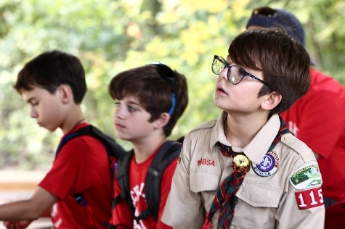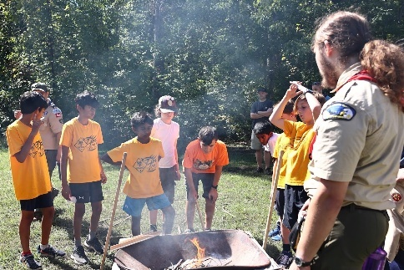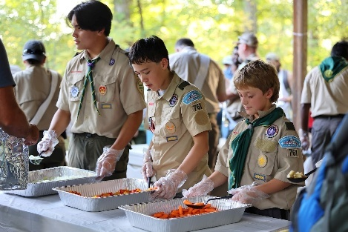

APPENDIX A: DIRECTIONS TO CAMP WILLIAM B. SNYDER
6100 Antioch Road, Haymarket VA

Loudoun District Webelos/AOL-O-Ree 2026
August 28 to 30, 2026

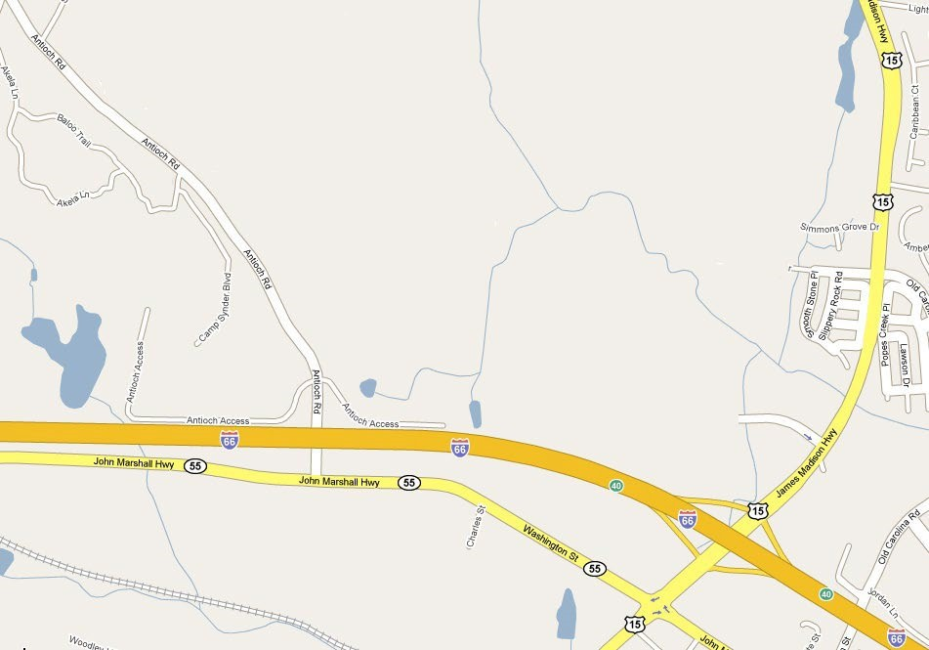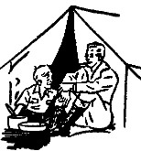
To Leesburg

From Sterling/Cascades/Ashburn (about 45 minutes):
- Travel south on Route 28 to Interstate 66.
- Travel west on Interstate 66 to exit #40 (Haymarket, VA).
- Travel south (left) on Route 15 to the first traffic light (1/4 mile) and turn right onto Route 55 (John Marshall Hwy). A Sheetz station will be on the opposite corner.
- Travel west about 1 mile to Antioch Road.
- Turn right onto Antioch Road, go over I-66, and follow signs to Camp Snyder on the left.

From Western Loudoun:
- Travel south on Route 15 to Interstate 66.
- Cross over Interstate 66 and go to the first traffic light, turn right onto Route 55 (John Marshall Hwy). A Sheetz station will be on the opposite corner.
- Follow directions #’s 4 and 5 above.

APPENDIX B: SCHEDULE

Loudoun District Webelos/AOL-O-Ree 2026
August 28 to 30, 2026

Saturday 8/29
6:15 AM Dens arrive. All those camping drop off gear at campsite and immediately move to parking lot.
9:00 AM Opening Ceremony (uniforms required)
9:00 AM Loop Road to campsite areas closed to vehicular traffic
9:30–11:30 AM Activity Areas open.
11:00 AM Entry to shooting sports area closes.
11:30–12:30 PM Lunch (bring your own), Campfire Skit Auditions at the
 | Headquarters Pavilion.
12:30-3:00 PM | Activity Areas reopen.
2:30 PM | Entry to shooting sports area closes
3:00 PM | Activity areas are closed.
3:15 PM | Webelos/AOL to Scouts BSA Orientation at Chapel
4:30 PM | Evening Flag Ceremony (uniforms not required, wash hands before arriving as you’ll be going straight to the dinner line)
4:45 PM | Dinner
8:00 PM | Evening campfire, meet and wait on road at Campsite #11
10:00 PM  Sunday 8/30 | Lights Out
7:00 AM | Reveille – No vehicles permitted into camp until this time.
7:30 AM | Breakfast area open at Headquarters Pavillion
8:00 AM | A Scout is Reverent (non-denominational service) at Chapel
9:00 AM | Break camp
10:00 AM | Camp is closed, everyone must be out by this time

APPENDIX C: REGISTRATION INSTRUCTIONS

Loudoun District Webelos/AOL-O-Ree 2026

August 28 to 30, 2026
- Registration is online. Go to https://scoutingevent.com/082-114067 to register.
- There are three different Webelos/AOL-O-Ree rates:
- A - Camping Overnight
- B - Staying for dinner and campfire
- C - Visiting for Saturday.
- For Rate A – Camping Overnight, there must be an adult for every Webelos or AOL Scout. In some cases, an adult can be responsible for a second camping Webelos or AOL (see FAQ’s-Registration).
- Scouts BSA Den Chiefs do not have to pay to attend (FREE!). Please note that a Den Chief is not an Adult Den Leader!
- Registration can be done either individually or as a Unit. All Scouts in a Unit will be assigned to the same campsite, regardless of how/when they are registered.
- We will send out periodic emails to those who have registered with any changes/notes about the event. The final schedule and campsite assignments will be sent Thursday.
- Note: If you start but don’t finish a registration, retain your registration ID #. When you return to the registration site, type it and your email address under “Lookup” in the upper right on the front page. If you don’t have your registration ID#, contact the Registrar.
- Joe Kotch, Activities and Camping Coordinator, joe.kotch11@gmail.com, can let Pack/Den leaders know which Scouts in your Unit have registered.
- Remember that members of Scouts BSA do not register at the website. They must volunteer for which Training Activity their Troop will conduct and how many Scouters and Scouts will attend.
- 