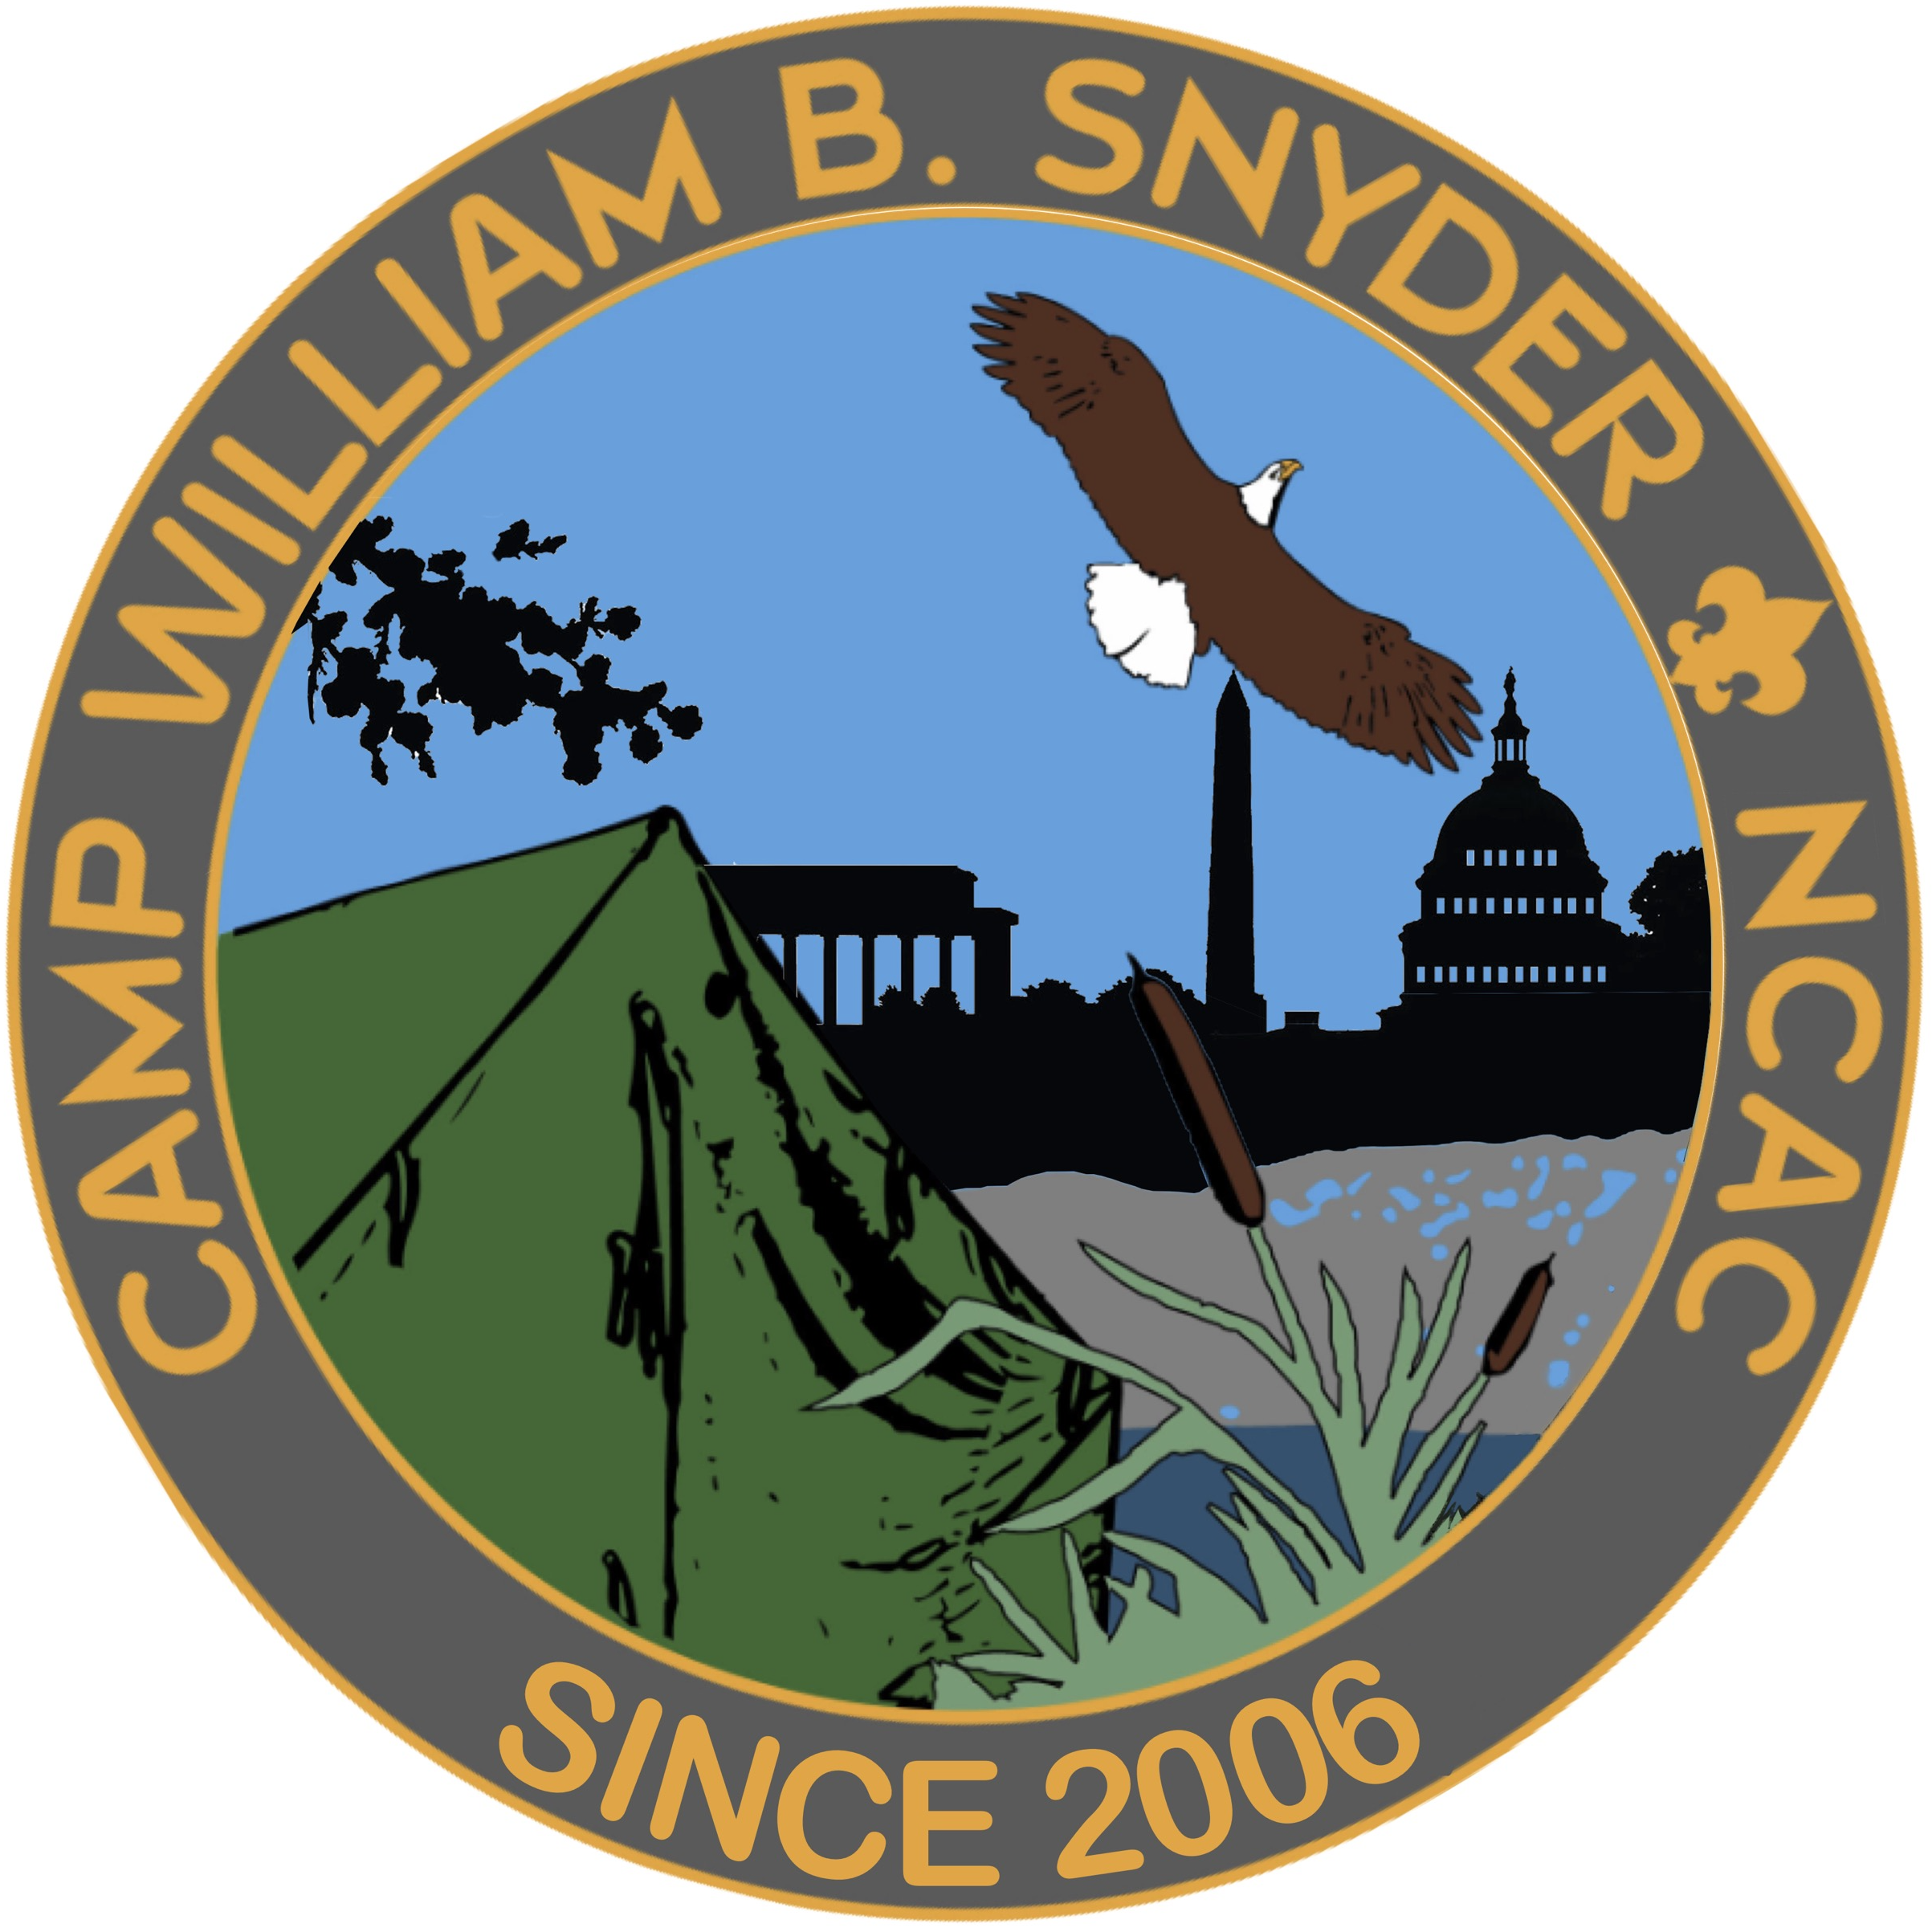

2026
Camp William B. Snyder
Leader & Parent Guide

Camp William B. Snyder | 6100 Antioch Rd., Haymarket, VA 20169 571.248.4904 Camp.Snyder@Scouting.org

Greetings Leaders and Parents,

On behalf of the volunteers and staff of the National Capital Area Council and Camp William B. Snyder, thank you for choosing Camp Snyder as your summer camp for 2026. We are very excited to have you at Camp with us this summer and hope you are just as excited.

The goal of this guide is to help ensure you arrive at camp prepared to have an awesome time. Please read through the information here and let us know if you have any questions at all! Keep in mind that our program is constantly changing and shaping itself around many factors, including requirements, but most importantly FUN so these documents may change slightly as we get closer to the summer.

We are already spending countless hours getting ready for your arrival this summer and on making sure you have the best experience possible.

If you have any questions that are not answered in this guide, please contact our staff at 571-248-4904 or Camp.Snyder@Scouting.org

We look forward to seeing you and your scout for what is sure to be a great camp experience!

Basic Rules of Camp Snyder
- General Rules:
  - Buddy System –Scouts are required to have a buddy at all times. Tiger Cub Scouts must be accompanied by an adult partner.
  - Two Deep leadership - Two Deep Adult Leadership is required at camp. The minimum leadership requirements for any Cub Scout unit attending camp is a ratio of two adults for up to ten youth. Tigers must have their own partner adult. Units who are bringing female campers to overnight programs must provide a youth protection trained Female leader. Individual attendees may attend camp with their parent. A direct parent chaperone is the only exception to the two deep leadership rules.
  - Running in camp – no one is allowed to run in camp, even during emergencies. Running at camp is unsafe because of the number of rocks and tree roots sticking out of the ground. The exception to this rule is during field games.
  - Anyone entering or leaving Camp Snyder, must sign In/out at the admin building. This includes when new leaders arrive or leave mid-week. Wristbands provided to identify campers and visitors must be worn at all times.
  - National Scouting America Policy does not allow smoking around or in sight of Scouts. The use of Tobacco is restricted to our designated smoking area located by our dining hall loading dock.
  - Report all injuries to the first aider immediately.
  - Please be on time for all flag ceremonies and make sure your Scouts show proper respect for the flag. Field Uniforms (Class A) are requested during evening flags. We strongly recommend Pack t shirts (they make your pack easier to keep together and to identify)
  - All camp attendees are expected to adhere to the Scout Oath and Scout Law. Managing the conduct and discipline of Scouts in a Pack/unit is the responsibility of the parents and leaders of that unit. Camp staff will intervene is there is a case of imminent bodily harm or property damage. Camp staff will offer guidance when behavior is not in alignment with the Scout Law.
- Shoes in Camp
  - Hard soled, closed toed shoes are required in camp.
  - Soft soled shoes such as aqua socks are only permitted at the pool, waterfront or shower house. Travel through camp to these areas should be accomplished in your normal shoes.
  - It is always a good idea to have an extra pair of sneakers and socks in your bag in case your shoes get wet.
- Shower house
  - Scouting America policy prohibits adults from showering with Scouts. This policy requires that youth aged 6-17 and adults aged 18 and above use separate shower facilities. Separate facilities are provided for male and female youth as well as male and female adults. Adults supervise youth bathrooms from outside. Please make sure all youth/adults are aware of these sections and locations.
  - Shower houses are used by the entire camp, please be courteous and clean up after yourself when using them.
  - Campsite trash should not be disposed of in the shower-house. Campsite trash should be placed in the dumpsters behind the dining hall.
- Dining Hall Rules
  - Please assemble at the flag pavilion before meals. Do not enter the dining hall until you are invited to do so.
  - Meals will be served family style.
  - Mealtimes – vary by session and will be provided in the check in packet on day 1 of each session.
  - Hand washing and restroom breaks should be handles ​before ​or after meals, not during grace, songs or skits.
  - Clean up after your Pack.
    - Trash all trash. Wipe down your tables. Take all dishes to the dish window. Fold and prop chairs against the table. Sweep around and under your table.
  - Any necessary announcements or changes will be shared when we are gathered for meals.
- Program
  - Do not arrive early for a program session. The extra time between sessions allows our staff a short break and time to prepare for the next session.
  - Do not enter a program area if it is closed or before the staff has invited you to enter.
  - Do not cut through / take shortcuts through program areas.
  - Buddy tags are used for every aquatics activity. After your swim check, your tags do not leave the peg board. Adult Leaders should make sure that all Scouts have moved their buddy tags from active to inactive on the buddy board and are accounted for before leaving the aquatics area. (If tags go missing scouts will be required to retake the swim test)
- Campsites
  - Each unit attending a resident session will be assigned to a campsite. All attendees from the same unit will be assigned to the same campsite. Campsites may be shared by more than one unit.
  - Each campsite has 9 large canvas tents with 4 cots. (upon request 1 additional cot can be added to a tent as needed)
  - Tenting is assigned based on the number of youth and adults attending from a unit as well as their genders. Scouts are expected to tent with Scouts and adults with adults.
  - Families are welcome to bring their own tents to set up in their assigned campsite if they prefer to tent as a family group rather than as indicated above.
  - Please let the camp know as soon as possible if you have individuals attending camp who need power access for CPAP.
  - The use of generators and extension cords is prohibited in campsites with the exception of approved medical needs.
  - Parking at campsites is prohibited. The main parking lot is located to the left of the camp entrance. No personal vehicles are allowed on designated camp access roads
What to bring to Camp Snyder
Cub Scout Day Camp:

    - Medical Forms A&B for all Participants (youth & adult)
    - Backpack
    - Swimsuit
    - Towel
    - Water shoes if desired for pool and boating time
    - Sunscreen
    - Bug Spray
    - A FULL water bottle
    - Hat
    - Any necessary medications
    - Change of clothes
    - Raincoat or Poncho
    - Trading Post Money

Resident Weekends:
Individual

- Medical Forms A&B for all Participants (youth & adult)
- Any necessary medications
- Backpack
- Swimsuit
- Towel
- Water shoes if desired for pool and boating time
- Sunscreen
- Bug Spray
- Water bottle
- Hat
- Sneakers or hiking boots
- Scout Uniform Shirt (accessories are optional)
- Underwear
- Socks
- T-Shirts
- Shorts
- 1 pair of pants
- Toiletries
- Sweatshirt or light jacket
- Raincoat or Poncho
- Flashlight
- Sleeping Bag, Pillow and Ground pad
- Trading Post Money

Pack:

    - File System for camper records if desired
    - Pack/Den Flags
    - Clipboard
    - Camera
    - Games & Sporting Equipment (used for campsite down time)
    - Lanterns
    - Lockable Storage Container for Scout money
    - Clothesline
    - Camp Chair
    - Footlocker or Chuck Box
    - Pocket Knives (Adults Only)
    - Laundry Soap (in case of accidents, we have laundry facilities.

DO NOT BRING
BB guns, archery equipment, axes/hatchets, sheath knives, bicycles, electronic toys, game systems (DS, PSP, etc.), mobile phones (youth), personal 2-way radios, pets or animals of any kind, alcohol, fireworks, cigarettes (including e-cigarettes), things you do not want to lose, and things easily damaged by moisture & weather.

Liability
Neither Camp Snyder, National Capital Area Council, Scouting America nor its agents will be held responsible for the loss of or damage to personal or unit property and/or equipment.

Lost & Found
All items found at camp should be turned into the Administration Building or at the Dining Hall. Leaders are asked to please check for lost items before departing camp. Items remaining at camp after the camp session will be donated to charity.

Emergency / Medical Needs
- Trained Staff:
  - Camp William B. Snyder has a trained Medic on duty during Camp operating hours.
  - All staff receive Red Cross First Aid training.
  - The Medic responds to first aid issues throughout the camp and can be located in the Medics office at the Hylton Training Center during the day. They are available by phone when campers are onsite overnight.
  - The medic can be reached by any staff member with a camp radio.
- Medications:
  - Prescription medications must be listed on the Scout’s medical forms.
  - Medications such as epi pens, inhalers should be carried by the scout or their accompanying leader at all times.
  - Medications that require refrigeration may be stored at the medic’s office in the dedicated medical fridge or, in the case of insulin, at the dining hall to be administered at mealtimes as needed.
  - Parents must provide written permission to administer over the counter medications or prescription drugs if they are not in attendance at camp.
- Emergencies:
  - Weather:
    - In most weather situations campers will remain in their program locations or campsites unless otherwise indicated by camp staff.
    - If weather is severe enough to impact program or safety all campers will be instructed to proceed to the dining hall or nearby shower houses to await additional instructions.
  - Lost Scout / Leader:
    - First check tent / campsite and immediate area.
    - If not found report to admin with:
      - Name and description
      - What they were last seen wearing
      - Their favorite program areas
      - Any other descriptive information
    - Upon report, a normal day will continue for other participants while the staff conducts a search of the whole camp.
    - If after a reasonable search the scout is not found a siren will be sounded at which time all campers and leaders should report to the flag pavilion.
  - Intruder:
    - All Adults at camp should be wearing a wristband provided by the camp
    - If you notice an adult not wearing a wristband, please report it to camp admin staff immediately
    - You should not approach the person if you are not 100% comfortable with the situation unless a scout could be in danger.
  - Lost Scout Drill:
    - The Lost Scout Drill is signified by three blasts of the air horn three times.
    - If this signal is sounded all program areas close and Scouts shelter in place.
    - All clear is 3 long blasts if the air horn
Important Phone Numbers:

Camp Office (Stephanie Messenger) 571-248-4904
Haymarket Medical Center 571-284-1000 or 571-284-1200 (Emergency Room)
Prince William Medical Center 703-369-8000 or 703-369-8337 (Emergency Room)
Prince William County Police 703-792-6500
National Capital Area Council Office 301-214-9100
Camp Director (Eric Smith) 540-493-5409

Haymarket Medical Center & ER Prince William Medical Center & ER
(2.22 Miles from Camp) (11.56 Miles from Camp)
15195 Heathcote Blvd. 8700 Sudley Road
Haymarket, VA 20169 Manassas, VA 20110-4418

Check in / Administrative Details
- Health Forms:
  - Medical Forms A&B for ALL Participants (youth and adult)
  - Please make sure you are using the newest forms. Medical forms are only good for 1 year from the date they are signed. Scouting America medical forms are available https://www.scouting.org/health-and-safety/ahmr/ Medical forms must be turned in during check in and should be picked up at check out.
- Dietary Needs
  - Camp Snyder has integrated our dietary request form into the online registration system. Please ensure that any dietary needs for medical or religious purposes are entered during the registration process.
  - We are working with a new food service vendor this year. There may be an additional dietary request link sent out prior to the start of camp.
  - Our kitchen staff will do their best to accommodate dietary needs but can only do so if they are notified in a timely fashion. Requests not submitted in advance cannot be accommodated.
  - Approved special dietary items will be available for pick up during each meal from the kitchen staff.
  - In the case of severe allergies, it is recommended that individuals bring food with them that can be used to supplement their meals. This food should be placed in sealed labeled containers and may be brought to the kitchen manager for storage in the camp refrigerator and freezer.
  - The summer camp menu will be posted to the camp website as soon as it is finalized.
- Check in – All Sessions
  - Check in occurs at the main parking lot pavilion unless there is signage posted that indicates otherwise.
  - Families are asked to coordinate with their pack in advance and to meet in the parking lot to check in as a group.
  - Please have 1 adult unit representative check in for each unit with all medical forms.
  - Resident Camp Specific Items:
    - A limited number of vehicles will be allowed to proceed to the assigned campsite to unload camping gear.
    - Check in is offered Thursday evening. Late check in is offered Friday morning.
    - Site guides will be in each campsite to assist with tent assignments.
    - All vehicles must be returned to the main parking lot as soon as they have unloaded.
    - If a family arrives outside of standard check in hours, they will be advised when they may drive back to their campsite.
    - No vehicular campers of any sort are allowed on Camp Snyder property.
  - Day Camp Specific Items:
    - Packs should plan to have a meeting / drop off location for days 2-5. We recommend the field near the parking lot pavilion or the field to the left of the Hylton Training Center.
- Swim Checks – All Sessions
  - ALL Scouts and Adults attending camp must take the annual Scouting America swim test given by the camp aquatic staff before they are permitted to participate at any aquatic area.
  - Swim tests will be administered the first-time campers visit the pool. (Resident sessions will conduct swim tests on Thursday evening following check-in to allow for more swim time on Friday and Saturday)
  - The swim test is:
    - Swimmer: Jump feet first into water over your head. Swim 75 yards, including 1 turn utilizing any strong stroke. Swim 25 yards using elementary backstroke. Float motionless.
    - Beginner: Jump feet first into water over your head. Swim 50 feet.
    - Learner: No swimming required. Limited use of boating and swimming activities. Anyone who declines to participate in the swim test will be categorized as a non-swimmer and limited to the shallow end of the pool. These restrictions will impact boating area as well.
    - Please carefully consider the adults who will be attending with your unit when you plan for your weekas your adults who have a swim test will impact your Scout’s ability to participate in boating.
- Leaders Meetings
  - Day Camp
    - On the first morning of camp there will be a leader meeting for one adult leader from each Pack.
    - Additional information will be shared at morning flags or after lunch daily as needed.
  - Resident Camp
    - On the first morning of camp there will be a leader meeting for one adult leader from each Pack.
    - There will be a daily leader touch base as needed.
    - Information concerning the camp, camp policies, emergency procedures, and alert systems are covered. Please plan to have one leader from each Pack to attend.
- Songs and Skits
  - Campfire / Lunchtime
    - All Packs are encouraged to have skits, songs and/or run-ons to present at resident session closing campfire.
    - All Packs are encouraged to have skits, songs and/or run-ons to share at lunch time daily during day camp.
    - Day campers will also have an opportunity to learn / share skits and songs on the Friday of their camp session.
- Trading Post - The camp provides a well-stocked trading post of Scouting materials, souvenirs, drinks and snacks.
  - Store
    - The store will remain open to the public during standard camp hours and is closed during breakfast & dinner.
    - Store Hours of operation will be posted on the camp website and voice mail.
Advancement –

Tiger, Wolf, Bear, & Webelos Adventures/Electives will be worked on during sessions at camp.

The Camp will provide a summary list of activities completed, planned, attempted to unit leaders.

This list will be posted on the Camp website to assist both parents and Leaders in transferring any items earned at Camp into each Scout’s personal handbooks / records.

Parents and Leaders Guide – Scouting America Addendum

The Diversity, Equity, and Inclusion Statement of the Scouting America

Scouting America promotes a culture where each youth, volunteer, and employee feels a sense of belonging and builds communities where every person feels respected and valued. Leading by example and encouraging each other to live by the values expressed by the Scout Oath and Scout Law, we welcome families of all backgrounds to help prepare young people to serve as successful members and leaders of our nation’s increasingly diverse communities.

A Note on Language

This guide uses several terms interchangeably. The terms, “adult,” “leader,” “advisor,” and “Scoutmaster,” describe any attending adult over the age of eighteen participating in the programs of Camp Snyder. The terms, “youth,” “youth participants,” “Scouts,” and “Venturers,” describe any youth participant in any Camp Snyder program. Please note that Venturing participants over the age of eighteen are adults for purposes of Youth Protection policies, though they may still participate in the Venturing awards, and advancement program.

Youth Protection

All participating adults, eighteen or older, must have current Scouting America Youth Protection Training, as verified by their units. This training is required for adults to be registered in any program of Scouting America. Venturing participants over the age of eighteen must also complete Youth Protection Training. Youth Protection Training documentation can be obtained from individual my.Scouting profiles or from the local council.

Hazing, Initiations, Discipline

Any form of hazing, initiation, ridicule, or inappropriate teasing is prohibited and will not be allowed in any circumstance. Any disciplinary action must be constructive and must meet the standards of the Youth Protection policies of Scouting America. Involvement in any of the aforementioned activities may result in removal from the Camp Snyder property.

Harassment

Camp Snyder and Scouting America prohibit language or behavior that belittles or puts down others, unwelcome advances, racial slurs, chastisement for religious or other beliefs, or any other actions or comments that are derogatory of people. Participants who do not meet these expectations may be asked to leave.

A Word About Conduct …

The Scout Oath and Law serve as the standards for all interactions between participants (youth and adult) and staff members. Camp Snyder and Scouting America serve individuals from diverse backgrounds, and it is important that each group respects each other. Any behavior that belittles, harasses, or makes another individual uncomfortable is not acceptable. Remember, a Scout is kind! The current edition of the Scouter Code of Conduct is available at https://www.scouting.org/health-and-safety/gss/bsa-scouter-code-of-conduct/ Each unit should develop procedures to mitigate and address inappropriate/unacceptable behavior. Expectations and consequences should be set with all Scouts, parents/guardians, and adult participants during unit pre-trip planning; expectations should align with the Scout Oath and Law and the policies of Scouting America, and consequences should be understood and acknowledged. Unit advisors are responsible for their participants during the entire stay at Camp Snyder. If a participant (youth or adult) is removed from the Camp Snyder property or program in which they are participating, they will be responsible for traveling home at their own expense. An adult advisor is required to provide supervision and assist with transportation arrangements in the event that a youth participant is removed from participation.

