Wolf Trap District
Cub-o-Ree Program
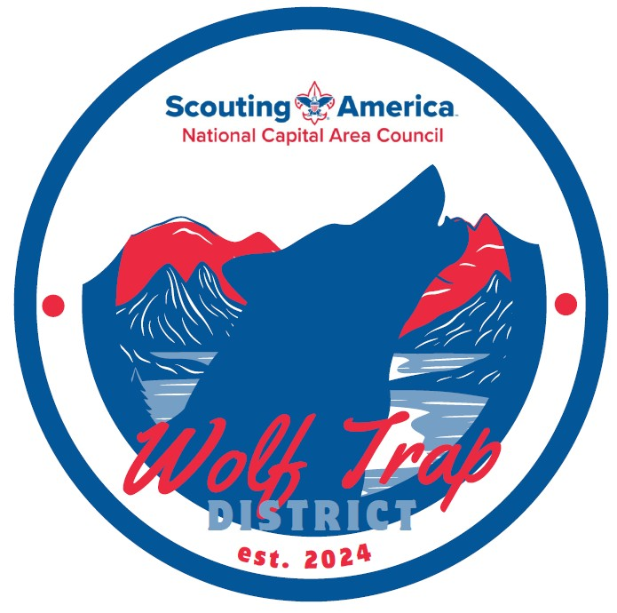
Adventure Day
May 2, 2026
(overnight camping available May 1 and 2)
Camp Snyder
6100 Antioch Road,
Haymarket, Virginia 20169

Cub-o-Ree Contacts:
Traci Yates, District Chair, traci.yates@cox.net

Overview
The Cub Scout “Adventure Day” themed Cub-O-Ree will be held on Saturday, May 2, 2026, and will feature BB Guns, Archery, Climbing Wall, Gaga Ball, STEM and Slingshots, with overnight camping available on Friday, May 1 and Saturday, May 2. The event will take place at Camp Snyder. The event is open to all Cub Scouts and prospective youth. Cub Scout Packs are encouraged to use this event for recruitment and invite prospective youth for the day who may want to join Cub Scouts. Youth do not need to be registered Scouts to participate in activities, but they do need to be of cub scouting age (5-11 years).
Overnight Camping
Camp sites include access to bath houses that have separate facilities for adult males and females and separate youth facilities for boys and girls. Camp sites also include a pavilion with picnic tables, and a fire pit. Packs need to bring their own tents, sleeping bags, cooking equipment and food. Each pack needs to bring garbage bags and carry their trash home for disposal. There is a Walmart and several fast-food restaurants less than five miles away in the town of Haymarket. On Sunday morning, packs can depart at any time by checking out with their camp site Commissioner. Everyone must depart prior to 11 AM on Sunday.
Please note that prospective youth cannot camp overnight, they can only participate in the activities during the day on Saturday.
Registration
Registration is open on Black Plug on the NCAC Web Site: National Capital Area Council - Wolf Trap District Cub O Ree.
Packs should register their scouts/prospective youth for this event. After registering to start, you can add more youth as needed.
- The cost for youth ages five to eleven who are attending Adventure Day is $30 for early bird registration until March 31, $35 for regular registration until April 19 and $40 after that date.
- Prospective Youth attend for free.
- Adults attending Adventure Day with their scouts are $15.
- Cub o’Ree staff attend for free.
The fees above include camping on both Friday and Saturday nights. Meals are not included and will be provided by the pack.
Online registration closes on April 30.
Traffic control and parking
As you enter Camp Snyder, there is a large parking lot to the left. You can park there and then walk to the Hylton Center porch for check-in. For scouts that are camping, drivers can drive to their assigned campsite and drop off gear. We request that you drop off the gear quickly and then return to the large parking lot. There is no long-term parking allowed at campsites.

Check In
On-site check-in will be from 5-7 pm at the Hylton Center front porch on Friday, May 1 and starting at 9 am on Saturday, May 2. At check-in, Scouts will be assigned to groups based on their Pack/Den and they will receive their schedule. Each Scout and prospective youth must attend as part of a Pack. Adults must accompany their scouts and prospective youth at each station. The District Staff does not have the capability to supervise individual scouts or unaccompanied youth. Each Pack will bring lunch for their group.
Uniform
The uniform for youth attending is the Cub Scout Class B or similar clothing. The class B (activity) uniform is a Scout or unit T-shirt with long pants or shorts, and any other clothing appropriate for the weather (e.g. rain jacket). Prospective youth can wear similar regular clothes. All youth must wear enclosed shoes such as sneakers or other solid footwear. Youth cannot wear sandals or clogs. All youth need to bring a water bottle.
Friday’s Schedule
Check in between 5 and 7 pm at the Hylton Center front porch
Saturday’s Schedule
Time Activity
9 AM Check-in begins at the Hylton Center front porch
9:45 Opening Ceremony
10 AM – 1 PM Morning Activities
1-1:30 PM Lunch (pack provides lunch for its participants)
1:30-4:30 PM Afternoon Activities
4:30-7 PM Open, Dinner, Campsite set-up
8 PM Campfire
Sunday Schedule – Depart prior to 11 AM.

Weather Decision
In the event of inclement weather, a decision will be made on Thursday night, April 30, 2026, by 5 PM and registered participants will be notified of any changes or cancellation.
First Aid
A first aid station will be at the check-in at the Hylton Center.
Lost and Found
Lost and found items will be at the check-in at the Hylton Center. Please label any items, such as water bottles, to facilitate their return.
Address: Camp Snyder, 6100 Antioch Road, Haymarket, Virginia 20169, (571) 248-4904
Emergency Telephone Numbers and Information
Emergency Police, Fire, and Rescue: 911
Prince William County Police (non-emergency number) 703-792-6500
Emergency Rooms:
- UVA Haymarket Medical Center, 571-284-1000, 15225 Heathcote Blvd, Haymarket, VA (2.22 miles from camp)
- UVA Prince William Medical Center, 703-369-8000, 8700 Sudley Road, Manassas (11.56 miles from camp)
Frequently Asked Questions
Our pack normally does spring family camping at Camp Snyder. How is this different?
- Since the Cub-o-Ree is specific to the Wolf Trap District, there are fewer scouts, and as a result, every scout can participate in every planned activity. At a larger family camping event, they may have a smaller set of activities. This year, Camp Snyder family camping limits scheduled activities to four per scout.
- We may ask packs to provide some volunteers to supervise the various stations. However, volunteers for the Range and Target Activities (archery, BB guns, sling shots) and Climbing will be provided by the District because they have specific skill sets. We will also ask Scouts BSA troops and the Order of the Arrow to assist.

Can we camp overnight at Camp Snyder on both Friday and Saturday evening?
Yes! You can camp on either or both nights. Or you can opt to not camp at all and just come out for the day.
Can my cub scout bring a friend?
Yes! This is a great recruitment opportunity. Friends must be of cub scouting age (5-11 years). Friends should also be registered with the pack on Black Pug and are free. Please note that although friends can participate in the activities on Saturday during the day, they cannot camp overnight on Friday and Saturday evenings.

