2026 Pinewood Derby Rules National Capital Area Council

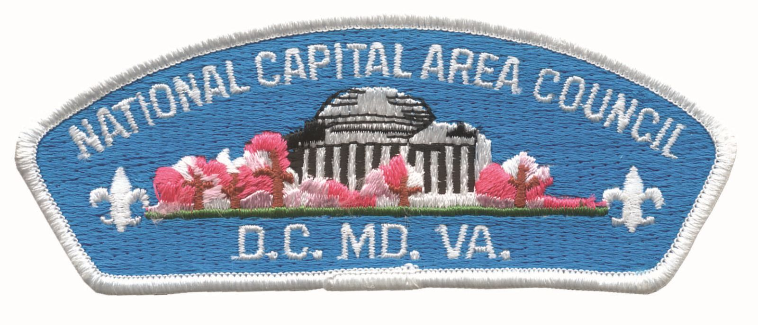
***Decisions of the Judges during the heats and races are final***

- General – Entry is limited to one car per participant
  - Membership requirements for Scout Divisions (Lions through AOL)
    - Registered as a Cub Scout at some point since January 1st, 2026
    - 5th Grade Cub Scout who bridged (joined) Scouts BSA since September 1st, 2025 are allowed
  - (Optional) Outlaw Divisions; these participants do not need to be registered with Scouts BSA in any way, but may be included at the discretion of the race director for fun and as a way to exemplify life-long learning. And this may be combined into a single division.
    - Open Youth will include youth under the age of 18.
    - Open Adult will include anyone over the age of 18.
  - Eligibility
    - All scouts may register for a spot in the Scout Divisions, you need not have finished 1st, 2nd, or 3rd at the district level in your division.
    - If available, any scout under 18 may race in the Outlaw category, regardless of pack or district finishing.
    - If available, any adult may race in the Outlaw category, regardless of age.
  - Scout Division cars must be built for the current season, NO REPEATS or REPAINTS. Outlaw Divisions may be repeats.
  - Cars may not be sent to a third-party facility for tuning or for other performance enhancements.
  - A youth advances, NOT the specific car. Cars built for the year may be re-tuned, or even whole new cars built to take advantage of different rules.
  - No Proxy Racers for 2026
    - We are not accepting mail-in cars this season. You may contact the race director with specific questions on arrangements for getting our car to the race.
    - If a scout must leave early and no one is specifically assigned by the participant for their race time, the car will be under control of the race director or their designee.
  - By registering, you acknowledge that the car meets the rules to the best of your knowledge.

Everyone is encouraged to wear their scout uniform! This is NOT a requirement, as we recognize participants may have come from or be headed to other events.

A Scout is Trustworthy. We expect everyone to abide by the rules in letter and spirit.

Note: just because your car has passed every previous inspection does not ensure it will pass here! While we hate to inconvenience you to change your car last-minute, we also strive for the fairest race when the margins for winning are so thin.

- Body

  - The main body may be made of any safe material--including wood, 3D-printed materials, etc. The car design may be enhanced by the addition of other stable materials such as plastic or metal. Any additions must be firmly attached, non-moving, and meet car size specifications.
  - Cars must meet the following specifications using on-site tools and jigs.
    - Weight: not to exceed 5.0 oz on scales accurate to 0.1 oz. For scales that have more than a single digit beyond the decimal point, the maximum weight is 5.0100 oz.
      - The council will not provide tools to help reduce weight.
      - Consider using some easily-removable weight to fine-tune at the race site if needed (see 6. Weights)
    - Total width: not to exceed 2.75 inch
    - Total length: not to exceed 7.0 inch (inc. wheels and any decorations)
    - Total height: not to exceed 6.0 inch
    - Clearance: only the wheels may touch the track.
    - Center rail: wheels must clear the center guide rails, about 1.75 inch. The car bottom should be at least 3/8 (0.375) inch from the surface to avoid the center rail.
    - Wheelbase: the distance between the centers of the front and rear wheel must be at least 4 inch. Cars may use the axle slots or drill new axle holes.
    - Front: the front/leading edge of the car must be at least ½ inch wide at the center of the car, and no more than 1 inch above the wheel lane of the track. No pointed-front cars.
    - No part of the car may protrude beyond the starting pin.
    - At least 4 wheels must be attached to the sides of the car body.
      - Each wheel must be attached to the car’s body with a legal axle.
      - Only 3 wheels need to touch the track.
    - The complete inside and outside lettering of each wheel must be visible when the wheel is attached to the body.
    - Washers (e.g. delrin) and/or body treatment (e.g. teflon tape, graphite) between the car body and wheel are permitted. These must be affixed to the car body and not be in violation of other rules (i.e. no wheel-cover).
    - Fenders and fairings are permitted, but must not cover the inside or outside of the wheel nor interfere with the center rail.
    - Each attached wheel must not be angled more than 20 degrees from vertical.
    - Front-most and rear-most wheels must be positions across the body from each other.
    - Air Dams covering the inside or outside of the wheel are not permitted.
    - The following items are prohibited:
      - Springs
      - Starting devices or propellants
      - Electronic or lighting devices that interfere with the race electronics
      - Liquids, wet paint, oil, sticky substances, or powders of any kind (other than used for axle lubrication)
      - Glass or excessively fragile parts
      - Bearings and/or bushings
      - “Hubcaps” covering the nail head
      - Loose/moving objects in/on the car.

- Wheels

  - Only official BSA wheels are allowed.
    - Wheels from the box kits (black), or various colors from the 4-packs are acceptable.
    - Aftermarket BSA wheels may be used, but must meet all rules. Please check what you purchase!
  - All lettering and numbering, both inside and outside of the wheel, must remain complete and be visible with the wheel on the car.
  - The fluting (small bumps on the outside edge of the tread), spokes and other markings on the outside wheel area must remain visible.
  - The minimum wheel diameter is 1.16 inch
  - The tread surface must be at least 0.295 inch (7.5 mm).
  - All surfaces of the wheel may be polished.
  - The tread surface must be flat and parallel to the wheel bore. Therefore, the following modifications are prohibited (see Figure 1):
    - Rounding of the tread surface
    - Grooving, H-cutting, or V-cutting the tread surface
  - The following wheel modifications are prohibited:
    - Removing material from the inside tread surface or the inside sidewall surface
    - Drilling holes in the tread, sidewalls, or spoke area.
    - Removing material from the sidewalls or Spoke
    - Filling wheel tread with any type of material
    - Filling the wheel bores and re-drilling the bore
    - Adding wheel covers inside our outside
These rules would allow for the same wheel found under the North Star Council Pinewood Derby rules. Several vendors offer similarly specified wheels.
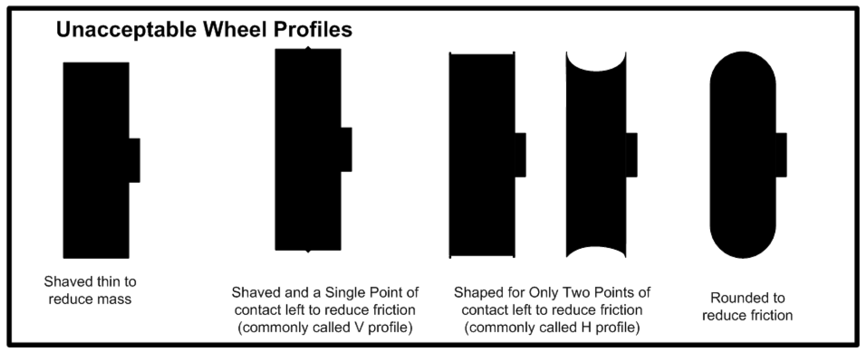Figure 1: Examples of unacceptable wheel modifications. Changes to the wheels should be minimal, and to remove small imperfections such as flashing (if any).
- Axles
  - Metal axles with a nail head are required, and must have a diameter of at least 0.084 inch. (typical nails are 0.088-0.092 inch diameter)
    - Axles may be polished and grooved, provided the part the wheel rides on meets the above diameter requirement.
    - After-market nail-type axles may be purchased and used if they meet the specifications.
  - One-piece metal axles extending through the width of the car to support both wheels are not permitted.
  - Axles may be bent, as long as the wheel angle remains not more than 20 deg from vertical (see 2. Body).
  - Grooves cut into the outside nail head to tune the wheel tracking are permitted.

- Lubrication
  - Dry lubricants only (e.g. graphite, molybdenum, tungsten disulfide, powdered teflon, wax).
  - Liquid lubricants are prohibited (e.g. Krytox 100, oil, silicone).
  - Cars must be clean of excess lubricant
    - Excessive lubricant which results in shedding onto the track is not allowed.
    - Normal handling of a car should not make the hand dirty.

- Weights
  - Only non-toxic materials are allowed.
    - Good choices include tungsten, steel, zinc, copper, nickel
    - Weighted (tungsten) putty is allowed, and even encouraged, as it can be quickly added/removed to fine-tune the final weight at check-in.
  - Prohibited: lead, mercury, cadmium, etc. These are a serious health hazards not permitted in childrens’ toys, and present a danger to the health and safety of everyone under the Federal Hazardous Substances Act.
    - Safe “Pb-free” alternatives can be found at all scout and hobby shops.
    - We will no longer make allowances for this rule.

- Outlaw Rules
  - The restrictions for outlaw division are minimal
    - Length: the car must be no more than 7” long
    - Weight: not substantially more than 5.00 oz. This is at the discretion of the head judge, but cars that clearly exceed the weight will not be allowed to race.
    - Only use gravity for propulsion (no springs, engines, etc.)
    - May not contain projectiles or unsafe materials of any kind
  - Razor wheels, wheel bearings, oil, solid-piece axles, fairings, etc. are permitted

- Race Day
  - Race Officials are the adults and youth involved in putting on the race. There shall be a Race Director (RD), who may designate other roles to ensure smooth race operations. Other roles may include:
    - Track master – typically responsible for handling track operation and software. They should ensure the track is in good working order, and notify the RD of any problems.
    - Commentator(s) – entertain the crowd, generally inform the race status, etc.
    - Official Inspection judges – perform inspections of cars during check-in.
    - Repair judge – may assist with car repairs. Often useful during check-in to remove car weight. Should come prepared with a variety of hand tools to assist.
    - Scout runners – they ferry cars from the finish to the staging area during heats.
    - Parent liaison – this person may be an expert racer or someone who is well-versed in the rules that acts as an observer. The scouts/parents may also come to them with questions during the race. This person may alert the RD to potential issues and expedite a resolution.
  - Inspection
    - Each car must pass inspection by the Official Inspection Committee before it may compete. The inspectors will disqualify any car not meeting these rules. Any adult or scout may appeal the findings of the Inspectors to the Race Committee Chairperson (often the RD), whose decision is final.
    - Every effort will be made to do the inspection without any altering of the car.
      - If race officials cannot verify that the wheels have not been lightened due to interior wheel weights, fenders, or other reasons, we will ask YOU (or the proxy) to take the wheels off for inspection.
      - If the race officials cannot confirm only dry lubricant was used, we may ask YOU (or the proxy) to add your dry lubricant to the wheels.
    - After a car has passed inspection, only race officials may handle the car.
      - Racers may withdraw their car at any time.
      - After check-in, adjustments are not allowed without re-inspection.
      - Car repairs during the race are allowed only when authorized by the race officials (such as wheel failure, or impact from another car).
      - If a car is damaged from an official mishandling, the owner may be asked to reinspect their car and confirm it is in working order. A reasonable time may be allowed for repair at the discretion of the race officials.
    - Once Inspection is PASSED before the race, the car will not be re-inspected after the race.
  - Racing
    - Each car will participate in the number of heats as lanes on the track. E.g. 4 heats, running once on each of the 4 track lanes (most likely configuration).
    - The average time to complete the four heats will determine the fastest car in each den level and for the overall categories.
    - The track may be wiped down as needed to keep it clean.
    - Additional rules
      - If a car comes off the track during a heat, a “No Race” will be declared and the heat will be run again. If the same car jumps off the track a second time, that car’s time for that heat will default to 9.9999 seconds.
      - If a car suffers a major mechanical problem, a “No Race” will be declared and race
officials may allow car repair (typically 5 minutes). If the car is still unable to
compete, the damaged car will be assigned a time of 9.9999 seconds for the heat
and any remaining heats.
      - If a car or cars do not make it to the Finish Line, the car(s) will be assigned a time of 9.9999 seconds for the heat.
      - If two cars tie with identical average times, then the car with the fastest run wins the tie-breaker.
      - If the RD determines that track malfunction/inconsistency renders differences between top overall performers nearly equal after the Den heats, a Grand Final set of heats may be raced to determine the overall placements. The number to include is at the discretion of the Race Officials, but will likely be less than 5.
    - Race officials have final discretion on whether to allow a car repair, and for how long.
    - Good sportsmanship and behavior is expected. Race officials understand that emotions may run high, as a great deal of time and effort goes into these cars. However, race officials may ask anyone not following this rule to leave the race area.
    - If time allows, the RD may permit unofficial heats between Outlaw- and Scout-Division racers for fun. However, these do not affect the official times and standings.
  - Awards
    - Overall awards/trophies for 1st, 2nd, and 3rd places will be presented to the scouts with the fastest average times overall.
    - Den-level awards/trophies for 1st, 2nd, and 3rd places will be presented to the scouts with the fastest average times for their den, excluding those winning an overall award. I.e. scouts who place 2nd overall and 1st Webelos will only receive the 2nd overall award, and other webelos den members will “roll up” to receive the 3 den-level trophies
    - Den-level design/concourse trophies for the 1st and 2nd places will be presented to the scouts as determined by a panel of judges.
    - A Best in Show award may be given to the most outstanding design as determined by a panel of judges.
    - (Optional) Open/outlaw awards/trophies may be awarded for 1st, 2nd, and 3rd places.

- Questions/Disputes
Questions may be addressed to the Race Officials. Please be specific, noting the race heat and/or cars involved, rules broken, and/or mistakes needing correction.

The Scout owner of a non-compliant car may still race in the "Outlaw" section and will not qualify for a speed award.

Decisions of the Judges during the heats and races are final.

- Footnotes
These rules were adapted from the many district rule sets of the NCAC, as well as the Northern Star Scouting Pinewood Derby Rules. We acknowledge the thought behind this particular rule set as a means to balance competition and innovation with practicality and accessibility for all scouts.

We may update these rules as needed to fix typos or to clarify a rule.

Brief Rationale

These build rules are less restrictive, in some cases substantially, than many PWD rule sets for the district races. The reasons for this are as follows:

1. Encourage experimentation and innovation, core concepts of STEM
2. Impossible/ineffective enforcement of some existing rules
3. Discrepancies between district rule sets

There should be a balance between allowing cub scouts and parents to run wild with exotic designs and being mindful that this should not become a cost-prohibitive endeavor. Generally, a car design element/modification that does not make cost a factor is acceptable. For example, it largely does not matter where the wheels and axles are on the car, provided it stays on the track and doesn’t interfere with other cars. Similarly, drilling holes in wood is often necessary for adding weight anyway, the cost is low, and information on how to do it is readily available.

Some rules are also not practically enforceable. We do not ban after-market parts because they are (a) relatively moderately priced, (b) often use existing PWD parts (blocks, wheels, & axles), or are not substantially different materials, and (c) can be a substantial time and cost savings to families without tool shops and experience while still allowing families to design, build, and tune a car themselves. Also, detection of these parts, especially axles, can be very difficult (esp. trying to register dozens of scouts while everyone waits for things to get started), as they are often designed to look identical to stock parts when assembled.

What about fully pre-built cars? We strongly discourage purchasing these, as we think scouts will get much more out of working on their own cars. However, we would have a very hard time proving a scout/parent broke this rule. If you must race one of these cars, be honest about it, and we encourage you to enter it into an Open division.

We only permit dry lubricant at this time. To the best of our knowledge, all districts align with this rule
except one. There is an argument that oil lubrication is actually less messy, more cost effective, and even safer for cub scouts than traditional graphite, in addition to being higher-performance. This may be the case for adult PWD racing leagues; however, at this time we feel the potential downside from oil-based lubricants being misused, cost, and health risks outweigh the positives for scouts and their families.

We attempted to lay out rules that target potential safety, handling, and cost concerns without discouraging cub scouts and their families from exploring the boundaries of their imaginations. We welcome feedback and constructive criticism, and may update the rules each year to better meet the goals of Scouting.

Do Your Best, and Happy Racing!

Jason Kralj
2025 NCAC Council Pinewood Derby Chairman

